Lesson 27
Objective: Identify a growth pattern using objects.

Suggested Lesson Structure
 Fluency Practice (2 minutes)
 Application Problem (6 minutes)
 Concept Development (14 minutes)
 Student Debrief (3 minutes)
Total Time (25 minutes)
Fluency Practice (2 minutes)
- Dribble and Shoot PK.CC.1 (2 minutes)
Dribble and Shoot (2 minutes)
Note: In this activity, students do counting movements in an AB pattern while reviewing one of their core fluencies, rote counting to 20. Consider drawing students’ attention to the pattern in the later teen numbers: sixTEEN, sevenTEEN, etc.
T: Today, let’s use a dribble and shoot pattern.
T: First we’ll dribble, and then we’ll shoot. Then we’ll dribble, and then we’ll…?
S: Shoot!
T: You’ve got it! Now, let’s count to 20 the Say Ten Way as we dribble and shoot.
Count to 20 the Say Ten Way, alternating between dribbling and shooting as students count.
Application Problem (6 minutes)
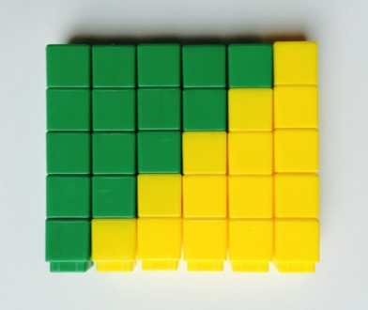
Materials: (T) Linking cubes in two colors (enough for each child to have 10 cubes altogether)
Place linking cubes in piles where students can easily access them. Ask each student to make a tower with five cubes. Have students put the same colors next to each other in the tower, e.g., YYGGG rather than YGYGG.
Next, have students use their towers to create a pattern as pictured to the right. First, select a tower with five green cubes. Next, choose the tower with one yellow and four green cubes and place it beside the first tower. Continue until there are four towers next to each other. Ask children if they see a pattern. See if they can figure out the next two towers in the pattern. With the extras, see if you can make another set. If one or two towers are missing, have students try to make the one(s) that would complete the pattern.
Note: This Application Problem shows a growth pattern, reminiscent of the number stairs that show the pattern of 1 more. Encourage children to make these connections as a precursor to the lesson. Be prepared to create any partners of 5 needed to complete the pattern.
Concept Development (14 minutes)
Part 1: Concept Introduction
Materials: (T) Bin of colored linking cubes (red, blue, green) (S) Baggie of 18 (8 red, 6 blue, 4 green linking cubes per pair
Gather students in a circle on the floor. Give each pair a baggie of linking cubes to share.
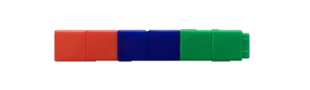
- Say, “Listen to my story: When Julia gets home from school, she takes off her shoes and puts them by the front door. I’m going to use my cubes to show her pair of red shoes. You do the same.” Put two red cubes together as students do the same.
- Say, “In the afternoon, Julia’s mom comes home from work and puts her blue shoes by the door.” “Let’s build a new tower to show all the shoes then. (Connect two red cubes and two blue cubes.) “I’m going to put the new tower next to the first tower of two red cubes. You do the same.”
- Say, “In the evening, Julia’s brother comes home from basketball practice and puts his green shoes by the door, too.” “Let’s build a new tower to show all the shoes then. (Connect two red cubes, two blue cubes, and two green cubes.) Put the new tower next to the first 2 towers.”
- Say, “Look, we made a growth pattern! Who would like to continue the story? Who might come home next and put his or her shoes next to the door?”
- Encourage students to continue the pattern. Check that each student’s tower is growing by 2.
Part 2: Practice

NOTES ON
MULTIPLE MEANS
OF REPRESENTATION:
Provide a model of the tower for students having difficulty building the pattern, especially if they have not yet learned their color words. Ask specific questions like, “How is your tower growing?” Students can check their work against the model. This helps them to feel more comfortable taking risks.
Materials: (S) Bin of colored linking cubes (per table)
Instruct students to return to prepared tables.
- Say, “You are going to make a new tower as I tell another story.”
- Say, “Some friends were stomping outside in some rain puddles. George came inside first and put his blue rain boots by the door. Show my story with your cubes.” Students connect two blue cubes.
MP.7
- Say, “Jade came inside next and put his yellow rain boots by the door. Make a new tower to show what all the boots look like now.” Students connect two blue cubes with two yellow cubes.
- Say, “With a partner, continue my story. Each of you tells one more story and adds on to your towers.”
MP.7
- Circulate and listen to students’ stories and representations, using parallel talk: e.g., “I heard Cecily say, ‘Angel came inside and put his green rain boots by the door. We need to add two more to a new tower.’”
- Invite students to share their stories and to show their towers.
Student Debrief (3 minutes)
Lesson Objective: Identify a growth pattern using objects.
The Student Debrief is intended to invite reflection and active processing of the total lesson experience. It is also an opportunity for informal assessment. Consider taking anecdotal notes or using a simple checklist to note each child’s progress toward meeting the lesson objective.
As students complete the Practice portion of the Concept Development, listen for misconceptions or misunderstandings that can be addressed in the Debrief.
You may choose to use any combination of the questions below to help students express ideas, make connections, and use new vocabulary.
- (Create three different towers to show what the shoe line-up might look like by the door.) Which of these shows the shoes of one person? Of two people? How do you know?

CENTER CONNECTION:
At the art center, invite children to use colored dot painters to represent the shoes, or even mittens, by the door. Provide construction paper doors for students to glue. Encourage students to create and to share their story with a partner.
- How are the shoes and boots patterns different from the patterns we have made before? How are they the same?
- Think about the number stairs we built earlier in the year to show the 1 more pattern. How were our towers today like the number stairs? Did our towers grow by 1 more today?

