Lesson 26
Objective: Duplicate and extend patterns with movement and objects.

Suggested Lesson Structure
 Fluency Practice (4 minutes)
 Application Problem (6 minutes)
 Concept Development (12 minutes)
 Student Debrief (3 minutes)
Total Time (25 minutes)
Fluency Practice (4 minutes)
- Count Out Pennies PK.CC.3 (4 minutes)
Count Out Pennies (4 minutes)
Materials: (T) Numeral cards 6–10 (Lesson 1 Template) (S) baggie or container of 10 pennies or objects
Note: Students maintain fluency with counting out objects and reading written numbers 6–10.
Pass out one baggie to each pair of students.
T: (Show the 10 card). What’s my number?
S: 10.
T: Count out 10 pennies. (Provide time to count.)
T: Count them again as you put them back in your baggie.
S: 1, 2, 3, 4, 5, 6, 7, 8, 9, 10.
Continue showing different numeral cards. Gently remind any students who count past the target number to stop when they get to the number on your card.
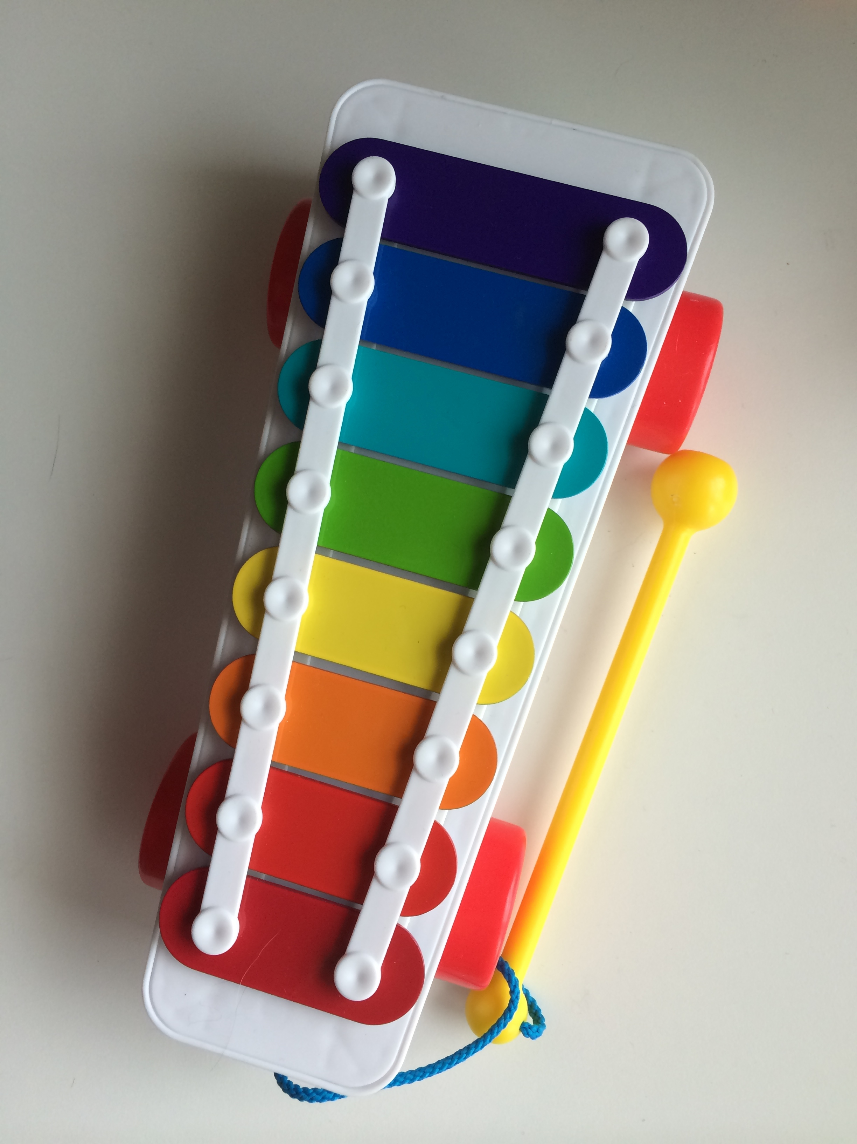
Application Problem (6 minutes)
Materials: (T) Xylophone or other instrument with at least 2 very different notes/tones
Play a note (A) on one end of the xylophone. Have children hop whenever they hear that note. Play a different note (B) on the other end of the xylophone. Have children step forward when they hear that note. If the instrument has a third note, play it (C) and ask children to step back.
Play the notes in a pattern as children move their bodies. Consider using the following suggested sequence: ABAB, ABCABC, BBCCBBCC, AABCAABC.
Note: In this problem, children see that the same set of sounds or movements can be rearranged to make different patterns. If a student struggles to distinguish between different notes, seat her next to the instrument so she can see which note is being played.
Concept Development (12 minutes)
Part 1: Concept Introduction
Materials: (T) Bin of linking cubes (of various colors)
- Show an ABAB pattern: clap, hop, clap, hop. Have students stand and do it, too.
- Ask students, “What is the repeating part of the pattern?”
- Say, “Show me this whole pattern with linking cubes.” Students do, e.g., RYRY.
- Ask students to extend the pattern: “What comes next in our pattern?” (Pause.) Use students’ suggestions to extend the pattern, doing it again.
- Say, “Hmm…I wonder if we can extend the pattern with linking cubes.” Ask, “Who can show the next part of the pattern?” Call on two more students to do so.
- Say, “Good! Let’s say the pattern together, ‘clap, hop, clap, hop…’ (while pointing to cubes).”
- Repeat Steps 1–6 with a new pattern, identifying the repeating part with students and encouraging them to extend the pattern with cubes.
Note: Different patterns can be used: ABCABC, AABBAABB, ABBABB, etc.
Part 2: Practice
Materials: (S) Tray with 5 different linking cube trains (per table), e.g., GGB, YB, RRGG, RGY, BGG
Send students to prepared tables with the linking cube tray in the middle.
- Say, “On your table, there are trains with only the repeating part. You are going to use each train to build a pattern, like this.” Model how to build a pattern, beginning with the repetend, i.e., repeating part, AABB. Complete the next repeating part (eight cubes total).

NOTES ON
MULTIPLE MEANS
OF ENGAGEMENT:
Provide a challenging extension for students who are ready by having them build upon a more difficult repetend, or by encouraging them to make their own repetend that the class can build upon.
- Say, “Now, it’s your turn!” Students work independently to build various patterns with linking cube trains.
- Circulate and ask questions to check for understanding: What is the repeating part? What comes next in the pattern?
- Once students have successfully built a pattern, instruct them to return the train to the original repeating part and place it back on the tray for another student.
- Students should have time to practice with at least 2–3 trains.
Student Debrief (3 minutes)
Lesson Objective: Duplicate and extend patterns with movement and objects.
The Student Debrief is intended to invite reflection and active processing of the total lesson experience. It is also an opportunity for informal assessment. Consider taking anecdotal notes or using a simple checklist to note each child’s progress toward meeting the lesson objective.
As students complete the Practice portion of the Concept Development, listen for misconceptions or misunderstandings that can be addressed in the Debrief.
You may choose to use any combination of the questions below to help students express ideas, make connections, and use new vocabulary.
- If you know the repeating part of a pattern, can you make the pattern longer? How? Could it go on forever?

CENTER CONNECTION:
Create a center where children can use manipulatives to extend patterns. Linking cubes, beads, buttons, leaves, and rocks can be used to create the initial pattern. Pattern cards can also be created for reuse. Be sure to provide two complete pattern units before asking children to replicate or extend the pattern.
- Have you seen patterns outside? In your house? What patterns have you seen?
- (Show two trains from Part 2: GGBGGB, BGGBGG.) Do you need the same cubes to extend these patterns? How are they similar? Different?
- Does the American flag have a pattern? How do you know if it is or isn’t a pattern? What is the repeating part?

