Lesson 24
Objective: Identify patterns using objects.

Suggested Lesson Structure
 Fluency Practice (10 minutes)
 Concept Development (12 minutes)
 Student Debrief (3 minutes)
Total Time (25 minutes)
Fluency Practice (10 minutes)
- Decompose 4 PK.CC.5 (4 minutes)
- Count Out Pennies PK.CC.3 (4 minutes)
- Dribble the Basketball PK.CC.1 (2 minutes)
Decompose 4 (4 minutes)
Materials: (T) 3 paper plates (1 large, 2 small), 4 apple slices, numeral card for 4 (Lesson 1 Template)
Note: This activity helps lay the foundation for thinking about part-whole relationships. The small plates show the parts and the large plate shows the total, anticipating the number bond, a model that students use from Module 4 of Kindergarten through Grade 5.
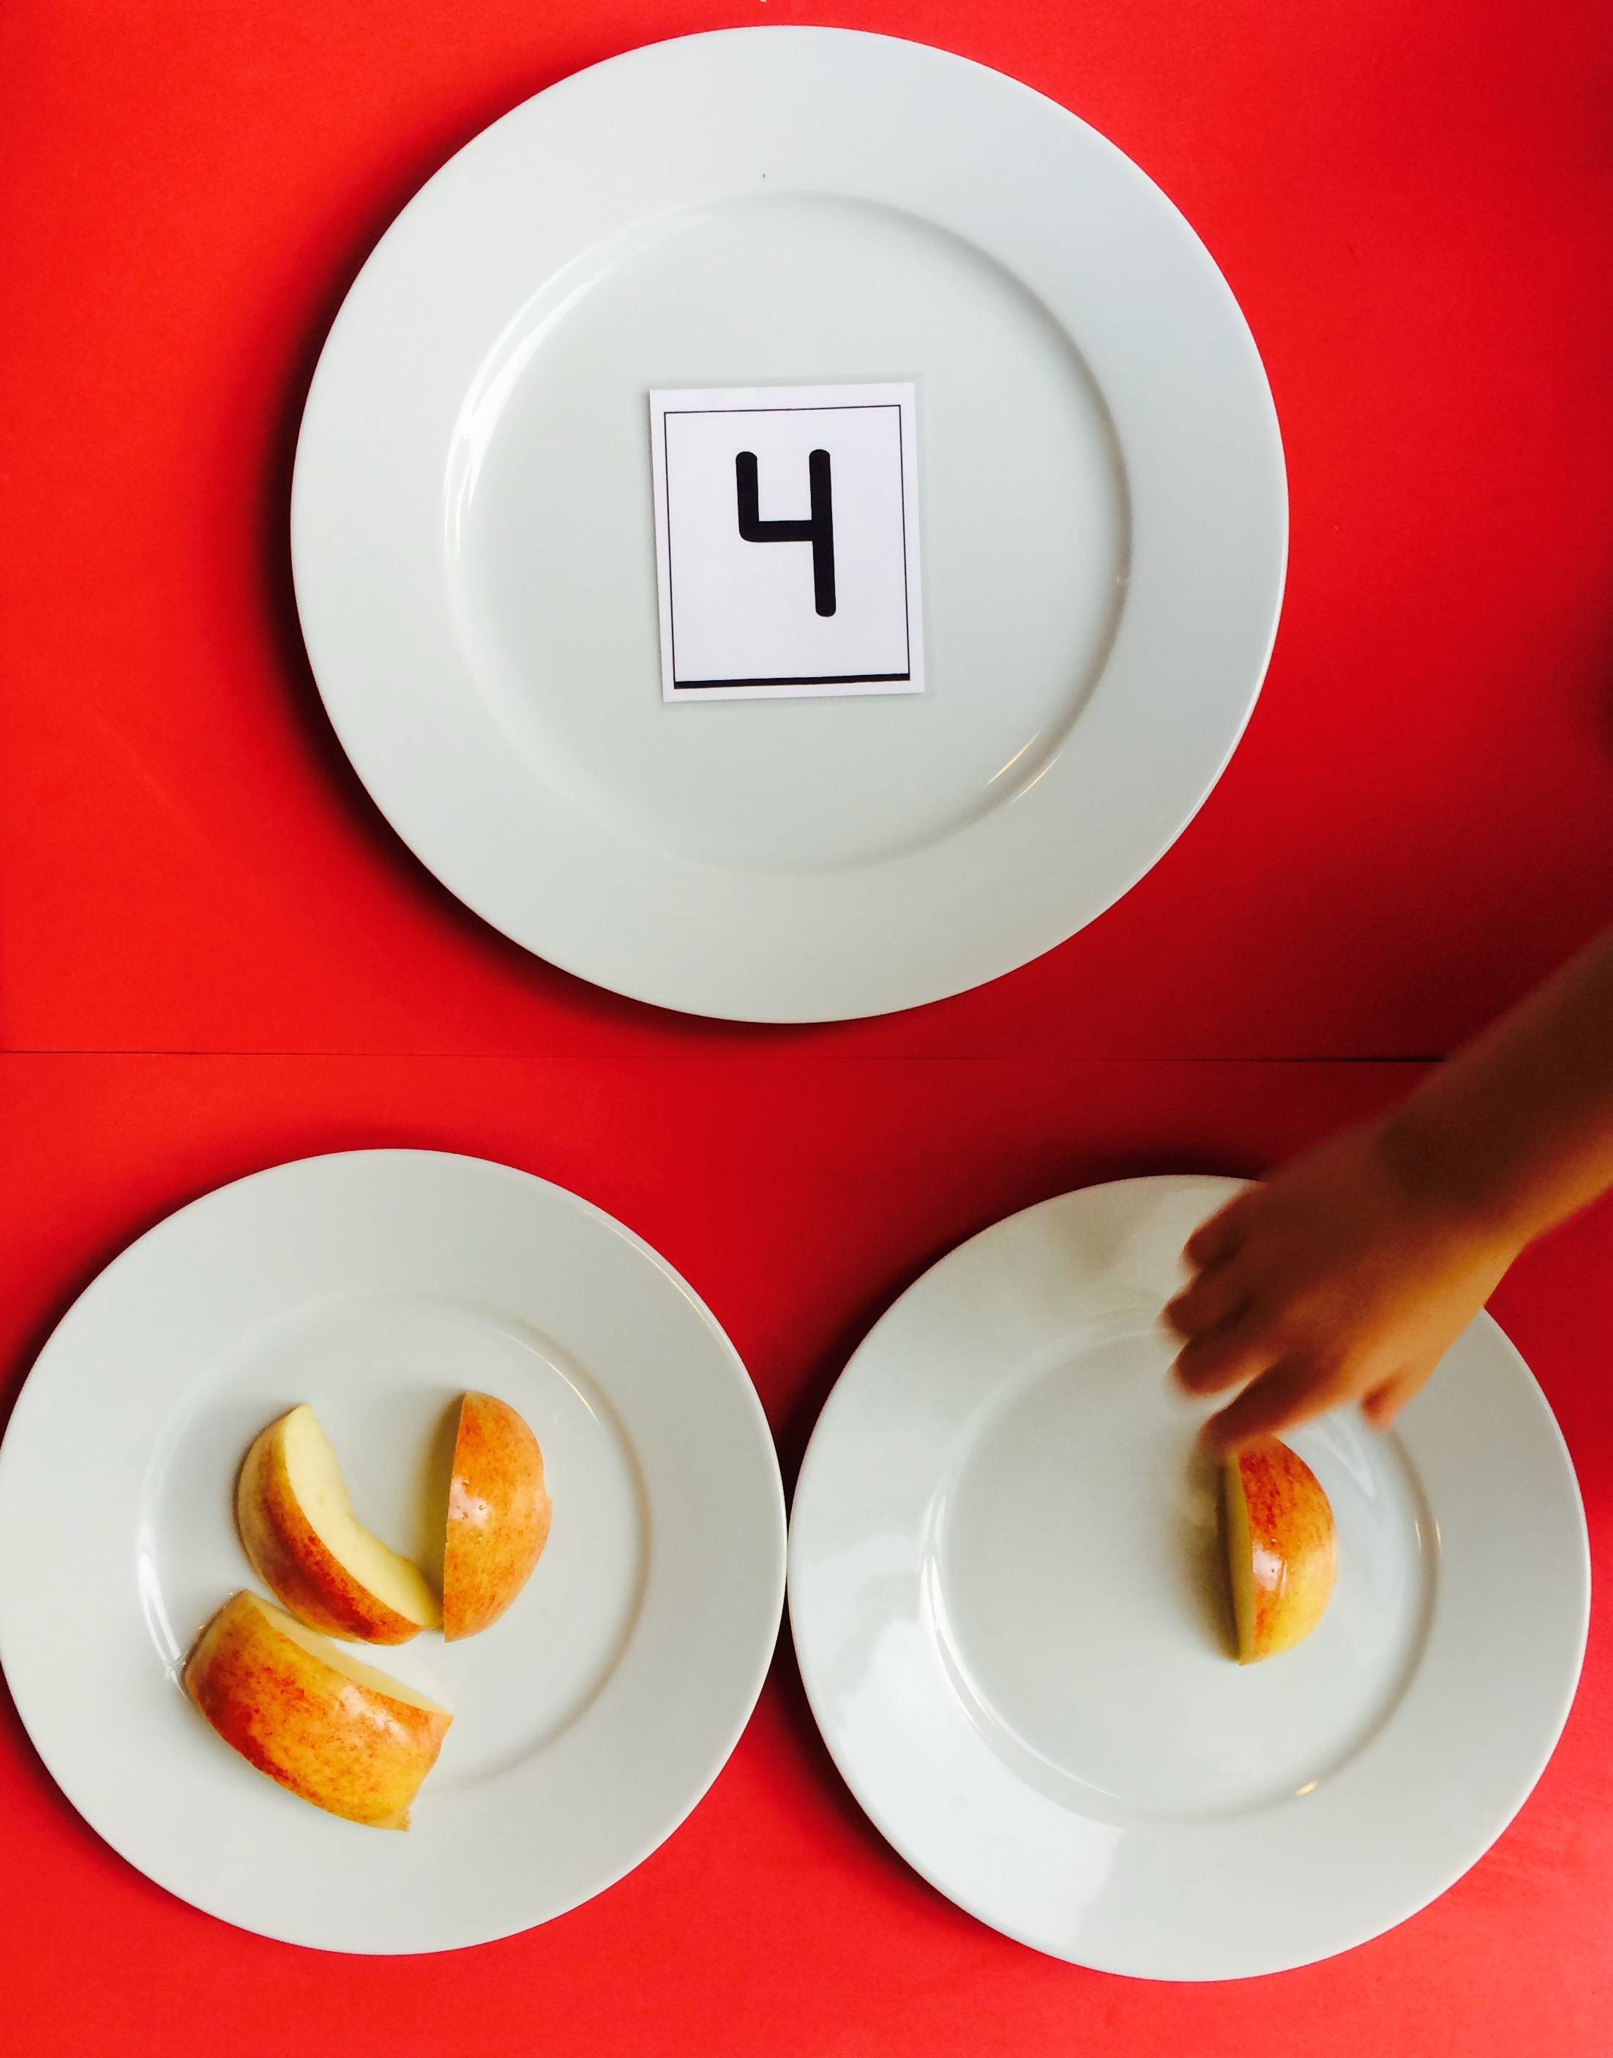
Place four apples slices on the large plate.
T: Count the apple slices I have for your snack today. (Touch as students count.)
S: 1, 2, 3, 4.
T: That is the number I have here! (Replace the apple slices with the 4-card on the larger plate. Lay out the small plates.) What are some ways I can share my apple slices with a friend?
S: Give your friend one. Give your friend two.
T: Okay, let’s start by sharing one. (Decompose the group of four apple slices by placing one slice on a smaller plate. Have students count as you move the rest to the other plate.)
T: Let’s put them back together and share them in a different way. (Recount and repeat as time allows.)

Count Out Pennies (4 minutes)
Materials: (T) Numeral cards 6–10 (Lesson 1 Template) (S) baggie of 10 pennies per pair.
Note: Students maintain fluency with counting out objects from a larger set of 10 and reading written numbers 6–10. Pass out one baggie to each pair of students.
T: (Show the 6-card). What’s my number?
S: 6.
T: Take six pennies out of your bag. (Provide time to count.)
T: Count them again as you put them back in your baggie.
S: 1, 2, 3, 4, 5, 6.
Show numeral card 7. Gently remind any students who count past the target number to stop when they get to the number on your card.
Dribble the Basketball (2 minutes)
Note: In this activity, students review one of the core fluencies, rote counting to 20.
T: Let’s pretend we are basketball players dribbling the ball.
S: (Students and teacher pretend to dribble the ball.)
T: Let’s count to 20 together as we dribble. Start at 1 with me.
Count to 20 as you dribble.
Concept Development (12 minutes)
Part 1: Concept Introduction
Materials: (T) Sun and star cards (Template)
Keep students seated at their tables for Part 1.
- “When I go to sleep at night, it is dark and the stars are in the sky. Pretend to go to sleep.” As the children pretend to go to sleep, tape a star card to the board.
- Say, “Wake up! It’s morning! What is in the sky during the day?” When the students answer, “The sun,” tape a sun next to the star card on the board.
- Repeat this pattern of pretending to go to sleep (taping the star card on the board) and waking up with the class (taping the sun on the board) until you have at least three stars and three suns on the board in an AB pattern.
- Pointing, say the pattern together, “Star, sun, star, sun, star, sun.”
- Say, “This is a pattern. Every day the stars and the sun repeat this pattern.”
- Remove suns and stars from the board and repeat the activity beginning with the sun first this time.
Part 2: Practice
Materials: (S) Two types of crackers (at least 3 of each per student), paper towel

NOTES ON
MULTIPLE MEANS
OF ACTION AND EXPRESSION:
Encourage students to discover patterns throughout their day and to make connections to the math, for example, when they are building with blocks in the block corner or when sorting fruit in the kitchen corner.
- Pass out crackers and paper towels to each student and say, “On your paper towel, put your snacks in a pattern, like we did with the stars and the sun.”
- Say, “Tell your neighbor your pattern, like ‘round cracker, square cracker.’”
- Say, “Eat the first two crackers of your pattern (Pause). Tell your neighbor the pattern that is still there.”
- Continue to eat two pieces and say the rest of the pattern until all the pieces are gone. This is a pre-cursor to recognizing the repeating part of the pattern, or repetend.
Student Debrief (3 minutes)
Lesson Objective: Identify patterns using objects.
The Student Debrief is intended to invite reflection and active processing of the total lesson experience. It is also an opportunity for informal assessment. Consider taking anecdotal notes or using a simple checklist to note each child’s progress toward meeting the lesson objective.
As students complete the Practice portion of the Concept Development, listen for misconceptions or misunderstandings that can be addressed in the Debrief.
You may choose to use any combination of the questions below to help students express ideas, make connections, and use new vocabulary (pattern).
- (Have a bin of blue (B) and yellow (Y) linking cubes to explore this question.) Look at my pattern: BBYBBYBBY. Can you make a different pattern with these two colors? Share it with a partner.

CENTER CONNECTION:
Use the art center as a place to explore patterns in nature. Find images of patterns on animals, plants, and other natural formations, e.g., zebra stripes, tree bark, snowflakes. Invite the children to say the pattern and draw or paint it.
- The objects in a pattern repeat. If we had red (R), green (G), and yellow (Y) apple slices in a RGYRGY pattern, how many apples would we have to eat until the repeating part started over again?
- Our pattern of the paper sun and stars (point) is a way to easily see a pattern of daytime and nighttime, being awake and going to sleep! We are using these objects to represent those patterns, just like we used blocks to represent lizards. What pictures might I use to represent the pattern of being at school and being at home?

sun and star cards
sun and star cards

