Lesson 23
Objective: Solve subtraction story problems with representative drawings.

Suggested Lesson Structure
 Fluency Practice (5 minutes)
 Application Problem (3 minutes)
 Concept Development (13 minutes)
 Student Debrief (4 minutes)
Total Time (25 minutes)
Fluency Practice (5 minutes)
- Find the Card PK.CC.2, PK.CC.4 (4 minutes)
- Ski Jumps PK.CC.1 (1 minute)
Find the Card (4 minutes)
Materials: (T) Numeral cards 6–10 (Lesson 1 Template), (S) baggie of picture cards from Lesson 22 with one 10-card added (Fluency Template), construction paper work mat
Note: Students maintain fluency with counting pictures arranged in varied formations and reading written numbers 6–10.
Pass out one baggie to each student.
T: Lay your cards on your work mat.
T: (Show the 10 card.) What number is this?
S: 10.
T: Find the card with 10 things. (Pause.)
T: Stand up with your card when you find it. (All the 10 cards are food. Check to see that students are holding a card with hamburgers, hotdogs, or sandwiches.)
As time permits, repeat for 6 (checking for fruit), 7 (vegetables), 8 (pond animals), or 9 (balls).
Ski Jumps (1 minute)
Note: This activity targets the core counting fluency, rote counting to 20.
T: Take out your ski poles! (Demonstrate holding imaginary ski poles.) Let’s count to 20 the Say Ten Way as we ski.
Jump left to right holding your imaginary ski poles to mimic skiing as you count to 20. Then, count again but stop at 17, challenging students to pay close attention to the count sequence.
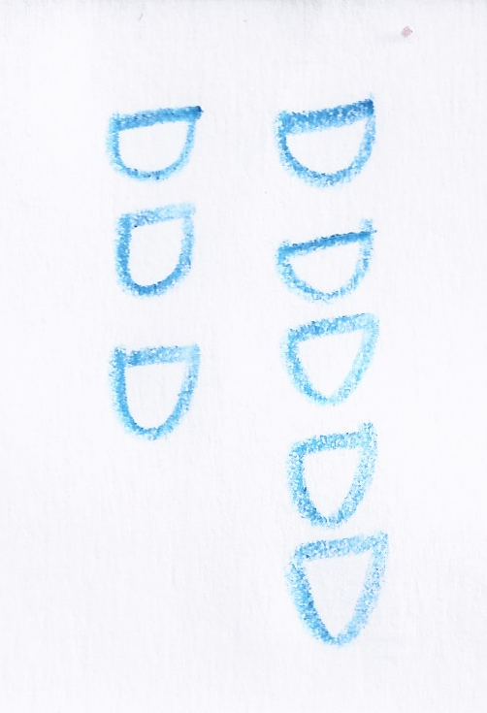
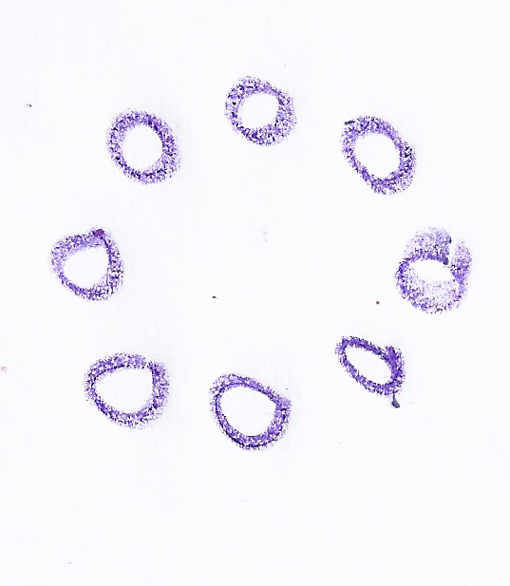
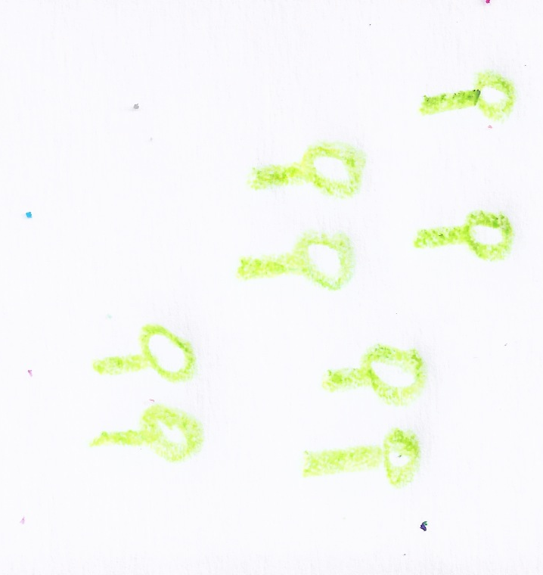
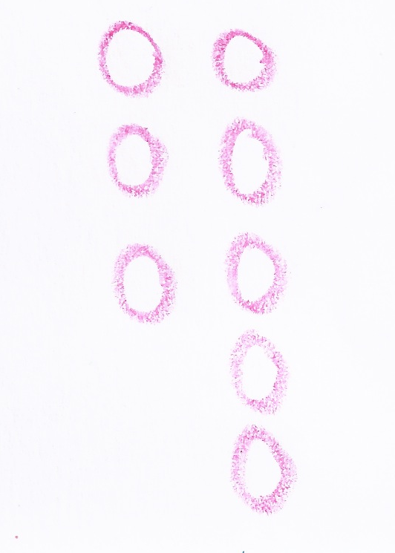
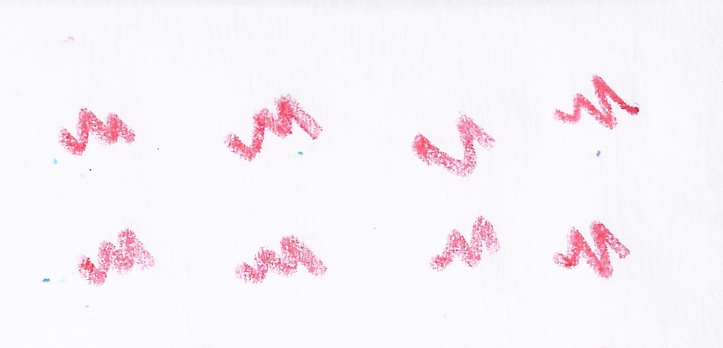
Application Problem (3 minutes)
Materials: (S) Blank paper, crayons
Say, “Amaya is having a party. There are 8 people dancing at the party.”
Have children make a math drawing of the eight dancers. Remind them that math drawings are quick and not detailed. Give one minute for drawing. Show a few of the drawings and discuss the different ways that children represented the dancers.
Note: This problem reminds children about the purpose of math drawings: to accurately and efficiently represent a mathematical situation. The drawing comparison provides other ideas about how eight dancers can be represented. This prepares children to use math drawings to solve subtraction stories in the Concept Development.
Concept Development (13 minutes)
Materials: (T) Chart paper, markers (S) Personal white board
Be sure to use the unit when expressing the answer to story problems. This is an important part of having children re-contextualize the story after making representative drawings.
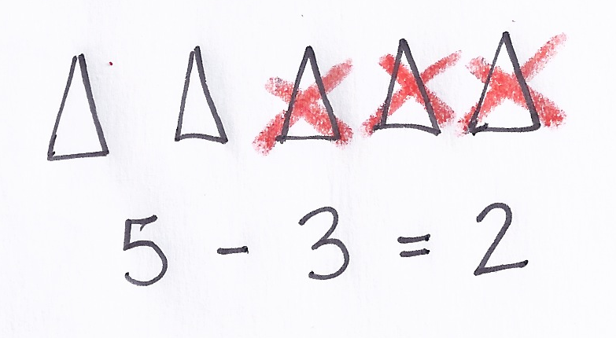
- Say, “Let’s use math drawings with a subtraction story: There are 5 pieces of cake. Three pieces are eaten. How many pieces of cake are left?”
- Have students repeat the story one chunk at a time. Make a simple drawing to match their retelling. (Use triangles to represent pieces of cake.)
- Have students answer the question as a group, emphasizing that there are two pieces of cake left. Write the number sentence and have students say, “5 take away 3 equals 2.”
- Say, “I did not draw fancy pieces of cake. What did I draw instead?” Guide students to see that the triangles were a fast and easy way to draw pieces of cake.
- Say, “Can anyone think of a subtraction story about people dancing at a party?” Have students share their ideas. Choose a story and repeat it for the class while students draw the first part of the story. Create a math drawing on the board again using triangles so that students recognize that the triangle can represent a piece of cake or a person dancing.
- Invite a student to come up to the board and cross off objects on the math drawing to solve. Have students exchange their drawings with a neighbor and cross off to solve.
- Guide a discussion about how students used math drawings to represent the objects in the story. Students share a few different ideas with the class.
Part 2: Practice

NOTES ON
MULTIPLE MEANS
OF ACTION AND EXPRESSION:
Provide scaffolds for students who may have a difficult time thinking of their own subtraction stories. Possible scaffolds could include providing a model or picture of a story or asking questions for each of the components of the story problem. For example, “What would you like your story to be about? How many will you have to start? How many will be taken away?”
Materials: (S) blank paper, crayons
- Tell students that they will create their own subtraction stories and share with a partner. Say, “Your drawing should show only the first part of the story. Let your partner cross off the things that go away.”
- Circulate and support students as they create two statements and then ask a question.
- While students draw, check for understanding by having them quietly share their stories one-on-one.
- Match students with a partner to share stories and to solve by crossing off objects.
- As time permits, write children’s subtraction stories on the drawing or on a sticky note as they dictate them.
Student Debrief (4 minutes)
Lesson Objective: Solve subtraction story problems with representative drawings.
The Student Debrief is intended to invite reflection and active processing of the total lesson experience. It is also an opportunity for informal assessment. Consider taking anecdotal notes or using a simple checklist to note each child’s progress toward meeting the lesson objective.
As students complete the Practice portion of the Concept Development, listen for misconceptions or misunderstandings that can be addressed in the Debrief. You may choose to use any combination of the questions below to help students express ideas, make connections, and use new vocabulary.

CENTER CONNECTION:
In the library center, place several ABC or 123 books with easily countable pictures and small self-stick paper pads. Instruct students to count the items, e.g., pencils, on the page and then tell a story about how some of the pencils broke, covering them with the self-stick papers. Limit four self-stick papers per student and encourage students to use them over again for each group of items they count.

- When you make a math drawing, does it need to be fancy and detailed? Why not?
- Invite a few students to share and explain their subtraction stories and drawings. Have the class draw and solve.
MP.1
- How were your drawings the same as your partner’s drawings? How were they different?
- In our cake story, we said, “5 take away 3 equals 2.” What did the 2 stand for?
- (Use the students’ subtraction stories to create questions like, “4 take away 2 is…?” Write the matching number sentence.)

Cut along dashed lines. Add one 10-card to the baggies of 6-and 9-cards that were used in Lesson 22.

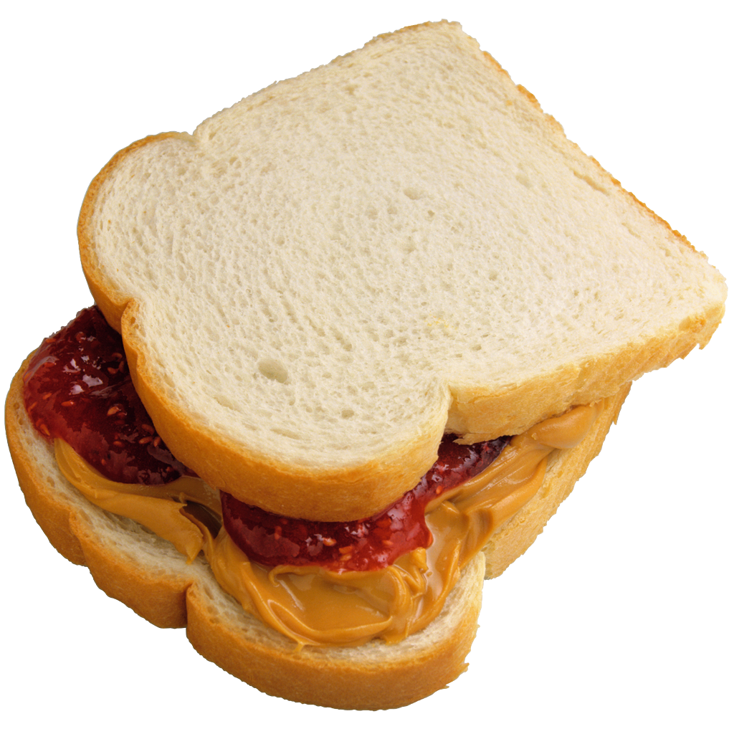

picture cards: 10

