Lesson 21
Objective: Solve subtraction story problems using fingers.

Suggested Lesson Structure
 Fluency Practice (6 minutes)
 Application Problem (3 minutes)
 Concept Development (13 minutes)
 Student Debrief (3 minutes)
Total Time (25 minutes)
Fluency Practice (6 minutes)
- Find the Card PK.CC.2, PK.CC.4 (4 minutes)
- Stomp and Count PK.CC.1 (2 minutes)
Find the Card (4 minutes)
Materials: (T) Numeral cards 6–8 (Lesson 1 Template) (S) baggie of picture cards from Lesson 20 with one 8-card added (Fluency Template), construction paper work mat
Note: Students maintain fluency with counting pictures arranged in varied formations and reading written numbers 6–8.
Pass out one baggie to each student.

NOTES ON
MULTIPLE MEANS
OF ENGAGEMENT:
Students struggling to count the pictorial representations would benefit from having concrete manipulatives, such as beans, to support 1:1 correspondence. Place the manipulative directly on top of the image. Slowly remove the concrete manipulatives as students count with more accuracy and precision.
T: Lay your cards on your work mat.
T: (Show the 8 card.) What number is this?
S: 8.
T: Find the card with eight things. (Pause.) Let me see you touch and count!
T: Stand up with your card when you find it. (All the 8 cards are pond animals. Check to see that students are holding a card with ducks, fish, or frogs.)
As time permits, repeat for 6 (checking for fruit) and 7 (vegetables).

Stomp and Count (2 minutes)
Note: Say Ten counting supports the core fluency goal of rote counting to 20 while laying a foundation that helps students understand place value in later years. Encourage students to count once for each number. This will help them understand that ten 1 is one number, not two.
T: Are you ready to be grumpy giants again? (Make a grumpy face). Let’s stomp like a giant as we count to 20 the Say Ten Way.
T/S: 1, 2, 3…ten 9, 2 tens. (Make synchronous exaggerated stomps for each number.)
Application Problem (3 minutes)
Materials: (T) Box of toasted cereal o’s (or another small healthy snack), napkin
Pass out napkins and five pieces of cereal to each student. With the class, put your left hand flat on the table and count the cereal by putting one piece at the end of each of your fingertips, beginning with the pinky.
T: How many pieces of cereal do you have?
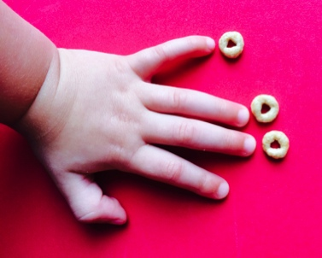
S: 5.
T: Eat two pieces (at the end of the thumb and left index finger). How many do you have left?
S: 3.
T: Eat three more pieces. Now, how many do you have?
S: None.

Repeat with different decompositions with totals of 5.
Note: This Application Problem reviews decompositions of numbers (5 is 2 and 3) and is also a natural and familiar lead into taking away.
Concept Development (13 minutes)
Part 1: Concept Introduction
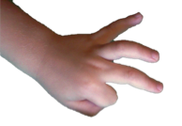
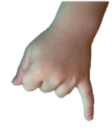
Materials: (T) White board or chart paper, numeral cards 1–4 (Lesson 1 Template)
- Say, “I’m going to tell another subtraction story today, but first I’m going to pick a card to tell me how many to take away. Oh, look! I picked the number 2. Let me think: Hmmm…I’d better start with a number that is greater than 2 so I can take 2 away! There were 3 ducks on the lake. Show me 3 ducks on your fingers.” Show three fingers the Math Way.
- Hold up the 2 card. “Two ducks flew away (hide two fingers on the same hand). Show me the 2 ducks that flew away by hiding 2 fingers.”
- Ask, “How many ducks are left?” Provide wait time. Signal for students to answer chorally.
- Write the number sentence on the board as children say, “3 take away 2 is 1.” Have students answer in a complete sentence, re-contextualizing the answer, “1 duck is left.”
- Have children turn to a neighbor and tell a different subtraction story about ducks on the lake. Listen carefully and choose a student to share his story with the class.
- Repeat Steps 1–4 using a student’s subtraction story.
- Pick another take away card, e.g., 3, and repeat Steps 1–4 with another problem: There are 5 frogs sitting on a log. Three frogs jump into the lake. How many frogs are sitting on the log?
Note: Include a situation whereby the total and amount being taken away are equal. Say, “Oh, the number being taken away doesn’t have to be greater; it can be the same, too! I have 5. I can take away 5.”
Part 2: Practice
Materials: (S) per pair: numeral cards 1–4 (Lesson 1 Template)
- Instruct Partner A to pick a card to tell how many to take away and think of a subtraction story: e.g., “Five alligators were in the lake. Two went away. How many were left?”
- Have Partner A tell the subtraction story while Partner B shows it on the fingers of the left hand and answers the question.
MP.2
- Have Partner B retell the story while Partner A shows it.
- Encourage partners to make a subtraction statement, e.g., “5 take away 2 is 3,” and then to answer in a complete sentence, re-contextualizing the answer, “Three alligators were left.”
- Repeat Steps 1–4 as Partner B picks a take away card and tells a subtraction story.
Circulate and listen as children take turns telling a story and solving with fingers. Help students create questions and say the corresponding subtraction statement as needed.
Student Debrief (3 minutes)

CENTER CONNECTION:
Put sets of five bears and a paper cup (for bears going home) at the center table. Encourage students to tell stories about some bears: “Four bears were playing, but then one had to go home (under cup).” Listen and prompt students to say, “4 take away 1 is 3,” as they tell their stories and ask how many questions about the bears.

Lesson Objective: Solve subtraction story problems using fingers.
The Student Debrief is intended to invite reflection and active processing of the total lesson experience. It is also an opportunity for informal assessment. Consider taking anecdotal notes or using a simple checklist to note each child’s progress toward meeting the lesson objective.
As students complete the Practice portion of the Concept Development, listen for misconceptions or misunderstandings that can be addressed in the Debrief.
You may choose to use any combination of the questions below to help students express ideas, make connections, and use new vocabulary.
- Invite a few students to share their subtraction stories. Have all students use their fingers to solve. (Consider taking a video of students sharing their stories as a record of their growth in Pre-K.)
- Use your fingers to show me 3 take away 2.
- Listen to this situation: Tommy picked the number 4 to take away. His story started with three bears playing. Show me this story on your fingers. What’s wrong? Can we fix it?
- How do you think you could show a subtraction story with your fingers if you started with six ducks?

Cut along dashed lines. Add one 8-card to the baggies of 6 and 7 that were used in Lesson 20.

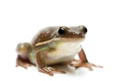
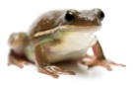

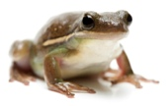

picture cards: 8

