Lesson 20
Objective: Solve subtraction story problems using fingers.

Suggested Lesson Structure
 Fluency Practice (6 minutes)
 Application Problem (3 minutes)
 Concept Development (13 minutes)
 Student Debrief (3 minutes)
Total Time (25 minutes)
Fluency Practice (6 minutes)
- Find the Card PK.CC.2, PK.CC.4 (4 minutes)
- Stomp and Count PK.CC.1 (2 minutes)
Find the Card (4 minutes)
Materials: (T) Numeral cards 6 and 7 (Lesson 1 Template), (S) Baggie of 2 picture cards: 6 and 7 (Fluency Template), construction paper work mat
Note: Students maintain fluency practice with counting pictures arranged in varied formations and reading written numerals 6 and 7. This activity will be repeated throughout Topic E. Each day, an additional card will be added to the baggie.
Pass out one baggie to each student.
T: Lay your cards on your work mat.
T: (Show numeral card 6.) What number is this?
S: 6.
T: Find the card with six things. (Pause.)
T: Stand up with your card when you find it. (All the 6 cards are fruit. Check to see that students are holding the card with fruit. If a student is holding a vegetable card, gently suggest a recount.)
Repeat for 7, checking for vegetables.
Stomp and Count (2 minutes)
Note: Varying movements helps keep counting exercises fresh as students strengthen their core fluency counting skills to 20.
T: Let’s pretend we’re a team of grumpy giants. (Make a grumpy face.) Stomp like a giant with me.
T/S: (Make exaggerated stomps together.)
T: Now, let’s count and stomp like grumpy giants up to 20.
Count and stomp to 20, keeping the movement synchronous with the count. If time permits, repeat the activity the Say Ten way.
Application Problem (3 minutes)
Materials: (T) Basket, 5 apples
Instruct the students to make a fist with their left hand on the table and to count to 5 the Math way.
- Say, “We have 5 apples. I’ll pretend to eat 2 apples.” Pretend to eat two apples and hide them.
- Ask, “How many apples do we have left? Show me that number of apples on your fingers the Math Way.”
- Ask, “How many apples did we have at first?” and “How many fingers did you show at first?” “How many apples did I pretend to eat?” and “How many fingers did you hide?” “How many apples are left?” and “How many fingers are still sticking out?”
Repeat.
Note: This Application Problem explores decompositions of 5; it relates five apples to the five fingers of one hand, supporting the concept that all the fingers of one hand make 5.
Concept Development (13 minutes)
Part 1: Concept Introduction
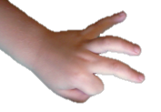
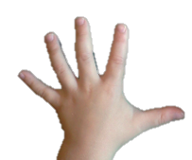
Materials: (T) Basket, 5 apples, paper lunch bag or lunch box
5 - 2 = 3
Place the apples in the basket where they can easily be seen and counted.
- Say, “We are going to pack apples in lunchboxes. First, show me on one hand: How many apples are in the basket?” Model showing all five fingers on the left hand.
- Hand one child a paper bag and invite her to pack some apples. Say, “Regina packed 2 apples.” Hide two fingers to show the fruit she took away. Model hiding the thumb and pointer finger.
- Ask, “How many apples are left?” Have students say the answer as they show it with their fingers: “Three apples are left.” If needed, model counting the fingers still lifted. Take the fruit out of the basket to confirm there are three pieces left.
- Write the number sentence as students say, “5 take away 2 equals 3.”
- Repeat Steps 1–3 with the remaining fruit in the basket. This time, have students ask a how many question about the fruit.
- Replace fruit as needed and continue to model until children understand the activity.
Part 2: Practice
Materials: (S) per pair: 5 small fruits (use apples from Lesson 8 Template 2 if needed), paper bag/lunchbox
Pair children and have them work at prepared tables.

NOTES ON
MULTIPLE MEANS
OF ACTION AND EXPRESSION:
Note students who need to count each finger to answer the how many questions and provide extra practice with finger work. This practice should be kept fun and energetic.
- Pairs will continue the activity from Part 1 with one student packing apples in the bag and making a statement, e.g., “I packed four apples in the bag.”
- The other partner uses the fingers of one hand to show what happened to the apples.
- The packer asks a how many question about the remaining apples, e.g., “How many apples are on the table now?”
- Partners make a subtraction statement together, e.g., “5 take away 4 equals 1.”
- After each round, partners change roles.

CENTER CONNECTION:
Place sets of five lunch bags (different color bags will help keep the sets together) with numbers 1–5 written on them in the kitchen center. Set up five plastic food items in a basket for each set of lunch bags. Instruct students to pack the lunch bags with the indicated number of items from the basket. Remind students to count aloud as they pack or unpack the bags. Allow students to pack the bags in any order they choose. Some may fill the bags chronologically, and some may start with Bag 3. Have them return the food to the basket before packing the next bag.

Student Debrief (3 minutes)
Lesson Objective: Solve subtraction story problems using fingers.
The Student Debrief is intended to invite reflection and active processing of the total lesson experience. It is also an opportunity for informal assessment. Consider taking anecdotal notes or using a simple checklist to note each child’s progress toward meeting the lesson objective.
As students complete the Practice portion of the Concept Development, listen for misconceptions or misunderstandings that can be addressed in the Debrief.
You may choose to use any combination of the questions below to help students express ideas, make connections, and use new vocabulary.
- What did we show with our fingers today?
- How did you use your fingers to show how many apples were left?
- Use your fingers to show my subtraction story: There were 4 balls. Two balls rolled away. (Pause.) How many balls were left?
- (Show four fingers.) What did the four fingers stand for? (Put down two fingers.) What did the fingers that were tucked away show? What about the two fingers that are left?

Cut along dashed lines. Put one 6–card and one 7–card in each bag.

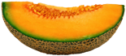 |  | 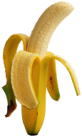

Cut along dashed lines. Put one 6–card and one 7–card in each bag.
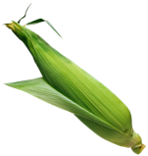
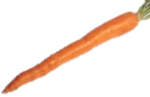 | 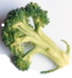
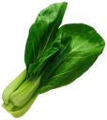 |  | 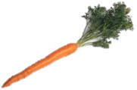
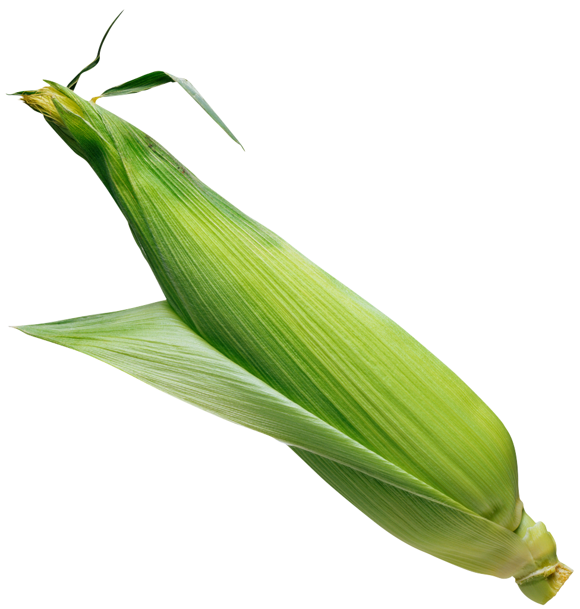
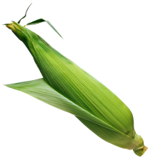
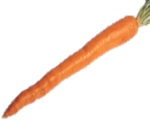

picture cards: 6
picture cards: 7

