Lesson 19
Objective: Solve addition story problems with representative drawings.

Suggested Lesson Structure
 Fluency Practice (5 minutes)
 Application Problem (4 minutes)
 Concept Development (13 minutes)
 Student Debrief (3 minutes)
Total Time (25 minutes)
Fluency Practice (5 minutes)
- Lazy Lizards PK.CC.3 (3 minutes)
- Squeak and Roar PK.CC.1 (2 minutes)
Lazy Lizards (3 minutes)
Materials: (S) Cup of 10 beans, tray
Note: This activity provides practice with organizing objects to count within 10, a core fluency for Pre-K students. In this variation, students arrange and count objects in both a line and an array configuration.
Pass out one cup to each student.
T: Empty your beans on your tray. Pretend your beans are lazy lizards, napping on a rock.
T: Wake up your lizards and move them in a line to help count them. (Pause.)
T: Use your fingers to show how many lizards are on your rock. (Informally assess for accuracy.)
T: It’s almost time for your lizards to go back in their cage (the cup). Put them in two equal lines. Stand up when you think you know how many lizards you have. When I give my signal, tell me how many lizards you counted. Ready? (Give the signal.)
S: 10.
If time permits, tell students to make one lizard hide by placing it under their chairs and repeat the activity to count 9.
Squeak and Roar (2 minutes)
Note: Changing the volume as students count requires them to pay close attention to the count sequence.
T: Today, let’s squeak count like a mouse and roar count like a lion!
T: When I put my hands by my mouth like this (cup hands to your mouth, as if telling a secret), squeak count as quietly as a little field mouse.
T: When I put my hands in the air like this (hold your arms out high and wide, making your fingers look like a lion’s claws), roar count as loudly as a lion.
Guide students to squeak count to 10, and then roar count to 20 the Say Ten Way. Then repeat, alternating back and forth between squeak and roar counting.
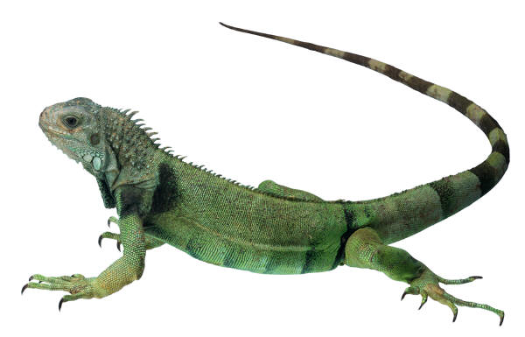
Application Problem (4 minutes)
Materials: (T) Lizard picture (Template 1) (S) Paper, crayons
Show a picture of a lizard. Give students four minutes to draw the lizard with lots of detail. They should draw as many detailed lizards as possible during this time.
Note: This activity helps children to see how time-consuming detailed drawings can be in comparison with the math drawings they will do in the Concept Development.
Concept Development (13 minutes)
Part 1: Concept Introduction
Materials: (T) chart paper, markers (S) Personal white board
Note: Be sure to use the unit when expressing the answer to story problems. This is an important part of having children re-contextualize the story after making representative drawings.
- Say, “Listen to my addition story. Four lizards are running. Another lizard starts to run. Now, how many lizards are running?”
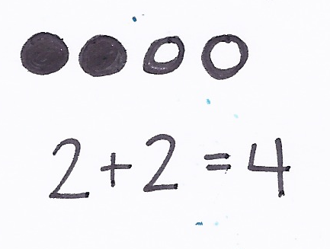
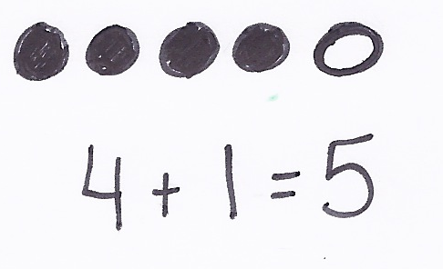
- Have children repeat the story and make a math drawing to match their retelling (use circles to represent lizards). Answer the question as a group, emphasizing that there are five lizards. Write and have students say the number sentence, “4 + plus 1 = equals 5. There are 5 lizards running.”
MP.8
- Say, “It took us a long time to draw one lizard, and I had to draw five for this addition story! What did I draw instead of lizards? Why do you think I did that?” Help children see that the circles were much faster to draw than lizards.
- Say, “Use circles to draw this addition story. Two lizards have spots and two lizards have stripes. How many lizards are there in all?” Have children share their circle drawings and the answer to the question with a neighbor.
- Have students say the number sentence together (while teacher writes it), “2 + 2 = 4. There are 4 lizards in all.”
- Guide a discussion about how much faster it was to draw circles than lizards. Say, “In math, we want to use simple math drawings that help us to solve problems. Using circles to stand for lizards helped us to answer the question correctly without spending lots of time on our drawings."
Part 2: Practice
Materials: (S) Small writing rectangle (Template 2) inserted into personal white board, 5 children (Template 3, see note box)

NOTES ON
MULTIPLE MEANS
OF ACTION AND EXPRESSION:
Insert an image of five children (Template 3) into personal white board. Instruct students to draw lines (2 and 3) for the addition story above each child in order to match the person with the more abstract representation. Then, remove the template to show only the lines.
- Say, “Draw my addition story using lines. Two girls are hunting for lizards. Three boys join them. How many children are hunting for lizards now?”
- Have partners compare math drawings and solve. When the partners agree on the answer, they write it on their boards.
- Say the expression as a group, “2 + 3.” Say the number sentence together (while teacher writes it), “2 + 3 = 5. There are 5 children hunting lizards.”
- Repeat with other problems as time permits.
Student Debrief (3 minutes)
Lesson Objective: Solve addition story problems with representative drawings.
The Student Debrief is intended to invite reflection and active processing of the total lesson experience. It is also an opportunity for informal assessment. Consider taking anecdotal notes or using a simple checklist to note each child’s progress toward meeting the lesson objective.
As students complete the Practice portion of the Concept Development, listen for misconceptions or misunderstandings that can be addressed in the Debrief.

CENTER CONNECTION:
In the library center, place several ABC or 123 books with prominent, easily countable pictures, as well as paper and crayons. Encourage students to use the paper and crayons to draw simple representations (lines, circles, dots, etc.) of the pictures in the books. Listen for students saying things like, “I drew 3 lines to show the three dogs on this page.”

You may choose to use any combination of the questions below to help students express ideas, make connections, and use new vocabulary (math drawing).
- Why do we draw circles and lines instead of lizards or children to solve problems in math?
- (Display circle drawing from earlier lizard problem.) This is my math drawing from the lizard addition story. Which lizards are these empty circles showing? Which lizards are these filled circles showing?
- (Show lines drawing from Part 2.) Can you help me think of another addition story that could match this math drawing?

lizard picture
small writing rectangle
5 children (see note box in the Practice portion of the Concept Development)

