Lesson 18
Objective: Solve addition story problems with representative objects.

Suggested Lesson Structure
 Fluency Practice (6 minutes)
 Application Problem (4 minutes)
 Concept Development (12 minutes)
 Student Debrief (3 minutes)
Total Time (25 minutes)
Fluency Practice (6 minutes)
- Lazy Lizards PK.CC.4 (4 minutes)
- Squeak and Roar PK.CC.1 (2 minutes)
Lazy Lizards (4 minutes)
Materials: (S) cup of 9 linking cubes, tray
Note: This activity provides practice with organizing objects to count within 10, a core Fluency for Pre-K students. In this variation, students pretend the cubes are lizards in preparation for the Concept Development, where the cubes will be animals at the zoo.
Pass out one cup to each student.
T: Empty your cubes onto your tray. Pretend your cubes are lazy lizards, napping on a rock.
T: Wake up your lizards and move them in a line to count them. (Pause.)
T: Use your fingers to show how many lizards there are.
T: It’s almost time for your lizards to go in their cage (the cup). Count them one more time from the other direction to make sure they’re all here. Stand up when you think you know how many lizards you have. When I give my signal, tell me how many lizards you counted. Ready? (Give the signal.)
S: 9.
If time permits, tell students to make one lizard hide by placing it under their chairs and repeat the activity to count 8.
Squeak and Roar (2 minutes)
Note: Changing the volume as students count requires them to pay close attention to the count sequence.
T: Today, let’s squeak count like a mouse and roar count like a lion!
T: When I put my hands by my mouth like this (cup hands to your mouth, as if telling a secret), squeak count as quietly as a little field mouse.
T: When I put my hands in the air like this (hold your arms out high and wide, making your fingers look like a lion’s claws), roar count as loudly as a lion.
Guide students to squeak count to 10, and then roar count to 20 the regular way. Then repeat, alternating back and forth between squeak and roar counting.
Application Problem (4 minutes)
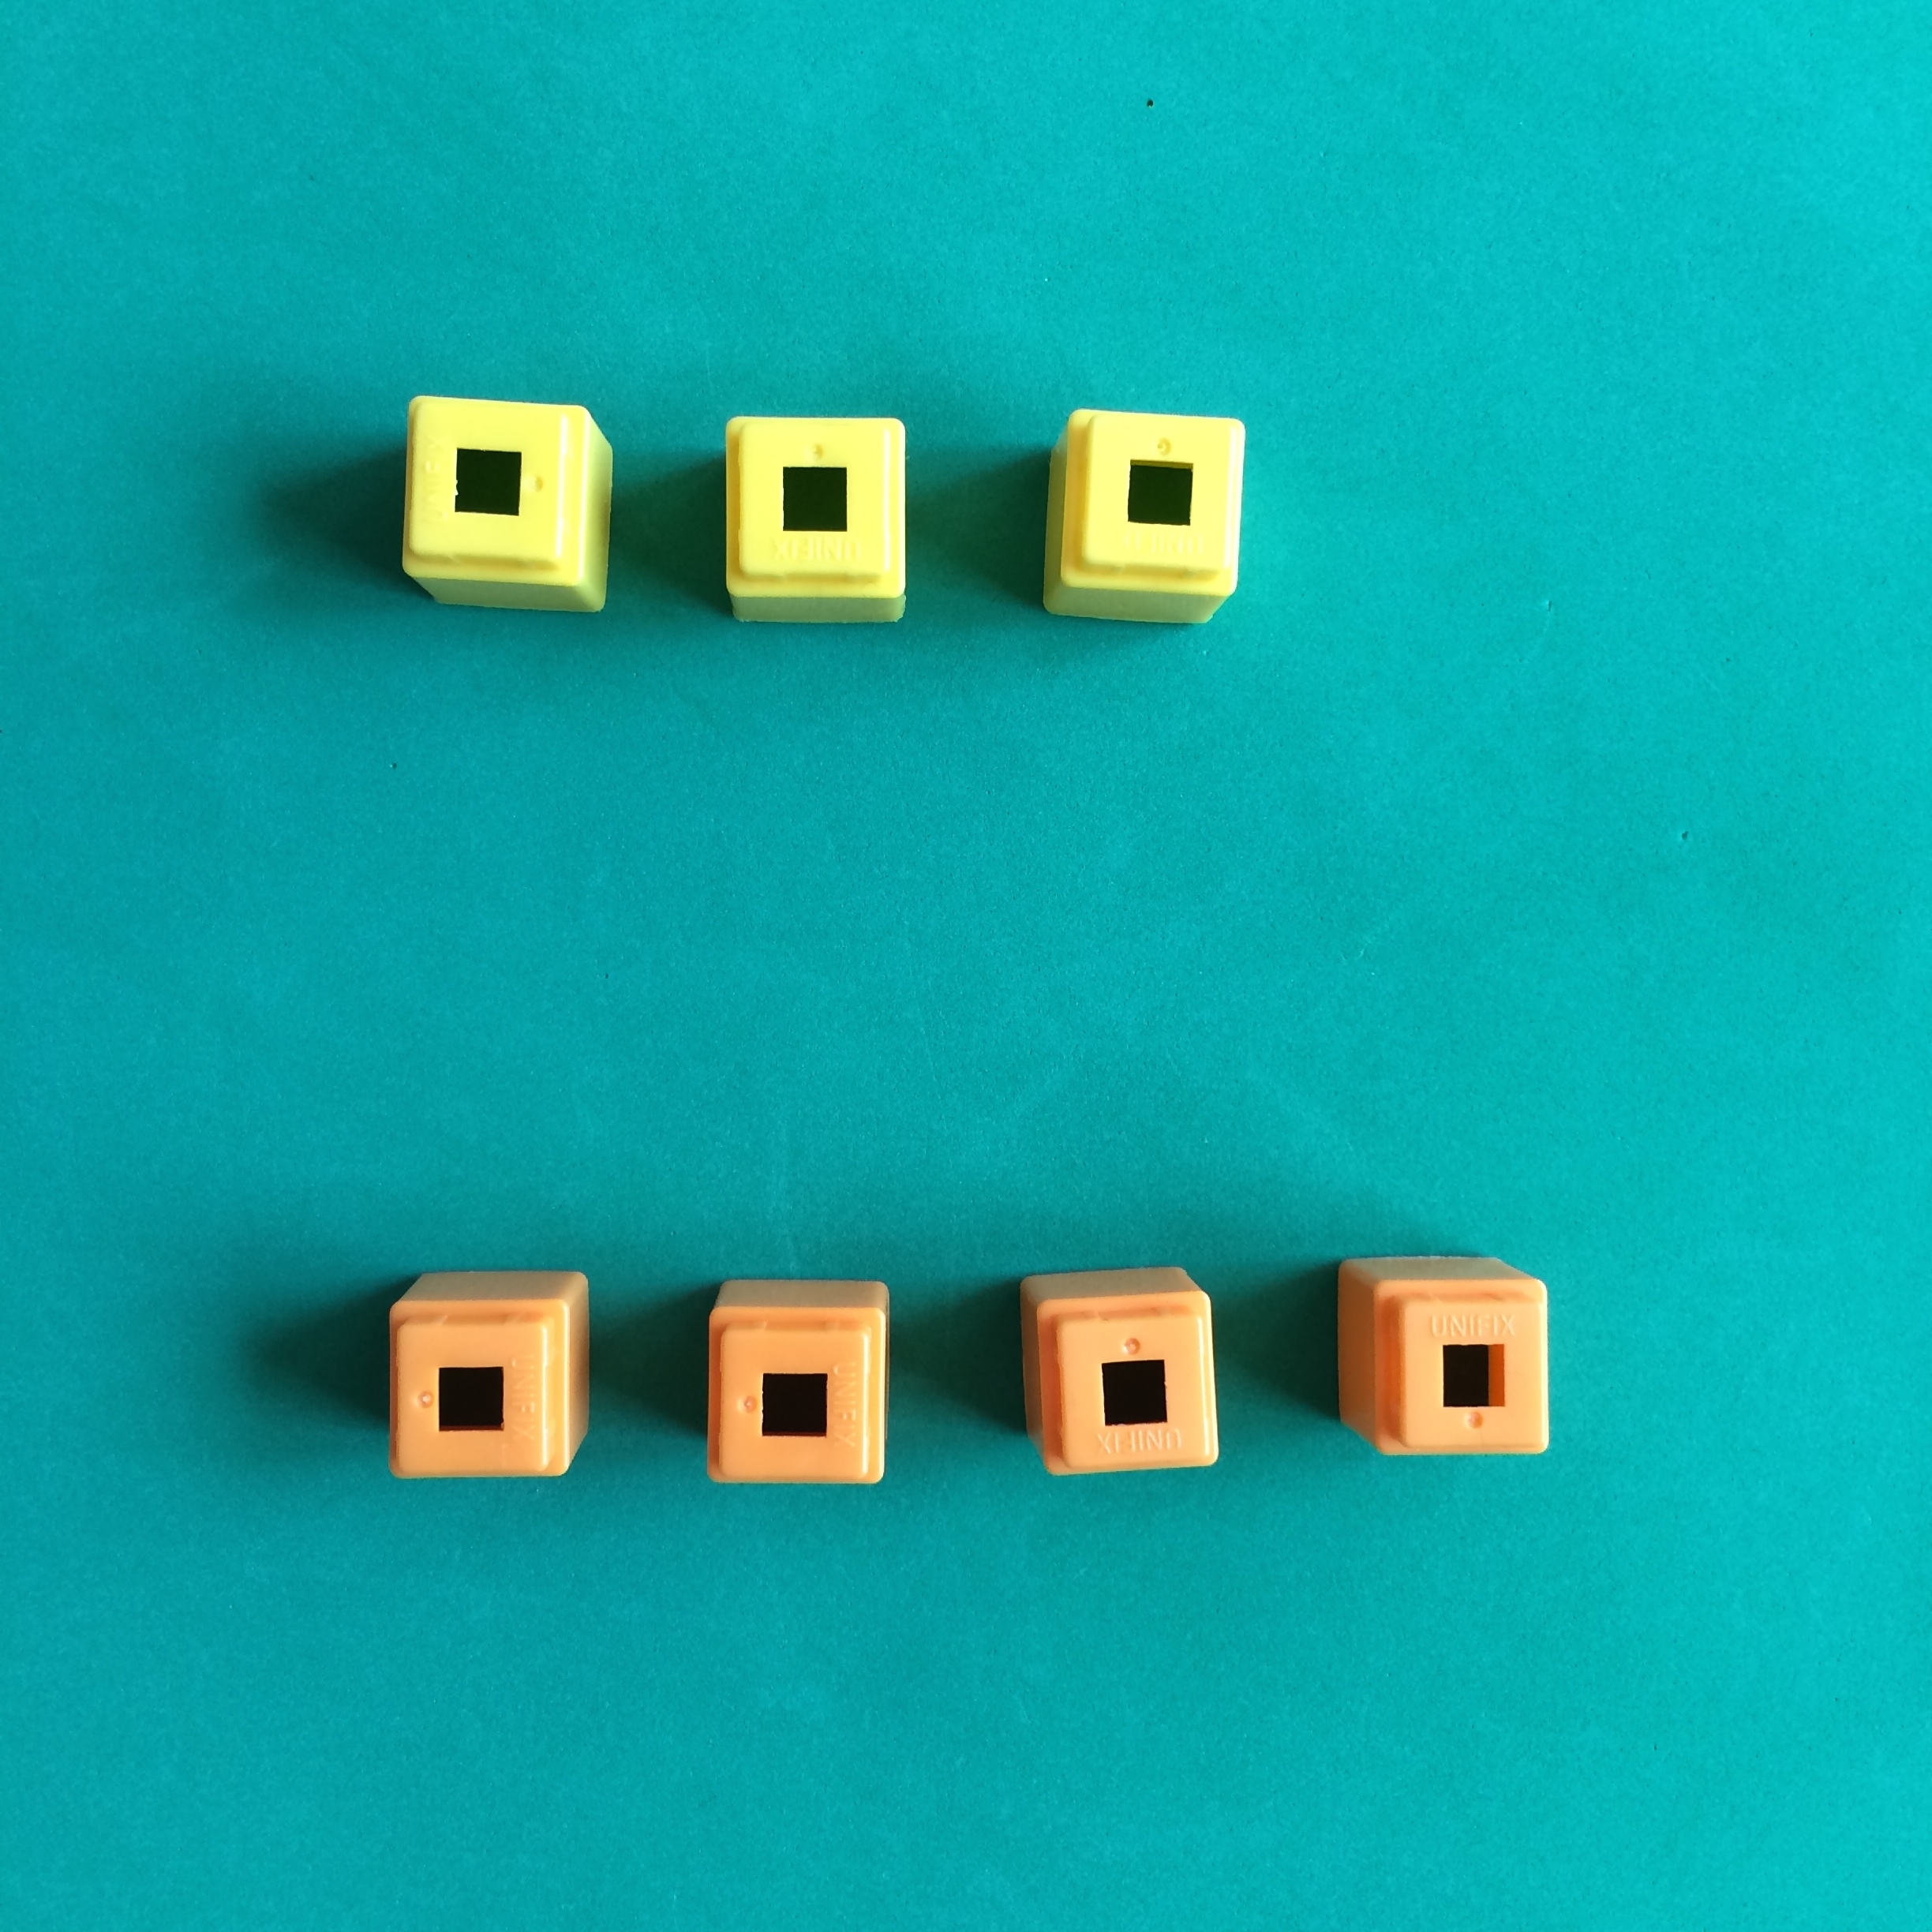
Materials: (S) 1–5 linking cubes
“Together we have more than 5 pieces of food.”
Give each student 1–5 cubes (petting zoo food). Say, “We are going to visit the petting zoo today. Count how many pieces of food you have. (Pause.) Find a friend who’d like to visit the zoo with you and count how many pieces of food you have all together. If you and your friend have more than 5 pieces of food together, sit down. If you and your friend have fewer than 5 pieces of food together, stay standing.” Repeat with new partners if time permits.
Note: Today’s Application Problem reviews the comparison work of Module 4 and continues the work of addition. Although the addition standard for Pre-kindergarten is totals to 5, children are able to employ counting strategies learned from previous modules to be successful with this task.
Concept Development (12 minutes)
Part 1: Concept Introduction
Materials: (T) 10 loose linking cubes (5 one color, 5 of another color) (S) 10 loose linking cubes (5 of one color, 5 of another color)
- Tell children that they have been invited to help the zookeeper make sure all of the animals are in their habitats.
- Say, “First, we’ll go past the lions. One lion is napping under a tree. Oh look! Two more lions are coming to nap.” Make a train with one cube for the lion that was napping. Add two different colored cubes for the lions that come to nap. Invite students to do the same.
1 + 2 = 3
- Have children ask their neighbor a how many question about the lions, e.g., “How many lions are napping now?”
- Quickly draw the train on the board and write the number sentence beneath as students say it aloud (do not use units), "1 + 2 = 3."
- Ask, “What does the blue cube tell us? What do the two orange cubes tell us? What does the 3 tell us?” Make sure that students can put the story back into the lion context.
MP.2
- Repeat Steps 2–5 with the following story: There are 2 prairie dogs playing and 3 prairie dogs hiding. For this problem, have students make the train without a teacher model.
- If time permits, encourage children to make up a different zoo addition story using the same
5-train.
Part 2: Practice
Materials: (S) 10 loose linking cubes (5 one color, 5 of another color)
Pair children to work together.
- Say, “Use your cubes to show this zoo story: Three seals are doing tricks. Another seal swims over to do tricks.”
- Have children ask their neighbor a how many question about the seals, e.g., “How many seals are doing tricks now?”

NOTES ON
MULTIPLE MEANS
OF ACTION AND EXPRESSION:
Circulate and slowly repeat the story one sentence at a time as necessary to support students who have difficulty processing the whole story at once.
- Have partners compare their trains and share their answers. As a class, say the number sentence,
“3 + 1 = 4.”
- Have partners tell one another what each set of cubes represents, e.g., three seals doing tricks.
- As time permits, repeat Steps 1–3 with other addition stories such as: There are 2 adult gorillas and 2 baby gorillas. How many gorillas are there all together?
Student Debrief (3 minutes)

CENTER CONNECTION:
Make a variety of symbol cards (two types of symbols) up to 5 (shown):

Place linking cubes of two different colors and symbol cards in the center. Allow students to use the linking cubes to represent the symbols on the card. Encourage students to say things like, “These two green cubes stand for the hearts and this yellow cube stands for the circle.”

Lesson Objective: Solve addition story problems with representative objects.
The Student Debrief is intended to invite reflection and active processing of the total lesson experience. It is also an opportunity for informal assessment. Consider taking anecdotal notes or using a simple checklist to note each child’s progress toward meeting the lesson objective.

As students complete the Practice portion of the Concept Development, listen for misconceptions or misunderstandings that can be addressed in the Debrief. You may choose to use any combination of the questions below to help students express ideas, make connections, and use new vocabulary.
- How did we help the zookeeper solve the zoo addition stories today?
- What is different about using cubes instead of lions to solve an addition story?
- (Repeat the gorilla story.) Use your fingers to solve the gorilla story. What’s the same as using cubes? What’s different?
- In the gorilla story, 2 and 2 make how many? (Write addition sentence.) What does the 4 tell us?
- (Remind students of the seal story and show the linking cube train. Tell a similar zoo story with 3 and 1 as parts and show the train.) What is the same about these 2 trains?

