Lesson 17
Objective: Solve addition story problems using fingers.

Suggested Lesson Structure
 Fluency Practice (7 minutes)
 Application Problem (3 minutes)
 Concept Development (12 minutes)
 Student Debrief (3 minutes)
Total Time (25 minutes)
Fluency Practice (7 minutes)
- Counting Pennies PK.CC.5 (4 minutes)
- Birds of a Feather PK.CC.1 (3 minutes)
Counting Pennies (4 minutes)
Materials: (T) 1 extra penny for each student (S) cup or baggie of 9 pennies, work mat
Note: Similar to Lesson 16, this fluency activity provides practice with organizing and counting up to 10 objects in a linear configuration.
Give one cup to each student.
T: Empty your cup on your work mat. Put your pennies in a line. (Pause.) How many pennies? Show me on your fingers.
S: (Show 9 on fingers.)
T: Now, count your pennies from the other direction. (Pause.) How many? Show me.
S: (Show 9 fingers.)
T: (Give one more penny to each student.) Add one more penny. How many? Show me.
S: (Show 10 on fingers.)
T: Count your pennies from the other direction. (Pause.) How many? Show me.
S: (Show 10 on fingers.)
If time permits, tell students to make one penny disappear by placing it under their chair and repeat the activity.

Birds of a Feather (3 minutes)
Note: In this activity, students practice one of the core fluency goals of Pre-K, rote counting to 20. Practicing the same movement two days in a row enables students to become comfortable with the physical activity, so it can be easily repeated in later lessons.
T: Are you ready to be bald eagles again? Hold out your wings and count to 20 the Say Ten Way. When we get to 20, let’s relax in our nests.
T/S: 1, 2, 3…ten 8, ten 9, 2 tens. (Slowly raise and lower arms to mimic an eagle gliding. Sit down.)
T: Now we’re baby hummingbirds, hungry for more nectar. Let’s fly and count again. This time we’ll count the regular way and stop at 18. Ready?
T/S: 1, 2, 3…17, 18. (Flap hands at a relatively quick pace but slowly enough to keep movement synchronous with the count.)
Application Problem (3 minutes)
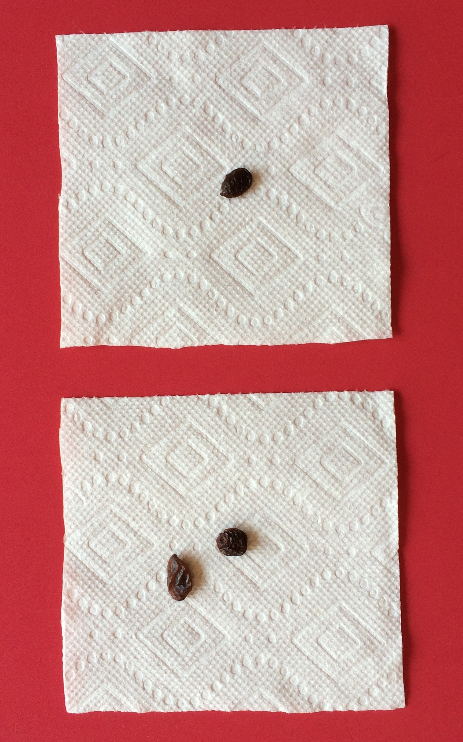
Materials: (S) Raisins (small box), two napkins
Put two raisins on one of your napkins. Put one raisin on the other napkin. With your fingers show me how many raisins are on each napkin (using one or two hands is acceptable). Say, “A hungry little puppy came along and gobbled up all the raisins! How many raisins did the puppy gobble up?” Allow children to count the raisins one at a time as they put them in their mouths. Repeat with the following sequence of numbers: 1 and 4, 3 and 2, 1 and 1, 2 and 2, 3 and 1.
Note: This application problem leads into today’s Concept Development, wherein students add two quantities together. Allowing them to use one or both hands to show their raisins helps students to understand that the same number can be represented in different ways.
Concept Development (12 minutes)
4 + 1 = 5
Part 1: Concept Introduction
Materials: (T) White board or chart paper
Note: This lesson provides exposure to using the fingers on one hand to solve addition problems with totals to 5. Children may be more comfortable showing the addends on separate hands. While both methods should be accepted at this level, counting on fingers from left to right builds towards the strategy of counting on in future grades.
- Say, “Listen to my addition story: There were 4 bunnies. Show me the 4 bunnies on your fingers.” Students show four fingers the Math Way.
- Say, “One more bunny hopped over. (Raise one more finger on the same hand.) Show me 1 more bunny on the same hand.” Students do.
- Ask, “How many bunnies are there now?” Provide wait time. Signal for children to answer chorally.
- Write the number sentence on the board, 4 + 1 = 5, as students say it.
- Repeat Steps 1–4 with the following stories:
  - Three bunnies were white. One bunny was gray. How many bunnies were there all together?
  - Three bunnies were sleeping. Two more bunnies went to sleep. How many bunnies were sleeping in all?
Part 2: Practice.
Pair students to work together to solve.

NOTES ON
MULTIPLE MEANS
OF REPRESENTATION:
Pairing the reading of word problems with visuals can support students who are visual learners or those who are deaf or hearing impaired. For example, provide a picture for the puppy stories.
- Say, “Listen to my addition story: Three puppies are playing. Another puppy comes to play.”
- Have students turn to a partner and retell the addition story while holding up fingers on the left hand.
- Ask, “How many puppies are playing now?” Partners tell one another the answer.
MP.5
- After students solve, write the number sentence on the board, 3 + 1 = 4. Have students say the number sentence to their partners.
- Repeat Steps 1–4 with the following problem: Ginger has 3 black puppies and 2 brown puppies. How many puppies does Ginger have in all?
Student Debrief (3 minutes)

CENTER CONNECTION:
Place a tub of plastic animals in the center with some small boxes, i.e., barns. Encourage students to choose up to five animals. Then have them put some animals in the barn and some outside the barn and tell addition stories to each other. Remind students not to put too many animals in each place so that they can say the addition sentences learned in the Concept Development, e.g., “3 plus 1 equals 4.”

Lesson Objective: Solve addition story problems using fingers.
The Student Debrief is intended to invite reflection and active processing of the total lesson experience. It is also an opportunity for informal assessment. Consider taking anecdotal notes or using a simple checklist to note each child’s progress toward meeting the lesson objective.
As students complete the Practice portion of the Concept Development, listen for misconceptions or misunderstandings that can be addressed in the Debrief.
You may choose to use any combination of the questions below to help students express ideas, make connections, and use new vocabulary.
- Show me this story on one hand: There are 2 brown puppies and 2 spotted puppies. (Write the number sentence on the board.) Can you show the same story using two hands? What do you notice about the total each time?
- Listen to my addition story: There are 3 green apples and 1 red apple. (Write the number sentence on the board.) With your partner, pick one person to show my story on one hand and the other person to show it on two hands. What is different about what you see? (Relate to part/whole thinking.)
- Do you like to use two hands or one hand to solve addition stories? Why?
- Use your fingers to show me 2 plus 1. (Have students share the different ways they solved using the fingers of one or two hands.

