Topic D
Decontextualizing Addition Stories to Solve Using Fingers, Objects, and Drawings
PK.OA.1, PK.CC.2
Focus Standards: | PK.OA.1 | Demonstrate an understanding of addition and subtraction by using objects, fingers, and responding to practical situations (e.g., if we have 3 apples and add two more, how many apples do we have all together?).
Instructional Days: | 4
Coherence -Links to: | GK–M1 | Numbers to 10
 | GK–M4 | Number Pairs, Addition and Subtraction to 10
Topic D builds on the work of Topic B, again providing opportunities for children to solve addition story problems while taking a step forward by representing the objects in the story with fingers, counters, and simple drawings. For example, in order to solve "2 apples and 1 more apple. How many apples in all?" students decontextualize the story to represent the apples with their fingers. To answer the problem, they must recognize that the answer is not simply 3 or 3 fingers, but rather, "There are 3 apples." In so responding, students have put the solution found on their fingers back into the context of the story (MP.2).
In Lessons 16 and 17, children use fingers to add (PK.OA.1). In Lesson 16, students represent the number of pieces of fruit (e.g., three oranges and one kiwi) inside two mystery bags. Instead of acting out the story, children show three fingers on one hand and one finger on the other hand, and they count all of the fingers to solve (MP.5). In Lesson 17, students work on one hand to solve animal story problems where they are adding 1 or 2 more, e.g., 3 + 1, 3 + 2, 4 + 1. They also practice saying the number sentences without using the unit, “4 plus 1 equals 5” rather than “4 bunnies and 1 bunny makes 5 bunnies.”
Children decontextualize using linking cube trains to solve addition zoo stories in Lesson 18, as shown on right. "One lion is napping under a tree. Oh look! Two more lions are coming to nap. How many lions are napping now?” Students count out one cube and two cubes to represent the lions in the story (PK.OA.1). In the Debrief, students consider more abstract addition questions such as, "2 and 2 make how many?" They observe as the teacher writes an addition sentence, and then re-contextualize the 4 as 4 gorillas.
1 + 2 = 3

Lesson 19 is very similar to Lesson 10 in that students create their own addition stories. The key difference is that children learn to make math drawings, quick representations of a story’s objects. For example, circles are used to show lizards running (shown below). Some children love to create elaborate art, but the focus of this lesson is on efficient drawings to find an accurate solution promptly.
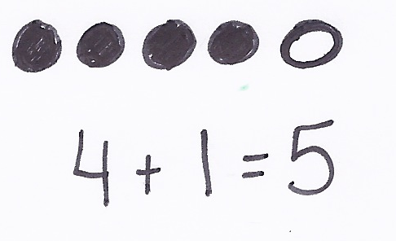

In Topic D Fluency Practices, students continue to organize and count up to 10 objects in linear and array configurations using pennies and cubes (to represent lazy lizards). They also count to 20 the regular and Say Ten Way, varying the speed and context (Birds of a Feather) and changing their volume (Squeak and Roar) to keep activities fresh and fun.
A Teaching Sequence Toward Mastery of Decontextualizing Addition Stories to Solve Using Fingers, Objects, and Drawings
Objective 1: Solve addition story problems using fingers.
(Lessons 16–17)
Objective 2: Solve addition story problems with representative objects.
(Lesson 18)
Objective 3: Solve addition story problems with representative drawings.
(Lesson 19)

