Lesson 15
Objective: Create and solve subtraction story problems by drawing.

Suggested Lesson Structure
 Fluency Practice (6 minutes)
 Application Problem (3 minutes)
 Concept Development (13 minutes)
 Student Debrief (3 minutes)
Total Time (25 minutes)
Fluency Practice (6 minutes)
- Hide and Seek PK.CC.3 (4 minutes)
- Elephant Splashes PK.CC.1 (2 minutes)
Hide and Seek (4 minutes)
Materials: (S) Per pair: cup or bowl, 4 counters
Note: This activity prepares children to subtract by hiding a part. It also reinforces partners of 4.
Pair students and give each pair a cup or bowl with counters. Make one partner the hider and the other partner the guesser.
T: How many bears are in your cup?
S: 4.
T: Guessers, close your eyes. Hiders, hide this many bears under your cup. (Show 1 finger.)
T: Guessers, open your eyes. How many bears are not hiding?
S: 3.
T: Guess how many bears are hiding.
S: I don’t know. 1.
T: Hiders, show how many bears are hiding.
Have students switch roles and repeat, this time hiding 1 bear. Give partners a chance to play independently when they are ready.

Elephant Splashes (2 minutes)
Note: This activity targets one of the core fluencies for Pre-K students, rote counting to 20.
T: Eli Elephant wants to splash and play again! Let’s pretend we’re Eli. Let’s swing our trunks to splash our friends as we count to 20 the regular way.
Demonstrate swinging an arm back and forth, mimicking an elephant’s trunk. Count to 20 again the Say Ten Way, keeping the movement synchronous with the count.
Application Problem (3 minutes)
Materials: (T) 5 balloons (S) Personal white board
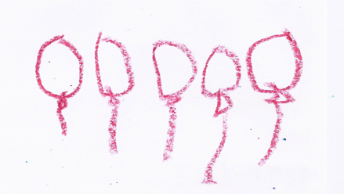
Display the 5 balloons where children can easily see them. Ask students to draw what they see on their boards and make a statement about it. Have students put their drawing next to a neighbor’s. Have them count all of the balloons they drew.
Note: This problem transitions directly into the Concept Development where children will create subtraction stories. Using easy-to-draw objects such as balloons will speed up the drawing process.
Concept Development (13 minutes)
Part 1: Concept Introduction
Materials: (T) 5 balloons from Application Problem (S) Personal white board
- Say, "Let’s create a subtraction story about our balloons." Instruct students to say a complete sentence about the balloons.
- Have students turn to a neighbor and say a sentence about taking away some balloons. Tell students to be specific about how many balloons will be taken away.
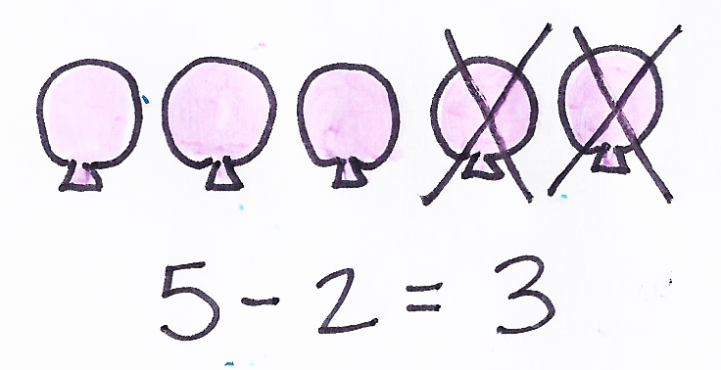
- Select one balloon scenario and have students draw (e.g., "Two balloons pop.")
- Say, "Now, we need to ask a question about the balloons. What question could we ask?" Lead students to see that they can ask a how many question about the balloons.
- Say the full subtraction story as a class: "We have 5 balloons. Two balloons pop. How many balloons are left?"
- Have children exchange drawings and cross off balloons to solve. Write the number sentence on the board (5 – 2 = 3) while saying together: “5 take away 2 is 3.”
- Challenge students to think of a different subtraction story about taking away 2 balloons. Reduce the language scaffolding as children become more comfortable telling subtraction stories.
- Write the number sentence for the new story: 5 – 2 = 3. Ask students to talk about what the 2 stories have in common.
Part 2: Practice
Materials: (S) Baggie containing 2−5 beads and string, blank paper, crayons
Children can use the beads and string as a context for creating their own subtraction story. If they prefer to develop their own context, encourage them to do so.
- Tell children that they will create their own subtraction stories.
NOTES ON
MULTIPLE MEANS
OF ACTION AND EXPRESSION:
Allow students to respond in a variety of ways. Some students may need to draw their picture first to support their subtraction story. Others may need to tell their story to a partner before representing the story with pictures.
- Say: "You are going to use the beads and string in your baggie to help you create a story, just like we did with the balloons."
- Circulate and support students as they create 2 statements, and then ask a question (e.g., “I had 4 beads on my necklace. Two beads fell off. How many beads do I have now?”).
MP.1
- While students draw, check for understanding by having them quietly share their stories one-on-one.
- After students complete their drawings, match them with a partner to share stories and to solve by crossing off objects.
- When time permits, have children dictate their subtraction stories while the teacher writes them on the drawing or on a sticky note.
Student Debrief (3 minutes)
CENTER CONNECTION:
Invite children to continue creating subtraction stories in the writing center or art center. Children in the writing center may be ready to label their drawings with words or numerals. Children in the art center might enjoy creating more detailed drawings to go along with their stories.
In Topics D and E, children will learn about making quick, efficient drawings during math. Allow students to work on more elaborate drawings in the art center; this may help students who like to add detail to make this transition during math time.
Lesson Objective: Create and solve subtraction story problems by drawing.
The Student Debrief is intended to invite reflection and active processing of the total lesson experience. It is also an opportunity for informal assessment. Consider taking anecdotal notes or using a simple checklist to note each child’s progress toward meeting the lesson objective.
As students complete the Practice portion of the Concept Development, listen for misconceptions or misunderstandings that can be addressed in the Debrief.
You may choose to use any combination of the questions below to help students express ideas, make connections, and use new vocabulary.
- Invite a few students to share their subtraction stories and drawings. Have the class draw and solve. (Consider taking a video of students sharing their stories for their portfolios.)
- Did any of our subtraction stories share a number sentence?
- How did your drawing help your partner to answer the question?
- What was fun about creating a subtraction story? What was hard?

