Lesson 14
Objective: Solve take from with result unknown story problems with objects from the story and drawings.

Suggested Lesson Structure
 Fluency Practice (9 minutes)
 Concept Development (13 minutes)
 Student Debrief (3 minutes)
Total Time (25 minutes)
Fluency Practice (9 minutes)
- Feed the Frog PK.CC.4 (3 minutes)
- Hide and Seek PK.CC.3 (4 minutes)
- Alligator Snaps PK.CC.1 (2 minutes)
Feed the Frog (3 minutes)
Materials: (T) Numeral cards 0−10 (Lesson 1 Template) (S) 10 counters (beans)
Note: This activity maintains the children’s ability to create and count a group of up to 10 objects in various configurations.
T: Pretend these beans are bugs to feed a hungry frog. (Show numeral card 5.) How many bugs does the hungry frog want to eat?
S: 5.
T: Count out 5 bugs and put them in a line. (Students do.)
T: Make your hand into a hungry frog and count as you eat each bug.
S: 1, 2, 3, 4, 5.
Repeat with the following suggested sequence: 6, 8, 7, 10, 9. If children are ready, have them organize their bugs into circles or 5-groups instead of 1 line.
Hide and Seek (4 minutes)
Materials: (S) Per pair: cup or bowl, 3 counters
Note: This activity prepares children to subtract by hiding a part in the Concept Development. It also reinforces partners of 3.
Pair students and give each pair a cup or bowl with counters. Make one partner the hider and the other partner the guesser.
T: How many bears are in your cup?
S: 3.
T: Guessers, close your eyes. Hiders, hide this many bears under your cup. (Show 2 fingers.)
T: Guessers, open your eyes. How many bears are not hiding?
S: 1.
T: Guess how many bears are hiding.
S: I don’t know. 2.
T: Hiders, show how many bears are hiding.
Have students switch roles and repeat, this time hiding 1 bear. Give partners a chance to play independently when they are ready.
Alligator Snaps (2 minutes)
Note: This activity targets one of the core fluencies for Pre-K students, rote counting to 20. Varying the stop number challenges students to remain attentive to the counting sequence.
T: It’s Allie Alligator’s lunchtime again. Let’s pretend we’re Allie catching fish for lunch. She wants 18 fish today. Let’s count to 18 the Say Ten Way.
Demonstrate arms open wide, one above the other, mimicking alligator jaws. Tell students that Allie is still hungry, and count once more to 19 the regular way.
Concept Development (13 minutes)
Part 1: Concept Introduction
Materials: (T) 5 frogs picture (Template) (S) 5 frogs picture (Template) inserted in personal white board
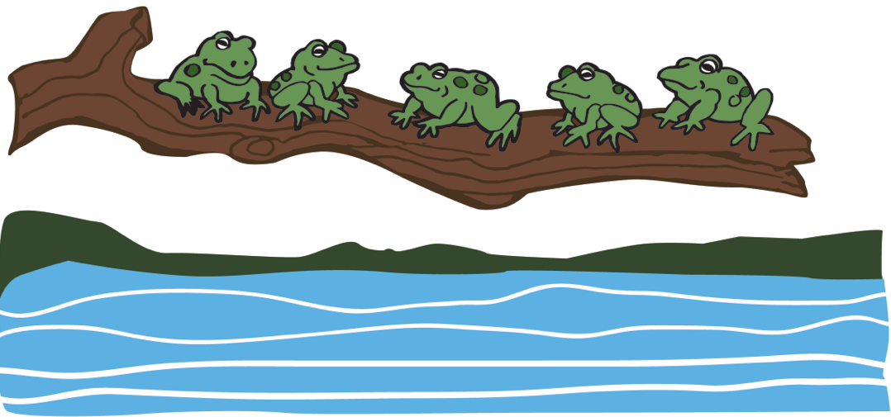
Note: This Concept Development was inspired by the popular children’s song, "5 Green and Speckled Frogs."
5 – 1 = 4
- Display 5 frogs picture. Say, "Listen to my new subtraction story: Five green and speckled frogs sat on a speckled log. One jumped into a pool where it was nice and cool."
- Say, "Tell me what happens first in the story. Does our picture show 5 frogs?" Have children count and confirm.
- Say, "Tell me what happens next." Cross off 1 frog while students do the same.
- Ask, "Who knows what the question might be?" Listen to different thoughts. Reiterate, "How many frogs are left?" Students repeat and count the remaining frogs.
- Say the number statement together, "5 frogs take way 1 frog is 4 frogs." Write the number sentence (5 – 1 = 4) saying, "5 take away 1 equals 4," and read it as a group.
- Ask, "What does the 5 in our number sentence tell us about?" Repeat the question for the numerals 1 and 4.
- Say, "Let’s draw a subtraction story about the delicious bugs the frogs like to eat. Turn to the blank side of your board." Say: "Four bugs were on a log. A frog gobbled up 2 of them. How many bugs were still on the log?" Ask volunteers to retell each part of the story, pause to draw, and check with a neighbor. Encourage quick, simple drawings.
- Ask, "Who can remember the question?" Then, say the number sentence as a class, repeating Steps 5−6.
Part 2: Practice
Materials: (S) Per student: 5 frogs picture (Template) and numeral writing rectangle (Lesson 5 Template 2) inserted in personal white board
Pair students and send them to tables.

NOTES ON
MULTIPLE MEANS
OF ACTION AND EXPRESSION:
Reread the problem one last time to allow students to check their work. Prompt students to circle the part of their drawing that answers the question. This provides students a chance to analyze their work and correct as needed.
- Say, "Five green and speckled frogs sat on a speckled log. Two jumped into a pool where it was nice and cool. How many were sitting on the log?"
- Instruct partners to retell the story with the question. They cross off 2 frogs and check to make sure the picture matches the story.
- Write the number sentence on the board (5 – 2 = 3) while saying together, "5 take away 2 equals 3."
- Say, "Under your picture, draw my new subtraction story with bugs: Four little bugs were crawling on a log. A frog gobbled up 3 of them. How many bugs were left?"
- Instruct partners to compare their drawings and solve.
- Write the number sentence on the board (4 – 3 = 1) while saying together, “4 take away 3 equals 1.”
Student Debrief (3 minutes)
Lesson Objective: Solve take from with result unknown story problems with objects from the story and drawings.
The Student Debrief is intended to invite reflection and active processing of the total lesson experience. It is also an opportunity for informal assessment. Consider taking anecdotal notes or using a simple checklist to note each child’s progress toward meeting the lesson objective.
As students complete the Practice portion of the Concept Development, listen for misconceptions or misunderstandings that can be addressed in the Debrief.
You may choose to use any combination of the questions below to help students express ideas, make connections, and use new vocabulary.
- When we say take away, do things get put together or separated?
CENTER CONNECTION:
While children are in the art center, look for opportunities to tell subtraction stories about what they are doing. For example, "Jonah had 5 crayons. He gave his red crayon to Sophie. How many crayons does Jonah have left?" Encourage children to solve and say the number sentence.
- What was different about the ways in which we showed subtraction stories today? Which way was your favorite? Why?
- (Write the number sentence 4 – 3 = 1.) We used this number sentence to tell how many bugs were left in our last subtraction story. Could this same number sentence work for another story? Can you think of one?

5 frogs picture

