Lesson 13
Objective: Represent take from with result unknown story problems using number sentences.

Suggested Lesson Structure
 Fluency Practice (5 minutes)
 Application Problem (3 minutes)
 Concept Development (14 minutes)
 Student Debrief (3 minutes)
Total Time (25 minutes)
Fluency Practice (5 minutes)
- Numbers in Rice PK.CC.2 (3 minutes)
- Swim and Count PK.CC.1 (2 minutes)
Numbers in Rice (3 minutes)
Materials: (T) Shape cutouts (Lesson 13 Fluency Template), if needed (S) Tray of sand or rice (or sealed plastic baggie with paint)
Note: In this activity, students practice forming numerals kinesthetically, strengthening their memory in the process. In this variation, point to various shapes throughout the classroom (or show a shape card) and invite students to hold up their fingers to match the number of sides or corners, rather than saying it. Provide wait time for those who need to count to do so. (Students repeat the chant below as they practice forming the numeral in the tray of sand or rice.)
- Point to a shape (e.g., a square). Ask, "How many sides? Show me on your fingers." (Students show silently.)
- Show the corresponding numeral card. (Students say the number name.)
- Invite students to say the number formation chant and write the numeral in the air with your finger.
0: Curve from the top; be a hero! Close the loop and make a zero.
1: Top to bottom, then I’m done. I just wrote the number 1.
2: Half a moon, there’s more to do; slide to the right, I wrote a 2.
3: Backwards C, backwards C, that is how I write a 3.
4: Down the side, to the right some more. Top to bottom, I’ve written 4.
5: Down the side, around a hive. Give it a hat. I’ve written 5.
Swim and Count (2 minutes)
Note: This fluency activity challenges students to remain attentive to the counting sequence while engaging in physical exercise.
T: Everyone stand up, put your swim goggles on, and dive into the pool! Swim and count with me. We’ll stop when we get to 20.
S: 1, 2, 3…20 (keeping arm movements synchronous with the count).
T: Great counting! Hold your nose! Let’s dive under water!
Count to 20 again the Say Ten Way.
Application Problem (3 minutes)
Materials: (S) Per pair: 10 blocks or linking cubes in a baggie
Pair students and distribute the baggies. Ask one child in each pair to take 5 blocks out of the baggie and put them in a line. Ask the other child to take 5 blocks out and put them in a different line. Have each partner take turns touching and counting (out loud) all the blocks.
Note: This problem asks students to practice organizing and counting 10 objects and make 2 groups of 5. They will use these groups of 5 blocks in the Concept Development.
Concept Development (14 minutes)
Part 1: Concept Introduction
Materials: (T) 5 blocks (S) Problem Set in personal white board
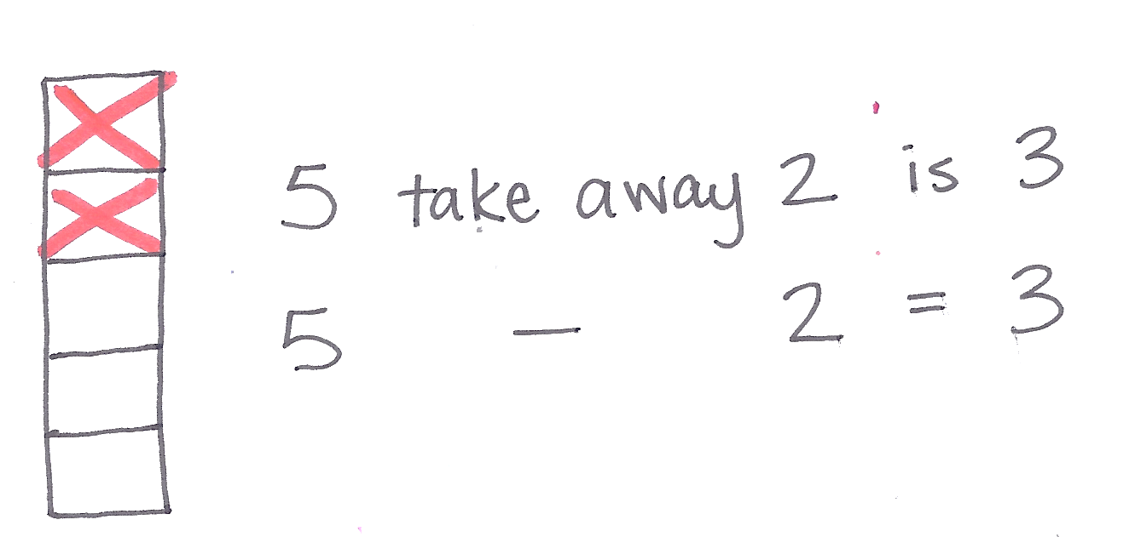
Seat children in a semicircle and select blocks that are large enough for all to see. Have them insert the Problem Set template into their board.
- Say: "Listen to my subtraction story: David’s tower is 5 blocks tall. Two blocks fall off. How many blocks are left?"
- Say: "Tell me what happens first in the story." Draw a tower of 5 blocks while students do the same on their Problem Set in their personal boards.
- Say: "Tell me what happens next." Cross off two blocks while students do the same.
- Point to the 3 blocks, asking, "How many blocks are left?” Provide wait time, then signal students to answer by showing their boards.
- Say the number sentence: "5 blocks take away 2 blocks is 3 blocks." Have students repeat.
- Say: "There’s a special way to tell about this subtraction story: 5 take away 2 equals 3. Say the number sentence with me (while writing on the board)."
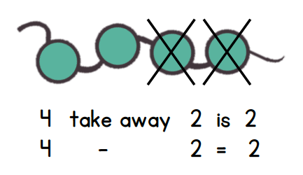
- Repeat Steps 2−5 with the following word problem: There are 4 beads on the necklace. Two beads come off. How many beads are left?
Part 2: Practice
Materials: (S) 5 blocks or linking cubes from Application Problem, Problem Set in personal white board
Pair students to work on the Problem Set if needed.
- Say, "Listen to my subtraction story. The tower is 5 blocks tall. Three blocks fall off."
NOTES ON
MULTIPLE MEANS
OF REPRESENTATION:
Often students learn a concept in an isolated fashion but have difficulty applying their knowledge to new situations. Provide opportunities for students to apply their knowledge of addition and subtraction stories in a variety of settings throughout the day, e.g., during snack, lunch, or in the block corner.
- Have children turn to a partner and retell the subtraction story. Encourage them to match their blocks to the story.
MP.2
- Point to the Problem Set and say: "This is a picture of the tower. Let’s cross of the blocks that fell."
- Ask, "How many blocks are left?" Have students repeat the question aloud to a partner. Then, have them solve and write the answer on their Problem Set.
- As a class, read the number sentence, "5 blocks take away 3 blocks is 2 blocks. 5 take away 3 equals 2."
- Repeat Steps 2−5 with the following word problem: There are 4 beads on the necklace. One bead comes off. How many beads are left?
Student Debrief (3 minutes)
Lesson Objective: Represent take from with result unknown story problems using number sentences.
CENTER CONNECTION:
Continue to incorporate subtraction stories into the dramatic play and sensory centers as described in previous lessons. Now ask children to say the number sentence after solving. Write the equation to help guide their sentences at first, but wait to write until after children have said the number sentence as they become proficient.
The Student Debrief is intended to invite reflection and active processing of the total lesson experience. It is also an opportunity for informal assessment. Consider taking anecdotal notes or using a simple checklist to note each child’s progress toward meeting the lesson objective.
As students complete the Practice portion of the Concept Development, listen for misconceptions or misunderstandings that can be addressed in the Debrief.
You may choose to use any combination of the questions below to help students express ideas, make connections, and use new vocabulary.
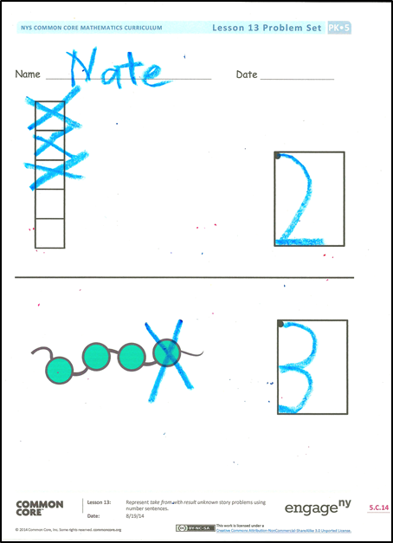
- Think about our last subtraction story. How many beads were on the necklace at first? (Show 4 beads.) How many beads fell off? (Remove 1 bead.) How many beads are left?
- How would we say that as a number sentence?
4 take away…
- (Use 4 beads.) Listen and watch (moving beads), "3 beads and 1 more bead make 4 beads." Now, watch again, "4 beads take away 1 bead is 3 beads." What was different this time?

Name Date

shape cutouts

