Lesson 12
Objective: Solve take from with result unknown story problems using objects from the story.

Suggested Lesson Structure
 Fluency Practice (6 minutes)
 Application Problem (3 minutes)
 Concept Development (13 minutes)
 Student Debrief (3 minutes)
Total Time (25 minutes)
Fluency Practice (6 minutes)
- Stand Up on Your Number PK.CC.2 (4 minutes)
- Balance Challenge PK.CC.1 (2 minutes)
Stand Up on Your Number (4 minutes)
Materials: (T) Numeral cards 6−10 (Lesson 1 Template) (S) Per pair: one baggie of 6−10 interesting objects, one type per bag (buttons, coins, beans, crayons, erasers, etc.)
Note: Students maintain fluency with counting and reading written numbers through 10. Observe how children organize objects for counting.
Pass out one baggie to each pair of students.
NOTES ON
MULTIPLE MEANS
OF ENGAGEMENT:
Provide assistance for students who are struggling with counting by prompting them to organize their manipulatives in a linear configuration. Challenge students who are ready to arrange their objects in a circular or scattered configuration before counting.
T: With your partner, count the things in your bag. (Provide time to count.)
T: (Show numeral card 10.) What number is this?
S: 10.
T: If you have 10 things, stand up with your partner. If you have a different number of things in your bag, put your hands on your head.
Continue showing different numeral cards, allowing partners to count again the items in their bag to determine whether they should stand up or put their hands on their head.

Balance Challenge (2 minutes)
Note: This activity addresses one of the core fluency goals for the grade—rote counting to 20. Varying the stop number challenges students to remain attentive to the counting sequence.
T: Let’s balance on one foot while we count to 5. Ready?
S: 1, 2, 3, 4, 5.
Repeat to 10, then to 15. If time permits, count again to 15 the Say Ten Way.
Application Problem (3 minutes)
Materials: (S) 4 teddy bear counters per pair
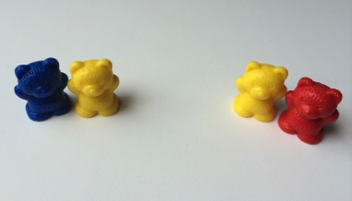
Select 4 students to act out this story—4 students are sitting on the rug. 2 students go back to their seats. How many students are left on the rug?
Give each pair of students 4 bear counters. Ask Partner A to show the first part of the story as it is acted out. Ask Partner B to show the next part of the story. Ask, "How many students are left on the rug?" Provide wait time, and then signal students to answer. Ask, "How did you know?"
Note: This is a take from with result unknown problem. Acting the story out and using objects to solve serve as a transition to working solely with objects during the Concept Development.
Concept Development (13 minutes)
Part 1: Concept Introduction
Materials: (T) Strip of blue construction paper, 4 teddy bear counters, cup or bowl (S) numeral writing rectangle (Lesson 5 Template 2) in personal white board
Distribute a personal white board to each student. Children are asked to count out objects from a larger group. The teacher demonstrates this in Part 1, giving children a model for counting and organizing their objects based on the subtraction story.
- Say, "Listen to my subtraction story: There were 4 bears swimming in the river. Three bears got out of the river."
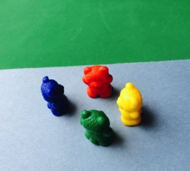
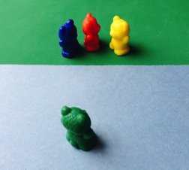
- Say, "Tell me what was happening in the story at first." After students respond, model counting out 4 bears and place them on the construction paper strip (river).
- Say, "Tell me what happened next." After students respond, take 3 bears off the construction paper.
- Say, "Hmm…who can think of a good question for this story?" (Pause.)
- If necessary, rephrase the question, "How many bears are swimming now?" Provide wait time, and then signal students to answer on their boards. Write “1 bear” on the board and read it. Ask, "How did you know the answer?"
- Guide students to say the number statement: "4 bears take away 3 bears is 1 bear."
- Replace the construction paper with a cup. Repeat Steps 1–6 with the following word problem: Five bears were eating when they heard a noise. 2 bears hid in a cave (cup). This time, have students ask and answer the question with a partner, "How many bears were still eating?"
Part 2: Practice
Materials: (S) Cup or bowl with 5 teddy bear counters, strip of blue construction paper, numeral writing rectangle (Lesson 5 Template 2) in personal white board
- Say, "Use your bears to show my subtraction story: Five bears are fishing in the river. One bear gets out of the river."
- Have students turn to a partner and retell the subtraction story. Encourage them to set up their bears as they retell.
- Guide one partner to ask a question (e.g., "How many bears are fishing now?" or "How many bears are left?") Provide wait time as children answer on their boards, then signal for them to share answers with a partner. Circulate and comment, "Yes! You wrote 4! There are 4 bears left."
- Invite partners to remember the question and share. Then ask, "How did you know the answer? Tell your partner."
- Guide students to say the number statement, "5 bears take away 1 bear is 4 bears."
- Repeat Steps 1−5 with the following word problem: Five bears are eating dinner. Three bears leave to sleep in a cave (cup). How many bears are eating now? As students work, make sure that they are counting the bears that are left rather than those that are hidden.
Student Debrief (3 minutes)
CENTER CONNECTION:
Have children fill five cups of water at a water table in the sensory center. Ask them to solve subtraction stories such as: "There were 5 cups of water. 1 cup spilled. How many cups of water are left?" Invite students to use the remaining cups to create more subtraction stories.
Lesson Objective: Solve take from with result unknown story problems using objects from the story.
The Student Debrief is intended to invite reflection and active processing of the total lesson experience. It is also an opportunity for informal assessment. Consider taking anecdotal notes or using a simple checklist to note each child’s progress toward meeting the lesson objective.
As students complete the Practice portion of the Concept Development, listen for misconceptions or misunderstandings that can be addressed in the Debrief.
You may choose to use any combination of the questions below to help students express ideas, make connections, and use new vocabulary (subtraction).
- In our stories, did we add more bears or take away bears? (Students respond.) We call this subtraction.
- Show me 5 bears. If I ask you to take away 2 bears, what will you do? How many bears are left?
- When we take away bears, what happens to the group of bears?
- (Retell a subtraction story.) Who remembers the question?

