Topic C
Contextualizing Subtraction Stories to Solve
PK.OA.1, PK.CC.2, PK.CC.3, PK.CC.4
Focus Standards: | PK.OA.1 | Demonstrate an understanding of addition and subtraction by using objects, fingers, and responding to practical situations (e.g., if we have 3 apples and add two more, how many apples do we have all together?).
Instructional Days: | 5
Coherence -Links to: | GK–M1 | Numbers to 10
 | GK–M4 | Number Pairs, Addition and Subtraction to 10
In Topic C, children shift focus to subtraction stories with numbers 1 to 5, again acting them out, using fingers, manipulating objects, drawing, and counting pictorial representations to model the problem (PK.OA.1). Throughout this topic, students will use these tools to count the total number of objects, the number taken away, and the result.
In Lesson 11, children act out take from with result unknown stories, counting themselves to find how many are left. For example, "Three friends are dancing. One friend stops to sit down. How many friends are dancing now?" Children take turns being a part of the action and counting the whole (3 friends), the number taken away (1 friend), and the result (2 friends). Asking subtraction questions involves new vocabulary, so children will again restate the situation and the question in their own words to practice this skill.
In Lesson 12, children begin to use objects to solve subtraction stories (PK.OA.1). For example, they use teddy bear counters to model and solve the following: "Five bears are eating dinner. Three bears leave to sleep in a cave. How many bears are eating now?" Children move and hide the objects to solve, for example, using a cup to represent a cave. Similarly to Topic B, children manipulate objects reminiscent of the story.
In Lesson 13, children make subtraction statements: "4 beads take away 2 beads is 2 beads." (In Pre-Kindergarten, the term take away better represents the action of subtraction; minus is terminology learned in Kindergarten.) They learn to cross off a part in drawings to show subtraction (see image on next page). The teacher writes a number sentence (4 – 2 = 2) to provide exposure to equations; however, children are not expected to write or master number sentences in Pre-Kindergarten.

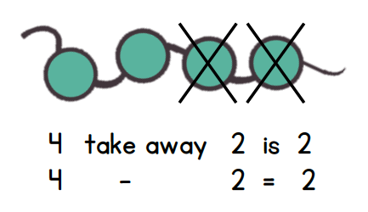

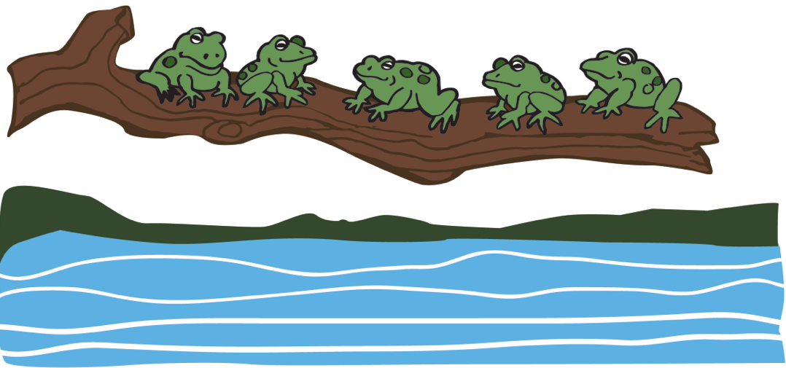
In Lesson 14, children work with both objects and drawings to solve take from with result unknown problems inspired by the popular children’s song, “Five Green and Speckled Frogs.” Students cross off a part to subtract and make the statement, “5 take away 1 equals 4,” as shown at right. Then, students begin to draw their own stories about a frog gobbling up some bugs on a log.
Students have an opportunity to create their own subtraction stories in Lesson 15. Again, they create detailed drawings to accompany their stories and to help them share and solve one another’s problems. Teachers continue to provide language support when children ask and answer questions.
In Topic C Fluency Practice, students begin by practicing put together story situations; they draw a numeral card and take the corresponding number of bears. Students continue to practice rote counting to 20 and counting a group of 10 in various configurations via activities such as Feed the Frog. The Hide and Seek activity reinforces partners of 3 and 4 as students hide a part of the whole, a foundational concept for understanding subtraction.
A Teaching Sequence Toward Mastery of Contextualizing Subtraction Stories to Solve
Objective 1: Act out take from with result unknown story problems to solve.
(Lesson 11)
Objective 2: Solve take from with result unknown story problems using objects from the story.
(Lesson 12)
Objective 3: Represent take from with result unknown story problems using number sentences.
(Lesson 13)
Objective 4: Solve take from with result unknown story problems with objects from the story and drawings.
(Lesson 14)
Objective 5: Create and solve subtraction story problems by drawing.
(Lesson 15)

