Lesson 9
Objective: Solve put together with total unknown story problems with objects from the story and drawings.

Suggested Lesson Structure
 Fluency Practice (6 minutes)
 Application Problem (3 minutes)
 Concept Development (13 minutes)
 Student Debrief (3 minutes)
Total Time (25 minutes)
Fluency Practice (6 minutes)
- Stand Up on Your Number PK.CC.3, PK.CC.4 (4 minutes)
- Ski Jumps PK.CC.1 (2 minutes)
Stand Up on Your Number (4 minutes)
Materials: (T) Numeral cards 4–8 (Lesson 1 Template) (S) per pair: 1 baggie of 4–8 interesting objects, 1 type per bag (buttons, coins, beans, crayons, erasers, etc.)
Note: Students maintain fluency practice by counting and reading written numerals 4–8.
Pass out 1 baggie to each pair of students.
T: With your partner, count the items in your bag. (Provide time to count.)
T: (Show numeral card 8.) What number is this?
S: 8.
T: If you have 8 items, stand up with your partner. If you have a different number of items in your bag, put your hands on your head.
Continue showing different numeral cards, allowing partners to recount the items in their bags to determine whether they should stand up or put their hands on their heads.
Ski Jumps (2 minutes)
Note: This fluency activity targets the core counting fluency—rote counting to 20.
T: Let’s ski jump as we count again! Take out your ski poles. (Demonstrate holding imaginary ski poles). Let’s count to 20 the regular way as we ski.
Jump from left to right, holding your imaginary ski poles to mimic skiing as you count to 20. Then, count again to 20 the Say Ten Way.
Application Problem (3 minutes)
Materials: (S) Numeral writing rectangle (Lesson 5 Template 2) in personal white board
Select 5 students to act out the following addition story: 3 children are reading at the library. 2 more children come to read. How many children are reading all together?
Give children time to count and write the answer on their personal white boards. Invite volunteers to discuss how they solved the problem. Say the statement and number sentence as a group, “3 children and 2 children make 5 children. 3 plus 2 equals 5.”
Note: This add to with result unknown problem introduces the class to solve put together with total unknown problems (e.g., “2 children are reading and 3 children are looking at picture books in the library. How many children are in the library in all?”) While the former involves the action of adding to, there is no action in the latter story, making it a less engaging, and thus more challenging, problem.
Concept Development (13 minutes)
Part 1: Concept Introduction
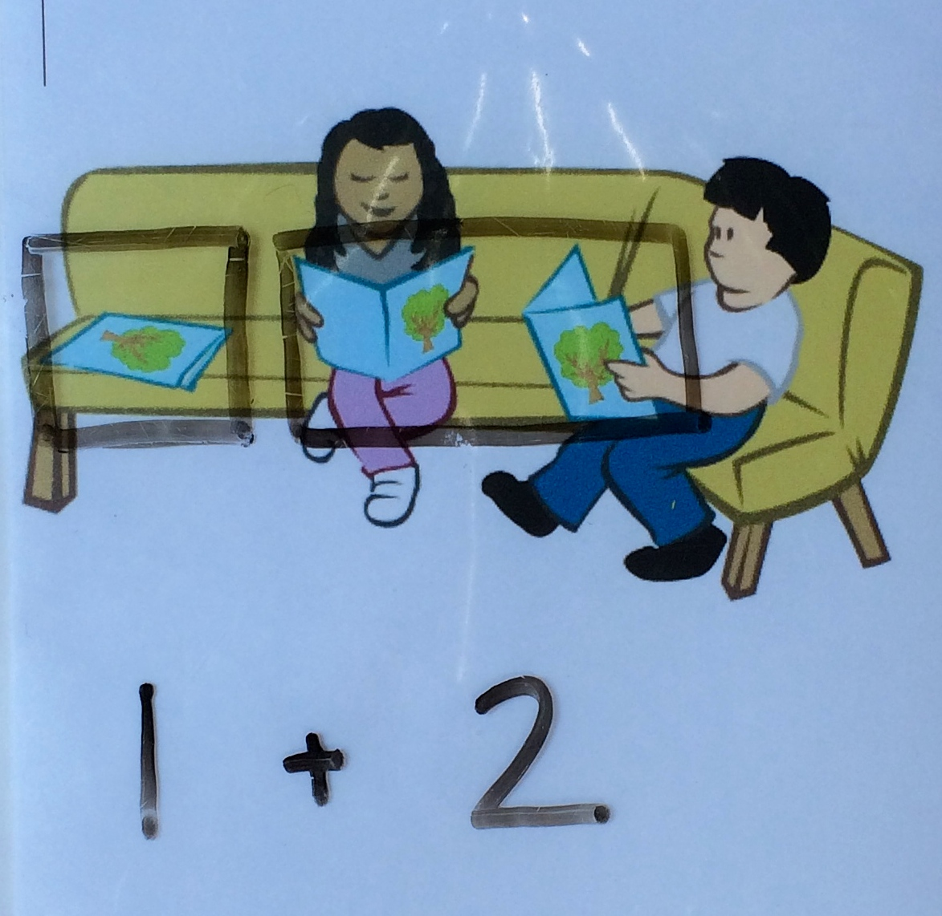
Materials: (T) Reader picture (Template) in personal white board, chart paper, marker (S) Numeral writing rectangle (Lesson 5 Template 2) in personal white board
For the first problem, fold the reader picture so only the couch is showing.
For the second problem, display the full picture and select book titles that are familiar to students.
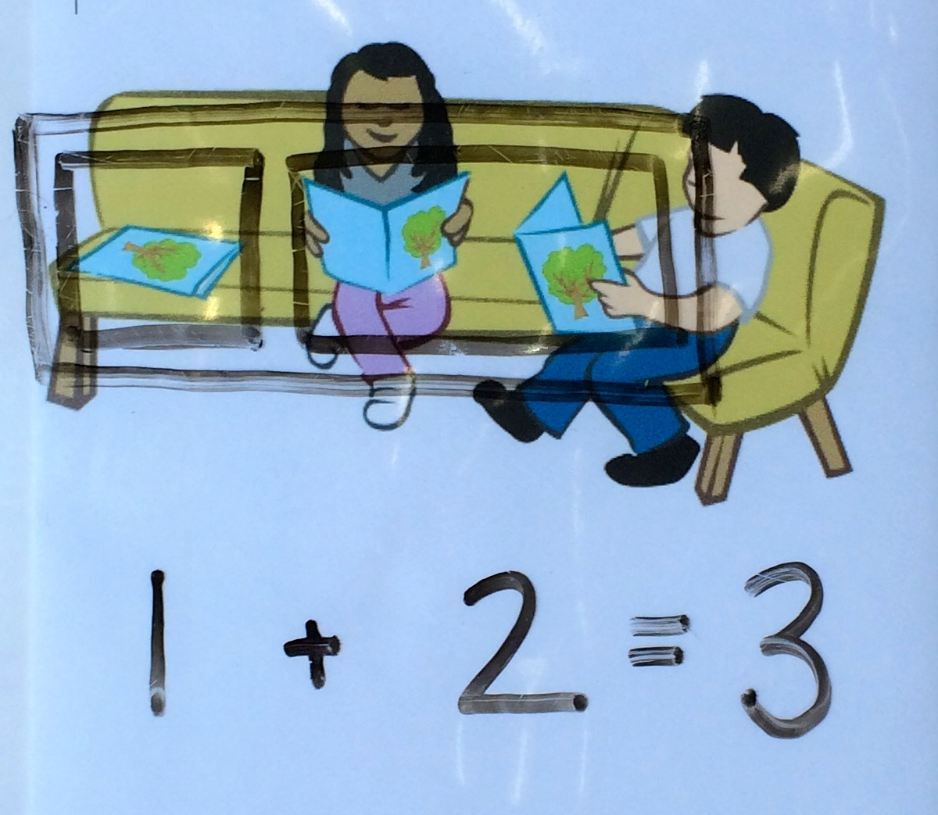
- Display the folded reader picture. Say, “Listen to a new addition story about the library: 1 book is lying on the couch. 2 books are being read.”
- Ask, “How many books are lying on the couch?” Circle that book and write 1 below. Have students draw 1 book on their personal white boards.
- Repeat Step 2 for books being read as students draw two more books on their personal white boards. Read the expression as a class, “1 + 2.”
- Ask, “How many books are there in all?” Circle all of the books and invite students to write the answer on their personal white boards. Say the number sentence together (while the teacher writes it), “1 + 2 = 3.”
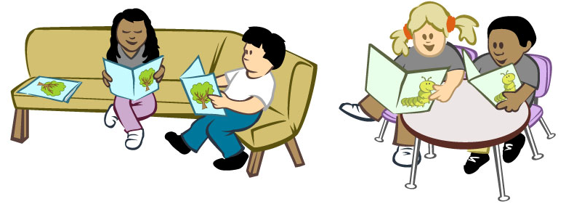
- Display the full reader picture. Say, “There are 3 copies of Chicka Chicka Boom Boom. There are 2 copies of The Hungry Caterpillar.”
- Have students retell the story while drawing a picture of the books. Read the expression as a class, “3 + 2.”
- Repeat Step 4.
Part 2: Practice
Materials: (S) Paper folded in half, 1 red and 1 green crayon
Pair students and send them to prepared tables. Instruct them to draw 1 addition story on each half of the paper.
- Say, “Use your paper and crayons to draw my addition story: The hungry caterpillar ate 1 red apple and 2 green pears. How many pieces of fruit did he eat in all?”

NOTES ON
MULTIPLE MEANS
OF ENGAGEMENT:
Provide opportunities for multiple retellings of the addition story. Use prompts such as, “There are...” Do not insist on precision, but rather encourage statements that meaningfully communicate two parts to the addition story.
- Instruct partners to retell the story with the question, compare drawings, and solve. When the partners agree on the answer, they write the answer on their paper.
- Say the number sentence together (while the teacher writes it), “1 + 2 = 3.”
- Repeat Steps 1–3 with another addition story: 2 boys are reading. 1 girl is reading. How many children are reading all together?
Student Debrief (3 minutes)
Lesson Objective: Solve put together with total unknown story problems with objects from the story and drawings.
The Student Debrief is intended to invite reflection and active processing of the total lesson experience. It is also an opportunity for informal assessment. Consider taking anecdotal notes or using a simple checklist to note each child’s progress toward meeting the lesson objective.
As students complete the Practice portion of the Concept Development, listen for misconceptions or misunderstandings that can be addressed in the Debrief. You may choose to use any combination of the questions below to help students express ideas, make connections, and use new vocabulary.
- How did the pictures help you solve the addition stories?

CENTER CONNECTION:
Create 5 bags of counters that students can use to create stories. Bags should contain 2–5 objects in two different colors (e.g., 1 blue bear and 2 red bears). Invite partners to make addition statements or number sentences based on the objects (e.g., “1 bear and 2 bears make 3 bears” or “1 plus 2 equals 3”).
- Pretend you don’t have any objects or pictures to count. How can drawing help you solve?
- (Write the number sentence 3 + 2 = 5.) This is the number sentence we used to tell how many children were reading at the library. We used the same number sentence to tell how many books there were in all. How can the same number sentence work for both stories?
MP.8
- Did you notice anything cool about the stories you practiced with your partner? Let’s look at and say their number sentences, “2 + 1 = 3 and 1 + 2 = 3.”

reader picture

