Lesson 8
Objective: Represent add to with result unknown story problems using number sentences.

Suggested Lesson Structure
 Fluency Practice (6 minutes)
 Application Problem (3 minutes)
 Concept Development (13 minutes)
 Student Debrief (3 minutes)
Total Time (25 minutes)
Fluency Practice (6 minutes)
- Stand Up on Your Number PK.CC.2 (4 minutes)
- Elephant Splashes PK.CC.1 (2 minutes)
Stand Up on Your Number (4 minutes)
Materials: (T) Numeral cards 3–7 (Lesson 1 Template) (S) Per pair: 1 baggie of 3–7 interesting objects, 1 type per bag (buttons, coins, beans, crayons, erasers, etc.)
Note: Students maintain Fluency Practice by counting and reading written numerals 3–7. Observe to see how students organize objects for counting.
Pass out 1 baggie to each pair of students.
T: With your partner, count the items in your bag. (Provide time to count.)
T: (Show numeral card 7.) What number is this?
S: 7.
T: If you have 7 items, stand up with your partner. If you have a different number of items in your bag, put your hands on your head.
Continue showing different numeral cards, allowing partners to recount the items in their bags to determine whether they should stand up or put their hands on their heads.
Elephant Splashes (2 minutes)
Note: This activity targets one of the core fluencies for Pre-K students—rote counting to 20.
T: Silly Eli elephant is at it again! Let’s pretend we’re Eli. Let’s swing our trunks to splash our friends while counting to 17.
Demonstrate swinging an arm back and forth, mimicking an elephant’s trunk. Count again to 17 the Say Ten Way, maintaining synchronous movement with the count.
Application Problem (3 minutes)
Materials: (S) Numeral writing rectangle (Lesson 5 Template 2) in personal white board
Select 3 students to act out the following story—1 seed grows into a flower. 2 more seeds grow into flowers. How many flowers are there now?
Provide students time to count and write the answer on their personal white boards. Invite volunteers to discuss how they solved the problem. Guide students to answer the question with a number statement, “1 flower and 2 flowers make 3 flowers.”
Note: This add to with result unknown problem type segues into the introduction of number sentences in the Concept Development.
Concept Development (13 minutes)
Part 1: Concept Introduction
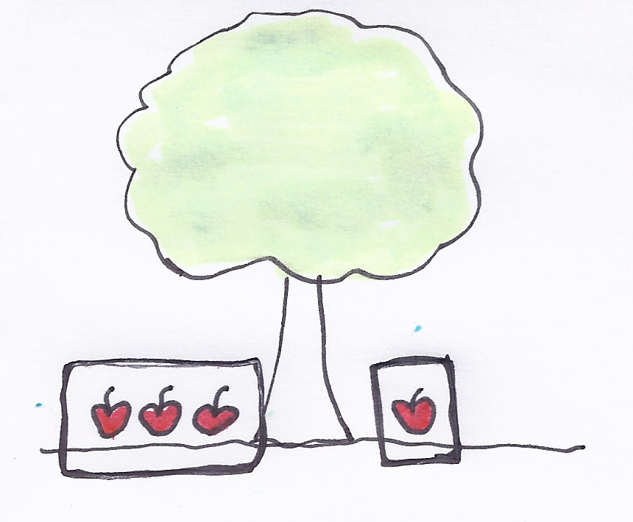
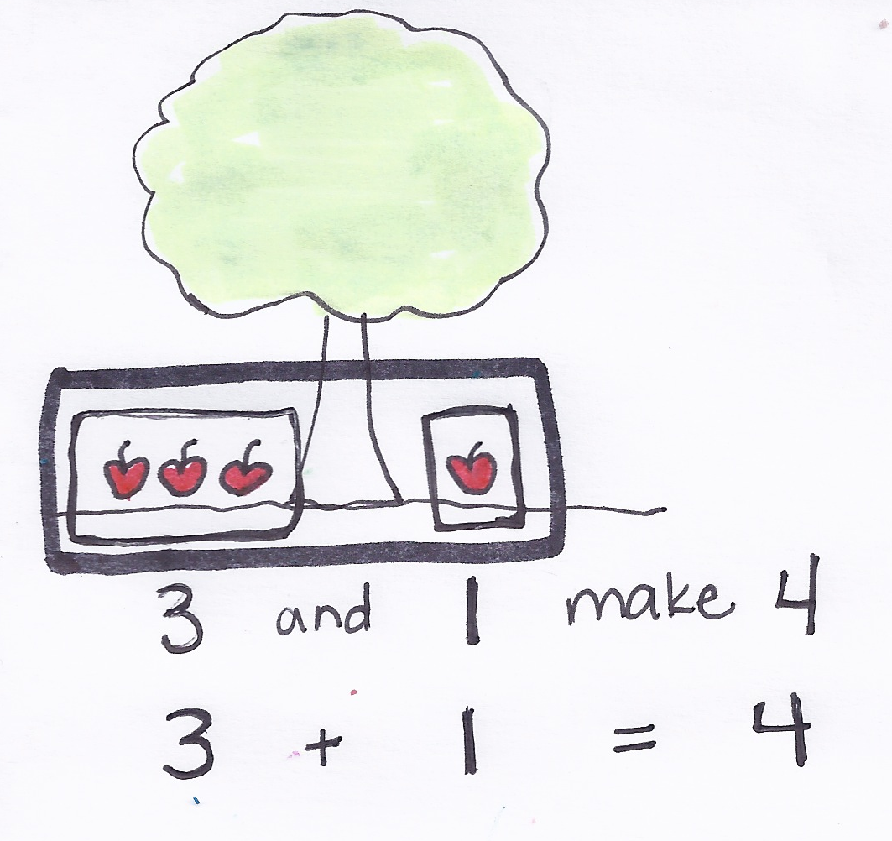
Materials: (T) 5 apples, enlarged apple tree mat (Template 1) (S) Numeral writing rectangle (Lesson 5 Template 2) in personal white board
- Say, “Listen to my addition story: 3 apples fell on the ground.
1 other apple fell.”
- Say, “Tell me what happened first in the story.” After students answer, place 3 apples on the apple tree mat (below the tree) and draw a box around them.
- Say, “Tell me what happened next.” Follow the procedure in Step 2.
- Box all of the apples and ask, “How many apples are on the ground now?” Provide wait time, and then signal students to answer by showing their personal white boards.
- Say the statement, “3 apples and 1 apple make 4 apples.” Students repeat.
- Say, “There’s a special way to talk about this addition story: 3 plus 1 equals 4. Say the number sentence with me (while writing on the board).”
- Repeat Steps 2–6 with the following word problem (using the apple mat): Mom picked 3 apples. Dad picked 2 apples. How many apples did they pick in all?

Part 2: Practice
Materials: (S) Apple tree mat (Template 1), 5 apple cards (Template 2), numeral writing rectangle (Lesson 5 Template 2) in personal white board
Pair students to work on these problems, if necessary. Send children to prepared tables.
- Say, “Listen to my addition story: Kojo saw 2 apples in the tree. Then, he saw 3 more.”
- Have students turn to a partner and retell the addition story. Encourage them to match their apples to the story. Support students in terms of counting the correct number of apples.
- Ask, “How many apples did Kojo see?” Have students repeat the question aloud to a partner. Then, have them solve and write the answer on their personal white boards.

NOTES ON
MULTIPLE MEANS
OF ENGAGEMENT:
Challenge students who are ready to write the number sentences to write answers that match the stories.
- As a class, make the statement, “2 apples and 3 apples make 5 apples,” and then the number sentence, “2 plus 3 equals 5.”
- Repeat Steps 1–4 with the following word problem: Dad picked 1 apple. Kojo picked 4 apples. How many apples did they pick in all?
Student Debrief (3 minutes)

CENTER CONNECTION:
Continue to incorporate addition stories into the dramatic play and block centers as described in previous lessons. Now, ask children to say the number sentence after solving. When possible, write the equation to help guide their sentences at first, but wait to write until after children have said the number sentence as they become proficient.

Lesson Objective: Represent add to with result unknown story problems using number sentences.
The Student Debrief is intended to invite reflection and active processing of the total lesson experience. It is also an opportunity for informal assessment. Consider taking anecdotal notes or using a simple checklist to note each child’s progress toward meeting the lesson objective.
As students complete the Practice portion of the Concept Development, listen for misconceptions or misunderstandings that can be addressed in the Debrief.
You may choose to use any combination of the questions below to help students express ideas, make connections, and use new vocabulary (plus, equals, number sentence).
- Think about our last addition story. How many apples did Kojo’s dad pick? (Show 1 apple.) How many apples did Kojo pick? (Show 4 apples.) How many apples did they pick all together?
- How would we say that as a number sentence? (1 plus 4 equals 5.)
- (Write 1 + 4 = 5.) What is special about number sentences? (Draw students’ attention to the + and = symbols.)

Copy and cut. Each student needs 5 apples.

apple tree mat
apple cards

