Lesson 7
Objective: Solve add to with result unknown story problems using objects from the story.

Suggested Lesson Structure
 Fluency Practice (6 minutes)
 Application Problem (3 minutes)
 Concept Development (13 minutes)
 Student Debrief (3 minutes)
Total Time (25 minutes)
Fluency Practice (6 minutes)
- Stand Up on Your Number PK.CC.2 (4 minutes)
- Alligator Snaps PK.CC.1 (2 minutes)
Stand Up on Your Number (4 minutes)
Materials: (T) Numeral cards 2–6 (Lesson 1 Template) (S) per pair: 1 baggie of 2–6 interesting objects,
1 type per bag (buttons, coins, beans, crayons, erasers, etc.)
Note: Students maintain fluency practice by counting and reading written numerals 2–6. Observe to see how children organize objects for counting. This activity is repeated throughout Topic B. Each day the lowest and highest numbers increase by 1; for example, Lesson 8 will work with numerals 3–7, etc.
Pass out 1 baggie to each pair of students.
T: With your partner, count the items in your bag. (Provide time to count.)
T: (Show the 6 card.) What number is this?
S: 6.
T: If you have 6 items, stand up with your partner. If you have a different number of items in your bag, put your hands on your head.
Continue showing different numeral cards, allowing partners to recount the items in their bags to determine whether they should stand up or put their hands on their heads.

Alligator Snaps (2 minutes)
Note: Say Ten counting facilitates the core fluency goal of rote counting to 20 while laying a foundation that helps students understand place value in future grades. Encourage students to clap once for each number, reinforcing that ten 1 is one number, not two.
T: It’s Allie Alligator’s lunchtime again. Let’s pretend we’re Allie catching fish for lunch. She wants 16 fish today. Let’s count to 16 the Say Ten Way.
Demonstrate with arms open wide, one above the other, mimicking alligator jaws. Close arms and hands together to create a snapping sound while saying each number to 16 the Say Ten Way. Repeat to 20.
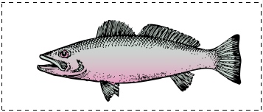
Application Problem (3 minutes)
Materials: (S) 3 small fish cards (Template 2) in a baggie per pair
Select 3 students to act out this story: The fisherman caught 1 fish in the morning. He caught 2 more fish in the afternoon. How many fish did he catch in all?
Give each pair of students 3 fish cards. Instruct Partner A to show the first part of the story as it is acted out. Then, instruct Partner B to show the next part of the story. Guide students to remember the question and then touch and count to solve.
Note: This is an add to result unknown problem. Acting out the story and using objects to solve serves as a transition to working solely with objects during the Concept Development.
Concept Development (13 minutes)
Part 1: Concept Introduction
Materials: (T) 5 large fish cards (Template 1) (S) bag with 5 small fish cards (Template 2), numeral writing rectangle (Lesson 5 Template 2) in personal white board
Distribute a bag and personal white board to each student. In this lesson, students are asked to count out objects from a larger group. The teacher demonstrates this activity in Part 1, providing students a model for counting and organizing their objects based on the addition story.
- Say, “Listen to my addition story: There were 2 fish splashing in the river. One more fish came to splash.”
- Say, “What was happening in the story at first?” Display 2 fish as students do the same with their fish.
- Say, “Tell me what happened next.” Display another fish as students do the same.
- Ask, “How many fish are splashing now?” Provide wait time, and then signal students to answer on their personal white boards. Write 3 on the board, saying “3 fish.” Ask, “How did you know the answer?”
- Say, “2 fish and 1 fish make 3 fish.” Have students repeat.
- Repeat Steps 1–4 with more word problems, such as the following:
  - 3 fish jumped into the air. One more fish jumped, too. How many fish jumped?
  - Mr. Fox caught 2 fish at first. Then, he caught 3 fish. How many fish did he catch all together?
Part 2: Practice
Materials: (S) Bag with 5 small fish cards (Template 2), numeral writing rectangle (Lesson 5 Template 2) in personal white board

NOTES ON
MULTIPLE MEANS
FOR ACTION AND EXPRESSION:
Circulate as students work, and support students who are struggling by repeating the story, one sentence at a time. Have students check the number of fish used to represent each part of the story.
- Say, “Use your fish to show my addition story. Four fish went to swim in a shady part of the lake. One more fish went to swim there, too.”
- Have children turn to a partner and retell the addition story. Encourage them to set up their fish as they retell the story.
MP.2
- Ask, “How many fish went to swim in the shady part of the lake?” Provide wait time as children write the answer on their boards, and then signal for students to share answers with a partner. Circulate and comment, “Yes, you wrote 5. There are 5 fish swimming in the shady part of the lake.”
- Invite partners to remember the question and share. Then ask, “How did you know the answer? Tell your partner.”
- Guide students to say the number statement, “4 fish and 1 fish make 5 fish.”
- Repeat Steps 1–5 with the following word problems:
- Two fish swam down the waterfall. Two other fish swam down the waterfall. How many fish swam down the waterfall in all?
- One fish goes to sleep. Two more fish go to sleep. How many fish are sleeping now?
Student Debrief (3 minutes)
Lesson Objective: Solve add to with result unknown story problems using objects from the story.

CENTER CONNECTION:
At the block center, invite students to build towers and create problems, such as, “I used 1 block. I added 4 more blocks. How many blocks are there in all?” Students can touch and count to check their answers.

The Student Debrief is intended to invite reflection and active processing of the total lesson experience. It is also an opportunity for informal assessment. Consider taking anecdotal notes or using a simple checklist to note each child’s progress toward meeting the lesson objective.
As students complete the Practice portion of the Concept Development, listen for misconceptions or misunderstandings that can be addressed in the Debrief.

You may choose to use any combination of the questions below to help students express ideas, make connections, and use new vocabulary (addition).
- In our stories, did we add more fish or take away fish? (Wait for students to respond.) We call this addition.
- Show me 3 fish. When I say, “Add 2 fish,” show me what to do with your fish.
- When we add more fish, what happens to the group of fish?
- Yesterday, we used dolls to act out addition stories. How is what we did with the fish like what we did with the paper dolls?

Make 1 copy. Cut.
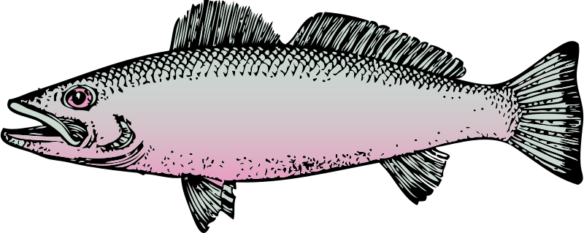

Copy and cut. Each student needs 5 fishes.

large fish cards
small fish cards

