Lesson 5
Objective: Write numeral 5.

Suggested Lesson Structure
 Fluency Practice (6 minutes)
 Application Problem (3 minutes)
 Concept Development (13 minutes)
 Student Debrief (3 minutes)
Total Time (25 minutes)
Fluency Practice (6 minutes)
- How Many? Number Practice PK.CC.2 (4 minutes)
- Say Ten Ski Jumps PK.CC.1 (2 minutes)
How Many? Number Practice (4 minutes)
Materials: (T) Numeral cards 6–10 (Lesson 1 Template) (S) Per pair: 10 baggies of 6–10 interesting objects, 1 type per bag (buttons, coins, beans, crayons, erasers, etc.)
Note: Students maintain fluency practice by counting and reading written numbers through 10. Observe to see how children organize objects for counting.
Pass out 1 baggie to each pair of students.
T: With your partner, count the items in your bag. (Provide time to count.) (Show numeral card 10.) What number is this?
S: 10.
T: If you have 10 items, stand up with your partner. If you have a different number of items in your baggie, put your hands on your head.
Continue showing different numeral cards, allowing partners to recount the items in their bags to determine whether they should stand up or put their hands on their heads.
Say Ten Ski Jumps (2 minutes)
Note: This fluency activity targets one of the core counting fluencies—rote counting to 20.
T: I had so much fun skiing with you yesterday that I want to ski again! Take out your ski poles. (Demonstrate holding imaginary ski poles). Today, let’s count to 20 the Say Ten Way as we ski.
Jump left to right, holding your imaginary ski poles to mimic skiing as you count to 20 the Say Ten Way. Then, count again to 17.
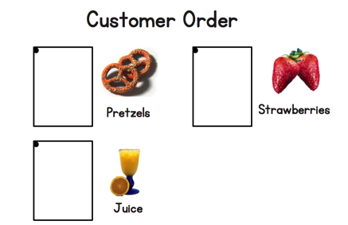
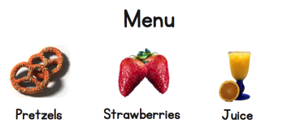
Application Problem (3 minutes)
Materials: (S) Per pair: pad of paper or menu items (Lesson 4 Template), marker, pretend menu including 3 items (pictures of juice, pretzels, and strawberries, or other appropriate items to order) or menu items (Lesson 4 Template)
Note: Students return to the café context from the previous lesson as they continue to see how written numerals communicate meaning.
Pair students and assign 1 to be the waiter and 1 to be the customer. Facilitate role-playing of ordering food at the café as in the previous lesson, restricting orders of up to 4. Have children switch roles and order again.
Concept Development (13 minutes)
Part 1: Concept Introduction
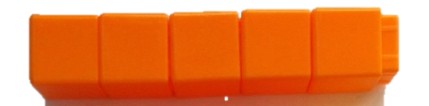
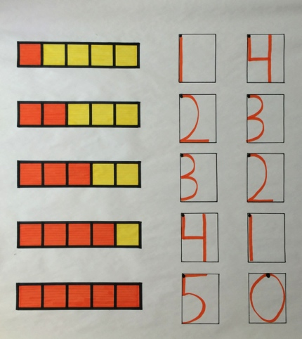
Materials: (T) 5-train (5 of a color), chart paper or white board, markers
Prepare chart paper or a white board with writing rectangles and dots as shown on the right.
- Show the 5-train. With the group, count how many cubes are in the train. (Five.) Ask, “How many are orange? How many are yellow?”
- Ask, “What is the quickest way to show that there are 5 orange cubes? Let’s write the number! Use your finger to write 5 in the air while I write it on the board.”
- Say the rhyme for 5 while writing 5 in the first rectangle: “Down the side, around a hive. Give it a hat, I’ve written 5.” Point out having started from the dot at the top and returned to the top to “give it a hat.”
- Practice two more times with students air-tracing the numeral and saying the rhyme.
- Draw the train on the poster begun in Lesson 1, and have students check to ensure it matches the concrete 5-train. Ask students to count the orange squares. Write 5 in the first rectangle while students air trace and say the rhyme.
- Ask children the number of yellow squares. Write 0 in the second rectangle and say the rhyme. (Curve from the top, be a hero! Close the loop and make a 0.)

Part 2: Practice
Materials: (S) Per student: Problem Set inserted into personal white board, dry erase crayon, 10 linking cubes (5 of a color, 5 of another color), make 5 (Template 1) inserted into opposite side of personal white board
Distribute a Problem Set and crayon to each student.
- Demonstrate tracing with a crayon. Invite students to pick up a crayon and trace the 5 while saying the rhyme. Continue until all rectangles are filled.
MP.4

NOTES ON
MULTIPLE MEANS
OF ENGAGEMENT:
Challenge students who are ready to find all of the ways to make 5 with the yellow and orange cubes. Teachers may want to tell them they will use each of the numbers they have learned to write.
- Distribute linking cubes. Direct students to make a 5-train (any 2 differently colored combinations, such as orange and yellow) and place it on their Problem Set. Support students so that cubes of the same color are touching.
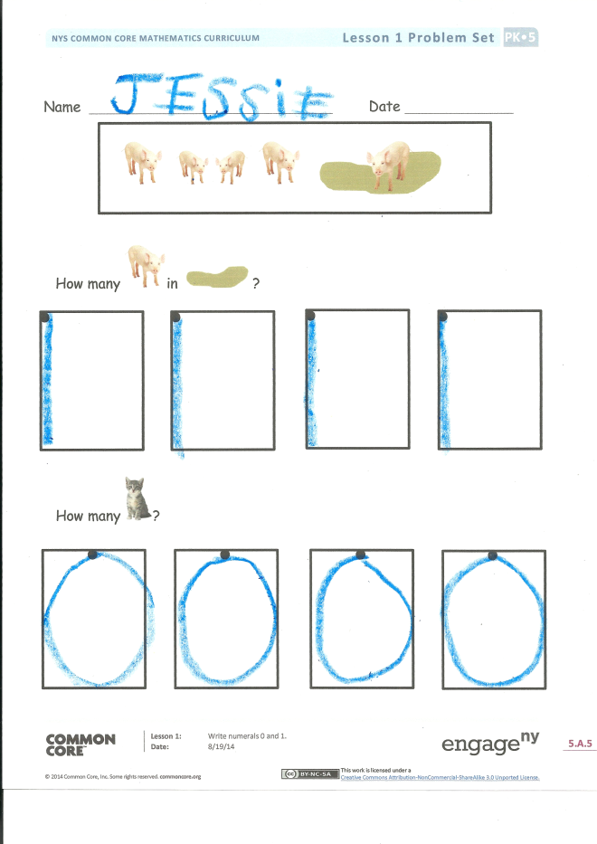
- Guide students to count the orange cubes and write the number in the first rectangle. Then, count the yellow cubes and write the number in the second rectangle.
- Have students turn over their personal white boards. They should make a different 5-train, and write the number of cubes in each color.
- Direct students to switch personal white boards with their partner and find a different way to make 5 on the bottom of Template 1, writing the number of cubes in each color.

Student Debrief (3 minutes)
Lesson Objective: Write numeral 5.

CENTER CONNECTION:
Prepare bags with 0–5 objects and personal white boards with the numeral writing rectangle template inserted (Template 2). Have children count the number of items in each bag and write the corresponding numeral on their personal white boards.

The Student Debrief is intended to invite reflection and active processing of the total lesson experience. It is also an opportunity for informal assessment. Consider taking anecdotal notes or using a simple checklist to note each child’s progress toward meeting the lesson objective.
As students complete the Practice portion of the Concept Development, listen for misconceptions or misunderstandings that can be addressed in the Debrief.
You may choose to use any combination of the questions below to help students express ideas, make connections, and use new vocabulary.
- (Remove the cube trains from a completed Template 1.) How could you use the numbers written here to make the tower again?
- (Display partner work from Templates 1 and 2.) What partners of 5 do you see? (Consider having children use fingers on both hands to show partners of 4.)
- (Display the chart with 5-trains.) How are the trains that we’ve been making throughout the past few days like your trains? What partners of 5 do you see?
- (Point to the numeral 4 on the chart.) Which color cube does this 4 tell us about in the train? (Point to the other numeral 4.) This one? (Continue the same process, moving between the abstract numbers and corresponding cubes. Say as little as possible so that students have the opportunity to discover the relationships and patterns!)

Name Date
5
5

cvc

cvc

cvc

cvc

cvc

cvc

make 5
numeral writing rectangle

