Lesson 4
Objective: Write numeral 4.

Suggested Lesson Structure
 Fluency Practice (5 minutes)
 Application Problem (3 minutes)
 Concept Development (14 minutes)
 Student Debrief (3 minutes)
Total Time (25 minutes)
Fluency Practice (5 minutes)
- Decompose 4 PK.CC.5 (3 minutes)
- Say Ten Ski Jumps PK.CC.1 (2 minutes)
Decompose 4 (3 minutes)
Materials: (T) 3 paper plates (1 large, 2 small), 4 crayons, numeral card for 4 (Lesson 1 Template)
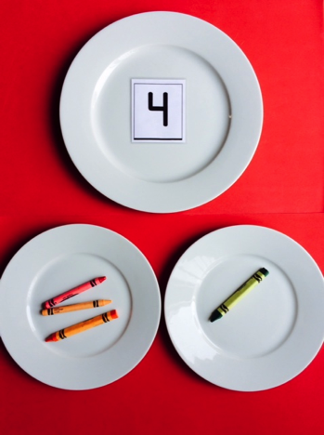
Note: Students have been working consistently with the composition and decomposition of numbers 0–5. This lays a strong foundation for work with decomposition and composition of numbers to 10—a Kindergarten standard.
T: (Place 4 crayons on the large plate.) I want to share these crayons with a friend. Let’s count them! (Touch as students count.)
S: 1, 2, 3, 4.
T: That is the number I have here! (Place the 4 card on the larger plate. What are some ways I can share?
S: (Make suggestions.) Give your friend 1. Give your friend 2.
T: Okay, let’s start by just sharing 1. (Decompose the group of 4 crayons by placing 1 crayon on one smaller plate. Have students count as you move the rest to the other plate.)
T: Let’s put them back together and share them in a different way. (Recount and repeat as time allows.)

Say Ten Ski Jumps (2 minutes)
Note: Varying movements helps keep counting exercises fresh as students strengthen their core fluency counting skills.
T: Let’s go on a ski adventure. Take out your ski poles. (Demonstrate holding imaginary ski poles). Let’s count and ski together.
Jump left to right to mimic skiing. Count to 19. Then count again to 20 the Say Ten way.
Application Problem (3 minutes)
Materials: (T) Pad of paper or menu items (Template), marker, pretend menu including 3 items (pictures of juice, pretzels, and strawberries, or other appropriate items to order) or menu items (Template)
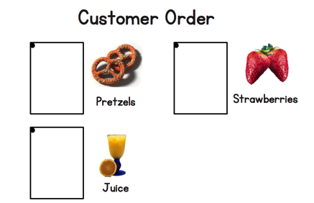
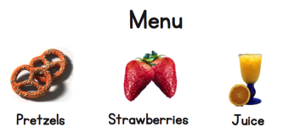
Note: This Application Problem returns students to a café setting. Set up a chair next to a small table to resemble a café. Today’s activity helps students see how written numerals communicate meaning.
Call on two students, one to be a customer and one to be a waiter (give the waiter the pad and marker). Facilitate role-playing of ordering food at the café. The exchange might occur as follows:
Waiter: Hello, what would you like to order?
Customer: I would like some pretzels.
Waiter: How many would you like (restrict the order of up to 3)?
Customer: 3.
Waiter: Writes the number 3 on the pad and shows the rest of the class.
Repeat as time allows, providing as many students as possible a chance to be the waiter or customer. Tell the students that the café will be set up during the centers today.
Concept Development (14 minutes)
Part 1: Concept Introduction
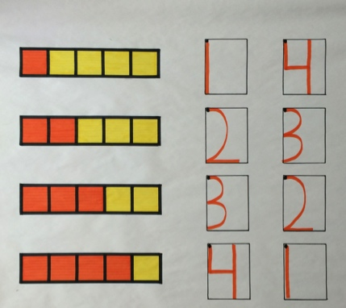
Materials: (T) 5 linking cube tower (4 of a color, 1 of another color), chart paper or personal white board, markers
Prepare chart paper or a white board with writing rectangles and dots as shown on the right.
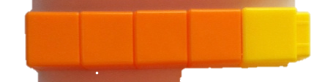
- Show the train. Ask children to tell how many cubes are in the train. (Five.) Have them count the number of yellow and orange cubes.
- Say, “I can write the number 4 to quickly show that there are 4 orange cubes. Use your finger to write 4 in the air while I write it on the board.”
- Say the rhyme for 4 while writing 4 in the first rectangle: “Down the side, to the right some more. Top to bottom, I’ve written 4.” Point out to begin from the dot at the top.
- Practice two more times with students, air tracing the numeral and saying the rhyme.
- Draw the train on the board and have children check to ensure it matches the concrete train. Have them count the orange squares. Write 4 in the first rectangle while children air trace and say the rhyme.
- Ask them to count the yellow squares. Write 1 in the second rectangle while children air trace and say the rhyme, “Top to bottom, then I’m done. I just wrote the number 1.”

NOTES ON
MULTIPLE MEANS
OF REPRESENTATION:
For students who continue to start writing their numbers from the bottom, place a small smiley face or star sticker on the starting dot before they begin to write. This will help the student call attention to where they should begin.
- Help children see that they can fill in a writing rectangle for another train. Write in 4 for the number train drawn in Lesson 1.
Part 2: Practice
Materials: (S) Problem Set inserted into personal white board, dry erase crayon, 8 linking cubes (4 of a color, 4 of another color)
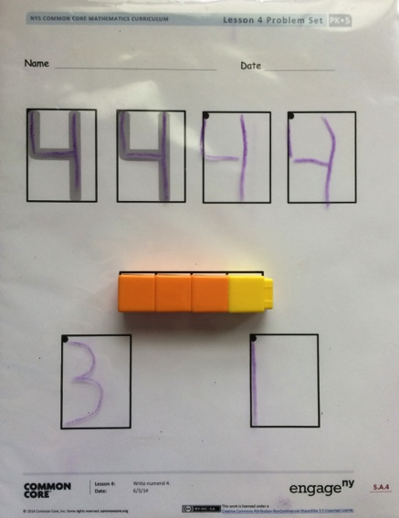
Distribute Problem Sets and crayons to each student.
- Demonstrate tracing with a crayon. Invite students to pick up a crayon and trace the 4 while saying the rhyme. Continue until all rectangles are filled.
- Distribute linking cubes to each student. Direct students to make a 4-train of 3 orange and 1 yellow and place it on their Problem Set as shown on the right.
- Guide students to count the orange cubes and write the number in the first rectangle. Then, count the yellow cubes and write the number in the second rectangle.
- Provide children time to discover other ways to make 4-trains and write the number of cubes of each color.

Student Debrief (3 minutes)
Lesson Objective: Write numeral 4.

CENTER CONNECTION:
Set up the kitchen center as a café so students can continue role-playing customer and waiter. Place several personal white boards with the template inserted into them, as well as dry erase crayons to encourage several orders of different numbers of items.

The Student Debrief is intended to invite reflection and active processing of the total lesson experience. It is also an opportunity for informal assessment. Consider taking anecdotal notes or using a simple checklist to note each child’s progress toward meeting the lesson objective.
As students complete the Practice portion of the Concept Development, listen for misconceptions or misunderstandings that can be addressed in the Debrief.
You may choose to use any combination of the questions below to help students express ideas, make connections, and use new vocabulary.
- Look at the trains we’ve been drawing over the last few days. What do you notice about the colors? The numbers?
- (Show numbers 0–4.) Which numbers have only straight lines? Which numbers have only curved lines? Which number has both straight and curved lines? (Put numbers into categories based on these attributes.)
- (Display student work showing 4 in different ways, i.e., 4 + 0, 1 + 3, 2 + 2, 3 + 1, and 0 + 4.) What is the same about all of these? What is different?
- Today, you found partners of 4. Say some of the partners of 4. (Consider having children use fingers on both hands to show partners of 4.)

Name Date
4
4

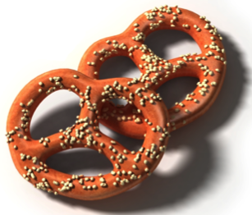
Menu
Strawberries
Pretzels
Juice

Customer Order
Strawberries
Juice
Pretzels

menu items

