Lesson 3
Objective: Write numeral 3.

Suggested Lesson Structure
 Fluency Practice (5 minutes)
 Application Problem (3 minutes)
 Concept Development (14 minutes)
 Student Debrief (3 minutes)
Total Time (25 minutes)
Fluency Practice (5 minutes)
- Numbers in Rice PK.CC.2 (3 minutes)
- Elephant Splashes PK.CC.1 (2 minutes)
Numbers in Rice (3 minutes)
Materials: (T) Numeral cards 0–2 (Lesson 1 Template) (S) Tray of sand or rice (or sealed plastic baggie with paint)
Note: In this activity, students practice forming recently learned numerals kinesthetically, strengthening their motor memory.
T: (Point to your nose.) How many noses do you have?
S: 1.
T: (Show numeral card 1.) Say the chant with me while you trace the number in your rice!
S: (While tracing.) Top to bottom, then I’m done. I just wrote the number 1.
Repeat for eyes (“Half a moon, there’s more to do; slide to the right, I wrote a 2.”) and tails (“Curve from the top, be a hero! Close the loop and make a 0.”).
If time permits, continue with other body parts for numbers 0–2.
Elephant Splashes (2 minutes)
Note: This activity targets one of the core fluencies for Pre-K students—rote counting to 20.
T: Silly Eli elephant is at it again! Let’s pretend we’re Eli. Let’s swing our trunks to splash our friends as we count to 18 the Say Ten Way.
Demonstrate swinging an arm back and forth, mimicking an elephant’s trunk. Count to 18 the Say Ten Way, keeping the movement synchronous with the count.
Application Problem (3 minutes)
Materials: (T) Numeral cards 0–5 (Lesson 1 Template), 5 interesting rocks (S) Baggies with 5 pebbles
Show students numeral card 5 and ask, “What number is this?” (Five.) Show 5 interesting rocks in a line and say, “Wait for the signal; how many rocks do you count?” After students respond chorally, “5 rocks,” have them put 5 pebbles in a line in front of them. Then, have students remove 1 rock. Say, “Wait for the signal. Five. 1 less is?” After students respond chorally, “4 rocks,” show the 4 card and repeat the process as time permits.
Note: In this problem, students practice counting and reading written numbers. The problem also supports the forthcoming transition from comparison (less) to subtraction in Topic C.
Concept Development (14 minutes)
Part 1: Concept Introduction
Materials: (T) 5 linking cube tower (3 of a color, 2 of another color), chart paper or personal white board, markers
Prepare chart paper or a white board with rectangles and dots as shown on the right.
- Show the train. Ask children to count how many cubes are in the train. Have them count the number of yellow and orange cubes.
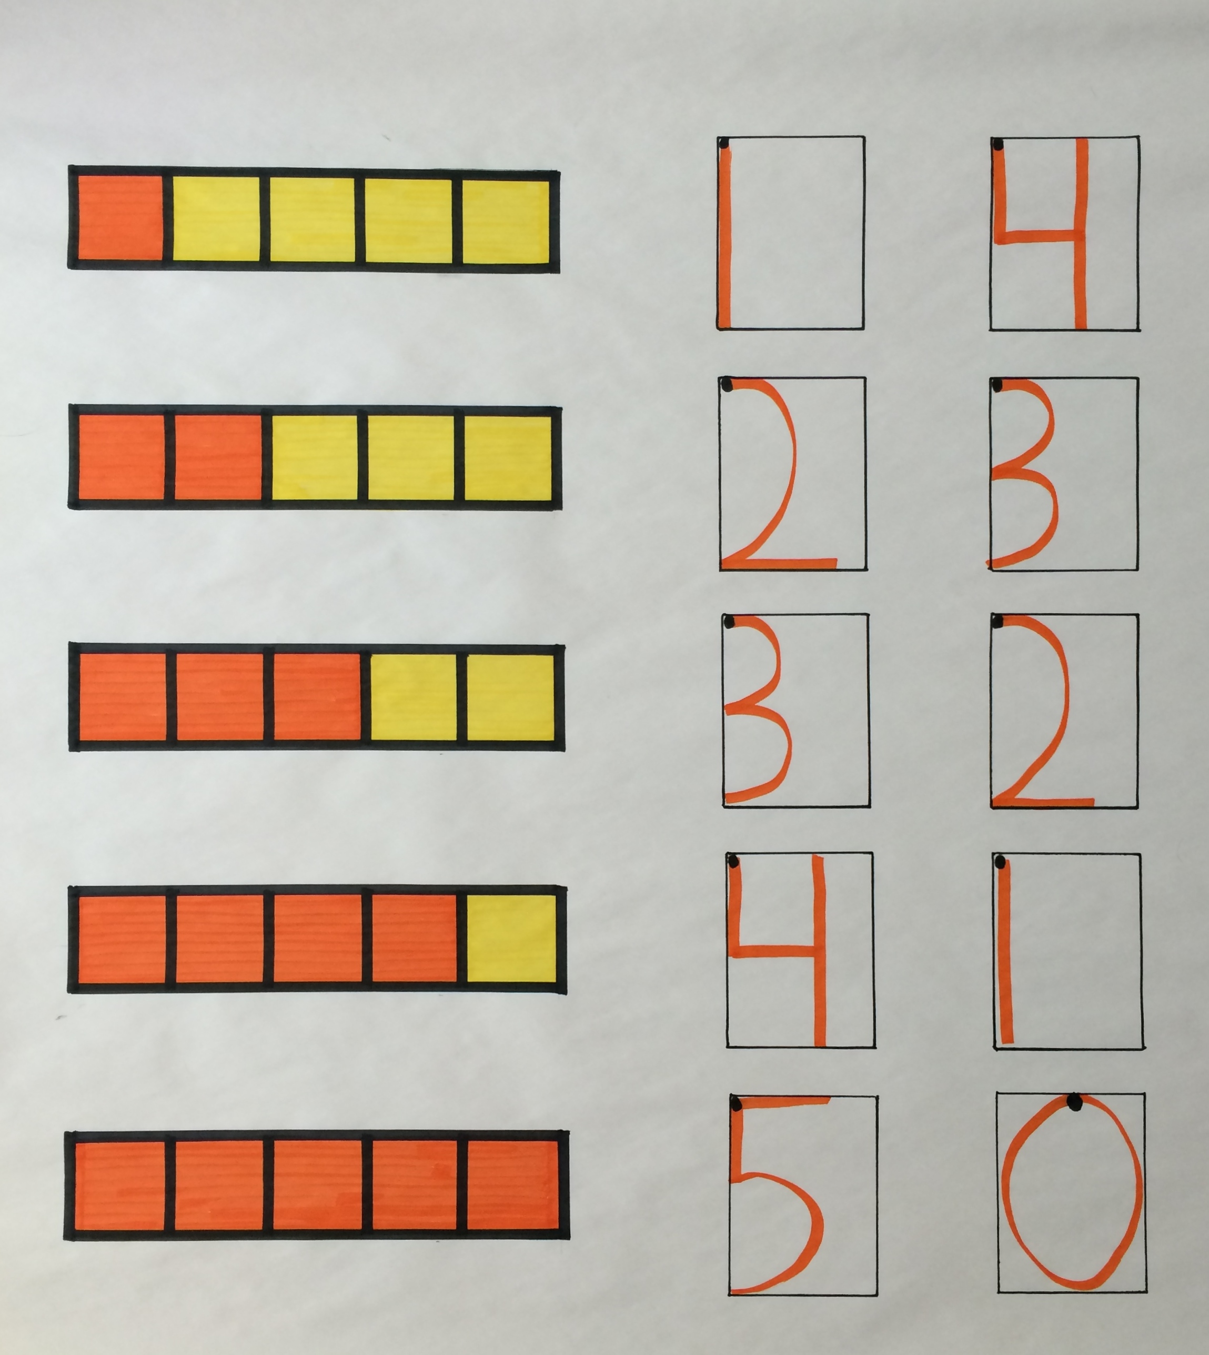
- Say, “I can write the number 3. It’s much easier and quicker than drawing a picture to show what I mean. Use your finger to write 3 in the air while I write it on the board.”
- Say the rhyme for 3 while writing 3 in the first writing rectangle, “Backwards C, backwards C, that is how I write a 3.” Point out that you started from the dot at the top.
- Practice two more times with students air tracing the numeral and saying the rhyme.
- Draw the train on the board and have children check to ensure it matches the concrete train. Ask children to count the orange squares. Write 3 in the first rectangle while children air trace and say the rhyme.

NOTES ON
MULTIPLE MEANS
OF ACTION AND EXPRESSION:
Students struggling with directionality would benefit from additional practice tracing before writing independently. Use a yellow highlighter to write 3s in the blank writing rectangles on their Problem Sets, and have the students trace the numbers.
- Ask them to count the yellow squares. Write 2 in the second rectangle while children air trace and say the rhyme, “Half a moon, there’s more to do; slide to the right, I wrote a 2.”
- Help children see that they can fill in a writing rectangle for another train. Write in 3 for the number train drawn in Lesson 2.
Part 2: Practice
Materials: (S) Problem Set inserted into personal white board, dry erase crayon, 5 linking cubes (3 of a color, 2 of another color)
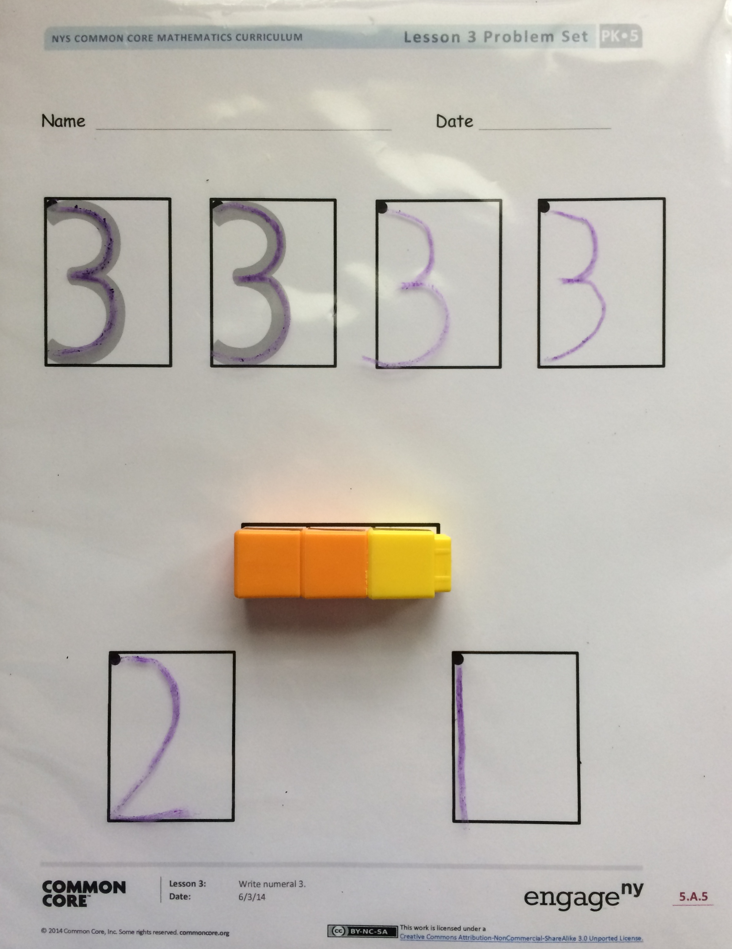
Distribute a Problem Set and crayon to each student.
- Demonstrate tracing the 3 with a crayon. Invite children to pick up a crayon and trace the 3 while saying the rhyme. Continue until all rectangles are filled.
- Distribute linking cubes to each student. Direct students to make a 3-train of 2 orange and 1 yellow, as well as place it on their Problem Set as shown on the right. Support students so that cubes of the same color are touching.
- Guide students to count the orange cubes and write the number in the first rectangle. Then, count the yellow cubes and write the number in the second rectangle.
MP.4
- Provide students time to discover other ways to show 3 using their linking cubes and write the number of cubes of each color.
Student Debrief (3 minutes)
Lesson Objective: Write numeral 3.
The Student Debrief is intended to invite reflection and active processing of the total lesson experience. It is also an opportunity for informal assessment. Consider taking anecdotal notes or using a simple checklist to note each child’s progress toward meeting the lesson objective.
As students complete the Practice portion of the Concept Development, listen for misconceptions or misunderstandings that can be addressed in the Debrief.

CENTER CONNECTION:
Invite students to search the classroom for items in sets of 3. Encourage them to make a list of their findings. They should write the numeral 3 and then draw a picture or use inventive spelling to show the type of object. Provide an example of a list entry before sending children on their search. To make the activity more challenging, invite students to search for items in groups of 2 or 3.
You may choose to use any combination of the questions below to help students express ideas, make connections, and use new vocabulary.
- What do you like about writing the number 3?
- (Display student work showing 3 in different ways, i.e., 3 + 0, 1 + 2, 2 + 1, and 0 + 3.) What is the same about all of these? What is different?
- Today you found partners of 3. Say some of the partners of 3.
- Look around our classroom. Where do you see a number 3? What is that 3 telling us?

Name Date
3
3

