Lesson 2
Objective: Write numeral 2.

Suggested Lesson Structure
 Fluency Practice (6 minutes)
 Application Problem (3 minutes)
 Concept Development (13 minutes)
 Student Debrief (3 minutes)
Total Time (25 minutes)
Fluency Practice (6 minutes)
- Hide and Seek: Friends and Chairs PK.CC.5 (4 minutes)
- Elephant Splashes PK.CC.1 (2 minutes)
Hide and Seek: Friends and Chairs (4 minutes)
Note: This activity provides practice with seeing embedded numbers—in this case, within 4. The empty chair(s) clearly show the missing part and decompositions of 4.
Set up 4 chairs in the front of the classroom, and invite 4 students to take a seat.
T: Let’s count the friends. Ready?
S: 1, 2, 3, 4.
T: Close your eyes. (Tell one of the students seated on a chair to hide in a designated location in the room.)
S: (Eyes closed.)
T: Open your eyes. How many friends do you see now?
S: 3.
T: How many are hiding?
S: 1.
T/S: Come out, come out, wherever you are! (The student comes out from hiding, and returns to his or her seat.)
T: Let’s count to see how many now.
S: 1, 2, 3, 4. Just like before!
Repeat with different numbers of students hiding.
Elephant Splashes (2 minutes)
Note: Varying movements helps keep counting exercises fresh as students strengthen their core fluency counting skills.
T: Eli elephant loves to swing his trunk to splash his friends! Pretend you’re Eli. Swing your trunk and count to 20 with me.
Demonstrate swinging an arm back and forth, mimicking an elephant’s trunk. Count to 20, keeping the movement synchronous with the count. If time permits, count again, but tell students to stop at 19.
Application Problem (3 minutes)
Materials: (T) Numeral cards 1–5 (Lesson 1 Template), 5 leaves
Show students numeral card 1 and ask, “What number is this?” (One.) Show 1 leaf.
T: How many leaves do you see? Raise your hand when you are ready to tell me. (Wait until all hands are raised, and then signal.)
S: 1 leaf.
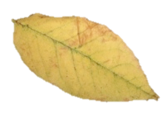
T: (Put another leaf in line.) How many leaves did I add?
S: 1 leaf.
T: How many leaves do you see in all? Raise your hand when you are ready to tell me. (Wait, and then signal.)
S: 2 leaves!
T: (Pointing) 1 and 1 more is…?
S: 2.
Repeat the process to 5 as time permits.
Note: Providing wait time rather than touching and counting allows students to use their own strategy to count the objects. Note that, in the vignette, students reply using the units, e.g., “5 leaves,” rather than simply saying “5.”
Concept Development (12 minutes)
Part 1: Concept Introduction
Materials: (T) 5-linking cube tower (2 of a color, 3 of another color), chart paper or personal white board
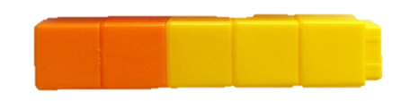
Prepare chart paper or a personal white board with writing rectangles and dots as shown below. Continue to draw the train on the same chart used in Lesson 1.

- Show the 5-train. Ask children to count how many cubes are in the whole train. (5.) Have them count the number of yellow and orange cubes.
- Say, “I can write the number 2 to help me remember that there are 2 orange cubes. Use your finger to write 2 in the air while I write it on the board.”
- Say the rhyme for 2 while writing 2 in the first writing rectangle, “Half a moon, there’s more to do; slide to the right, I wrote a 2.” Emphasize starting from the dot at the top.
- Practice at least twice with students air tracing the numeral and saying the rhyme.
- Draw the train on the board and have children check to ensure it matches the concrete train. Ask children to count the orange squares. Write 2 in the first writing rectangle while children air trace and say the rhyme. Leave the second writing rectangle empty until Lesson 3.
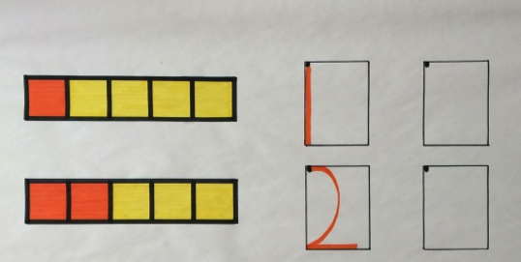

Part 2: Practice
Materials: (S) Problem Set, crayon
Distribute the Problem Set and crayon to each student. A Problem Set can be inserted into students’ personal white boards for additional practice.
- Direct children’s attention to the animals at the top of the Problem Set and have them count how many cows are on the farm.

NOTES ON
MULTIPLE MEANS
OF REPRESENTATION:
Students who are struggling to form numbers correctly would benefit from a multi-sensory approach, for example, building each number with clay, or tracing each number in a sand tray or in shaving cream as they repeat the number rhyme.
- Demonstrate how to trace the 2 while saying the rhyme. Have students do the same. Repeat a few times. Ensure that students start at the top dot.
- Demonstrate tracing and writing with a crayon. Invite children to pick up a crayon to trace and write the 2 while saying the rhyme. Continue until all rectangles are filled.
- Direct children’s attention to the animals again. Guide them to answer the how many questions at the bottom of the page.

Student Debrief (3 minutes)

CENTER CONNECTION:
Set up the sensory center with sand inside shallow rectangular trays (children’s shoe box tops work well). Help children write numerals 0, 1, and 2 in the sand. The rectangular tray mimics the rectangle used when writing and helps prevent reversals. After they have written the numerals in sand, invite students to write the numerals using paper and crayon.
Lesson Objective: Write numeral 2.
The Student Debrief is intended to invite reflection and active processing of the total lesson experience. It is also an opportunity for informal assessment. Consider taking anecdotal notes or using a simple checklist to note each child’s progress toward meeting the lesson objective.
As students complete the Practice portion of the Concept Development, listen for misconceptions or misunderstandings that can be addressed in the Debrief.
You may choose to use any combination of the questions below to help students express ideas, make connections, and explore new concepts.
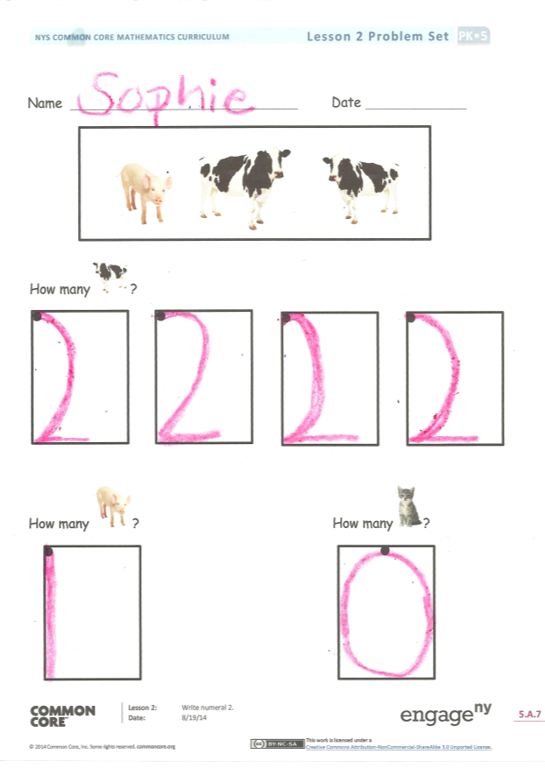
- Do you see a 2 written anywhere in our classroom?
- (Demonstrate writing 1 and 2 while students air trace.) What is different about writing 1 and 2?
- (Show numerals 0 and 2.) Which numbers have straight lines? Which numbers have curved lines?
- (Show a tower of 5 cubes with 3 of one color and 2 of another color.) Let’s play show and tell. Use this tower to tell about the number 5.

Name Date

220
2
How many ?

How many ? How many ?

