Lesson 1
Objective: Write numerals 0 and 1.

Suggested Lesson Structure
 Fluency Practice (5 minutes)
 Application Problem (3 minutes)
 Concept Development (14 minutes)
 Student Debrief (3 minutes)
Total Time (25 minutes)
Fluency Practice (5 minutes)
- Peek-a-Boo Counting PK.CC.3b (3 minutes)
- Alligator Snaps PK.CC.1 (2 minutes)
Peek-a-Boo Counting (3 minutes)
Materials: (T) 2 sets of 3 objects (e.g., 3 bananas and 3 bears), 2 manila file folders with ends stapled together to form a screen.
Note: This fluency activity builds upon students’ recent work with decompositions of 3 and strengthens their memory as they answer how many questions to 3. The use of wait time encourages students to subitize rather than having them touch and count.
T: (Before beginning the activity, place 2 bananas and 1 bear on a desk or table behind the screen.) Peek-a-Boo! (Raise and lower the screen.) Peek-a-Boo! (Again.)
T: Wait for the signal. How many things did you see in all? (Signal when ready.)
S: 3.
T: Wait for the signal. How many bananas? (Signal when ready.)
S: 2 bananas.
T: Wait for the signal. How many bears? (Signal when ready.)
S: 1 bear.
T: Very good. Let’s play again!
Continue with other decompositions of 3. As students progress, determine if they can remember the number for longer periods of time. Encourage them to show the number on their fingers the Math Way instead of saying it.

Alligator Snaps (2 minutes)
Note: Say Ten counting facilitates the core fluency goal of rote counting to 20 while laying a foundation that helps students understand place value in later years.
T: It’s lunchtime in the swamp, and Allie Alligator is ready to eat. Pretend you’re Allie catching fish for lunch. Let’s count the snaps the Say Ten Way.
Demonstrate arms open wide, one above the other, mimicking alligator jaws. Close arms and hands together to make a snapping sound while saying each number to 20 the Say Ten Way.
Application Problem (3 minutes)
Materials: (T) Numeral cards 0–5 (Template), 5 carrot sticks (or pretend carrots-orange strips of paper)
Show students the numeral 0 card and ask, “What number is this?” (Zero.) Show students your empty hands. Ask, “How many carrot sticks am I holding?” (Zero.) Say, “1 more than 0 is?” (One.)
Show students the numeral 1 card and ask, “What number is this?” (One.) Show 1 carrot stick and ask, “How many carrot sticks is this?” (One.) Add another carrot stick and say, “1 more than 1 is?” (Two.) Have students repeat the process, identifying the numeral 2, counting 2 carrot sticks, and then identifying 1 more. Continue through 5.
Note: In this problem, students practice counting and recognizing written numbers in anticipation of writing numbers in today’s Concept Development. The problem also supports the forthcoming transition from comparison (more) to addition in Topic B.
Concept Development (14 minutes)
Part 1: Concept Introduction
Materials: (T) 5-linking cube train (composed of 1 cube of 1 color and 4 cubes of another color), chart paper or white board
Prepare 2 charts:
- One with writing rectangles and dots (as shown to the right)
- One that can be used through Lesson 5 to record each day’s 5-train.
- Show the 5-train. Ask children to count how many cubes are in the train. (Five.) Have them count the number of yellow and orange cubes.
- Draw the train on the board and have children ensure it matches the concrete train. Say, “I can draw a picture of the train to help me remember there is 1 orange cube.”
- Say, “I can also write the number 1 to show 1 orange cube. Use your finger to write 1 in the air while I write it on the board.”

- Say the rhyme for 1 while writing 1 in the first writing rectangle, “Top to bottom, then I’m done. I just wrote the number 1.” Highlight that you started from the dot at the top. (Leave the second writing rectangle empty until Lesson 4.)
- Practice two more times using the separate writing rectangles as students air trace the numeral and say the rhyme.
- Show the 5-train again. Ask, “How many blue cubes are in the train?” Remind them that the math word for none is zero.
- Repeat Steps 2–4 to demonstrate writing 0. Say the rhyme for 0 while writing, “Curve from the top, be a hero! Close the loop and make a 0.”
Part 2: Practice
Materials: (S) Problem Set, crayon
Distribute the Problem Set and crayon to each student at a table. The Problem Set can be inserted into students’ personal white boards for additional practice.
- Direct children’s attention to the mud puddle at the top of the Problem Set and have them say how many pigs are in the mud.
MP.4

NOTES ON
MULTIPLE MEANS
OF REPRESENTATION:
Students who are struggling with number formation would benefit from tracing numbers made from a variety of textures (e.g., puffy paint, sandpaper, string, and chalk) as they repeat the rhyme. This will help develop students’ motor memory for each number formation.
- Demonstrate how to finger trace the 1, starting from the top. Say the rhyme while tracing. Then, have students trace and say the rhyme. Repeat a few times and check to ensure they start on the dot at the top.
- Demonstrate tracing with a crayon. Invite children to pick up a crayon and trace the 1 while saying the rhyme. Continue until all rectangles are filled.
- Direct children’s attention to the mud puddle again. Have them count how many cats are in the mud.
- Repeat Steps 2–3 to practice writing 0.
Student Debrief (3 minutes)

CENTER CONNECTION:
Set up the sensory center with dough and shallow rectangular trays (children’s shoe box tops work well). Help children make numerals 0 and 1 using the dough. The rectangular tray mimics the writing rectangle and helps prevent reversals. After they have built the numerals using dough, invite students to write the numerals using paper and crayon.
Lesson Objective: Write numerals 0 and 1.
The Student Debrief is intended to invite reflection and active processing of the total lesson experience. It is also an opportunity for informal assessment. Consider taking anecdotal notes or using a simple checklist to note each child’s progress toward meeting the lesson objective.
As students complete the Practice portion of the Concept Development, listen for misconceptions or misunderstandings that can be addressed in the Debrief.
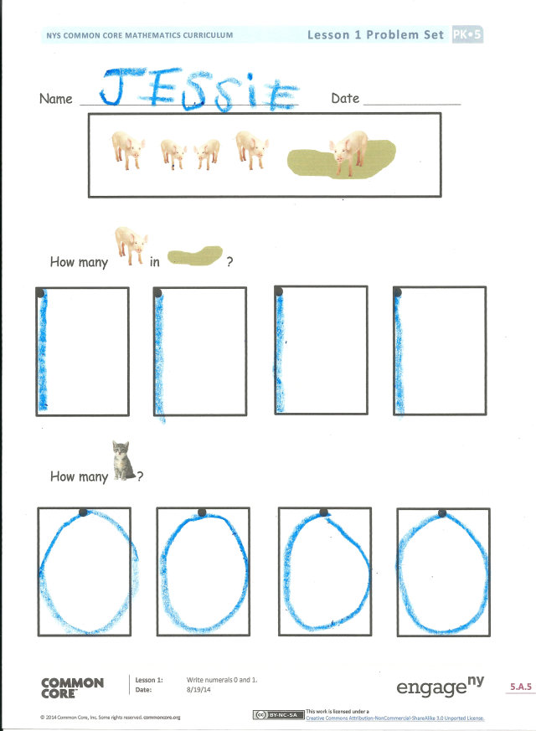
You may choose to use any combination of the questions below to help students express ideas, make connections, and use new vocabulary.
- Where do you see numbers written in our classroom?
- Which one was faster? Drawing the cubes to show 1 orange cube? Or, writing the number 1?
- Why is it important to be able to write numbers?
- Watch me carefully while I write 1 and 0. (Write both numbers starting from the bottom.) What mistake did I make?

Name Date

0
0
How many ?

1
1
How many in ?

1
2
3
4
5
6
7
8
9
0
10
_________________
numeral cards (Print and fold lengthwise so the outline on the numeral side matches the outline on the dot side. While the paper is folded, cut out individual cards. Do not cut along the fold! Laminate with cards folded so that numeral and dots match.)

