Topic A
Writing Numerals 0 to 5
PK.CC.2
Focus Standards: | PK.CC.2 | Represent a number of objects with a written numeral 0–5 (with 0 representing a count of no objects).
Instructional Days: | 5
Coherence -Links to: | GK–M1 | Numbers to 10
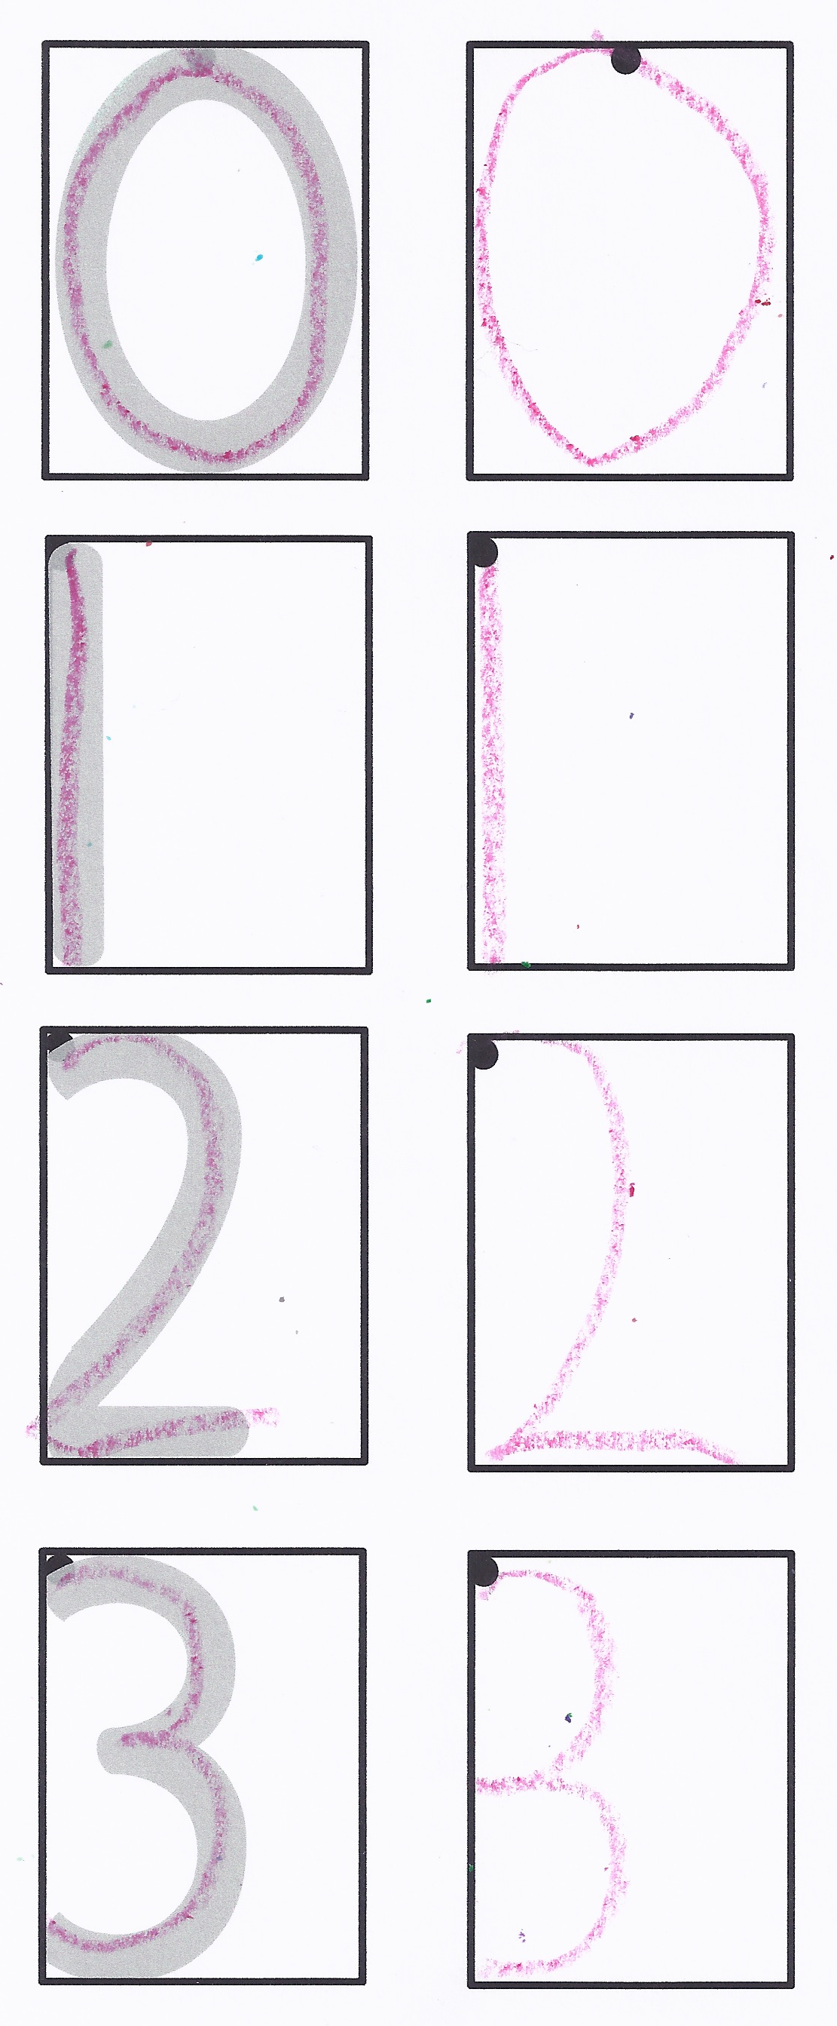
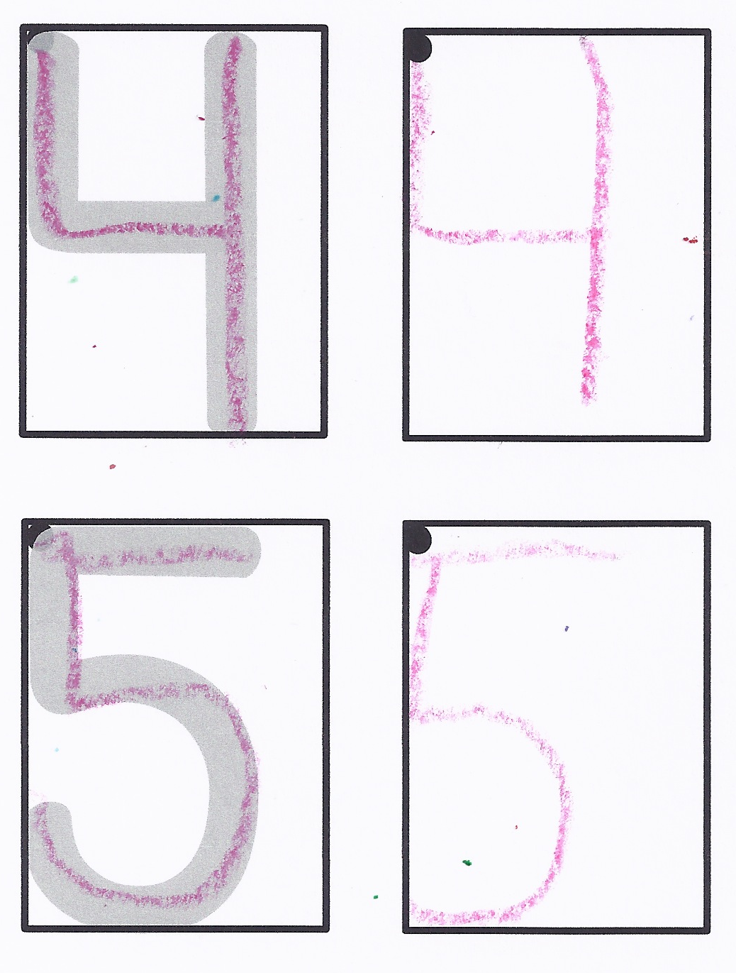
Children have been working with the numerals 1–5 since Module 1, as well as the number 0 since Module 3. Throughout the year, they have had many opportunities to match a number of objects with a prewritten numeral and develop their fine motor skills. In Topic A, children build on this experience and begin to write numerals 0–5 (PK.CC.2).
Lesson 1 begins with writing 0 and 1. The number 1 is particularly easy to write; it is a simple stroke from top to bottom. Often, certain numerals will already be familiar because of their similarities to letters. For example, 0 looks like the letter O. During this first lesson, students focus on starting all of their numbers from the top because that has a significant impact on their ability to write efficiently in later grades.
One numeral is introduced in each of the subsequent lessons in the topic (Lesson 2 focuses on 2, and so on). Numeral formation is taught using simple rhymes. Children may use tactile materials, such as clay, dough, sand, or rice, to remember the strokes for each numeral. They develop this learning by writing using personal white boards and crayons or pencils on paper. Students first trace the numeral and then practice writing it independently using a writing rectangle and a marked starting point to help prevent reversals. In each lesson, children have the opportunity to count the number of cubes in a linking cube train and write the matching numeral.
In Topic A Fluency Practices, students strengthen their core fluency counting skills to 20, both the Say Ten Way and the regular way, through energizing movements, such as ski jumps, elephant splashes, and alligator snaps. They practice decompositions of 3 and 4, and they increase their motor memory by forming numbers kinesthetically in rice.

A Teaching Sequence Toward Mastery of Writing Numerals 0 to 5
Objective 1: Write numerals 0 and 1.
(Lesson 1)
Objective 2: Write numeral 2.
(Lesson 2)
Objective 3: Write numeral 3.
(Lesson 3)
Objective 4: Write numeral 4.
(Lesson 4)
Objective 5: Write numeral 5.
(Lesson 5)

