|  |
| --- |
|  |

Lesson 13: How Do 3D Printers Work?

Student Outcomes

* Visualize cross-sections of three-dimensional objects.
* Have an understanding of how a 3D printer works and its relation to Cavalieri’s principle.

Lesson Notes

Students consider what it means to build a three-dimensional figure out of cross-sections and discuss the criteria to build a good approximation of a figure. After some practice of drawing cross-sections, students watch a 3D printer in action, and make a tie between how a 3D printer works and Cavalieri’s principle.

Classwork

Opening Exercise (5 minutes)

Opening Exercise

1. Observe the following right circular cone. The base of the cone lies in plane , and planes , , and are all parallel to . Plane contains the vertex of the cone.

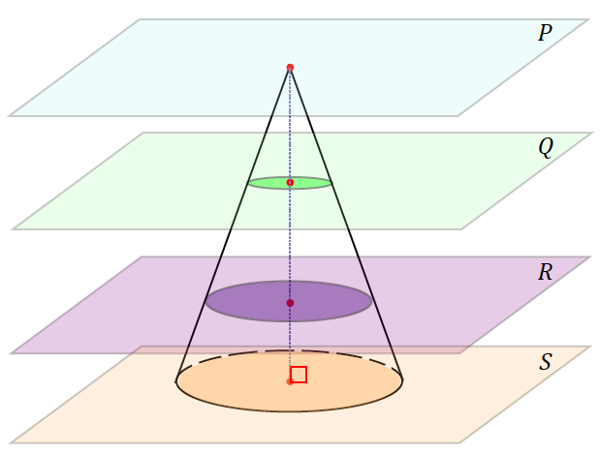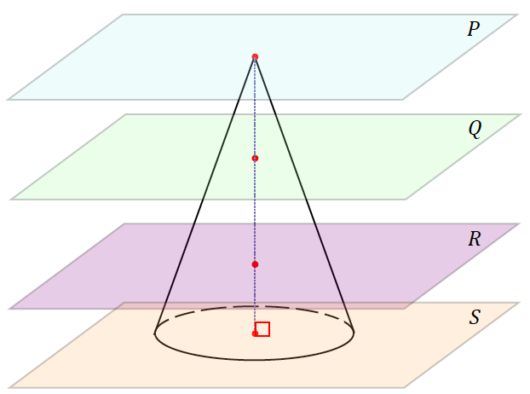

*Scaffolding:*

* Nets for circular cones are available in Grade 8, Module 7, Lesson 19.
* Consider marking a cone at levels that model the intersections with planes and as a visual aid to students.

Tell students that the sketches should be relative to each other; no exact dimensions can be determined from the figure. The goal is to get students thinking about solids as a set of cross-sections.

|  |  |
| --- | --- |
| Sketch the cross-section of the cone by plane . | Sketch the cross-section of the cone by plane . |
|  |  |
| Sketch the cross-section of the cone by plane . | Sketch the cross-section of the cone by plane . |
|  |  |

1. What happens to the cross-sections as we look at them starting with and work toward ?

The intersection of plane with the cone is a point, and each successive cross-section is a disk of greater radius than the previous disk.

**Discussion (10 minutes)**

Lead students through a discussion that elicits how to build a right circular cone (such as the one in the Opening Exercise) with common materials, such as foam board, styrofoam, cardboard, and card stock and what must be true about the material to get a good approximation of the cone.

Begin by showing students a sheet of Styrofoam; for example, a piece with dimensions . The idea is to begin with a material that is not as thin as say, card stock, but rather a material that has some thickness to it.

* Suppose I have several pieces of this material. How can I use the idea of slices to build the cone from the Opening Exercise? What steps would I need to take?

Allow students a moment to discuss with a partner before sharing out responses.

* + *You can cut several slices of the cone.*
  + *The disk cross-sections would have to be cut and stacked and aligned over the center of each disk.   
    Each successive disk after the base disk must have a slightly smaller radius.*
* Say the cone we are trying to approximate has a radius of inches and a height of inches. Assume we have as many pieces of quarter-inch thick styrofoam as we want. How many cross-sections would there be, and how would you size each cross-section?

Allow students time to discuss and make the necessary calculations. Have them justify their responses by showing the calculations or the exact measurements.

* + *If each piece of styrofoam is a quarter-inch thick, we will need a total of pieces of styrofoam.*
  + *The base should have a radius of inches, and each successive slice above the base should have a radius that is a quarter-inch less than the former slice.*

|  |  |  |  |  |  |  |  |  |  |  |  |  |
| --- | --- | --- | --- | --- | --- | --- | --- | --- | --- | --- | --- | --- |
| Slice | (base) |  |  |  |  |  |  |  |  |  |  |  |
| Radius |  |  |  |  |  |  |  |  |  |  |  |  |

Now hold up a sheet of the styrofoam and a thinner material, such as card stock, side by side.

*Scaffolding:*

* Consider having a model of this example built to share with students after completing the exercise.
* If the same cone is built with both of these materials, which will result as a better approximation of the cone? Why?
  + *The use of card stock will result in a better approximation of the cone, since the thickness of the card stock would require more cross-sections, and sizing each successive cross-section would be more finely sized than the quarter-inch jumps in radius of the styrofoam.*
* To create a good approximation of a three-dimensional object, we must have ideal materials, ones that are very thin, and many cross-sections, in order to come as close as possible to the volume of the object.

Exercise 1 (5 minutes)

Exercise 1

1. Sketch five evenly spaced, horizontal cross-sections made with the following figure.

**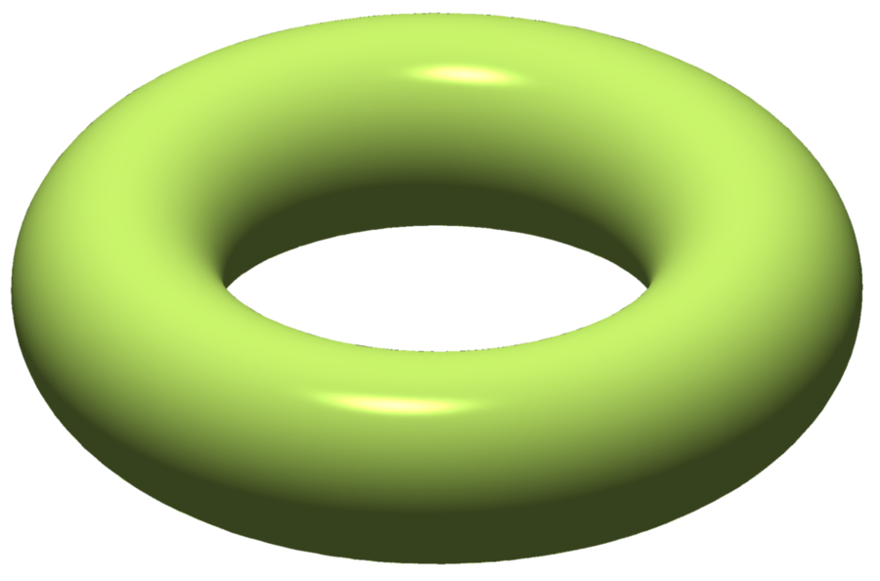

<http://commons.wikimedia.org/wiki/File%3ATorus_illustration.png>; By Oleg Alexandrov (self-made, with MATLAB) [Public domain], via Wikimedia Commons. *Attribution not legally required.*

Example 1 (7 minutes)

Before showing students a video clip of a 3D printer printing a coffee cup, have students sketch cross-sections of a coffee cup. Consider providing students with model coffee cups to make their sketches from. Otherwise students can use the photo below.

Example 1

Let us now try drawing cross-sections of an everyday object, such as a coffee cup.

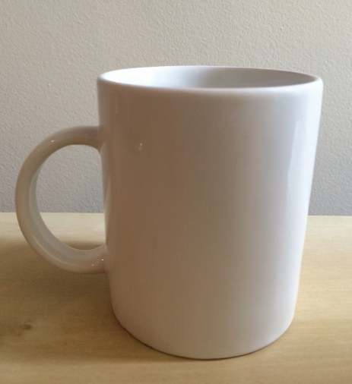 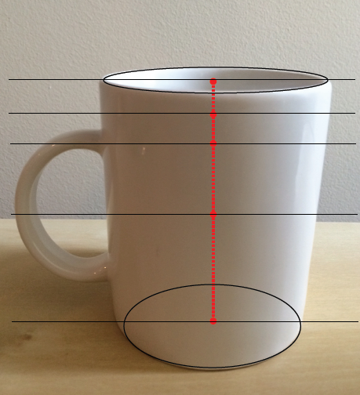

2

3

5

4

1

Sketch the cross-sections at each of the indicated heights.

|  |  |  |  |
| --- | --- | --- | --- |
| 1 | 2 | | 3 |
|  |  | |  |
| 4 | | 5 | |
|  | |  | |

Review each of the five sketches. Have students explain why the cross-sections look the way they do. For example, students should be able to describe why sketch 4 has a gap between the body of the mug and the handle.

**Discussion (11 minutes)**

We provide four video links for this lesson, one we embed in this discussion to follow the previous example on the cross-section of the coffee cup. You may want to briefly discuss what a 3D printer is first, or show the video first and then discuss what a 3D printer is based on what students see in the video (this is the treatment taken in the Discussion below).

The coffee cup video clip is just over minutes long and shows the print process of a full-sized coffee cup from start to finish. During preparation of this lesson, you will probably want to watch the video and decide which sections of it to show students. For example, after showing roughly a minute of it, you may want to skip to and pause to highlight the beginning of the handle of the cup.

**Video (3D Printer, Coffee Cup):** <https://www.youtube.com/watch?v=29yHrWrs1ok>

* What you just saw is a 3D printer at work, printing a coffee cup. How would you describe a 3D printer?
  + *Answers will vary. Students may describe in their own words how a 3D printer looks like it builds a three-dimensional object a little at a time, perhaps one layer at a time.*
* Consider what a regular printer does. It takes data from an application like Microsoft Word, and the file has the instructions on how the printer should deliver ink to paper.
* A 3D printer effectively does the same thing. Electronic data from an application such as CAD (computer-aided design) is used to design a 3D model. When the data is sent to the printer, software will create fine slices of the model, and the printer will release “ink” in the form of a plastic or a metal (or some combination of several mediums) one slice at a time, until the entire model is complete.
* The technology is relatively recent, beginning in the s, but it is showing signs of revolutionizing how we think about design. You will hear 3D printing referred to as *additive manufacturing* in the next clip.

Now show the entirety of the next clip (roughly three and a half minutes), which provides a history and the scope of possibilities with 3D printing.

**Video (3D Printer, General):** <http://computer.howstuffworks.com/3-d-printing.htm>

* Why is 3D printing also called additive manufacturing?
  + *Objects are created by adding only what is needed.*
* What is one benefit to producing an object in this way?
  + *There is no excess waste, since you are not carving, cutting, or melting out an object out of the original material.*
* What are some of the mentioned uses of 3D printing?
  + *It has medical uses, such as printing human tissue components to create a kidney. It has aerospace uses, NASA is using it make repairs on equipment. It is also used in jewelry and food industries.*
* Explain how the process of 3D printing invokes Cavalieri’s principle.
  + *By knowing the cross-section of a solid, we can approximate the volume of the solid.*

The programming in the software that dictates how 3D printers print is rooted in algebra. We can see an example of this in the platform that moves left, right, and down to add each successive layer of the coffee cup. This movement is programmed in a coordinate system.

Exercises 2–4

With any time remaining, have students complete a selection of the following exercises.

Exercises 2–4

1. A cone with a radius of and height of is to be printed from a 3D printer. The medium that the printer will use to print (i.e., the “ink” of this 3D printer) is a type of plastic that comes in coils of tubing which has a radius of . What length of tubing is needed to complete the printing of this cone?

The volume of medium used (contained in a circular cylinder) must be equal to the volume of the cone being printed.

*The cone will require*  *of tubing*.

1. A cylindrical dessert in diameter is to be created using a type of 3D printer specially designed for gourmet kitchens. The printer will “pipe” or, in other words, “print out” the delicious filling of the dessert as a solid cylinder. Each dessert requires of filling. Approximately how many layers does each dessert have if each layer is thick?

*The total height of the dessert is approximately* *. Since each layer is* (*or* ) *thick*,

Each dessert has about layers.

1. The image shown to the right is of a fine tube that is printed from a 3D printer that prints replacement parts. If each layer is thick, and the printer prints at a rate of roughly layer in seconds, how many minutes will it take to print the tube?

Note: Figure not drawn to scale.

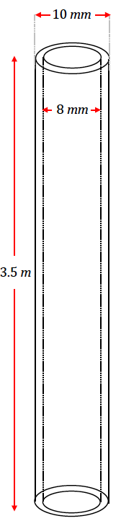

*The printer prints at a rate of layers per second. The total height of the tube is , or . If each layer is , or thick, then the tube has a total of layers.*

The time to print the tube is seconds, or minutes.

Closing (2 minutes)

Consider watching a clip of either of the remaining videos:

* Video (3D Printer, Wedding Rings): https://www.youtube.com/watch?v=SIuDbRUUG1w
* Video (3D Printer, Food): https://www.youtube.com/watch?v=XQni3wb0tyM

Exit Ticket (5 minutes)

Name Date

Lesson 13: How Do 3D Printers Work?

Exit Ticket

Lamar is using a 3D printer to construct a circular cone that has a base with radius .

* 1. 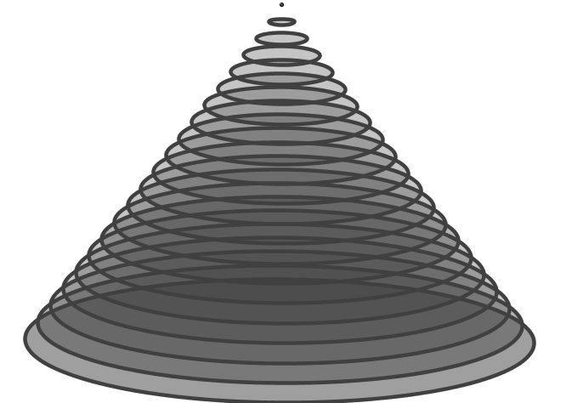If his 3D printer prints in layers that are thick (similar to what is shown in the image below), what should be the change in radius for each layer in order to construct a cone with height ?
  2. What is the area of the base of the th layer?
  3. Approximately how much printing material is required to produce the cone?

Exit Ticket Sample Solutions

Lamar is using a 3D printer to construct a circular cone that has a base with radius .

* 1. If his 3D printer prints in layers that are thick (similar to what is shown in the image below), what should be the change in radius for each layer in order to construct a cone with height ?

The change in radius between consecutive layers is inch.

* 1. What is the area of the base of the th layer?

*The th layer of the cone will have a radius reduced by inch times.*

*The radius of the th layer is .*

*The area of the base of the disk in the th layer is approximately* .

**

* 1. Approximately how much printing material is required to produce the cone?

The volume of printing material is approximately equal to the volume of a true cone with the same dimensions.

**Approximately  *of printing material is required.***

Problem Set Sample Solutions

1. Horizontal slices of a solid are shown at various levels arranged from highest to lowest. What could the solid be?

Answers will vary. The solid could be a ball with a hole in it.

1. Explain the difference in a 3D printing of the ring pictured in Figure 1 and Figure 2 if the ring is oriented in each of the following ways.



**Figure 1**

**Figure 2**

For the first ring, the cross-sections are circles or regions between concentric circles. For the second ring, the cross-sections are stretched cirles and then two separted regions.

1. Each bangle printed by a 3D printer has a mass of exactly of metal. If the density of the metal is , what length of a wire in radius is needed to produce each bangle? Find your answer to the tenths place.

*Radius of filament:*

*The wire must be a length of* .

1. A certain 3D printer uses of plastic filament that is in diameter to make a cup. If the filament has a density of , find the mass of the cup to the tenths place.

*Length of filament:*

*Radius of filament:*

*Mass of cup:*

*The mass of the cup is approximately* .

1. When producing a circular cone or a hemisphere with a 3D printer, the radius of each layer of printed material must change in order to form the correct figure. Describe how radius must change in consecutive layers of each figure.

The slanted side of a circular cone can be modeled with a sloped line in two dimensions, so the change in radius of consecutive layers must be constant; i.e., the radius of each consecutive layer of a circular cone decreases by a constant .

The hemisphere does not have the same profile as the cone. In two dimensions, the profile of the hemisphere cannot be modeled by a line but, rather, an arc of a circle, or a semicircle. This means that the change in radius between consecutive layers of print material is not constant. In fact, if printing from the base of the hemisphere, the change in radius must start out very close to , then increase as the printer approaches the top of the hemisphere, which is a point that we can think of as a circle of radius .

1. Suppose you want to make a 3D printing of a cone. What difference does it make if the vertex is at the top or at the bottom? Assume that the 3D printer places each new layer on top of the previous layer.

If the vertex is at the top, new layers will always be supported by old layers. If the vertex is at the bottom, new layers will hang over previous layers.

1. Filament for 3D printing is sold in spools that contain something shaped like a wire of diameter . John wants to make 3D printings of a cone with radius and height . The length of the filament is meters. About how many cones can John make?

*The volume of the cone is*.

*The volume of the filament is* .

*Since* *,* *John can make cones as long as each 3D-printed cone has volume no more than* .

1. John has been printing solid cones but would like to be able to produce more cones per each length of filament than you calculated in Problem 7. Without changing the outside dimensions of his cones, what is one way that he could make a length of filament last longer? Sketch a diagram of your idea and determine how much filament John would save per piece. Then determine how many cones John could produce from a single length of filament based on your design.

***Students’ answers will vary. One possible solution would be to print only the outer shell of the cone, leaving a hollow center in the shape of a scaled-down cone. Something that students may consider in their solution is the thickness of the wall of the shell and the integrity of the final product. This will provide a variety of answers.***

1. A 3D printer uses one spool of filament to produce congruent solids. Suppose you want to produce similar solids that are longer in each dimension. How many such figures could one spool of filament produce?

Each new solid would have volume times the volume of an original solid. Let be the number of new figures produced. Then and .

It should be possible to print of the larger solids.

1. A fabrication company 3D-prints parts shaped like a pyramid with base as shown in the following figure. Each pyramid has a height of . The printer uses a wire with a density of , at a cost of .

It costs to set up for a production run, no matter how many parts they make. If they can only charge per part, how many do they need to make in a production run to turn a profit?

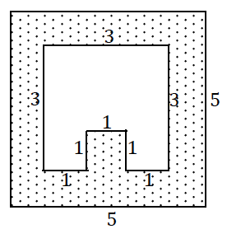Volume of a single part:

*;* ***the volume of each part is*** *.*

Mass of a single part:

***The mass of a single part is* .**

Cost of a single part:

The cost of a single part is .

The sum of the production run cost and the cost to make the total number of parts must be less than the product of the price and the total number of parts. Let be the total number of parts:

Therefore, in order to turn a profit, parts must be made in a production run.