Lesson 13: How Do 3D Printers Work?

Classwork

Opening Exercise

* 1. Observe the following right circular cone. The base of the cone lies in plane , and planes , , and are all parallel to . Plane contains the vertex of the cone.

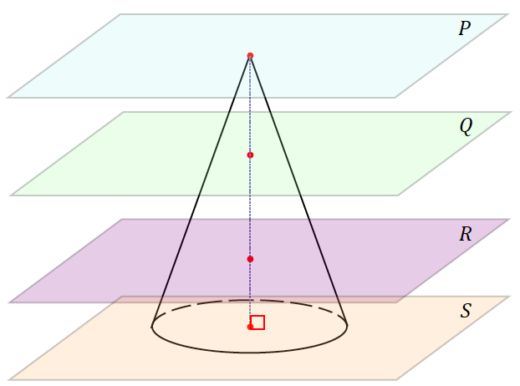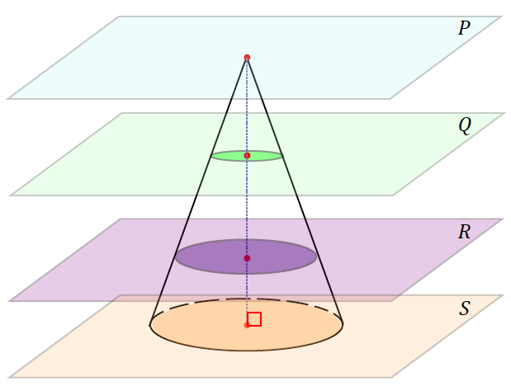

|  |  |
| --- | --- |
| Sketch the cross-section of the cone by plane . | Sketch the cross-section of the cone by plane . |
|  |  |
| Sketch the cross-section of the cone by plane . | Sketch the cross-section of the cone by plane . |
|  |  |

* 1. What happens to the cross-sections as we look at them starting with and work toward ?

Exercise 1

1. Sketch five evenly spaced, horizontal cross-sections made with the following figure.

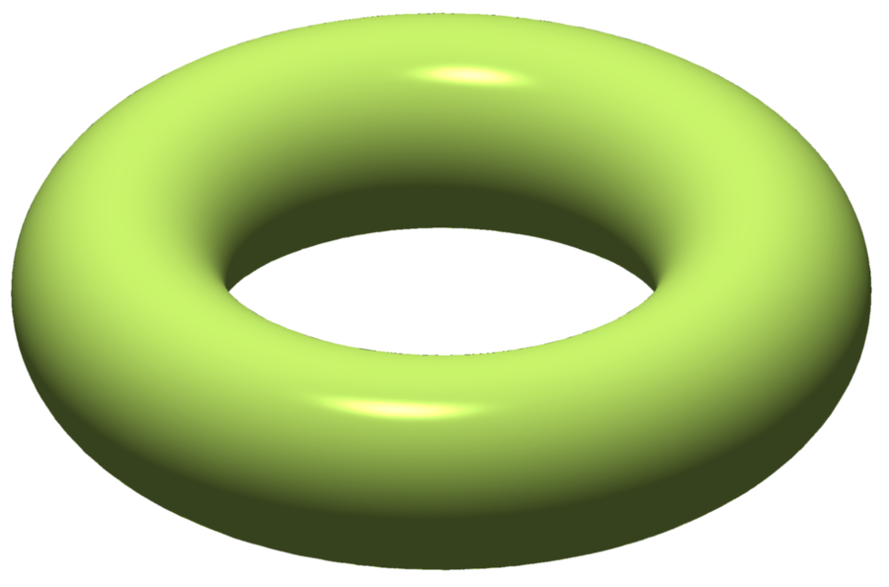

<http://commons.wikimedia.org/wiki/File%3ATorus_illustration.png>; By Oleg Alexandrov (self-made, with MATLAB) [Public domain], via Wikimedia Commons. Attribution not legally required.

|  |  |  |  |  |
| --- | --- | --- | --- | --- |
|  |  |  |  |  |

Example

Let us now try drawing cross-sections of an everyday object, such as a coffee cup.

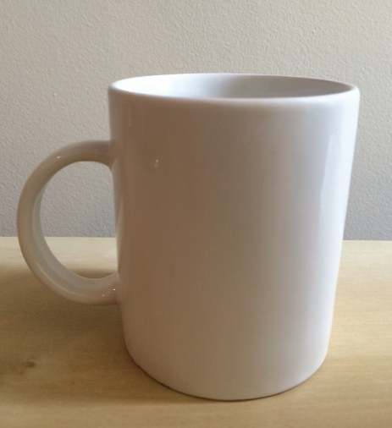 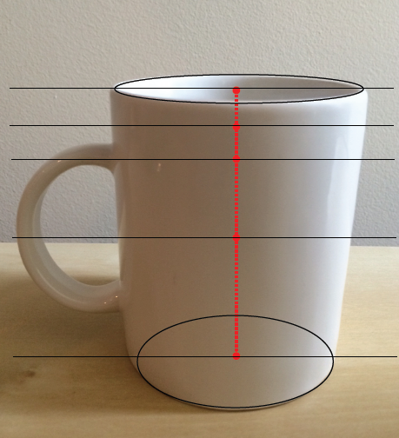

3

5

4

2

1

Sketch the cross-sections at each of the indicated heights.

|  |  |  |  |
| --- | --- | --- | --- |
| 1 | 2 | | 3 |
|  |  | |  |
| 4 | | 5 | |
|  | |  | |

Exercises 2–4

1. A cone with a radius of and height of is to be printed from a 3D printer. The medium that the printer will use to print (i.e., the “ink” of this 3D printer) is a type of plastic that comes in coils of tubing which has a radius of . What length of tubing is needed to complete the printing of this cone?
2. A cylindrical dessert in diameter is to be created using a type of 3D printer specially designed for gourmet kitchens. The printer will “pipe” or, in other words, “print out” the delicious filling of the dessert as a solid cylinder. Each dessert requires of filling. Approximately how many layers does each dessert have if each layer is thick?
3. The image shown to the right is of a fine tube that is printed from a 3D printer that prints replacement parts. If each layer is thick, and the printer prints at a rate of roughly layer in seconds, how many minutes will it take to print the tube?

**Note: Figure not drawn to scale.**

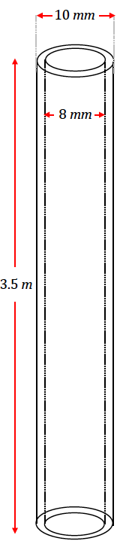

Problem Set

1. Horizontal slices of a solid are shown at various levels arranged from highest to lowest. What could the solid be?



1. Explain the difference in a 3D printing of the ring pictured in Figure 1 and Figure 2 if the ring is oriented in each of the following ways.



Figure 1

Figure 2

1. Each bangle printed by a 3D printer has a mass of exactly of metal. If the density of the metal is , what length of a wire in radius is needed to produce each bangle? Find your answer to the tenths place.
2. A certain 3D printer uses of plastic filament that is in diameter to make a cup. If the filament has a density of , find the mass of the cup to the tenths place.
3. When producing a circular cone or a hemisphere with a 3D printer, the radius of each layer of printed material must change in order to form the correct figure. Describe how radius must change in consecutive layers of each figure.
4. Suppose you want to make a 3D printing of a cone. What difference does it make if the vertex is at the top or at the bottom? Assume that the 3D printer places each new layer on top of the previous layer.
5. Filament for 3D printing is sold in spools that contain something shaped like a wire of diameter . John wants to make 3D printings of a cone with radius and height . The length of the filament is meters. About how many cones can John make?
6. John has been printing solid cones but would like to be able to produce more cones per each length of filament than you calculated in Problem 7. Without changing the outside dimensions of his cones, what is one way that he could make a length of filament last longer? Sketch a diagram of your idea and determine how much filament John would save per piece. Then determine how many cones John could produce from a single length of filament based on your design.
7. A 3D printer uses one spool of filament to produce congruent solids. Suppose you want to produce similar solids that are longer in each dimension. How many such figures could one spool of filament produce?
8. A fabrication company 3D-prints parts shaped like a pyramid with base as shown in the following figure. Each pyramid has a height of . The printer uses a wire with a density of , at a cost of *.*

It costs to set up for a production run, no matter how many parts they make. If they can only charge per part, how many do they need to make in a production run to turn a profit?

