Lesson 12: The Volume Formula of a Sphere

Student Outcomes
- Students give an informal argument using Cavalieri’s principle for the volume formula of a sphere and use the volume formula to derive a formula for the surface area of a sphere.

Lesson Notes
Students will informally derive the volume formula of a sphere in Lesson 12 (G-GMD.A.2). To do so, they examine the relationship between a hemisphere, cone, and cylinder, each with the same radius, and for the cone and cylinder, a height equal to the radius. Students will discover that when the solids are aligned, the sum of the area of the cross-sections at a given height of the hemisphere and cone are equal to the area of the cross-section of the cylinder. They use this discovery and their understanding of Cavalieri’s principle to establish a relationship between the volumes of each, ultimately leading to the volume formula of a sphere.

Classwork
Opening Exercise (5 minutes)
Opening Exercise
Picture a marble and a beach ball. Which one would you describe as a sphere? What differences between the two could possibly impact how we describe what a sphere is?
Answers will vary; some students may feel that both are spheres. Some may distinguish that one is a solid while the other is hollow. Share out responses before moving to the definition of sphere.
Definition | Characteristics
Sphere: Given a point $C$ in the three-dimensional space and a number $r>0$, the sphere with center $C$ and radius $r$ is the set of all points in space that are distance $r$ from the point $C$.  Solid Sphere or Ball: Given a point $C$ in the three-dimensional space and a number $r>0$, the solid sphere (or ball) with center $C$ and radius $r$ is the set of all points in space whose distance from the point $C$ is less than or equal to $r$.  Sphere | Sphere: hollow  Solid Sphere: filled or solid
Examples | Non-Examples
Sphere: beach ball, soap bubble  Solid Sphere: marble, planet | Sphere: an egg-shaped figure  Solid Sphere: a circle
It should be noted that a sphere is just the three-dimensional analog of a circle. You may want to have students compare the definitions of the two terms.
Tell students that the term hemisphere refers to a half-sphere, and solid hemisphere refers to a solid half-sphere.

Discussion (18 minutes)
Note that we will find the volume of a solid sphere by first finding half the volume, the volume of a solid hemisphere, and then doubling. Note that we often speak of the volume of a sphere, even though we really mean the volume of the solid sphere, just as we speak of the area of a circle when we really mean the area of a disk.
- Today, we will show that the sum of the volume of a solid hemisphere of radius $R$ and the volume of a right circular cone of radius $R$ and height $R$ is the same as the volume of a right circular cylinder of radius $R$ and height $R$. How could we use Cavalieri's principle to do this?
  - Allow students a moment to share thoughts. Some students may formulate an idea about the relationship between the marked cross-sections based on the diagram below.
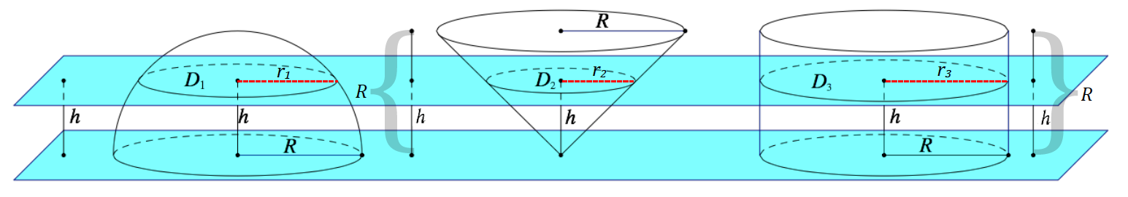
- Consider the following solids shown: a solid hemisphere, $H$; a right circular cone, $T$; and a right circular cylinder, $S$, each with radius $R$ and height $R$ (regarding the cone and cylinder).

Hemisphere $H$
Cylinder $S$
Cone $T$

- The solids are aligned above a base plane that contains the bases of the hemisphere and cylinder and the vertex of the cone; the altitude of the cone is perpendicular to this plane.
- A cross-sectional plane that is distance $h$ from the base plane intersects the three solids. What is the shape of each cross-section? Sketch the cross-sections, and make a conjecture about their relative sizes (e.g., order smallest to largest and explain why).
  - Each cross-section is in the shape of a disk. It looks like the cross-section of the cone will be the smallest, the cross-section of the cylinder will be the biggest, and the cross-section of the hemisphere will be between the sizes of the other two.
- Let $D_{1}, D_{2}, D_{3}$ be the cross-sectional disks for the solid hemisphere, the cone, and the cylinder, respectively.
- Let $r_{1}, r_{2}, r_{3}$ be the radii of $D_{1}, D_{2}, D_{3}$, respectively.
- Our first task in order to accomplish our objective is to find the area of each cross-sectional disk. Since the radii are all of different lengths, we want to try and find the area of each disk in terms of $R$ and $h$, which are common between the solids.

- Examine the hemisphere more closely in Figure 1.
Scaffolding:
- Students may have difficulty seeing that the hypotenuse of the right triangle with legs $h$ and $r_{1}$ is $R$. Remind students that $h$ and $r_{1}$ meet at $90°$.
- Students may try and form a trapezoid out of the existing segments:
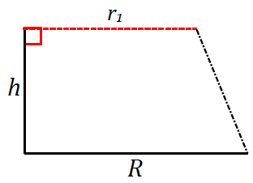
- Nudge students to reexamine Figure 1 and observe that the distance from the center of the base disk to where $r_{1}$ meets the hemisphere is simply the radius of the hemisphere.

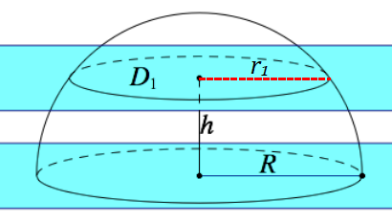

Figure 1

- What is the area formula for disk $D_{1}$ in terms of $r_{1}$?
  - $Area(D_{1})=π{r_{1}}^{2}$
- How can we find $r_{1}$ in terms of $h$ and $R$?
Allow students time to piece together that the diagram they need to focus on looks like the following figure. Take student responses before confirming with the solution.
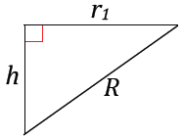
  - By the Pythagorean theorem:
$$r_{1}^{2}+h^{2}=R^{2} \\ r_{1}=\sqrt{R^{2}-h^{2}}$$
- Once we have $r_{1}$, substitute it into the area formula for disk $D_{1}$.
  - The area of $D_{1}$:
$$Area\left(D_{1}\right)=πr_{1}^{2}$$
$$Area\left(D_{1}\right)=π{\left(\sqrt{R^{2}-h^{2}}\right)}^{2}$$
$$Area\left(D_{1}\right)=πR^{2}-{πh}^{2}$$
- Let us pause and summarize what we know so far. Describe what we have shown so far.
  - We have shown that the area of the cross-sectional disk of the hemisphere is$πR^{2}-{πh}^{2}$.
Record this result in the classroom.
- Continuing on with our goal of finding the area of each disk, now find the radius $r_{2}$ and the area of $D_{2}$ in terms of $R$ and $h$. Examine the cone more closely in Figure 2.

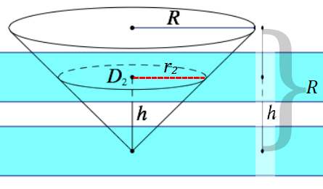
Figure 2

If students require a prompt, remind them that both the radius and the height of the cone are each length $R$.
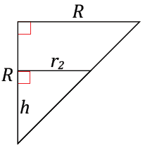
Scaffolding:
- Consider showing students the following image as a prompt before continuing with the solution:
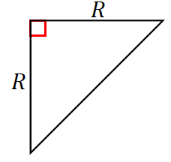
  - By using similar triangles:
$$\frac{r_{2}}{h}=\frac{R}{R}=1\text{, or }r_{2}=h$$
  - The area of $D_{2}$:
$$Area\left(D_{2}\right)=πr_{2}^{2}=πh^{2}$$
- Let us pause again and summarize what we know about the area of the cross-section of the cone. Describe what we have shown.
  - We have shown that the area of the cross-sectional disk of the hemisphere is$πR^{2}-{πh}^{2}$.
Record the response next to the last summary.
- Lastly, we need to find the area of disk $D_{3}$ in terms of $R$ and $h$. Examine the cone more closely in Figure 3.
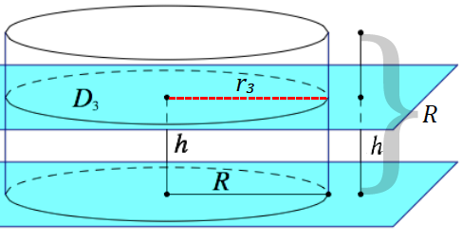

Figure 3

- In the case of this cylinder, will $h$ play a part in the area formula of disk $D_{3}$? Why?
  - The radius $r_{3}$ is equal to $R$, so the area formula will not require $h$ this time.
  - The area of $D_{3}$:
$$Area(D_{3})=πR^{2}$$
Write all three areas on the board as you ask:
- What do you now know about the three areas of the cross-sections?
  - $Area\left(D_{1}\right)=πR^{2}-{πh}^{2}$
$$Area\left(D_{2}\right)=πh^{2}$$
$$Area(D_{3})=πR^{2}$$
- Do you notice a relationship between the areas of $D_{1}, D_{2}, D_{3}$? What is it?
MP.7
  - The area of $D_{3}$ is the sum of the areas of $D_{1}$ and $D_{2}$.
$$Area\left(D_{1}\right)+Area\left(D_{2}\right)=Area\left(D_{3}\right) \\ \left(πR^{2}-{πh}^{2}\right)+{πh}^{2}=πR^{2}$$
- Then let us review two key facts: (1) The three solids all have the same height; (2) At any given height, the sum of the areas of the cross-sections of the hemisphere and cone are equal to the cross-section of the cylinder.
Allow students to wrestle and share out ideas:
MP.1
- How does this relate to our original objective of showing that the sum of the volume of a solid hemisphere $H$ and the volume of cone $T$ is equal to the volume of cylinder $S$?
- What does Cavalieri’s principle tell us about solids with equal heights and with cross-sections with equal areas at any given height?
  - Solids that fit that criteria must have equal volumes.
- By Cavalieri’s principle, we can conclude that the sum of the volumes of the hemisphere and cone are equal to the volume of the cylinder.
- Every plane parallel to the base plane intersects $H∪S$ and $T$ in cross-sections of equal area. Cavalieri’s principle states that if every plane parallel to the two planes intersects both solids in cross-sections of equal area, then the volumes of the two solids are equal. Therefore, the volumes of $H∪S$ and $T$ are equal.

Example (8 minutes)
Students now calculate the volume of a sphere with radius $R$ using the relationship they discovered between a hemisphere, cone, and cylinder of radius $R$ and height $R$.
Example
Use your knowledge about the volumes of cones and cylinders to find a volume for a solid hemisphere of radius $R$.

- We have determined that the volume of $H∪S$ is equal to the volume of $T$. What is the volume of $S$?
  - $Vol(S)=\frac{1}{3}×area of base×height$
$Vol(S)=\frac{1}{3}πR^{3}$
- What is the volume of $T$?
  - $Vol(T)=area of base×height$
$$Vol(T)=πR^{3}$$

- Set up an equation and solve for $Vol(H)$.
  - $Vol(H)+\frac{1}{3}πR^{3}=πR^{3}$
$Vol(H)=\frac{2}{3}πR^{3}$
- What does $\frac{2}{3}πR^{3}$ represent?
  - The $Vol(H)$, or the volume of a hemisphere with radius $R$
- Then what is the volume formula for a whole sphere?
  - Twice the volume of a solid hemisphere or $\frac{4}{3}πR^{3}$
- The volume formula for a sphere is $V=\frac{4}{3}πR^{3}$.

Exercises (8 minutes)
Have students complete any two of the exercises.
Exercises
- Find the volume of a sphere with a diameter of $12 cm$ to one decimal place.
$$V=\frac{4}{3}π{(6)}^{3}$$
$$V=\frac{4}{3}π(216)$$
$$V≈904.8$$
The volume of the sphere is approximately $904.8 {cm}^{3}$.

- An ice cream cone is $11 cm$ deep and $5 cm$ across the opening of the cone. Two hemisphere-shaped scoops of ice cream, which also have diameters of $5 cm$, are placed on top of the cone. If the ice cream were to melt into the cone, will it overflow?
$$Volume\left(cone\right)=\frac{1}{3}π{\left(\frac{5}{2}\right)}^{2}⋅(11)$$ | $$Volume\left(ice cream\right)=\frac{4}{3}π{\left(\frac{5}{2}\right)}^{3}$$
$$Volume\left(cone\right)≈72$$ | $$Volume\left(ice cream\right)≈65.4$$
The volume the cone can hold is roughly ${72 cm}^{3}$. | The volume of ice cream is roughly ${65.4 cm}^{3}$.
The melted ice cream will not overflow because there is significantly less ice cream than there is space in the cone.

- Bouncy, rubber balls are composed of a hollow, rubber shell $0.4"$ thick and an outside diameter of $1.2"$. The price of the rubber needed to produce this toy is $\$0.035/{in}^{3}$.
  - What is the cost of producing $1$ case, which holds $50$ such balls? Round to the nearest cent.
The outer shell of the ball is $0.4"$ thick, so the hollow center has a diameter of $0.8"$ and, therefore, a radius of $0.4"$.
The volume of rubber in a ball is equal to the difference of the volumes of the entire sphere and the hollow center.
$$V=\left[\frac{4}{3}π{\left(0.6\right)}^{3}\right]-\left[\frac{4}{3}π{\left(0.4\right)}^{3}\right] \\ V=\frac{4}{3}π\left[{\left(0.6\right)}^{3}-{\left(0.4\right)}^{3}\right] \\ V=\frac{4}{3}π\left[0.152\right] \\ V≈0.6367$$
The volume of rubber needed for each individual ball is approximately $0.6367 in^{3}$. For a case of $50$ rubber balls, the volume of rubber required is $\frac{4}{3}π\left[0.152\right]⋅50≈31.8$, or $31.8 in^{3}$.
Total cost equals the cost per cubic inch times the total volume for the case.
$$Total cost=\left[0.035\right]⋅\left[\frac{4}{3}π\left[0.152\right]⋅50\right] \\ Total cost≈1.11$$
The total cost for rubber to produce a case of $50$ rubber balls is approximately $\$1.11$.

  - If each ball is sold for $\$0.10$, how much profit is earned on each ball sold?
$Total sales=\left(selling price\right)⋅\left(units sold\right)$
$Total sales=(0.1)(50)$
$Total sales=5$
The total sales earned for selling the case of rubber balls is $\$5$.

$Profit earned=\left(total sales\right)-(expense)$
$Profit earned=\left(5\right)-(1.11)$
$Profit earned=3.89$
The total profit earned after selling the case of rubber balls is $\$3.89$.

$Profit per unit=\frac{3.89}{50}$
$Profit per unit=0.0778$
The profit earned on the sale of each ball is approximately $\$0.08$.

Extension: In the Extension, students derive the formula for the surface area of a sphere from the volume formula of the sphere.
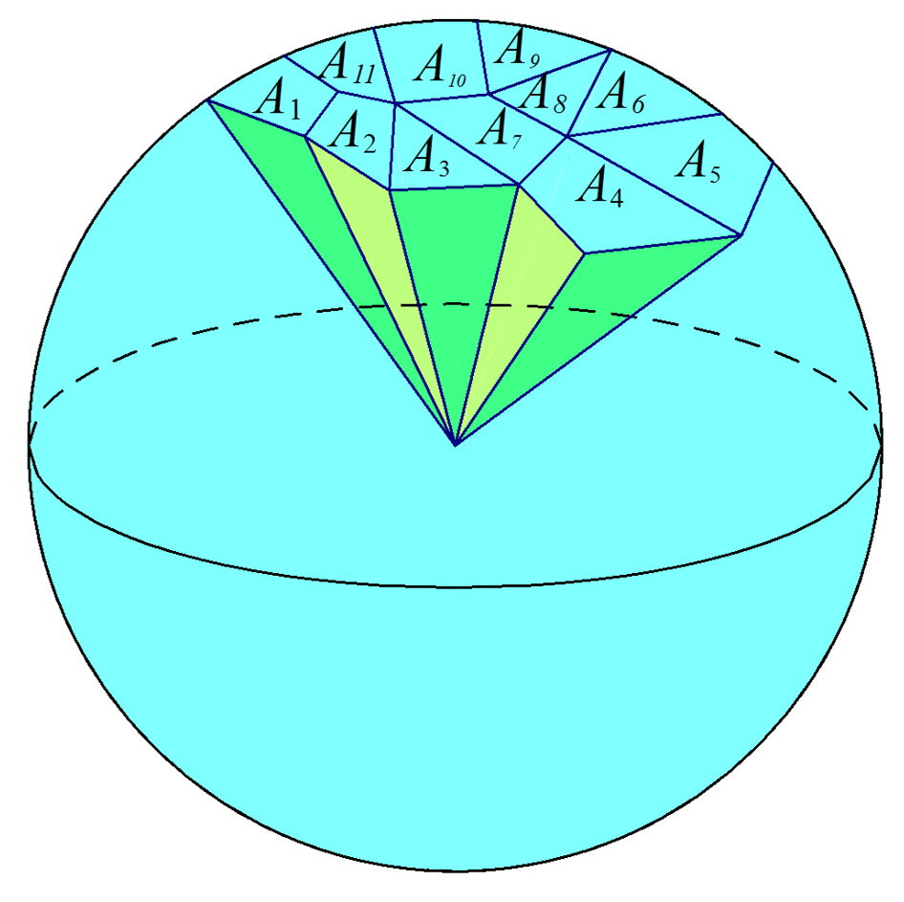
Extension

- The volume formula for a solid sphere can be used to find the surface area of a sphere with radius $R$.
- Cover the sphere with non-overlapping regions with area $A_{1},{ A}_{2},{ A}_{3}, …, { A}_{n}$.
- For each region, draw a “cone” with the region for a base and the center of the sphere for the vertex (see image).
We say “cone” since the base is not flat, as it is a piece of a sphere. However, it is an approximation of a cone.
- The volume of the cone with base area $A_{1}$ and height equal to the radius $R$ is approximately
$$Volume\left(A_{1}\right)≈\frac{1}{3}⋅A_{1}⋅R.$$
- How is the volume of the sphere related to the volume of the cones? Explain and then show what you mean in a formula.
MP.7
  - The volume of the sphere is the sum of the volumes of these “cones.”
$$\frac{4}{3}πR^{3}≈\frac{1}{3}⋅\left(A_{1}+A_{2}+⋯+A_{n}\right)⋅R$$
- Let $S$ be the surface area of the sphere. Then the sum is $A_{1}+A_{2}+⋯+A_{n}=S$. We can rewrite the last approximation as
$$\frac{4}{3}πR^{3}≈\frac{1}{3}⋅S⋅R.$$
Remind students that the right-hand side is only approximately equal to the left-hand side because the bases of these “cones” are slightly curved and $R$ is not the exact height.
- As the regions are made smaller, and we take more of them, the “cones” more closely approximate actual cones. Hence, the volume of the solid sphere would actually approach $\frac{1}{3}⋅S⋅R$ as the number of regions approaches $∞$.
- Under this assumption we will use the equal sign instead of the approximation symbol:
$$\frac{4}{3}πR^{3}=\frac{1}{3}⋅S⋅R.$$
- Solving for $S$, we get
$$S=4{πR}^{2}.$$
- Thus the formula for the surface area of a sphere is
$$Surface Area=4{πR}^{2}.$$

Closing (1 minute)
- What is the relationship between a hemisphere, a cone, and a cylinder, all of which have the same radius, and the height of the cone and cylinder is equal to the radius?
  - The area of the cross-sections taken at height $h$ of the hemisphere and cone is equal to the area of the cross-section of the cylinder taken at the same height. By Cavalieri’s principle, we can conclude that the sum of the volumes of the hemisphere and cone is equal to the volume of the cylinder.
- What is the volume formula of a sphere?
  - $V=\frac{4}{3}πR^{3}$
Lesson Summary
Sphere: Given a point $C$ in the three-dimensional space and a number $r>0$, the sphere with center $C$ and radius $r$ is the set of all points in space that are distance $r$ from the point $C$.
Solid sphere or ball: Given a point $C$ in the three-dimensional space and a number $r>0$, the solid sphere (or ball) with center $C$ and radius $r$ is the set of all points in space whose distance from the point $C$ is less than or equal to $r$.

Exit Ticket (5 minutes)

Name Date
Lesson 12: The Volume Formula of a Sphere

Exit Ticket
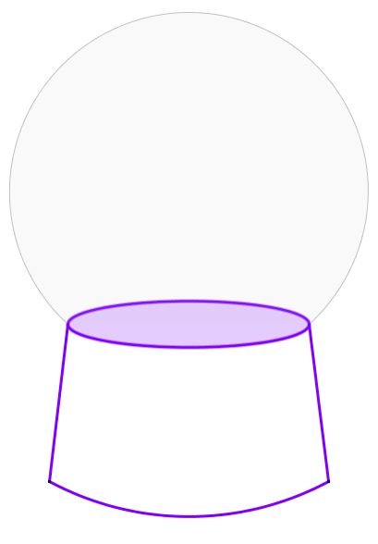
- Snow globes consist of a glass sphere that is filled with liquid and other contents.
If the inside radius of the snow globe is $3 in.$, find the approximate volume of material in cubic inches that can fit inside.

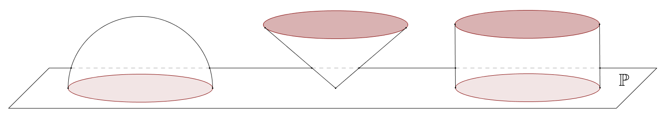
- The diagram shows a hemisphere, a circular cone, and a circular cylinder with heights and radii both equal to $9$.

  - Sketch parallel cross-sections of each solid at height $3$ above plane $P$.

  - The base of the hemisphere, the vertex of the cone, and the base of the cylinder lie in base plane $Ρ$. Sketch parallel cross-sectional disks of the figures at a distance $h$ from the base plane, and then describe how the areas of the cross-sections are related.
Exit Ticket Sample Solutions

- Snow globes consist of a glass sphere that is filled with liquid and other contents.
If the inside radius of the snow globe is $3 in.$, find the approximate volume of material in cubic inches that can fit inside.
$$Volume=\frac{4}{3}πR^{3}$$
$$Volume=\frac{4}{3}π∙3^{3}$$
$$Volume=36π≈113.1$$
The snow globe can contain approximately $113.1 in^{3}$ of material.

- The diagram shows a hemisphere, a circular cone, and a circular cylinder with heights and radii both equal to $9$.
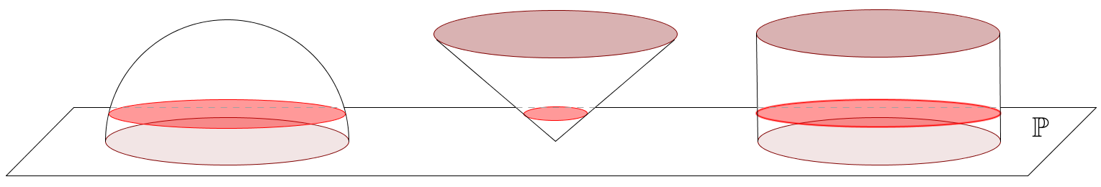

  - Sketch parallel cross-sections of each solid at height $3$ above plane $P$.
See diagram above.

  - The base of the hemisphere, the vertex of the cone, and the base of the cylinder lie in base plane $Ρ$. Sketch parallel cross-sectional disks of the figures at a distance $h$ from the base plane, and then describe how the areas of the cross-sections are related.
The cross-sectional disk is $\frac{1}{3}$ of the distance from plane $P$ to the base of the cone, so its radius is also $\frac{1}{3}$ of the radius of the cone’s base. Therefore, the radius of the disk is $3$, and the disk has area $9π$.
The area of the cross-sectional disk in the cylinder is the same as the area of the cylinder’s base since the disk is congruent to the base. The area of the disk in the cylinder is $81π$.
$Area\left(cylinder disk\right)=Area\left(hemisphere disk\right)+Area(cone disk)$
$81π=Area\left(hemisphere disk\right)+9π$
$72π=Area(hemisphere disk)$
The area of the disk in the hemisphere at height $3$ above plane $P$ is $72π≈226.2$.

Problem Set Sample Solutions

- A solid sphere has volume $36π$. Find the radius of the sphere.
$$\frac{4}{3}πr^{3}=36π \\ r^{3}=27 \\ r=3$$
Therefore, the radius is $3$ units.
- A sphere has surface area $16π$. Find the radius of the sphere.
$$4πr^{2}=16π \\ r^{2}=4 \\ r=2$$
Therefore, the radius is $2$ units.

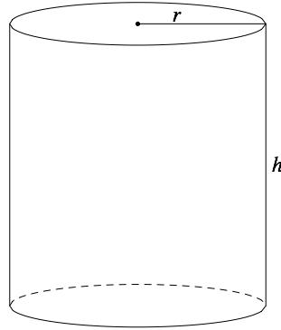
- Consider a right circular cylinder with radius $r$ and height $h$. The area of each base is $πr^{2}$. Think of the lateral surface area as a label on a soup can. If you make a vertical cut along the label and unroll it, the label unrolls to the shape of a rectangle.
  - Find the dimensions of the rectangle.
$2πr$ by $h$

  - What is the lateral (or curved) area of the cylinder?
$$Lateral Area=length×width$$
$$Lateral Area=2πrh$$

- Consider a right circular cone with radius $r$, height $h$, and slant height $l$ (see Figure 1). The area of the base is $πr^{2}$. Open the lateral area of the cone to form part of a disk (see Figure 2). The surface area is a fraction of the area of this disk.
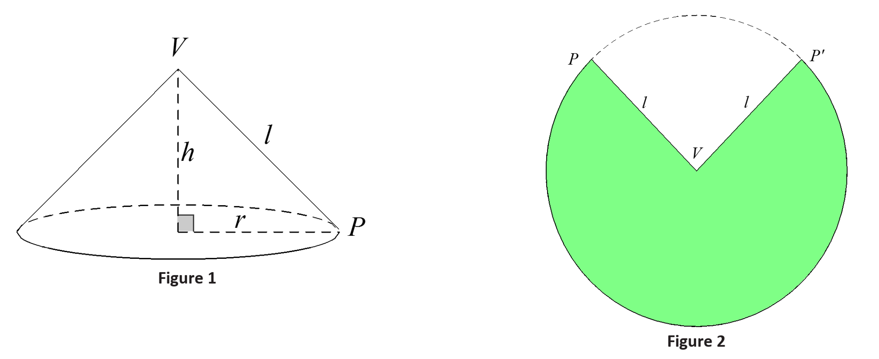
  - What is the area of the entire disk in Figure 2?
$Area=πl^{2}$

  - What is the circumference of the disk in Figure 2?
$$Circumference=2πl$$

The length of the arc on this circumference (i.e., the arc that borders the green region) is the circumference of the base of the cone with radius $r$ or $2πr$. (Remember, the green region forms the curved portion of the cone and closes around the circle of the base.)
  - What is the ratio of the area of the disk that is shaded to the area of the whole disk?
$$\frac{2πr}{2πl}=\frac{r}{l}$$

  - What is the lateral (or curved) area of the cone?
$$\frac{r}{l}×πl^{2}=πrl$$

- A right circular cone has radius $3 cm$ and height $4 cm$. Find the lateral surface area.
By the Pythagorean theorem, the slant height of the cone is $5 cm.$
The lateral surface area in $cm^{2}$ is $πrl=π3⋅5=15π$. The lateral surface area is $15 π cm^{2}$.

- A semicircular disk of radius $3 ft.$ is revolved about its diameter (straight side) one complete revolution. Describe the solid determined by this revolution, and then find the volume of the solid.
The solid is a solid sphere with radius $3 ft$. The volume in $ft^{3}$ is $\frac{4}{3}π3^{3}=36π$. The volume is $36π ft^{3}$.

- A sphere and a circular cylinder have the same radius, $r$, and the height of the cylinder is $2r$.
  - What is the ratio of the volumes of the solids?
The volume of the sphere is $\frac{4}{3}πr^{3}$, and the volume of the cylinder is $2πr^{3}$, so the ratio of the volumes is the following:
$$\frac{\frac{4}{3}πr^{3}}{2πr^{3}}=\frac{4}{6}=\frac{2}{3} .$$
The ratio of the volume of the sphere to the volume of the cylinder is $2:3$.

  - What is the ratio of the surface areas of the solids?
The surface area of the sphere is $4πr^{2}$, and the surface area of the cylinder is $2\left(πr^{2}\right)+(2πr∙2r)=6πr^{2}$, so the ratio of the surface areas is the following:
$$\frac{4πr^{2}}{6πr^{2}}=\frac{4}{6}=\frac{2}{3} .$$
The ratio of the surface area of the sphere to the surface area of the cylinder is $2:3$.

- The base of a circular cone has a diameter of $10 cm$ and an altitude of $10 cm$. The cone is filled with water. A sphere is lowered into the cone until it just fits. Exactly one-half of the sphere remains out of the water. Once the sphere is removed, how much water remains in the cone?
$$V_{cone}=\frac{1}{3}π{\left(5\right)}^{3}\left(10\right)$$
$$V_{hemisphere}=\left(\frac{1}{2}\right)\frac{4}{3}π{\left(5\right)}^{3}$$
$$V_{cone}-V_{hemisphere}=\frac{10}{3}π{\left(5\right)}^{3}-\frac{2}{3}π{\left(5\right)}^{3}$$
$$V_{cone}-V_{hemisphere}=\frac{1}{3}π{\left(5\right)}^{3}\left[10-2\right]$$
$$V_{cone}-V_{hemisphere}=\frac{8}{3}π{\left(5\right)}^{3}$$
The volume of water that remains in the cone is $\frac{8}{3}π{\left(5\right)}^{3}$, or approximately $1,047.2 {cm}^{3}$.

- Teri has an aquarium that is a cube with edge lengths of $24$ inches. The aquarium is$\frac{2}{3}$ full of water. She has a supply of ball bearings each having a diameter of $\frac{3}{4}$ inch.
  - What is the maximum number of ball bearings that Teri can drop into the aquarium without the water overflowing?
$$24 in\text{.}×24 in\text{.}×24 in\text{.}=13824 in^{3}$$
The volume of the cube is $13824 in^{3}$.
$$24 in\text{.}×24 in\text{.}×18 in\text{.}=10368 in^{3}$$
The volume of water in the cube is $10368 in^{3}$.
$$13824 in^{3}-10368 in^{3}=3456 in^{3}$$
The remaining volume in the aquarium is $3456 in^{3}$.
$$V=\frac{4}{3}π{\left(\frac{3}{8}\right)}^{3} \\ V=\frac{4}{3}π\left(\frac{27}{512}\right) \\ V=\frac{9}{128}π$$
The volume of one ball bearing is $\frac{9}{128}π in^{3}≈0.221 in^{3}$.
$$\frac{3456 }{\frac{9}{128}π }=\frac{49152}{π}≈15645.6$$
Teri can drop $15,645$ ball bearings into the aquarium without the water overflowing. If she drops in one more, the water (theoretically without considering a meniscus) will overflow.

  - Would your answer be the same if the aquarium was$\frac{2}{3}$ full of sand? Explain.
In the original problem, the water will fill the gaps between the ball bearings as they are dropped in; however, the sand will not fill the gaps unless the mixture of sand and ball bearings is continuously stirred.

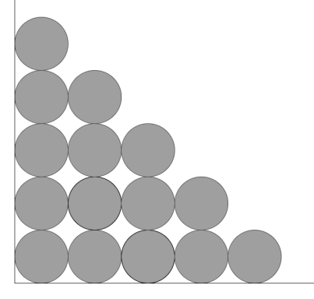
  - If the aquarium is empty, how many ball bearings would fit on the bottom of the aquarium if you arranged them in rows and columns as shown in the picture?
The length and width of the aquarium are $24$ inches, and $24$ inches divided into $\frac{3}{4}$ inch intervals is $32$, so each row and column would contain $32$bearings. The total number of bearings in a single layer would be $1,024$.

  - How many of these layers could be stacked inside the aquarium without going over the top of the aquarium? How many bearings would there be altogether?
The aquarium is $24$ inches high as well, so there could be $32$ layers of bearings for a total of $32,768$ bearings.

  - With the bearings still in the aquarium, how much water can be poured into the aquarium without overflowing?
$$\left(32768\right)\left(\frac{9}{128}π \right)≈7238.229474$$
The total volume of the ball bearings is approximately $7238.229474 in^{3}$.
$$13824-7238.229474=6585.770526$$
The space between the ball bearings has a volume of $6585.770526$ $in^{3}$.
$$6585.770526×0.004329=28.50980061$$
With the bearings in the aquarium, approximately $28.5$ gallons of water could be poured in without overflowing the tank.

  - Approximately how much of the aquarium do the ball bearings occupy?
A little more than half of the space.

- Challenge: A hemispherical bowl has a radius of $2$ meters. The bowl is filled with water to a depth of $1$ meter. What is the volume of water in the bowl? (Hint: Consider a cone with the same base radius and height and the cross-section of that cone that lies $1$ meter from the vertex.)
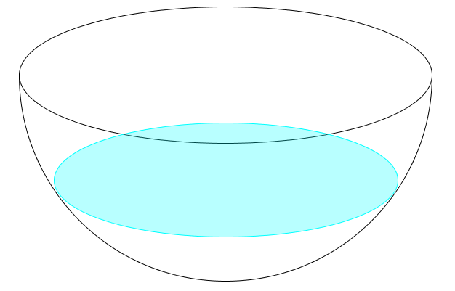
The volume of a hemisphere with radius $2$ is equal to the difference of the volume of a circular cylinder with radius $2$ and height $2$ and the volume of a circular cone with base radius $2$ and height $2$. The cross-sections of the circular cone and the hemisphere taken at the same height $h$ from the vertex of the cone and the circular face of the hemisphere have a sum equal to the base of the cylinder.
Using Cavalieri’s principle, the volume of the water that remains in the bowl can be found by calculating the volume of the circular cylinder with the circular cone removed, and below the cross-section at a height of $1$ (See diagram right).
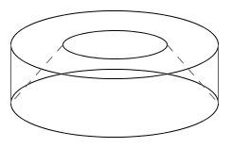
The area of the base of the cone, hemisphere, and cylinder:
$Area=πr^{2}$
$Area=π{\left(2 m\right)}^{2}=4π m^{2}$
The height of the given cross-section is$1 m=\frac{1}{2}\left(2 m\right)$, so the scale factor of the radius of the cross-sectional disk in the cone is $\frac{1}{2}$, and the area is then ${\left(\frac{1}{2}\right)}^{2}×\left(4π m^{2}\right)=π{ m}^{2}$.
The total volume of the cylinder: The total volume of the cone:
$V=Bh$ $V=\frac{1}{3}πr^{3}$
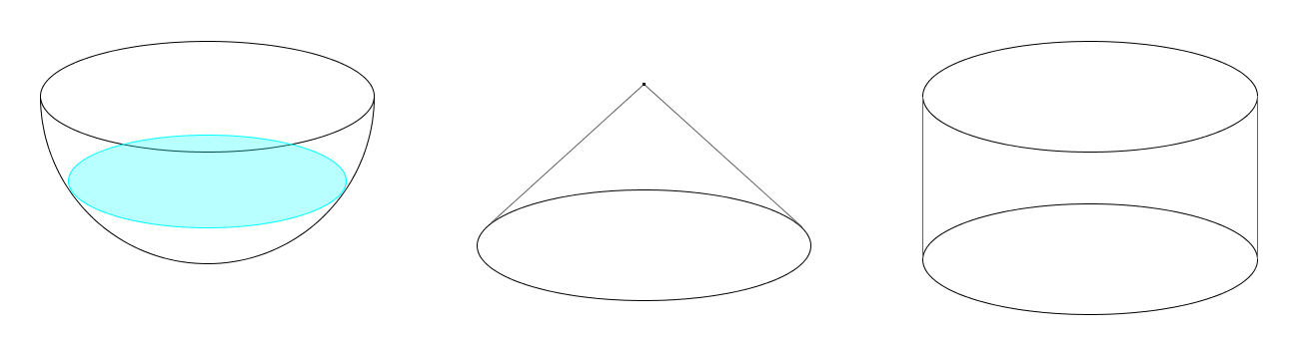
$V=π{\left(2 m\right)}^{2}∙2 m$ $V=\frac{1}{3}π{\left(2 m\right)}^{3}$
$V=8π m^{3}$ $V=\frac{8}{3}π m^{3}$
The volume of the cone above the cross-section:
$$V=\frac{1}{3}π{\left(1 m\right)}^{3}=\frac{π}{3} m^{3}$$
The volume of the cone below the cross-section:
$$V=\frac{8}{3}π m^{3}-\frac{1}{3}π m^{3}=\frac{7}{3}π m^{3}$$
The volume of the cylinder below the cross-section is $4π m^{3}$.
The volume of the cylinder below the cross-section with the section of cone removed:
$$V=4π m^{3}-\frac{7}{3}π m^{3}=\frac{5}{3}π m^{3}$$
The volume of water left in the bowl is $\left(\frac{5}{3}π\right)m^{3}$, or approximately $5.2 m^{3}$.

- Challenge: A certain device must be created to house a scientific instrument. The housing must be a spherical shell, with an outside diameter of $1 m$. It will be made of a material whose density is $14 g/{cm}^{3}$. It will house a sensor inside that weighs $1.2 kg$. The housing, with the sensor inside, must be neutrally buoyant, meaning that its density must be the same as water. Ignoring any air inside the housing, and assuming that water has a density of $1 g/{cm}^{3}$, how thick should the housing be made so that the device is neutrally buoyant? Round your answer to the nearest tenth of a centimeter.
Volume of outer sphere:  $$\frac{4}{3}π{(50)}^{3}$$ | Volume of inner sphere:  $$\frac{4}{3}π{(r)}^{3}$$ | Volume of shell:  $$\frac{4}{3}π{[{\left(50\right)}^{3}-(r)}^{3}]$$
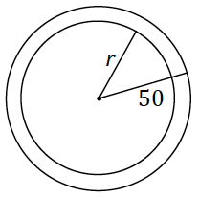
Mass of shell:
$$Mass=(14)\left(\frac{4}{3}π{[{\left(50\right)}^{3}-(r)}^{3}]\right)$$
In order for the device to be neutrally buoyant:
$$density of water=\frac{mass\left(sensor\right)+mass(shell)}{volume of housing} \\ 1=\frac{1200+(14)( \frac{4}{3}π{[{\left(50\right)}^{3}-(r)}^{3}])}{\frac{4}{3}π{(50)}^{3}} \\ r=\sqrt[3]{\frac{900π+(13)({50}^{3})}{14}}$$
The thickness of the shell is $50-\sqrt[3]{\frac{900π+\left(13\right)\left({50}^{3}\right)}{14}}$, which is approximately $1.2 cm$.

- Challenge: An inverted, conical tank has a circular base of radius $2 m$ and a height of $2 m$ and is full of water. Some of the water drains into a hemispherical tank, which also has a radius of $2 m$. Afterward, the depth of the water in the conical tank is $80 cm$. Find the depth of the water in the hemispherical tank.
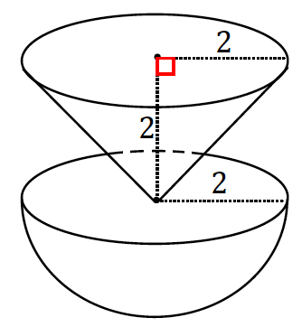
Total volume of water:
$$V=\frac{1}{3}π{\left(2\right)}^{2}(2)$$
$V=\frac{8}{3}π$; the total volume of water is $\frac{8}{3}π m^{3}$.

The cone formed when the water level is at $80 cm$ $(0.8 m)$ is similar to the original cone; therefore, the radius of that cone is also $80 cm$.
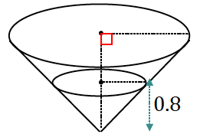
Volume of water once the water level drops to $80 cm$:
$$V=\frac{1}{3}π{\left(0.8\right)}^{2}(0.8 m) \\ V=\frac{1}{3}π(0.512)$$
The volume of water in the cone water once the water level drops to $80 cm$ is $\frac{1}{3}π(0.512) m^{3}$.

Volume of water that has drained into the hemispherical tank:
$$V=\left[ \frac{8}{3}π-\frac{1}{3}π\left(0.512\right)\right]$$
$$V=\frac{1}{3}π\left[8-\left(0.512\right)\right]$$
$$V=\frac{1}{3}π\left[7.488\right]$$
$$V=2.496π$$
The volume of water in the hemispherical tank is $2.496π m^{3}.$

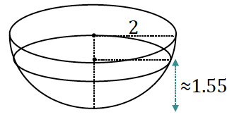
The pool of water that sits in the hemispherical tank is also hemispherical.
$$2.496π=\left(\frac{1}{2}\right)\frac{4}{3}πr^{3} \\ r^{3}=2.496\left(\frac{3}{2}\right) \\ r^{3}=3.744 \\ r≈1.55$$
The depth of the water in the hemispherical tank is approximately $1.55 m.$

