Lesson 12: The Volume Formula of a Sphere

Classwork
Opening Exercise
Picture a marble and a beach ball. Which one would you describe as a sphere? What differences between the two could possibly impact how we describe what a sphere is?

Definition | Characteristics
Sphere
Examples | Non-Examples

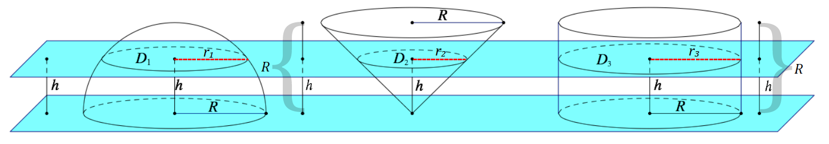
Cylinder $S$
Cone $T$
Hemisphere $H$
Example
Use your knowledge about the volumes of cones and cylinders to find a volume for a solid hemisphere of radius $R$.

Exercises
- Find the volume of a sphere with a diameter of $12 cm$ to one decimal place.

- An ice cream cone is $11 cm$ deep and $5 cm$ across the opening of the cone. Two hemisphere-shaped scoops of ice cream, which also have diameters of $5 cm$, are placed on top of the cone. If the ice cream were to melt into the cone, will it overflow?

- Bouncy, rubber balls are composed of a hollow, rubber shell $0.4"$ thick and an outside diameter of $1.2"$. The price of the rubber needed to produce this toy is $\$0.035/{in}^{3}$.
  - What is the cost of producing$1$ case, which holds $50$ such balls? Round to the nearest cent.

  - If each ball is sold for $\$0.10$, how much profit is earned on each ball sold?

Extension

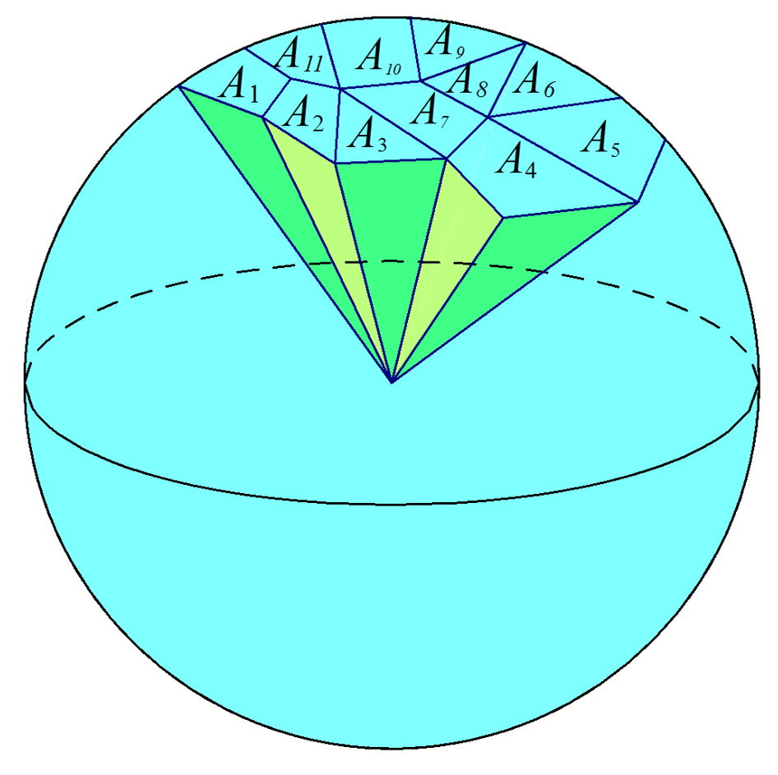

Problem Set
Lesson Summary
Sphere: Given a point $C$ in the three-dimensional space and a number $r>0$, the sphere with center $C$ and radius $r$ is the set of all points in space that are distance $r$ from the point $C$.
Solid sphere or ball: Given a point $C$ in the three-dimensional space and a number $r>0$, the solid sphere (or ball) with center $C$ and radius $r$ is the set of all points in space whose distance from the point $C$ is less than or equal to $r$.

- A solid sphere has volume $36π$. Find the radius of the sphere.

- A sphere has surface area $16π$. Find the radius of the sphere.

- Consider a right circular cylinder with radius $r$ and height $h$. The area of each base is $πr^{2}$. Think of the lateral surface area as a label on a soup can. If you make a vertical cut along the label and unroll it, the label unrolls to the shape of a rectangle.
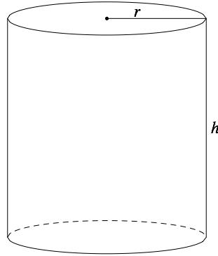
  - Find the dimensions of the rectangle.
  - What is the lateral (or curved) area of the cylinder?

- Consider a right circular cone with radius $r$, height $h$, and slant height $l$ (see Figure 1). The area of the base is $πr^{2}$.
Open the lateral area of the cone to form part of a disk (see Figure 2). The surface area is a fraction of the area of this disk.
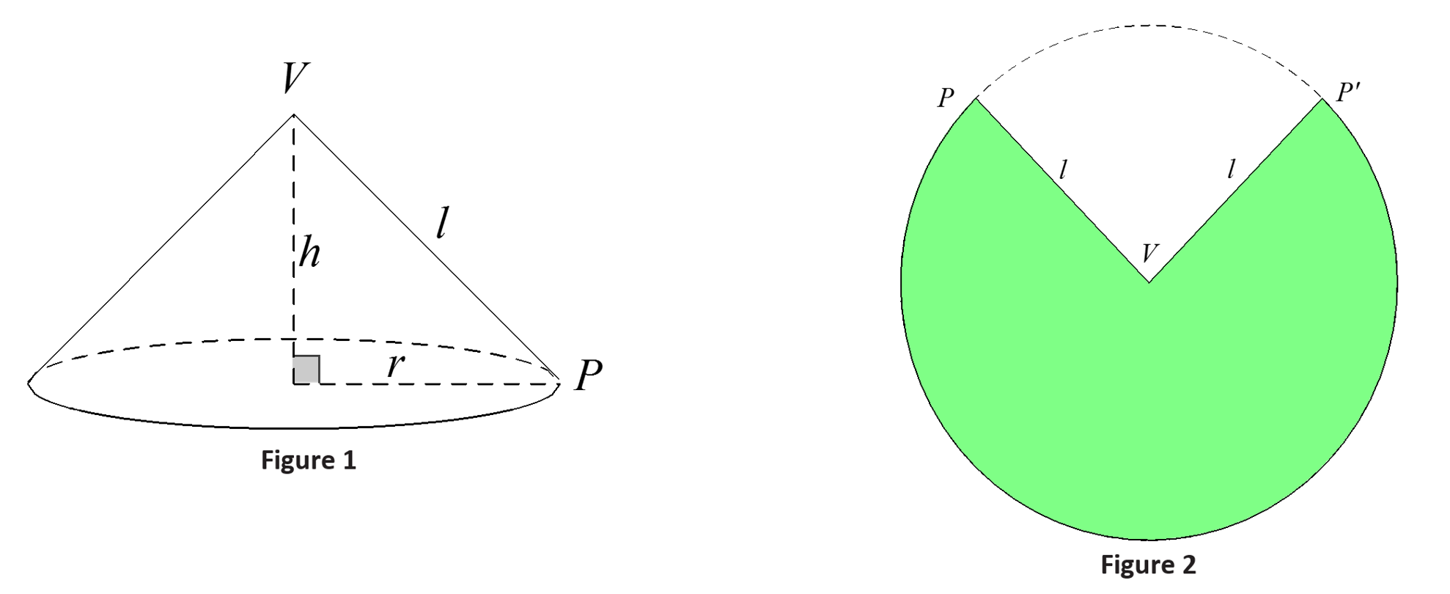
  - What is the area of the entire disk in Figure 2?
  - What is the circumference of the disk in Figure 2?
The length of the arc on this circumference (i.e., the arc that borders the green region) is the circumference of the base of the cone with radius $r$ or $2πr$. (Remember, the green region forms the curved portion of the cone and closes around the circle of the base.)
  - What is the ratio of the area of the disk that is shaded to the area of the whole disk?
  - What is the lateral (or curved) area of the cone?

- A right circular cone has radius $3 cm$ and height $4 cm$. Find the lateral surface area.

- A semicircular disk of radius $3 ft.$ is revolved about its diameter (straight side) one complete revolution. Describe the solid determined by this revolution, and then find the volume of the solid.

- A sphere and a circular cylinder have the same radius, $r$, and the height of the cylinder is $2r$.
  - What is the ratio of the volumes of the solids?
  - What is the ratio of the surface areas of the solids?

- The base of a circular cone has a diameter of $10 cm$ and an altitude of $10 cm$. The cone is filled with water. A sphere is lowered into the cone until it just fits. Exactly one-half of the sphere remains out of the water. Once the sphere is removed, how much water remains in the cone?

- Teri has an aquarium that is a cube with edge lengths of $24$ inches. The aquarium is $\frac{2}{3}$ full of water. She has a supply of ball bearings each having a diameter of $\frac{3}{4}$ inch.
  - What is the maximum number of ball bearings that Teri can drop into the aquarium without the water overflowing?
  - Would your answer be the same if the aquarium was $\frac{2}{3}$ full of sand? Explain.
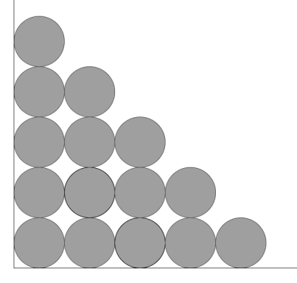
  - If the aquarium is empty, how many ball bearings would fit on the bottom of the aquarium if you arranged them in rows and columns as shown in the picture?
  - How many of these layers could be stacked inside the aquarium without going over the top of the aquarium? How many bearings would there be altogether?
  - With the bearings still in the aquarium, how much water can be poured into the aquarium without overflowing?
  - Approximately how much of the aquarium do the ball bearings occupy?

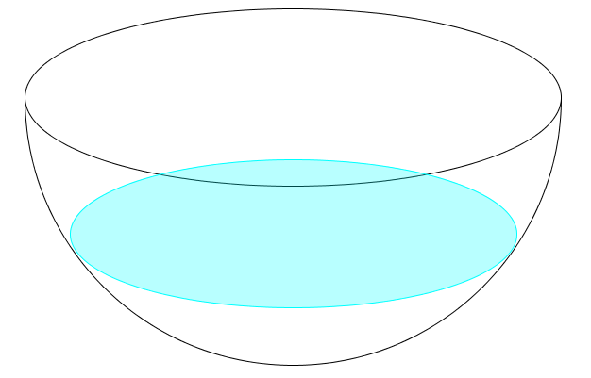
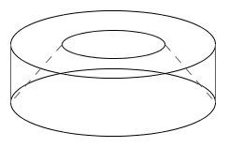
- Challenge: A hemispherical bowl has a radius of $2$ meters. The bowl is filled with water to a depth of $1$ meter. What is the volume of water in the bowl? (Hint: Consider a cone with the same base radius and height, and the cross-section of that cone that lies $1$ meter from the vertex.)

- Challenge: A certain device must be created to house a scientific instrument. The housing must be a spherical shell, with an outside diameter of $1 m$. It will be made of a material whose density is $14 g/{cm}^{3}$. It will house a sensor inside that weighs $1.2 kg$. The housing, with the sensor inside, must be neutrally buoyant, meaning that its density must be the same as water. Ignoring any air inside the housing, and assuming that water has a density of $1 g/{cm}^{3}$, how thick should the housing be made so that the device is neutrally buoyant? Round your answer to the nearest tenth of a centimeter.

- Challenge: An inverted, conical tank has a circular base of radius $2 m$ and a height of $2 m$ and is full of water. Some of the water drains into a hemispherical tank, which also has a radius of $2 m$. Afterward, the depth of the water in the conical tank is $80 cm$. Find the depth of the water in the hemispherical tank.
