|  |
| --- |
|  |

Lesson 11: The Volume Formula of a Pyramid and Cone

Student Outcomes

* Students use Cavalieri’s principle and the cone cross-section theorem to show that a general pyramid or cone has volume , where is the area of the base and is the height by comparing it with a right rectangular pyramid with base area and height .

Lesson Notes

The Exploratory Challenge is debriefed in the first discussion. The Exploratory Challenge and Discussion are the springboard for the main points of the lesson: (1) explaining why the formula for finding the volume of a cone or pyramid includes multiplying by one-third and (2) applying knowledge of the cone cross-section theorem and Cavalieri’s principle from previous lessons to show why a general pyramid or cone has volume Provide manipulatives to students, congruent pyramids and congruent pyramids, to explore the volume formulas in a hands-on manner; that is, attempt to construct a cube from congruent pyramids or congruent pyramids such as in the image below.

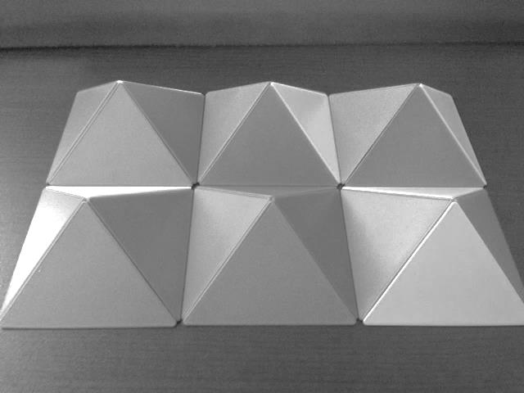 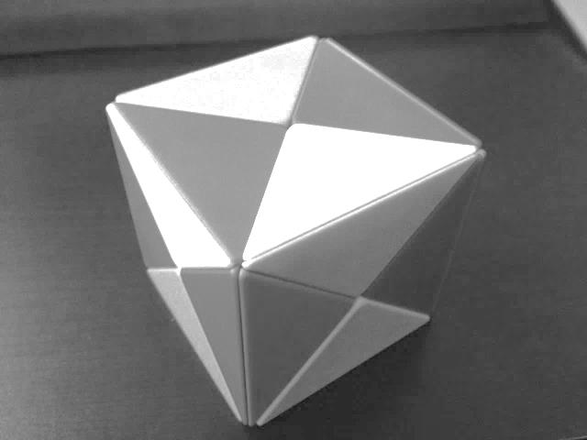

Classwork

Exploratory Challenge (5 minutes)

Exploratory Challenge

Use the provided manipulatives to aid you in answering the questions below.

* + 1. What is the formula to find the area of a triangle?
    2. Explain why the formula works.

The formula works because the area of a triangle is half the area of a rectangle with the same base and same height.

* + 1. What is the formula to find the volume of a triangular prism?

For base area and height of prism ,

* + 1. Explain why the formula works.

A triangular prism is essentially a stack of congruent triangles. Taking the area of a triangle, repeatedly, is like multiplying by the height of the prism. Then the volume of the prism would be the sum of the areas of all of the congruent triangles, which is the same as the area of one triangle multiplied by the height of the prism.

* + 1. What is the formula to find the volume of a cone or pyramid?

For base area and height of prism ,

* + 1. Explain why the formula works.

Answers will vary. Some students may recall seeing a demonstration in Grade 8 related to the number of cones (three) it took to equal the volume of a cylinder with the same base area and height, leading to an explanation of where the one-third came from.

Discussion (10 minutes)

Use the following points to debrief the Exploratory Challenge. Many students will be able to explain where the in the triangle area formula comes from, so the majority of the discussion should be on where the factor comes from, with respect to pyramid and cone volume formulas. Allow ample time for students to work with the manipulatives to convince them that they cannot construct a prism (unit cube) from congruent pyramids but will need congruent pyramids instead.

* What is the explanation for the in the area formula for a triangle, ?
  + *Two congruent triangles comprise a parallelogram with base, , and height, . Then the area of the triangle is one-half of the area of the parallelogram (or rectangle).*
* What is the volume formula for a cone or pyramid?
  + *The volume of a cone or pyramid is found using the formula .*
* Where does the in that formula come from? Can we fit together three congruent pyramids or cones to form a prism or cylinder (as we did for the area of a triangle)?

**MP.3**

Allow time for students to attempt this with manipulatives. Encourage students to construct arguments as to why a prism can be constructed using the manipulatives, or more to the point, why they cannot do this. Some groups of students may develop an idea similar to the one noted below, i.e., using congruent pyramids instead. If so, allow students to work with the congruent pyramids. If students do not develop this idea on their own, share the point below with students, and then allow them to work with the manipulatives again.

**MP.3**

Some students may recall seeing a demonstration in Grade 8 related to the number of cones (three) it took to equal the volume of a cylinder with the same base area and height, leading to an explanation of where the one-third came from.

* In general, we cannot fit three congruent pyramids or cones together, but we can do something similar. Instead of fitting three congruent pyramids, consider the following: Start with a unit cube. Take a pyramid whose base is equal to (same as one face of the cube) and height equal to (half the height of the cube). If placed on the bottom of the unit cube, it would look like the green pyramid in the diagram below.

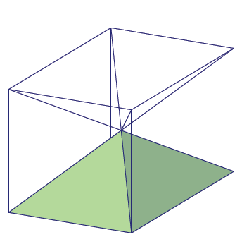

* How many total pyramids of the stated size would be needed to equal the volume of a unit cube?

Provide time for students to discuss the answer in pairs, if needed.

**MP.7**

* + *It would take of these pyramids to equal the volume of the cube: one at the bottom, one whose base is at the top, and four to be placed along the four sides of the cube.*
  + *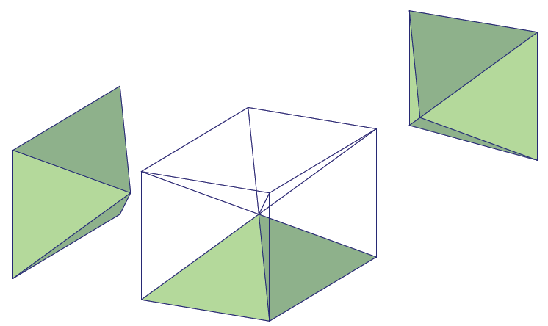Shown in the diagram below are two more pyramids in the necessary orientation to take up the volume along the sides of the cube.*
* A cube with side length is the union of six congruent square pyramids with base dimensions of and height of . Since it takes six such pyramids, then the volume of one must be . We will use this fact to help us make sense of the one-third in the volume formula for pyramids and cones.

**MP.7**

**Discussion (15 minutes)**

The discussion that follows is a continuation of the opening discussion. The first question asked of students is to make sense of the in the volume formula for pyramids and cones. It is important to provide students with time to think about how to use what was discovered in the opening discussion to make sense of the problem and construct a viable argument.

* We would like to say that three congruent pyramids comprise the volume of a cube. If we could do that, then making sense of the one-third in the volume formula for pyramids and cones would be easy. All we know as of now is that it takes six congruent pyramids whose base must be equal to a face of the cube and whose height is one-half. How can we use what we know to make sense of the one-third in the formula?

**MP.3**

Provide time for students to make sense of the problem and discuss possible solutions in a small group. Have students share their ideas with the class so they can critique the reasoning of others.

*Scaffolding:*

Divide the class into groups. As they struggle with answering the question, consider calling one student from each group up for a huddle. In the huddle, ask students to discuss how the heights of the six pyramids compare to the height of the prism and what they could do to make the height of one of those pyramids equal to the height of the prism. Send them back to their groups to share the considerations and how they may be applied to this situation.

This reasoning uses scaling:

* + *If we scaled one of the six pyramids by a factor of in the direction of the altitude of the cube, then the volume of the pyramid would also increase by a factor of This means that the new volume would be equal to . Further, it would take such pyramids to equal the volume of the unit cube; therefore, the volume of a pyramid is of the volume of a prism with the same base and same height.*



This reasoning uses arithmetic:

* + *Since the height of the green pyramid is that of the unit cube, then we can compare the volume of half of the unit cube, , to the known volume of the pyramid, that of the unit cube. Since   
    , then the volume of the pyramid is exactly the volume of a prism with the same base and same height.*
* If we scaled a square pyramid whose volume was of a unit cube by factors of ,, and in three perpendicular directions of the sides of the square and the altitude, then the scaled pyramid would show that a right rectangular prism has volume

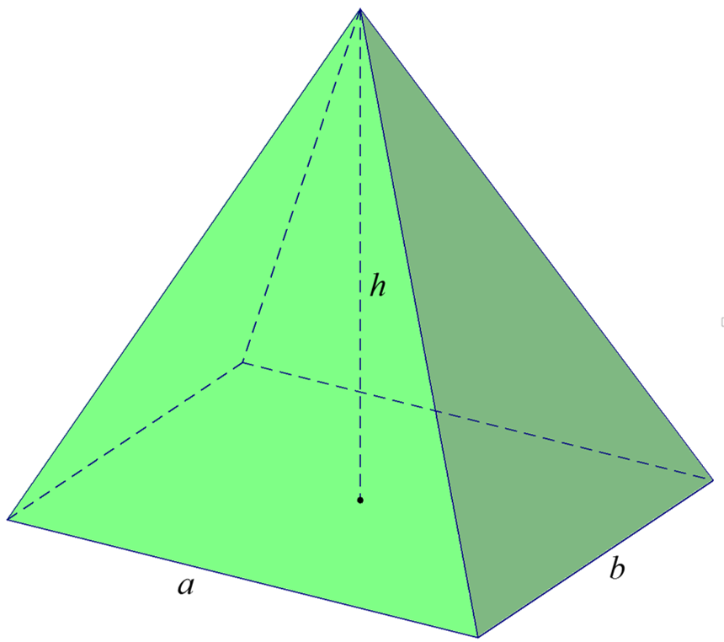

* Now let’s discuss how to compute the volume of a general cone with base area and height . Suppose we wanted to calculate the volume of the cone shown below. How could we do it?

Provide time for students to make sense of the problem and discuss possible solutions in a small group. Have students share their ideas with the class so they can critique the reasoning of others.

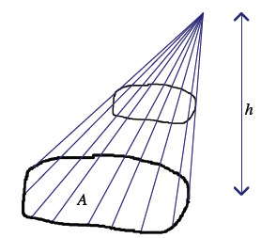

* + *Since the base, , is an irregular shape, we could compare this cone to a right rectangular pyramid that has the same base area and height*

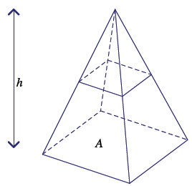

* + *The cone cross-section theorem states that if two cones have the same base area and the same height, then cross-sections for the cones, the same distance from the vertex, have the same area.*
* What does Cavalieri’s principle say about the volume of the general cone compared to the volume of the right rectangular pyramid?

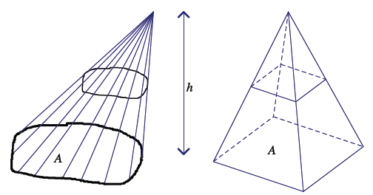

* + *Cavalieri’s principle shows that the two solids will have equal volume.*
* Given what was said about the cone cross-section theorem and Cavalieri’s principle, what can we conclude about the formula to find the volume of a general cone?
  + *The formula to find the volume of a general cone is*

Before moving into the following exercises, pause for a moment to check for student understanding. Have students talk with their neighbor for a moment about what they have learned so far; then ask for students to share aloud.

Exercises 1–4 (7 minutes)

The application of the formula in the exercises below can be assigned as part of the Problem Set or completed on another day, if necessary.

Exercises

1. 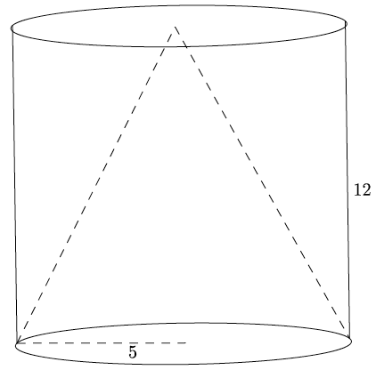A cone fits inside a cylinder so that their bases are the same and their heights are the same, as shown in the diagram below. Calculate the volume that is inside the cylinder but outside of the cone. Give an exact answer.

The volume of the cylinder is

The volume of the cone is .

The volume of the space that is inside the cylinder but outside the cone is

Alternative solution:

The space between the cylinder and cone is equal to the volume of the cylinder. Then the volume of the space is

1. A square pyramid has a volume of . The height of the pyramid is . What is the area of the base of the pyramid? What is the length of one side of the base?

*The area of the base is , and the length of one side of the base is* .

1. Use the diagram below to answer the questions that follow.
   1. 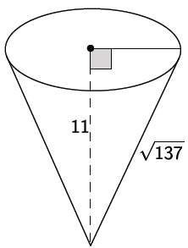Determine the volume of the cone shown below. Give an exact answer.

Let the length of the radius be .

The volume of the cone is .

* 1. Find the dimensions of a cone that is similar to the one given above. Explain how you found your answers.

Student answers will vary. Possible student answer:

A cone with height and radius is similar to the one given because their corresponding sides are equal in ratio, i.e., and . Therefore, there exists a similarity transformation that would map one cone onto the other.

* 1. Calculate the volume of the cone that you described in part (b) in two ways. (Hint: Use the volume formula and the scaling principle for volume.)

Solution based on the dimensions provided in possible student response from part (b).

Using the volume formula:

For two similar solids, if the ratio of corresponding sides is , then the ratio of their volumes is . The corresponding sides are in ratio , so their volumes will be in the ratio . Therefore, the volume of the cone in part (b) is times larger than the given one:

1. Gold has a density of . If a square pyramid has a base edge length of , a height of , and a mass of , is the pyramid in fact solid gold? If it is not, what reasons could explain why it is not? Recall that density can be calculated with the formula .

***The volume of the pyramid is*****.**

*Since the density of the pyramid is not* , *the pyramid is not solid gold. This could be because part of it is hollow, or there is a mixture of metals that make up the pyramid.*

Closing (3 minutes)

Ask students to summarize the main points of the lesson in writing, by sharing with a partner, or through a whole class discussion. Use the questions below, if necessary.

* Give an explanation as to where the comes from in the volume formula for general cones and pyramids.
  + *The volume formula for a general cylinder is the area of the cylinder’s base times the height of the cylinder, and a cylinder can be decomposed into three cones, each with equal volume; thus, the volume of each of the cones is the volume of cylinder.*

Exit Ticket (5 minutes)

Name Date

Lesson 11: The Volume Formula of a Pyramid and Cone

Exit Ticket

1. 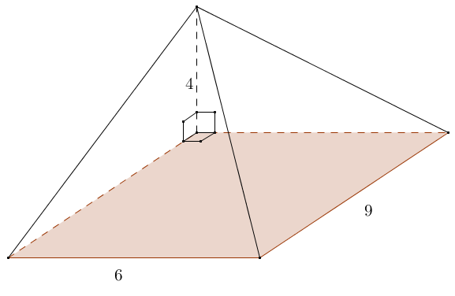Find the volume of the rectangular pyramid shown.
2. The right circular cone shown has a base with radius of . The slant height of the cone’s lateral surface is . Find the volume of the cone.

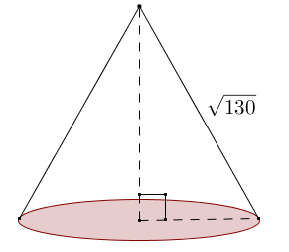Exit Ticket Sample Solutions

1. Find the volume of the rectangular pyramid shown.

The volume of the rectangular pyramid is .

1. The right circular cone shown has a base with radius of . The slant height of the cone’s lateral surface is . Find the volume of the cone.

The slant surface, the radius, and the altitude, , of the cone form a right triangle. Using the Pythagorean theorem,

The volume of the right circular cone is .

Problem Set Sample Solutions

1. **What is the volume formula for a right circular cone with radius**  and height ?
2. Identify the solid shown, and find its volume.

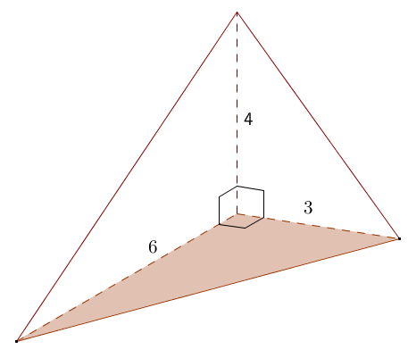The solid is a triangular pyramid.

The volume of the triangular pyramid is .

1. Find the volume of the right rectangular pyramid shown.

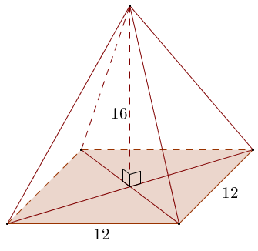

The volume of the right rectangular pyramid is .

1. 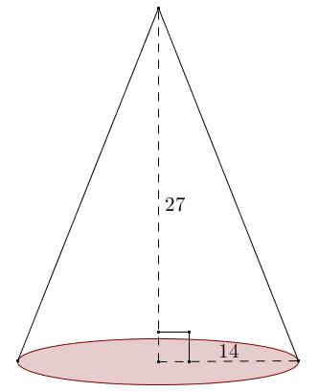Find the volume of the circular cone in the diagram. (Use as an approximation of pi.)

The volume of the circular cone is .

1. Find the volume of a pyramid whose base is a square with edge length and whose height is also.
2. Suppose you fill a conical paper cup with a height of with water.  If all the water is then poured into a cylindrical cup with the same radius and same height as the conical paper cup, to what height will the water reach in the cylindrical cup?

A height of

1. Sand falls from a conveyor belt and forms a pile on a flat surface. The diameter of the pile is approximately and the height is approximately . Estimate the volume of the pile of sand. State your assumptions used in modeling.

*Assuming that the pile of sand is shaped like a cone, the radius of the pile would be* , *and so the volume of the pile in cubic feet would be .*

1. A pyramid has volume and height . Find the area of its base.

Let be the area of the base.

The area of the base is .

1. 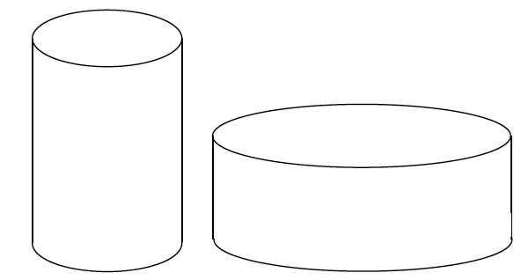Two jars of peanut butter by the same brand are sold in a grocery store.  The first jar is twice the height of the second jar, but its diameter is one-half as much as the shorter jar.  The taller jar costs , and the shorter jar costs.  Which jar is the better buy?

The shorter jar is the better buy because it has twice the volume of the taller jar and costs five cents less than twice the cost of the taller jar.

1. A cone with base area and height is sliced by planes parallel to its base into three pieces of equal height. Find the volume of each section.

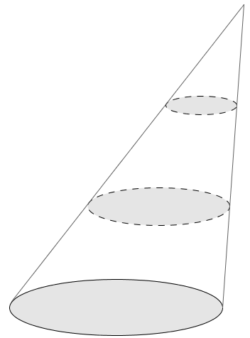The top section is similar to the whole cone with scale factor , so its volume is

The middle section has volume equal to the difference of the volume of the top two-thirds of the cone and the top one-third of the cone.

The bottom section has volume equal to the difference of the volume of the entire cone and the volume of the top two-thirds of the cone.

1. The frustum of a pyramid is formed by cutting off the top part by a plane parallel to the base. The base of the pyramid and the cross-section where the cut is made are called the *bases of the frustum*. The distance between the planes containing the bases is called the *height of the frustum*. Find the volume of a frustum if the bases are squares of edge lengths and , and the height of the frustum is .

Let be the vertex of the pyramid and the height of the pyramid with base the smaller square of edge length . Then is the height the pyramid. The smaller square is similar to the larger square with scale factor , but the scale factor is also . Solving gives . So, the volume of the pyramid whose base is the square of edge length and height   
 is . The volume of the pyramid with base the square of edge length and height is . The volume of the frustum is .

1. A bulk tank contains a heavy grade of oil that is to be emptied from a valve into smaller -quart containers via a funnel. To improve the efficiency of this transfer process, Jason wants to know the greatest rate of oil flow that he can use so that the container and funnel do not overflow. The funnel consists of a cone that empties into a circular cylinder with the dimensions as shown in the diagram. Answer each question below to help Jason determine a solution to his problem.
   1. 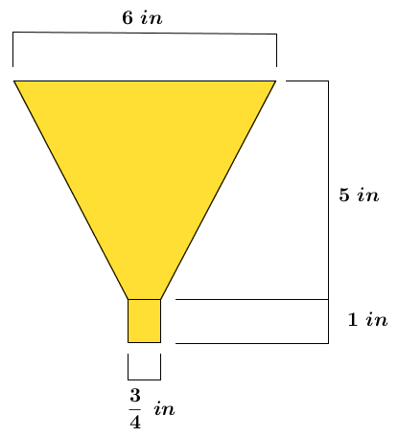Find the volume of the funnel.

The upper part of the funnel is a frustum, and its volume is the difference of the complete cone minus the missing portion of the cone below the frustum. The height of the entire cone is unknown; however, it can be found using similarity and scale factor.  
Let represent the unknown height of the cone between the frustum and the vertex. Then the height of the larger cone is   
.

Using corresponding diameters and heights:

***The height of the cone between the frustum and the vertex is , and the total height of the cone including the frustum is* .**

The volume of the frustum is the difference of the volumes of the total cone and the smaller cone between the frustum and the vertex.

Let represent the volume of the total cone in cubic inches, represent the volume of the smaller cone between the frustum and the vertex in cubic inches, and represent the volume of the frustum in cubic inches.

Let represent the volume of the circular cylinder at the bottom of the funnel in cubic inches.

Let represent the volume of the funnel in cubic inches.

*The volume of the funnel is approximately* .

* 1. If is equivalent in volume to , what is the volume of the funnel in quarts?

The volume of the funnel is approximately quarts.

* 1. If this particular grade of oil flows out of the funnel at a rate of quarts per minute, how much time in minutes is needed to fill the -quart container?

*Let represent the time needed to fill the container in minutes.*

*The container will fill in approximately* minutes () *at a flow rate of quarts per minute*.

* 1. Will the tank valve be shut off exactly when the container is full? Explain.

If the tank valve is shut off at the same time that the container is full, the container will overflow because there is still oil in the funnel; therefore, the tank valve should be turned off before the container is filled.

* 1. How long after opening the tank valve should Jason shut the valve off?

The valve can be turned off when the container has enough room left for the oil that remains in the funnel.

It is known that the flow rate out of the funnel is quarts per minute.

Let represent the time in minutes needed to fill the container and funnel with quarts of oil.

The container will have enough room remaining for the oil left in the funnel at approximately minutes; therefore, the valve on the bulk tank can also be shut off at minutes.

* 1. What is the maximum constant rate of flow from the tank valve that will fill the container without overflowing either the container or the funnel?

The flow of oil from the bulk tank should just fill the funnel at minutes, when the valve is shut off.

*Let represent the rate of oil flow from the bulk tank in quarts per minute.*

The flow of oil from the bulk tank can be at approximately quarts per minute to fill the container without overflowing the container or the funnel used.