Lesson 11: The Volume Formula of a Pyramid and Cone

Classwork

Exploratory Challenge

Use the provided manipulatives to aid you in answering the questions below.

* + 1. What is the formula to find the area of a triangle?
    2. Explain why the formula works.
    3. What is the formula to find the volume of a triangular prism?
    4. Explain why the formula works.
    5. What is the formula to find the volume of a cone or pyramid?
    6. Explain why the formula works.

Exercises

1. A cone fits inside a cylinder so that their bases are the same and their heights are the same, as shown in the diagram below. Calculate the volume that is inside the cylinder but outside of the cone. Give an exact answer.

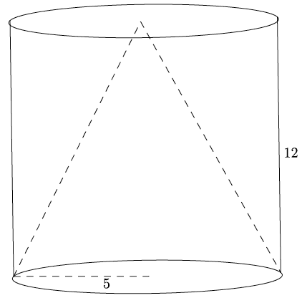

1. A square pyramid has a volume of . The height of the pyramid is . What is the area of the base of the pyramid? What is the length of one side of the base?
2. Use the diagram below to answer the questions that follow.
   1. 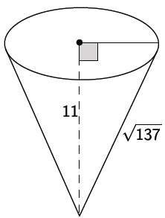Determine the volume of the cone shown below. Give an exact answer.
   2. Find the dimensions of a cone that is similar to the one given above. Explain how you found your answers.
   3. Calculate the volume of the cone that you described in part (b) in two ways. (Hint: Use the volume formula and the scaling principle for volume.)
3. Gold has a density of . If a square pyramid has a base edge length of , height of , and a mass of , is the pyramid in fact solid gold? If it is not, what reasons could explain why it is not? Recall that density can be calculated with the formula .

Problem Set

1. What is the volume formula for a right circular cone with radius and height ?
2. Identify the solid shown, and find its volume.

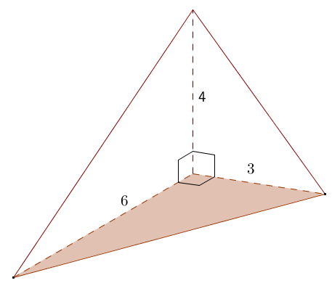

1. Find the volume of the right rectangular pyramid shown.

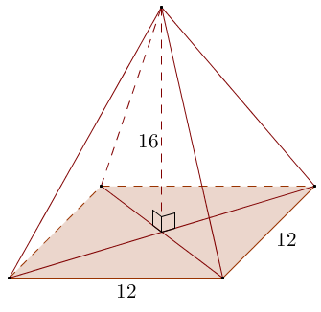

1. Find the volume of the circular cone in the diagram. (Use as an approximation of pi.)

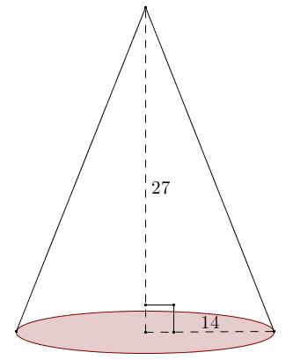

1. Find the volume of a pyramid whose base is a square with edge length and whose height is also.
2. Suppose you fill a conical paper cup with a height of with water.  If all the water is then poured into a cylindrical cup with the same radius and same height as the conical paper cup, to what height will the water reach in the cylindrical cup?
3. Sand falls from a conveyor belt and forms a pile on a flat surface. The diameter of the pile is approximately and the height is approximately . Estimate the volume of the pile of sand. State your assumptions used in modeling.
4. A pyramid has volume and height . Find the area of its base.
5. Two jars of peanut butter by the same brand are sold in a grocery store.  The first jar is twice the height of the second jar, but its diameter is one-half as much as the shorter jar.  The taller jar costs , and the shorter jar costs .  Which jar is the better buy?

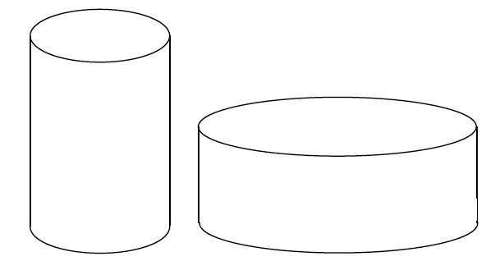

1. A cone with base area and height is sliced by planes parallel to its base into three pieces of equal height. Find the volume of each section.

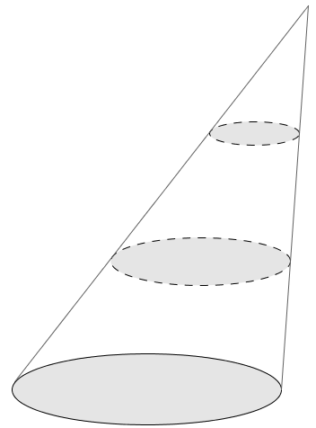

1. The frustum of a pyramid is formed by cutting off the top part by a plane parallel to the base. The base of the pyramid and the cross-section where the cut is made are called the *bases of the frustum*. The distance between the planes containing the bases is called the *height of the frustum*. Find the volume of a frustum if the bases are squares of edge lengths and , and the height of the frustum is .



1. 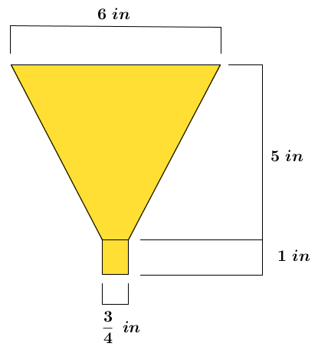A bulk tank contains a heavy grade of oil that is to be emptied from a valve into smaller -quart containers via a funnel. To improve the efficiency of this transfer process, Jason wants to know the greatest rate of oil flow that he can use so that the container and funnel do not overflow. The funnel consists of a cone that empties into a circular cylinder with the dimensions as shown in the diagram. Answer each question below to help Jason determine a solution to his problem.
   1. Find the volume of the funnel.
   2. If is equivalent in volume to , what is the volume of the funnel in quarts?
   3. If this particular grade of oil flows out of the funnel at a rate of quarts per minute, how much time in minutes is needed to fill the -quart container?
   4. Will the tank valve be shut off exactly when the container is full? Explain.
   5. How long after opening the tank valve should Jason shut the valve off?
   6. What is the maximum constant rate of flow from the tank valve that will fill the container without overflowing either the container or the funnel?