Lesson 10: The Volume of Prisms and Cylinders and Cavalieri’s Principle

Classwork

Opening Exercise

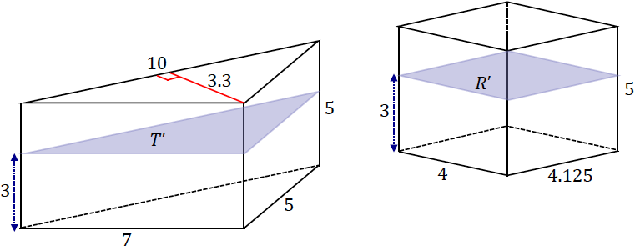The bases of the following triangular prism and rectangular prism lie in the same plane. A plane that is parallel to the bases and also a distance from the bottom base intersects both solids and creates cross-sections and .

1. Find .
2. Find .
3. Find .
4. Find .
5. If a height other than were chosen for the cross-section, would the cross-sectional area of either solid change?

Discussion

Figure 1

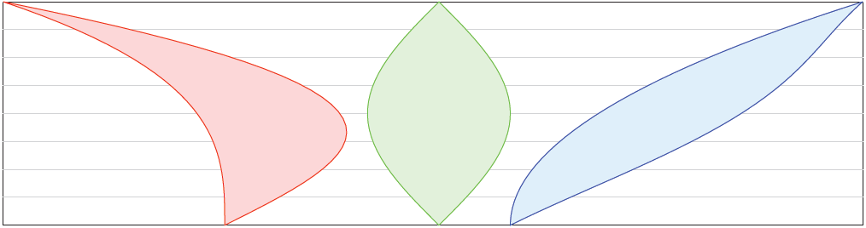

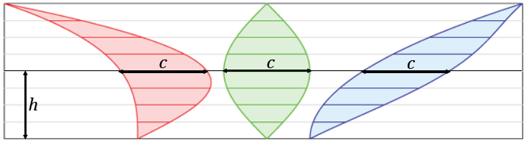

Example 1

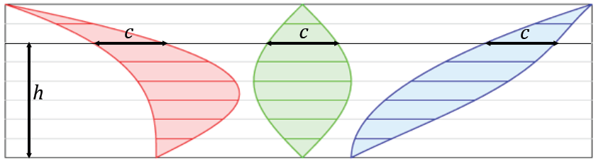

Example 2

**Principle of parallel slices in the plane:** If two planar figures of equal altitude have identical cross-sectional lengths at each height, then the regions of the figures have the same area.

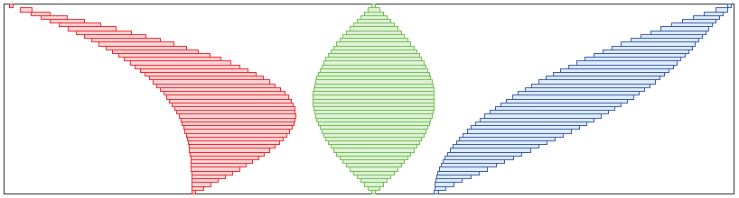

Figure 2

Example

* 1. The following triangles have equal areas: . The distance between and is Find the lengths and .

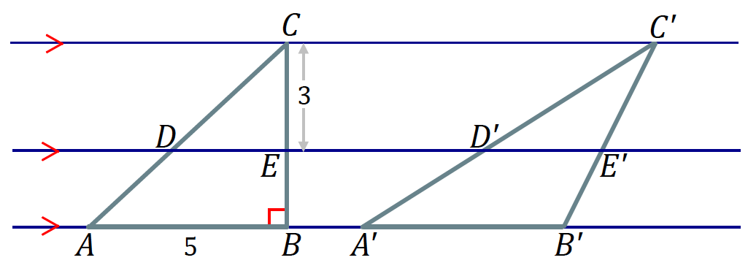

* 1. Joey says that if two figures have the same height and the same area, then their cross-sectional lengths at each height will be the same. Give an example to show that Joey’s theory is incorrect.

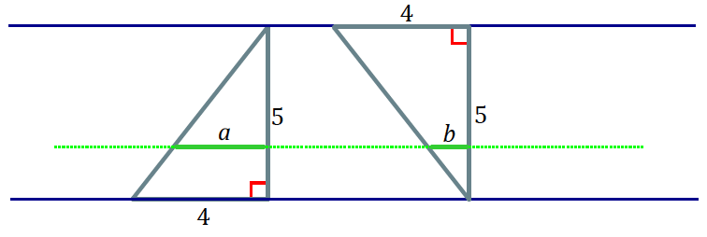

Discussion

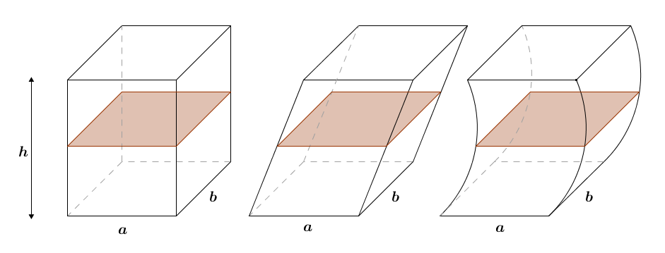

Figure 3

**Cavalieri’s principle:**  Given two solids that are included between two parallel planes, if every plane parallel to the two planes intersects both solids in cross-sections of equal area, then the volumes of the two solids are equal.

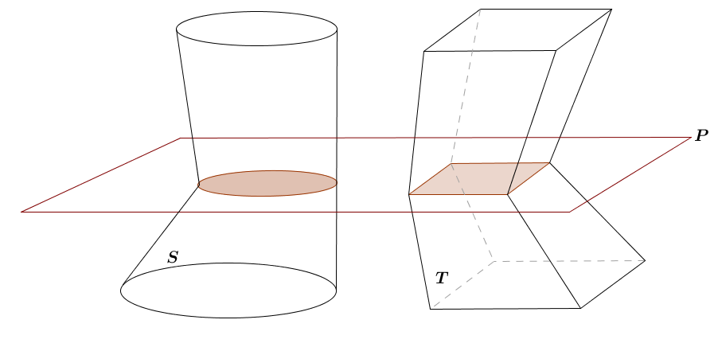

Figure 4



Figure 5



Figure 6

Problem Set

Lesson Summary

**Principle of parallel slices in the plane:** If two planar figures of equal altitude have identical cross-sectional lengths at each height, then the regions of the figures have the same area.

**Cavalieri’s principle:**  Given two solids that are included between two parallel planes, if every plane parallel to the two planes intersects both solids in cross-sections of equal area, then the volumes of the two solids are equal.

1. Use the principle of parallel slices to explain the area formula for a parallelogram.
2. Use the principle of parallel slices to show that the three triangles shown below all have the same area.



Figure 1 Figure 2 Figure 3

1. An oblique prism has a rectangular base that is . A hole in the prism is also the shape of an oblique prism with a rectangular base that is wide and long, and the prism’s height is (as shown in the diagram). Find the volume of the remaining solid.

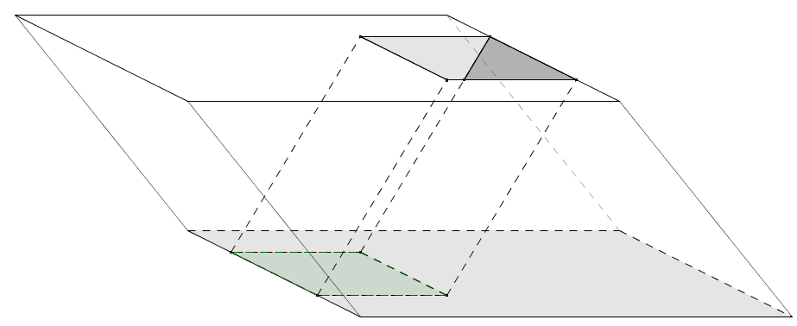

1. An oblique circular cylinder has height and volume . Find the radius of the circular base.



1. A right circular cone and a solid hemisphere share the same base. The vertex of the cone lies on the hemisphere. Removing the cone from the solid hemisphere forms a solid. Draw a picture, and describe the cross-sections of this solid that are parallel to the base.
2. Use Cavalieri’s principle to explain why a circular cylinder with a base of radius and a height of has the same volume as a square prism whose base is a square with edge length and whose height is also .