|  |
| --- |
|  |

Lesson 9: Scaling Principle for Volumes

Student Outcomes

* Students understand that given similar solids and so that the ratio of their lengths is , then the ratio of their volumes is .
* Students understand that if a solid with volume is scaled by factors of , , and in three perpendicular directions, then the volume is multiplied by a factor of so that the volume of the scaled solid is .

Lesson Notes

The Opening Exercise reviews the relationship between the ratio of side lengths of similar figures and the ratio of the areas of the similar figures. Some groups of students may not need the review in part (a) and can begin the Opening Exercise with part (b). In order to extend what students know about similar figures and scaled figures to three dimensions, students begin by investigating the effect that a scale factor (or scale factors) has on the volume of the figure. After each set of investigative problems is a brief discussion where students should be encouraged to share their observations. At the end of the first discussion, it should be made clear that when similar solids have side lengths with ratio , then the ratio of their volumes is At the end of the second discussion, it should be made clear that when a figure is scaled by factors of , , and in three perpendicular directions, then the volume is multiplied by a factor of . The foundation for understanding volume is laid in Grades 3–5. Students begin applying volume formulas for right rectangular prisms with fractional side lengths in Grade 6, Module 5 (**6.G.A.2**). Volume work is extended to three-dimensional objects composed of triangles, quadrilaterals, polygons, cubes, and right prisms in   
Grade 7, Modules 3 and 6 (**7.G.B.6**). It is in Grade 8, Module 5 that students learn about the volume of cylinders, cones, and spheres (**8.G.C.9**). There are many exercises for students to complete independently, in pairs, or as part of a group when the class is divided. Depending on your choice, you may need to complete this lesson over two days where the second day of content would begin with Exercise 2.

Classwork

Opening Exercise (8 minutes)

Students can complete the exercises independently or in pairs. You can divide the class and have each group complete one part of the table in part (a) and then come together as a class to share solutions and ideas about how the ratio of side lengths is related to the ratio of areas. It may be necessary to talk through the first problem with the class before letting them work independently. Some groups of students may be able to complete all of the problems independently and not need an exemplar or to work in pairs throughout the lesson. Once students have completed the exercises, have students share their conjectures about the relationship between the ratio of side lengths to the ratio of volumes as well as their reasoning. Consider having the class vote on which conjecture they believe is correct. When students have finished the Opening Exercise, show how they can write the ratio of areas using squared numbers, clearly demonstrating the relationship between side lengths of similar figures and their areas.

Opening Exercise

1. 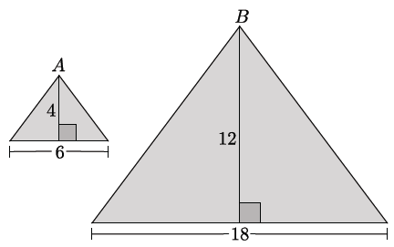For each pair of similar figures, write the ratio of side lengths or that compares one pair of corresponding sides. Then, complete the third column by writing the ratio that compares the areas of the similar figures. Simplify ratios when possible.

|  |  |  |
| --- | --- | --- |
| Similar Figures | Ratio of Side Lengths or | Ratio of Areas  or |
|  |  |  |
| Rectangle Rectangle |  |  |
|  |  |  |
|  |  |  |

|  |  |  |
| --- | --- | --- |
| Rectangle Rectangle |  |  |

*Scaffolding:*

* Consider having a class discussion around part (b) to elicit the relationship asked for in part (i). Then allow students to make their conjecture for part (ii) independently.
* Encourage students to write the ratios of volume using cubed numbers (e.g., for a ratio of side lengths , the corresponding ratio of volumes can be written ). Doing so will help students see the relationship between the ratio of side lengths and the ratio of volumes.
* Provide selected problems from previous grade levels (identified in the Lesson Notes) as additional homework problems leading up to this lesson to remind students of the volume formulas used in this portion of the lesson.

1. State the relationship between the ratio of sides and the ratio of the areas .

When the ratio of side lengths is , then the ratio of the areas is .

* 1. Make a conjecture as to how the ratio of sides will be related to the ratio of volumes . Explain.

When the ratio of side lengths is , then the ratio of the volumes will probably be . Area is two-dimensional, and the comparison of areas was raised to the second power. Since volume is three-dimensional, I think the comparison of   
volumes will be raised to the third power.

**MP.3**

1. What does is mean for two solids in three-dimensional space to be similar?

It means that a sequence of basic rigid motions and dilations maps one figure onto the other.

Exercise 1 (10 minutes)

Exercise 1 provides an opportunity for students to test their conjectures about the relationship between similar solids and their related volumes. If necessary, divide the class so that they complete just one problem and then share their solutions with the class. As before, it may be necessary to talk through the first problem before students begin working independently.

Exercises

1. Each pair of solids shown below is similar. Write the ratio of side lengths comparing one pair of corresponding sides. Then, complete the third column by writing the ratio that compares volumes of the similar figures. Simplify ratios when possible.

|  |  |  |
| --- | --- | --- |
| Similar Figures | Ratio of Side Lengths | Ratio of Volumes |
| Figure A Figure B |  |  |
| Figure A    Figure B |  |  |
| Figure A Figure B |  |  |

|  |  |  |
| --- | --- | --- |
| Figure A Figure B |  |  |
| Figure A    *Scaffolding:*   * Display the numbers in standard form in relation to their equivalent cubes for students to reference (e.g., , , , ).   Figure B |  |  |

**Discussion (4 minutes)**

* What do you notice about the relationships of the corresponding distances and the relationships of the volumes of the similar figures that you examined in the exercise above?

**MP.8**

* + *The ratios of the volumes of the similar figures are the cubes of the ratios of the corresponding distances of the similar figures.*
* Suppose a similarity transformation takes a solid to a solid at scale factor How do you think the volume of compares to the volume of ?

Allow students time to discuss in pairs or small groups, if necessary.

* If the ratio of the lengths of similar solids is , then the ratio of their volumes is
* Shemar says that if the figures were right rectangular prisms, then the observation above is true, i.e., given , then the ratio of their volumes is , but that if the figures were triangular prisms, then the ratio of volumes would be What do you think?

**MP.3**

Provide students time to consider Shemar’s statement. Ask students whether or not they would change their minds about the relationship between similar solids if was a right triangular prism or if was any solid. They should respond that the relationship would be the same as stated above because of what they know about equivalent ratios. Specifically, students may think that they need to include in the ratio, as Shemar did, because the comparison is of triangular prisms. However, based on what students know about equivalent ratios, they should conclude that

**MP.3**

Revisit the conjecture made in part (b) of the Opening Exercise. Acknowledge any student(s) who made an accurate conjecture about the relationship between similar figures and their related volumes.

Exercises 2–4 (10 minutes)

In Exercises 2–4, students explore what happens to the volume of a figure when it is scaled by factors of , , and in three perpendicular directions. If necessary, divide the class so that they complete just one problem and then share their solutions with the class. It is not expected that all students will immediately see the relationship between the volumes. It may be necessary to do this portion of the lesson on another day.

1. Use the triangular prism shown below to answer the questions that follow.

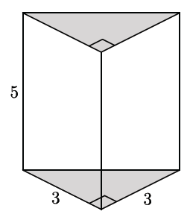

*Scaffolding:*

* Struggling students may need to work through Exercise 2 with the support and guidance of the teacher.
* Allow some groups of students to persevere in solving this problem in order to see the relationship on their own.
  1. Calculate the volume of the triangular prism.
  2. If one side of the triangular base is scaled by a factor of , the other side of the triangular base is scaled by a factor of , and the height of the prism is scaled by a factor of , what are the dimensions of the scaled triangular prism?

The new dimensions of the base are by , and the height is .

* 1. Calculate the volume of the scaled triangular prism.
  2. Make a conjecture about the relationship between the volume of the original triangular prism and the scaled triangular prism.

Answers will vary. Accept any reasonable response. The correct response is that the volume of the scaled figure is equal to the volume of the original figure multiplied by the product of the scaled factors. For this specific problem, .

* 1. Do the volumes of the figures have the same relationship as was shown in the figures in Exercise 2? Explain.

No. The figure was scaled differently in each perpendicular direction, so the volumes are related by the product of the scale factors .

1. Use the rectangular prism shown below to answer the questions that follow.

*Scaffolding:*

* Consider allowing students to work in groups to complete this exercise.
* Have student groups draw the scaled figures to help them recognize that the figures are not similar but are, in fact, stretched, squeezed, or both.

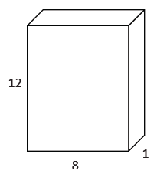

* 1. Calculate the volume of the rectangular prism.
  2. If one side of the rectangular base is scaled by a factor of , the other side of the rectangular base is scaled by a factor of , and the height of the prism is scaled by a factor of , what are the dimensions of the scaled rectangular prism?

Note that some students may have selected different sides of the base to scale compared to the solution below. Regardless, the result in part (c) will be the same.

The dimensions of the scaled rectangular prism are , , and .

OR

The dimensions of the scaled rectangular prism are ,, and .

* 1. Calculate the volume of the scaled rectangular prism.
  2. Make a conjecture about the relationship between the volume of the original rectangular prism and the scaled rectangular prism.

Answers will vary. Accept any reasonable response. The correct response is that the volume of the scaled figure is equal to the volume of the original figure multiplied by the product of the scaled factors. For this specific problem, .

1. A manufacturing company needs boxes to ship their newest widget, which measures .  Standard size boxes, -inch cubes, are inexpensive but require foam packaging so the widget is not damaged in transit.  Foam packaging costs per cubic inch.  Specially designed boxes are more expensive but do not require foam packing.  If the standard size box costs each and the specially designed box costs each, which kind of box should the company choose?  Explain your answer.

Volume of foam packaging needed in a standard box:

*; of foam packaging needed for standard-sized box.*

Total cost of widget packed in a standard box:

; total cost is

Therefore, the specially designed packages for each are more cost effective.

**Discussion (4 minutes)**

Debrief the exercises using the discussion points below.

* If a solid is scaled by factors of , , and in three perpendicular directions, what happens to the volume?

Allow students time to discuss in pairs or small groups, if necessary.

* + *If is the scaled solid, then .*

Ask students whether or not they would change their mind if was a right rectangular prism, if was a right triangular prism, or if was any solid. They should respond that the relationship would be the same as stated above.

* When a solid with volume is scaled by factors of , , and in three perpendicular directions, then the volume of the scaled figure is multiplied by a factor of

Closing (4 minutes)

Have students summarize the main points of the lesson in writing, talking to a partner, or as a whole class discussion. Use the questions below, if necessary.

* When a similarity transformation takes one solid to another, how are their volumes related?
  + *For two similar figures whose corresponding lengths are in the ratio , the ratio of their volumes is .*
* If a solid is scaled by factors of , , and in three perpendicular directions, what is the effect on the volume?
  + *The volume of the scaled figure is equal to the product of the volume of the original figure and the scale factors ,, and .*

Exit Ticket (5 minutes)

Name Date

Lesson 9: Scaling Principle for Volumes

Exit Ticket

1. Two circular cylinders are similar. The ratio of the areas of their bases is . Find the ratio of the volumes of the similar solids.
2. The volume of a rectangular pyramid is . The width of the base is then scaled by a factor of , the length of the base is scaled by a factor of , and the height of the pyramid is scaled such that the resulting image has the same volume as the original pyramid. Find the scale factor used for the height of the pyramid.

Exit Ticket Sample Solutions

1. Two circular cylinders are similar. The ratio of the areas of their bases is . Find the ratio of the volumes of the similar solids.

If the solids are similar, then their bases are similar as well. The areas of similar plane figures are related by the square of the scale factor relating the figures, and if the ratios of the areas of the bases is , then the scale factor of the two solids must be . The ratio of lengths in the two solids is, therefore, .

By the scaling principle for volumes, the ratio of the volumes of the solids is the ratio , or .

1. The volume of a rectangular pyramid is . The width of the base is then scaled by a factor of , the length of the base is scaled by a factor of , and the height of the pyramid is scaled such that the resulting image has the same volume as the original pyramid. Find the scale factor used for the height of the pyramid.

The scaling principle for volumes says that the volume of a solid scaled in three perpendicular directions is equal to the area of the original solid times the product of the scale factors used in each direction. Since the volumes of the two solids are the same, it follows that the product of the scale factors in three perpendicular directions must be .

Let represent the scale factor used for the height of the image:

The scale factor used to scale the height of the pyramid is .

Problem Set Sample Solutions

1. Coffees sold at a deli come in similar-shaped cups.  A small cup has a height of and a large cup has a height of .  The large coffee holds fluid ounces.  How much coffee is in a small cup?  Round your answer to the nearest tenth of an ounce.

The scale factor of the smaller cup is . The cups are similar so the scale factor is the same in all three perpendicular dimensions. Therefore, the volume of the small cup is equal to the volume of the large cup times , or .

The small coffee cup contains approximately fluid ounces.

1. Right circular cylinder has volume and radius . Right circular cylinder is similar to cylinder and has volume . Find the radius of cylinder .

Let be the radius of cylinder .

1. The Empire State Building is a -story skyscraper. Its height is from the ground to the roof. The length and width of the building are approximately and , respectively. A manufacturing company plans to make a miniature version of the building and sell cases of them to souvenir shops.
   1. The miniature version is just of the size of the original. What are the dimensions of the miniature Empire State Building?

*The height is , the length is about , and the width is* .

* 1. Determine the volume of the minature building. Explain how you determined the volume.

Answers will vary since the Empire State Building has irregular shape. Some students may model the shape of the building as a rectangular pyramid, rectangular prism, or combination of the two.

By modeling with a rectangular prism:

*The volume of the miniature building is approximately*

By modeling with a rectangular pyramid:

*The volume of the miniature building is approximately* .

By modeling with the composition of a rectangular prism and a rectangular pyramid:

*Combination of prisms; answers will vary. The solution that follows considers the highest of the building to be a pyramid and the lower of the building to be rectangular.*

*The volume of the miniature building is approximately .*

1. If a right square pyramid has a square base and height , then its volume is . Use this information to find the volume of a right rectangular prism with base dimensions and height .

Scale the right square pyramid by and in the directions determined by the sides of the square base and by in the direction perpendicular to the base. This turns the right square pyramid into a right rectangular pyramid with rectangular base of side lengths and and height that has volume

1. 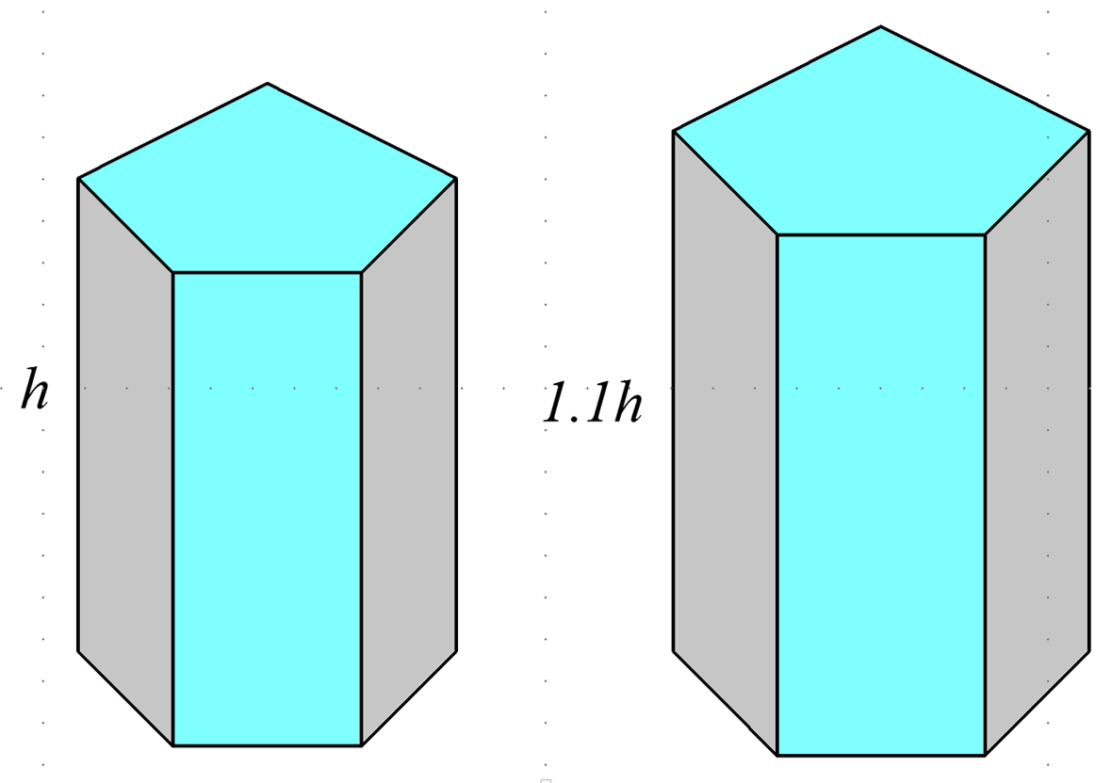The following solids are similar. The volume of the first solid is . Find the volume of the second solid.

1. A general cone has a height of . What fraction of the cone’s volume is between a plane containing the base and a parallel plane halfway between the vertex of the cone and the base plane?



The smaller top cone is similar to the whole cone and has volume of the volume of the whole cone. So, the region between the two planes is the remaining part of the volume and, therefore, has the volume of the whole cone.

1. A company uses rectangular boxes to package small electronic components for shipping. The box that is currently used can contain of one type of component. The company wants to package twice as many pieces per box. Michael thinks that the box will hold twice as much if its dimensions are doubled. Shawn disagrees and says that Michael’s idea provides a box that is much too large for pieces. Explain why you agree or disagree with one or either of the boys. What would you recommend to the company?

If the box’s dimensions were all doubled, the volume of the box should be enough to contain times the number of components that the current box holds, which is far too large for pieces. To double the volume of the box, the company could double the width, the height, or the length of the box, or extend all dimensions of the box by a scale factor of .

1. A dairy facility has bulk milk tanks that are shaped like right circular cylinders. They have replaced one of their bulk milk tanks with three smaller tanks that have the same height as the original but the radius. Do the new tanks hold the same amount of milk as the original tank? If not, explain how the volumes compare.

If the original tank had a radius of and a height of , then the volume of the original tank would be . The radii of the new tanks would be , and the volume of the new tanks combined would be . The bases of the new tanks were scaled down by a scale factor of in two directions, so the area of the base of each tank is the area of the original tank. Combining the three smaller tanks provides a base area that is the base area of the original tank. The ratio of the volume of the original tank to the three replacement tanks is

or , which means the original tank holds three times as much milk as the replacements.