Lesson 9: Scaling Principle for Volumes

Classwork

Opening Exercise

1. For each pair of similar figures, write the ratio of side lengths or that compares one pair of corresponding sides. Then, complete the third column by writing the ratio that compares the areas of the similar figures. Simplify ratios when possible.

|  |  |  |
| --- | --- | --- |
| **Similar Figures** | **Ratio of Side Lengths   or** | **Ratio of Areas**  **or** |
|  |  |  |
| Rectangle Rectangle |  |  |
|  |  |  |
|  |  |  |
| Rectangle Rectangle |  |  |

* 1. State the relationship between the ratio of sides and the ratio of the areas
  2. Make a conjecture as to how the ratio of sides will be related to the ratio of volumes   
      Explain.

1. What does is mean for two solids in three-dimensional space to be similar?

Exercises

1. Each pair of solids shown below is similar. Write the ratio of side lengths comparing one pair of corresponding sides. Then, complete the third column by writing the ratio that compares volumes of the similar figures. Simplify ratios when possible.

|  |  |  |
| --- | --- | --- |
| **Similar Figures** | **Ratio of Side Lengths** | **Ratio of Volumes** |
| Figure A Figure B |  |  |
| **Figure A**    **Figure B** |  |  |
| **Figure A Figure B** |  |  |
| **Figure A Figure B** |  |  |
| **Figure A**    **Figure B** |  |  |

1. 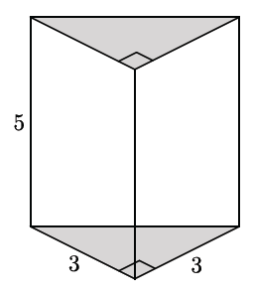Use the triangular prism shown to answer the questions that follow.
   1. Calculate the volume of the triangular prism.
   2. If one side of the triangular base is scaled by a factor of , the other side of the triangular base is scaled by a factor of , and the height of the prism is scaled by a factor of , what are the dimensions of the scaled triangular prism?
   3. Calculate the volume of the scaled triangular prism.
   4. Make a conjecture about the relationship between the volume of the original triangular prism and the scaled triangular prism.
   5. Do the volumes of the figures have the same relationship as was shown in the figures in Exercise 1? Explain.
2. 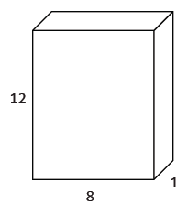Use the rectangular prism shown to answer the questions that follow.
   1. Calculate the volume of the rectangular prism.
   2. If one side of the rectangular base is scaled by a factor of , the other side of the rectangular base is scaled by a factor of , and the height of the prism is scaled by a factor of , what are the dimensions of the scaled rectangular prism?
   3. Calculate the volume of the scaled rectangular prism.
   4. Make a conjecture about the relationship between the volume of the original rectangular prism and the scaled rectangular prism.
3. A manufacturing company needs boxes to ship their newest widget, which measures .  Standard size boxes, -inch cubes, are inexpensive but require foam packaging so the widget is not damaged in transit.  Foam packaging costs per cubic inch.  Specially designed boxes are more expensive but do not require foam packing.  If the standard size box costs each and the specially designed box costs each, which kind of box should the company choose?  Explain your answer.

Problem Set

1. Coffees sold at a deli come in similar-shaped cups.  A small cup has a height of and a large cup has a height of .  The large coffee holds fluid ounces.  How much coffee is in a small cup?  Round your answer to the nearest tenth of an ounce.
2. Right circular cylinder has volume and radius . Right circular cylinder is similar to cylinder and has volume . Find the radius of cylinder .
3. The Empire State Building is a -story skyscraper. Its height is from the ground to the roof. The length and width of the building are approximately and , respectively. A manufacturing company plans to make a miniature version of the building and sell cases of them to souvenir shops.
   1. The miniature version is just of the size of the original. What are the dimensions of the miniature Empire State Building?
   2. Determine the volume of the minature building. Explain how you determined the volume.
4. If a right square pyramid has a square base and height , then its volume is . Use this information to find the volume of a right rectangular prism with base dimensions and height .
5. The following solids are similar. The volume of the first solid is . Find the volume of the second solid.

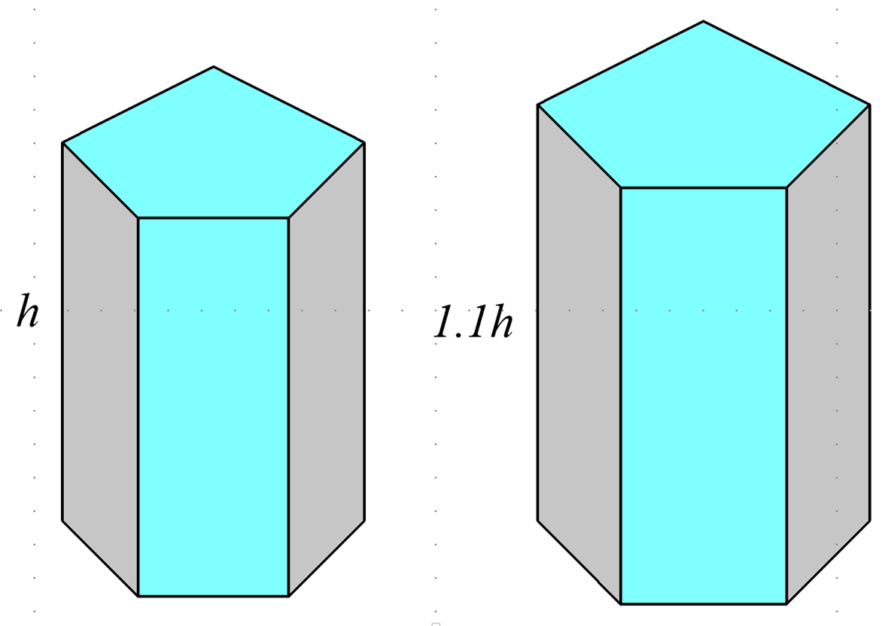

1. A general cone has a height of . What fraction of the cone’s volume is between a plane containing the base and a parallel plane halfway between the vertex of the cone and the base plane?



1. A company uses rectangular boxes to package small electronic components for shipping. The box that is currently used can contain of one type of component. The company wants to package twice as many pieces per box. Michael thinks that the box will hold twice as much if its dimensions are doubled. Shawn disagrees and says that Michael’s idea provides a box that is much too large for pieces. Explain why you agree or disagree with one or either of the boys. What would you recommend to the company?
2. A dairy facility has bulk milk tanks that are shaped like right circular cylinders. They have replaced one of their bulk milk tanks with three smaller tanks that have the same height as the original but the radius. Do the new tanks hold the same amount of milk as the original tank? If not, explain how the volumes compare.