|  |
| --- |
|  |

Lesson 8: Definition and Properties of Volume

Student Outcomes

* Students understand the precise language that describes the properties of volume.
* Students understand that the *volume of any right cylinder* is given by the formula .

Lesson Notes

Students have been studying and understanding the *volume properties* since Grade 5 (**5.MD.C.3**, **5.MD.C.4**, **5.MD.C.5**). We review the idea that the volume properties are analogous to the *area properties* by doing a side-by-side comparison in the table. Since the essence of the properties is not new, the idea is for students to become comfortable with the formal language. Images help illustrate the properties. The goal is to review the properties briefly and spend the better part of the lesson demonstrating why the volume of any right general cylinder is . It will be important to draw on the parallel between the *approximation process used for area* (in Lesson 1) and in this lesson. Just as rectangles and triangles were used for the upper and lower approximations to help determine area, so we can show that *right rectangular prisms* and *triangular prisms* are used to make the same kind of approximation for the volume of a general right cylinder.

Classwork

Opening (6 minutes)

* Today, we examine properties of volume (much as we examined the properties of area in Lesson 2) and why the volume of a right cylinder can be found with the formula .
* Just as we approximated the area of curved or irregular regions by using rectangles and triangles to create upper and lower approximations, we can approximate the volume of general cylinders by using rectangular and triangular prisms to create upper and lower approximations.

Spend a few moments on a discussion of what students believe *volume* means (consider having a solid object handy as a means of reference). Students will most likely bring up the idea of “amount of space” or “how much water” an object holds as part of their descriptions. If students cite volume as “how much water” (or sand, air, etc.) an object holds, point out that to measure the volume of water, we would have to discuss volume yet again and be stuck in circular reasoning. Conclude with the idea that, just like area, we leave volume as an undefined term, but we can list what we believe is true about volume; the list below contains assumptions we make regarding volume.

There are two options teachers can take in the discussion on volume properties. (1) Show the area properties as a point of comparison and simply ask students to describe properties that come to mind when they think of volume (students have been studying volume and its properties since Grade 5). (2) Provide students with the handout at the close of the lesson and ask them to describe in their own words what they think the analogous properties are in three dimensions for volume. Whichever activity is selected, keep it brief.

Then share the following table that lists the volume properties with precise language. Ask students to compare the list of area properties to the list of volume properties; elicit from students that the properties for volume parallel the properties for area. The goal is to move through this table at a brisk pace, comparing the two columns to each other, and supporting the language with the images or describing a potential problem using the images. The following statements are to help facilitate the language of each property during the discussion:

Regarding Property 1: We assign a numerical value greater than or equal to zero that quantifies the size but not the shape of an object in three dimensions.

Regarding Property 2: Just as we declared that the area of a rectangle is given by the formula , we are making a statement saying that the volume of a box, or a right rectangular or triangular prism, is .

Regarding Property 3: In two dimensions, we identify two figures as congruent if a sequence of rigid motions maps one figure onto the other so that the two figures coincide. We make the same generalization for three dimensions. Two solids, such as the two cones, are congruent if there is a series of three-dimensional rigid motions that will map one onto the other.

Regarding Property 4: The volume of a composite figure is the sum of the volumes of the individual figures minus the volume of the overlap of the figures.

Regarding Property 5: When a figure is formed by carving out some portion, we can find the volume of the remaining portion by subtraction.

Regarding Property 6: Just as in Lesson 1, we used upper and lower approximations comprised of rectangles and triangles to get close to the actual area of a figure, so we will do the same for the volume of a curved or irregular general right cylinder but with the use of triangular and rectangular prisms.

|  |  |
| --- | --- |
| Area Properties | Volume Properties |
| 1. The area of a set in two dimensions is a number greater than or equal to zero that measures the size of the set and not the shape. | * + - 1. The volume of a set in three dimensions is a number greater than or equal to zero that measures the size of the set and not the shape. |
| 1. The area of a rectangle is given by the formula . The area of a triangle is given by the formula .  A polygonal region is the union of finitely many non-overlapping triangular regions and has area the sum of the areas of the triangles. | * + - 1. A right rectangular or triangular prism has volume given by the formula . A right prism is the union of finitely many non-overlapping right rectangular or triangular prisms and has volume the sum of the volumes of the prisms. |
|  |  |

|  |  |
| --- | --- |
| 1. Congruent regions have the same area. | * + - 1. Congruent solids have the same volume. |
|  |  |
| 1. The area of the union of two regions is the sum of the areas minus the area of the intersection: | * + - 1. The volume of the union of two solids is the sum of the volumes minus the volume of the intersection: |
|  |  |
| 1. The area of the difference of two regions where one is contained in the other is the difference of the areas:   If , then . | * + - 1. The volume of the difference of two solids where one is contained in the other is the difference of the volumes:   If , then . |
|  |  |
| 1. The area of a region can be estimated by using polygonal regions and so that is contained in and is contained in . Then . | * + - 1. The volume of a solid can be estimated by using right prism solids and so that . Then . |
|  |  |

Opening Exercise (6 minutes)

For the following questions, students are expected to use general arguments to answer each prompt. Allow students to complete the questions independently or in small groups.

Opening Exercise

1. Use the following image to reason why the area of a right triangle is (Area Property 2).

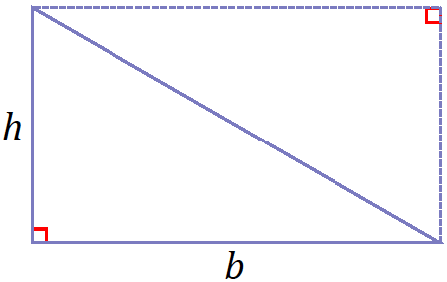

The right triangle may be rotated about the midpoint of the hypotenuse so that two triangles together form a rectangle. The area of the rectangle can be found by the formula . Since two congruent right triangles together have an area described by , one triangle can be described by half that value, or .

1. Use the following image to reason why the volume of the following triangular prism with base area and height is (Volume Property 2).

**MP.3**

**&**

**MP.7**

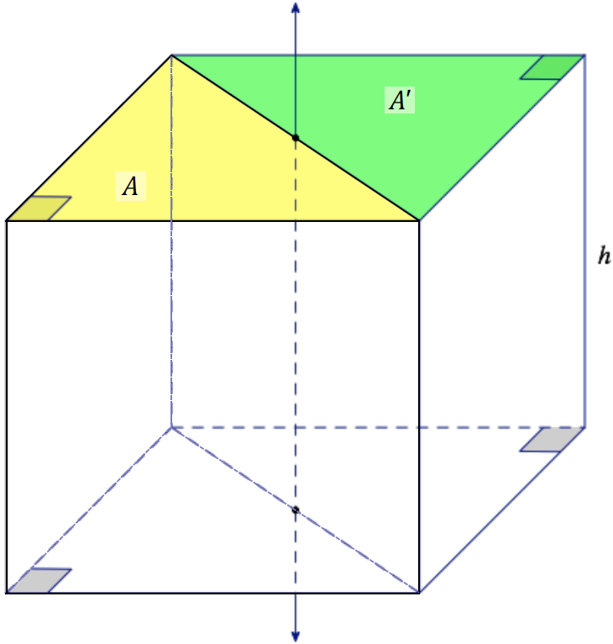

The copy of a triangular prism with a right triangle base can be rotated about the axis shown so that the two triangular prisms together form a rectangular prism with volume . Since two congruent right triangular prisms together have a volume described by , the triangular prism has volume half that value, or .

Note that the response incorporates the idea of a rotation in three dimensions. It is not necessary to go into great detail about rigid motions in three dimensions here, as the idea can be applied easily without drawing much attention to it. However, should students ask, it is sufficient to say that rotations, reflections, and translations behave much as they do in three dimensions as they do in two dimensions.

**Discussion (10 minutes)**

* As part of our goal to approximate the volume of a general right cylinder with rectangular and triangular prisms, we will focus our discussion on finding the volume of different types of triangular prisms.
* The image in Opening Exercise, part (b) makes use of a triangular prism with a right triangle base.
* Can we still make the argument that *any* triangular prism (i.e., a triangular prism that does not necessarily have a *right* triangle as a base) has a volume described by the formula ?

*Scaffolding:*

* Consider using the triangular prism nets provided in Grade 6, Module 5, Lesson 15 during this Discussion.
* Show how triangular prisms that do not have right triangle bases can be broken into right triangular prisms.

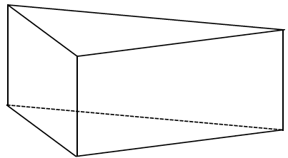 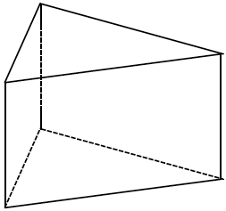

* Consider the following obtuse and acute triangles. Is there a way of showing that a prism with either of the following triangles as bases will still have the volume formula ?

**MP.3**

**&**

**MP.7**

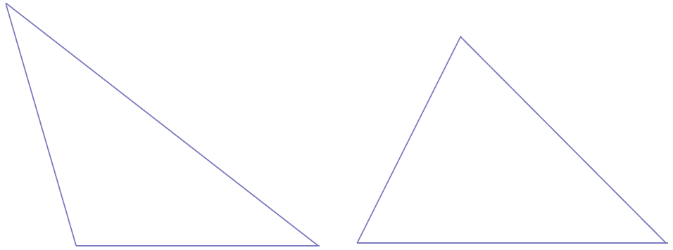

Allow students a few moments to consider the argument will hold true. Some may try to form rectangles out of the above triangles. Continue the discussion after allowing them time to understand the essential question: Can the volume of any triangular prism be found using the formula (where represents the area of the base, and represents the height of the triangular prism)?

* *Any* triangle can be shown to be the union of two right triangles. Said more formally, any triangular region is the union of two right triangular regions so that is a side of each triangle.

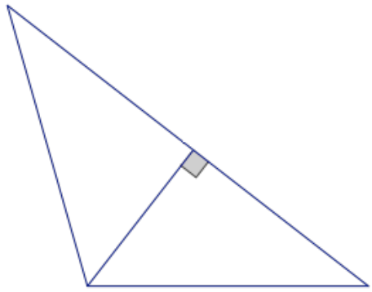 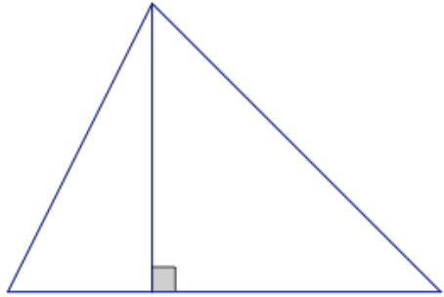

* Then we can show that the area of either of the triangles is the sum of the area of each sub-triangle:

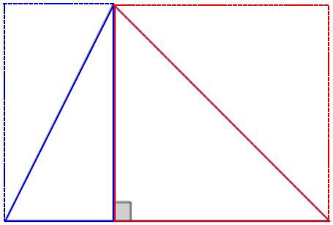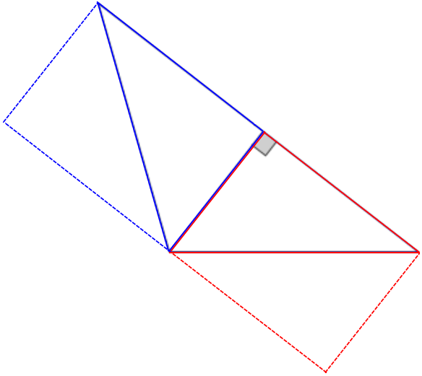

* Just as we can find the total area of the triangle by adding the areas of the two smaller triangles, we can find the total volume of the triangular prism by adding the volumes of each sub-triangular prism:

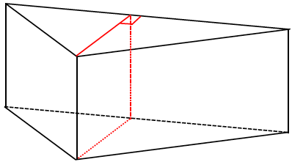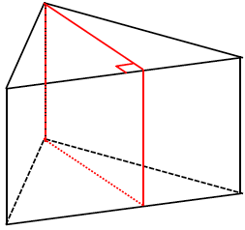

* What do we now know about any right prism with a triangular base?
  + *Any triangular region can be broken down into smaller right triangles. Each of the sub-prisms formed with those right triangles as bases has a volume formula of. Since the height is the same for both sub-prisms, the volume of an entire right prism with triangular base can be found by taking the sum of the areas of the right triangular bases times the height of the prism.*

Allow students to consider and share ideas on this with a partner. The idea can be represented succinctly in the following way and is a great example of the use of the *distributive property*:

* Any right prism with a triangular base and height is the union of right prisms with bases made up of right triangular regions and , respectively, so that is a rectangle of zero volume (Volume Property 4).

Note that we encountered a similar situation in Lesson 2 when we took the union of two squares and followed the respective Area Property 4 in that lesson: . In that case, we saw that the area of the intersection of two squares was a line segment, and the area had to be . The same sort of thing happens here, and the volume of a rectangle must be . Remind students that this result allows us to account for all cases, but that when the area or volume of the overlap is , we usually ignore it in the calculation.

* How is a general right prism related to a right triangular prism?
  + *The base of a general right prism is a polygon, which can be divided into triangles.*

Note: The *right* in right triangular prism qualifies the prism (i.e., we are referring to a prism whose lateral edges are perpendicular to the bases). To cite a triangular prism with a right triangle base, the base must be described separately from the prism.

* Given that we know that the base of a general right prism is a polygon, what will the formula for its volume be? Explain how you know.

Allow students a few moments to articulate this between partner pairs, and then have them share their ideas with the class. Students may say something to the following effect:

* + *We know that any general right prism has a polygonal base, and any polygon can be divided into triangles*. *The volume of a triangular prism can be calculated by taking the area of the base times the height. Then we can picture a general prism being made up of several triangular prisms, each of which has a volume of area of the base times the height. Since all the triangular prisms would have the same height, this calculation is the same as taking the sum of all the triangles’ areas times the height of the general prism. The sum of all the triangles’ areas is just the base of the prism, so the volume of the prism is area of the base times the height.*

Confirm with the following explanation:

* The base of a general right prism with height is always a polygonal region. We know that the polygonal region is the union of finitely many non-overlapping triangles:
* Let be the right triangular prisms with height with bases , respectively. Then   
   of non-overlapping triangular prisms, and the volume of right prism is

Exercises 1–2 (4 minutes)

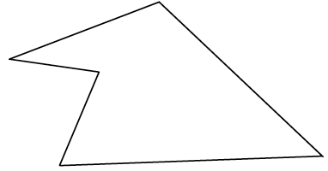  
Exercises 1–2

Complete Exercises 1–2, and then have a partner check your work.

1. Divide the following polygonal region into triangles. Assign base and height values of your choice to each triangle, and determine the area for the entire polygon.

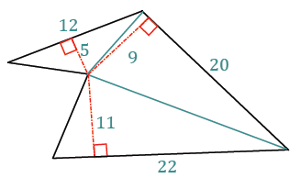Sample response:

1. 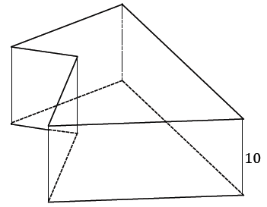The polygon from Exercise 1 is used here as the base of a general right prism. Use a height of and the appropriate value(s) from Exercise 1 to determine the volume of the prism.

Sample response:

**Discussion (8 minutes)**

* What have we learned so far in this lesson?
  + *We reviewed the properties of volume.*
  + *We determined that the volume formula for any right triangular prism and any general right prism is , where is the area of the base of the prism and is the height.*
* What about the volume formula for a general right cylinder? What do you think the volume formula for a general right cylinder will be?
* Think back to Lesson 1 and how we began to approximate the area of the ellipse. We used whole squares and half squares—regions we knew how to calculate the areas of—to make upper and lower area approximations of the curved region.



* Which image shows a lower approximation? Which image shows an upper approximation?

|  |  |  |
| --- | --- | --- |
| Lower approximation |  | Upper approximation |
|  |  |  |

* Now imagine a similar situation, but in three dimensions.

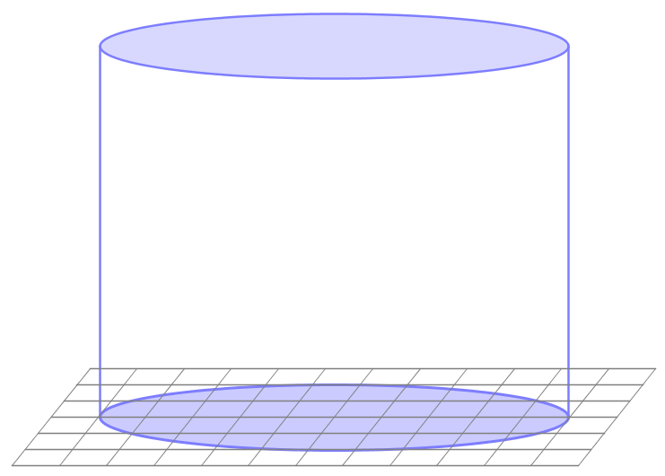

* To approximate the volume of this elliptical cylinder, we will use rectangular prisms and triangular prisms (because we know how to find their volumes) to create upper and lower volume approximations. The prisms we use are determined by first approximating the area of the base of the elliptical cylinder, and projecting prisms over these area approximations using the same height as the height of the elliptical cylinder:

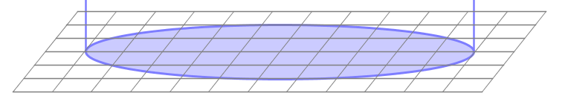

* For any lower and upper approximations, and , of the base, the following inequality holds:

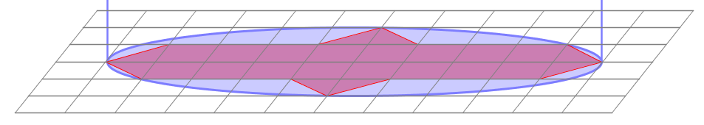

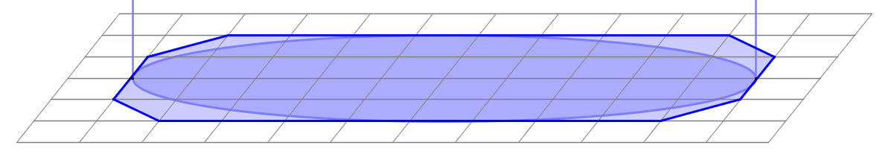

* Since this is true no matter how closely we approximate the region, we see that the area of the base of the elliptical cylinder, , is the unique value between the area of any lower approximation, , and the area of any upper approximation, .
* What would we have to do in order to determine the volume of the prisms built over the areas of the upper and lower approximations, given a height of the elliptical cylinder?

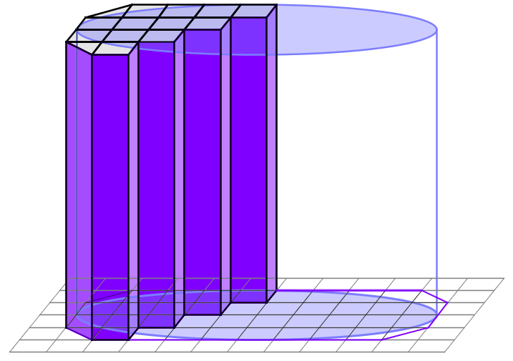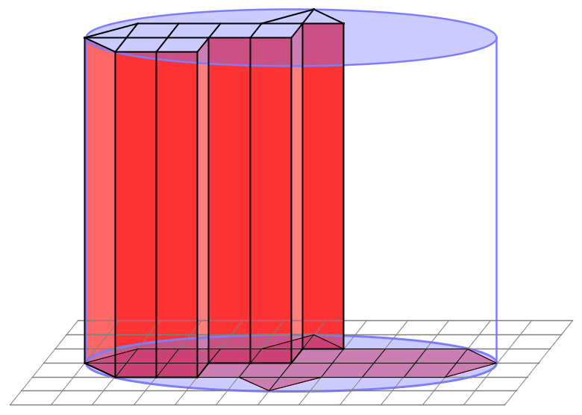

* + *We would have to multiply the area of the base times the height.*
* Then the volume formula of the prism over the area of the lower approximation is and the volume formula of the prism over the area of the upper approximation is .
* Since and , we can then conclude that
* This inequality holds for any pair of upper and lower approximations of the base, so we conclude that the volume of the elliptical cylinder will be the unique value determined by the area of its base times its height, or .
* The same process works for any general right cylinder.  Hence, the volume formula for a general right cylinder is area of the base times the height, or .

Exercises 3–4 (4 minutes)

With any remaining time available, have students try the following problems.

Exercises 3–4

We can use the formula to find the density of a substance.

1. A square metal plate has a density of and weighs .
   1. Calculate the volume of the plate.

*The volume of the plate is* .

* 1. If the base of this plate has an area of , determine its thickness.

Let represent the thickness of the plate in centimeter.

*The thickness of the plate is* .

1. A metal cup full of water has a mass of . The cup itself has a mass of . If the cup has both a diameter and a height of , what is the approximate density of water?

*The mass of the water is the difference of the mass of the full cup and the mass of the empty cup, which is* .

The volume of the water in the cup is equal to the volume of the cylinder with the same dimensions.

Using the density formula,

*The density of water is approximately* .

Closing (2 minutes)

Ask students to summarize the key points of the lesson. Additionally, consider asking students the following questions independently in writing, to a partner, or to the whole class.

* What is the volume formula for any triangular prism? Briefly describe why.
  + *The volume formula is area of the base times height, or . This is because we can break up any triangle into sub-triangles that are right triangles. We know that the volume formula for a triangular prism with a right triangle base is ; then the volume of a prism formed over a composite base made up of right triangles is also .*
* Compare the role of rectangular and triangular prisms in approximating the volume of a general right cylinder to that of rectangles and triangles in approximating the area of a curved or irregular region.
  + *Since we do not know how to calculate the area of a curved or irregular region, we use figures we do know how to calculate the area for (rectangles and triangles) to approximate those regions. This is the same idea behind using rectangular and triangular prisms for approximating volumes of general right prisms with curved or irregular bases.*
* What is the volume formula for any general right cylinder?
  + *The volume formula is area of the base times height, or .*

Exit Ticket (5 minutes)

Name Date

Lesson 8: Definition and Properties of Volume

Exit Ticket

The diagram shows the base of a cylinder. The height of the cylinder is . If each square in the grid is , make an approximation of the volume of the cylinder. Explain your reasoning.

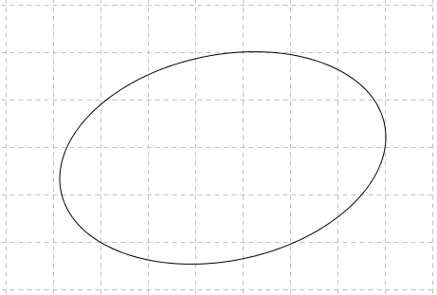

Exit Ticket Sample Solutions

The diagram shows the base of a cylinder. The height of the cylinder is . If each square in the grid is , make an approximation of the volume of the cylinder. Explain your reasoning.

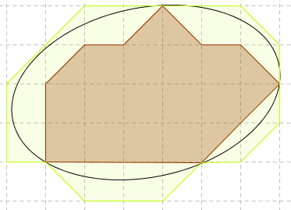

*By counting the unit squares and triangles that make up a polygonal region lying just within the given region, a low approximation for the area of the region is* . *By counting unit squares and triangles that make up a polygonal region that just encloses the given region, an upper approximation for the area of the region is* . *The average of these approximations gives a closer approximation of the actual area of the base.*

***The average approximation of the area of the base of the cylinder is* .**

The volume of the prism is equal to the product of the area of the base times the height of the prism.

*The volume of the cylinder is approximately* .

Problem Set Sample Solutions

1. Two congruent solids and have the property that is a right triangular prism with height and a base that is an equilateral triangle of side length . If the volume of is , find the volume of .

The area of the base of the right triangular prism is and the volume of the right triangular prism is . Let equal the volume of in cubic units. Then, the volume of in cubic units is .

*The volume of . So . The volume of is* .

1. Find the volume of a triangle with side lengths , , and .

A triangle is a planar figure. The volume of any planar figure is zero because it lies in the plane and, therefore, has no height.

1. 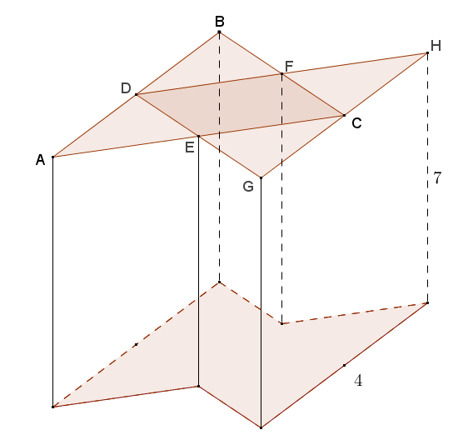The base of the prism shown in the diagram consists of overlapping congruent equilateral triangles and . Points , , , and are midpoints of the sides of triangles and . , and the height of the prism is . Find the volume of the prism.

connects the midpoints of and and is, therefore, the altitude of both triangles and . The altitude in an equilateral triangle splits the triangle into two congruent -- triangles. Using the relationships of the legs and hypotenuse of a -- triangle, .

Volume of triangular prism with base :

The volume of the triangular prism with base is also by the same reasoning.

Volume of parallelogram :

The volume of the prism is .

1. Find the volume of a right rectangular pyramid whose base is a square with side length and whose height is .

Hint: Six such pyramids can be fit together to make a cube with side length as shown in the diagram.

Piecing six congruent copies of the given pyramid together forms a cube with edges of length . The volume of the cube is equal to the area of the base times the height:

Since there are six identical copies of the pyramid forming the cube, the volume of one pyramid is equal to of the total volume of the cube:

The volume of the given rectangular pyramid is cubic units.

1. Draw a rectangular prism with a square base such that the pyramid’s vertex lies on a line perpendicular to the base of the prism through one of the four vertices of the square base, and the distance from the vertex to the base plane is equal to the side length of the square base.

Sample drawing shown:

1. The pyramid that you drew in Problem 5 can be pieced together with two other identical rectangular pyramids to form a cube. If the side lengths of the square base are , find the volume of the pyramid.

If the sides of the square are length , then the cube formed by three of the pyramids must have edges of length . The volume of a cube is the cube of the length of the edges, or . The pyramid is only of the cube, so the volume of the pyramid is of the volume of the cube:

The volume of the pyramid is cubic units.

1. Paul is designing a mold for a concrete block to be used in a custom landscaping project. The block is shown in the diagram with its corresponding dimensions and consists of two intersecting rectangular prisms. Find the volume of mixed concrete, in cubic feet, needed to make Paul’s custom block.

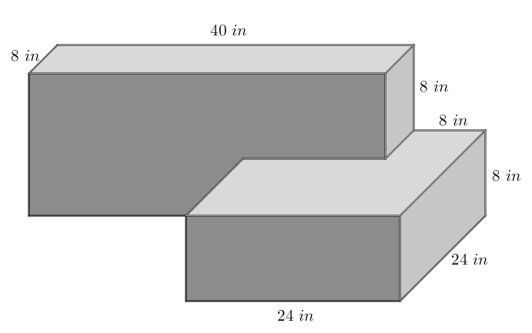The volume is needed in cubic feet, so the dimensions of the block can be converted to feet:

.

*The two rectangular prisms that form the block do not have the same height; however, they do have the same thickness of*, *and their intersection is a square prism with base side lengths of* , *so Volume Property 4 can be applied:*

*Paul will need just over* *of mixed concrete to fill the mold.*

1. Challenge: Use card stock and tape to construct three identical polyhedron nets that together form a cube.



Opening

|  |  |
| --- | --- |
| **Area Properties** | **Volume Properties** |
| 1. The area of a set in two dimensions is a number greater than or equal to zero that measures the size of the set and not the shape. |  |
| 1. The area of a rectangle is given by the formula . The area of a triangle is given by the formula . A polygonal region is the union of finitely many non-overlapping triangular regions and has area the sum of the areas of the triangles. |  |
|  |  |
| 1. Congruent regions have the same area. | 1. Congruent solids have the same volume. |
|  |  |
| 1. The area of the union of two regions is the sum of the areas minus the area of the intersection: |  |
|  |  |
| 1. The area of the difference of two regions where one is contained in the other is the difference of the areas: If , then . |  |
|  |  |
| 1. The area of a region can be estimated by using polygonal regions and so that is contained in and is contained in .   Then . |  |
|  |  |