|  |
| --- |
|  |

Lesson 7: General Pyramids and Cones and Their  
Cross-Sections

Student Outcomes

* Students understand the definition of a *general pyramid* and *cone,* and that their respective *cross-sections* are similar to the base.
* Students show that if two cones have the same base area and the same height, then cross-sections for the cones the same distance from the vertex have the same area.

Lesson Notes

In Lesson 7, students examine the relationship between a cross-section and the base of a general cone. Students understand that pyramids and circular cones are subsets of general cones just as prisms and cylinders are subsets of general cylinders. In order to understand why a cross-section is similar to the base, there is discussion regarding a *dilation in three-dimensions,* explaining why a dilation maps a plane to a parallel plane. Then, a more precise argument is made using triangular pyramids; this parallels what is seen in Lesson 6, where students are presented with the intuitive idea of why bases of general cylinders are congruent to cross-sections using the notion of a translation in three dimensions, followed by a more precise argument using a triangular prism and *SSS triangle congruence.* Finally, students prove the *general cone cross-section theorem,* which we will later use to understand *Cavalieri’s principle*.

Classwork

Opening Exercise (3 minutes)

The goals of the Opening Exercise are to remind students of the parent category of general cylinders, how prisms are a subcategory under general cylinders, and how to draw a parallel to figures that “come to a point” (or, they might initially describe these figures); some of the figures that come to a point have polygonal bases, while some have curved bases. This is meant to be a quick exercise; allow seconds for students to jot down ideas and another seconds to share out responses.

Opening Exercise

Group the following images by shared properties. What defines each of the groups you have made?

|  |  |  |  |
| --- | --- | --- | --- |
| cid:1EBD0332-8124-4693-BE2A-9FB32B7832A2@wp.comcast.net |  |  |  |
|  |  |  |  |
|  |  |  |  |
|  |  |  |  |

Group A: General cylinders, images and .

Group B: Prisms, images and .

Group C: Figures that come to a point with a polygonal base, images and .

Group D: Figures that come to a point with a curved or semi-curved region as a base, images and .

**Discussion (10 minutes)**

*Scaffolding:*

* Consider using the Frayer model as part of students’ notes for the definition.
* Consider choral repetition of the vocabulary.

Spend 6–7 minutes on the definitions of cone and rectangular pyramid in relation to the Opening Exercise. Provide time for students to generate and write down their own definitions in partner pairs (for both rectangular pyramid and general cone) before reviewing the precise definitions; encourage students to refer to the language used in Lesson 6 for general cylinder.

Leave the balance of time for the discussion on why cross-sections of pyramids are similar to the base and how to find the scale factor of the dilation that maps the base to the cross-section.

* Image 4 of the Opening Exercise is an example of a rectangular pyramid. What would be your definition of a rectangular pyramid?
* Images 2, 4, 5, and 8 are examples of general cones. What would be your definition of a general cone?

Have the definition of *general cylinder* prominently visible in the classroom as a point of comparison to the definition of a *general cone*.

Rectangular pyramid: Given a rectangular region in a plane and a point not in , the *rectangular pyramid with base and vertex*  is the collection of all segments for any point in .

General cone: Let be a region in a plane and be a point not in . The *cone with base and vertex*  is the union of all segments for all points in (See Figures 1 and 2).

Figure 2



Figure 1



* You have seen rectangular pyramids before. Look at the definition again, and compare and contrast it with the definition of general cone.

*Scaffolding:*

* Consider highlighting the terms *lateral faces* and *edges* with the use of nets for rectangular pyramids that are available in the supplemental materials of Grade 7, Module 6.
* The definitions are essentially the same. The only difference is that a rectangular pyramid has a rectangular base. A general cone can have any region for a base.
* Much like a general cylinder, a general cone is named by its base.
* A general cone with a disk as a base is called a *circular cone*.
* A general cone with a polygonal base is called a *pyramid.* Examples of this include a rectangular pyramid or a triangular pyramid.
* A general cone whose vertex lies on the perpendicular line to the base and that passes through the center of the base is a *right cone* (or a *right pyramid* if the base is polygonal). Figure 4 shows a right rectangular pyramid, while Figure 3 shows a rectangular pyramid that is not right.

Figure 4



Figure 3



* A *right circular cone* has been commonly referred to as a *cone* since the elementary years; we will continue to use *cone* to refer to a *right circular cone.*

For pyramids, in addition to the base, we have lateral faces and edges.

* Name a lateral face and edge in Figure 5 and explain how you know it is a lateral face.

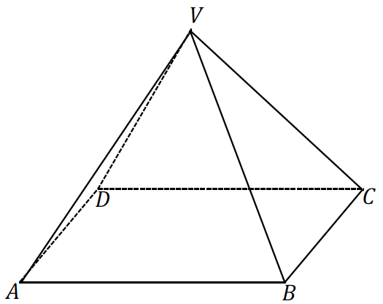

Figure 5

* + *The triangular region is defined by a side of the base, , and vertex and is an example of a lateral face.*
  + *The segments , ,, and are all lateral edges.*

Once the definitions of general cone and rectangular pyramid have been discussed, begin the discussion on how the cross-section is similar to the base.

* Observe the general cone in Figure 6. The plane is parallel to and is between the point and the plane . The intersection of the general cone with gives a cross-section .

Figure 6



*Scaffolding:*

* Remind students of their study of cross-sections of general cylinders in Lesson 6; a cross-section is a slice taken parallel to the base of the solid.
* Ask students, “Can a cross-section of a pyramid be made at an angle, or does it have to be parallel to the base?” (It must be parallel to the base.)
* We can show the existence of a dilation that maps to ; this similarity transformation would imply that the cross-section is similar to the base.
* We have only studied dilations in two dimensions, or in the plane, but it turns out that dilations behave similarly in three-dimensional space.
* A *dilation* of three-dimensional space with center and scale factor is defined the same way it is in the plane. The dilation maps to itself and maps any other point to the point on ray so that .

Emphasize that we already knew that a dilation is thought of as two points at a time: the center and a point being dilated. This still holds true in three dimensions.

A visual may help establish an intuitive sense of what a dilation of a three-dimensional figure looks like. This can be easily done using interactive whiteboard software that commonly includes images of prisms. By enlarging and reducing the image of a prism, students can get a feel of what is happening during the dilation of a 3D figure. Snapshots are provided below.

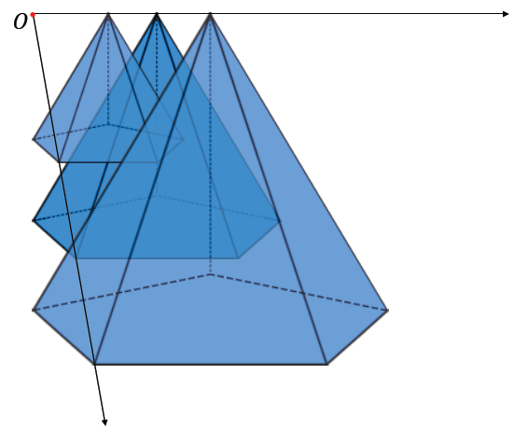

enlargement

reduction

original

Example 1 (8 minutes)

* We have made the claim that a cross-section of a general cone is similar to its base. Use the following question as a means of demonstrating why this should be true.

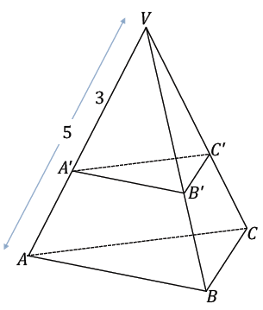  
Example 1

In the following triangular pyramid, a plane passes through the pyramid so that it is parallel to the base and results in the cross-section . If the area of is , what is the area of ?

* Based on the fact that the cross-section is parallel to the base, what can you conclude about and ?
  + *They must be parallel.*
* Since , by the *triangle side splitter theorem,* we can conclude that splits proportionally. Then a dilation maps to and to by the same scale factor. What is the center and scale factor of this dilation?
  + *The center must be and the scale factor must be .*
* What does the *dilation theorem* tell us about the length relationship between and ?
* Furthermore, since the cross-section is parallel to the base, what conclusions can we draw about the relationship between and , and and ?
  + *and and, just as with and , a dilation with center and the scale factor maps to and to . and .*
* If each of the lengths of is the corresponding lengths of , what can be concluded about the relationship between and ?
  + *The triangles are similar by the SSS similarity criterion.*
* What is the relationship between the areas of these similar figures?
* Find the area of .
  + *; the area of is .*
* Based on what we knew about the cross-section of the pyramid, we were able to determine that the cross-section is in fact similar to the base and use that knowledge to determine the area of the cross-section.

Example 2 (7 minutes)

* In Example 1, we found evidence to support our claim that the cross-section of the pyramid was similar to the base of the pyramid. We were able to find the area of the cross-section because the lengths provided along an edge of the pyramid allowed us to find the scale factor of the dilation involved.
* Can we solve a similar problem if the provided lengths are along the altitude of the pyramid?

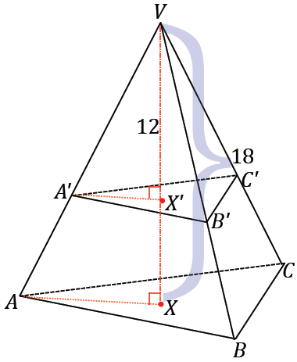  
Example 2

In the following triangular pyramid, a plane passes through the pyramid so that it is parallel to the base and results in the cross-section . The altitude from is drawn; the intersection of the altitude with the base is , and the intersection of the altitude with the cross-section is . If the distance from to is , the distance from to is , and the area of is , what is the area of ?

Allow students time to wrestle with the question in partner pairs or small groups. Triangles and can be shown to be similar by the AA Similarity. The argument to show that the cross-section is similar to the base is the same as that presented in Example 1. The difference here is how to determine the scale factor of the dilation. Since the corresponding sides of the right triangles are proportional in length, the scale factor is . The area of the base can be calculated as follows:

The area of is .

Before moving to either the Extension or Exercise 1, have a brief conversation on how a cone can be generated from rotating a right triangle about either leg of the triangle.

* As we saw in Lesson 6, it is possible to generate a three-dimensional figure from a two-dimensional figure. What would happen if a right triangle were rotated about one of its sides? What figure would be outlined by this rotation?

Model what this looks like by taping one leg of a piece of paper cut in the shape of a right triangle to a pencil and spinning the pencil between the palms of your hands. Students should see that the rotation sweeps out a cone. Question 4, parts (a) and (b) in the Problem Set relate to this concept.

**Extension:** This Extension generalizes the argument of why cross-sections are similar to their bases. This section could be used as a substitute for Example 1. If this Extension is not being used in the lesson, proceed to Exercise 1.

* Now, let’s look at a special case: a triangular pyramid. In this case, we can use what we know about triangles to prove that cross-sections are similar to the base.

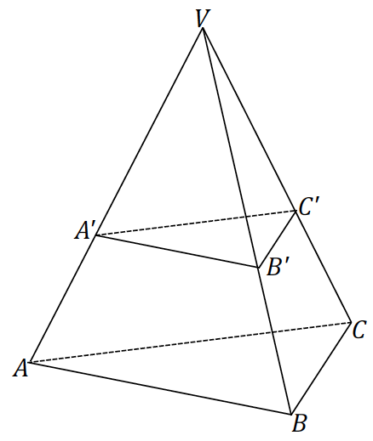  
Extension

* Look at plane . Can you describe a dilation of this plane that would take to ? Remember to specify a center and a scale factor.
  + *The dilation would have center and scale factor* .
* Do the same for plane
  + *The scale factor for this dilation would also be* .
* What about plane ?
  + *The scale factor is still* .
* Since corresponding sides are related by the same scale factor, what can you conclude about triangles and ?
  + *by the SSS similarity criterion.*
* How can this result be used to show that any pyramid (i.e., those with polygonal bases rather than those with triangular bases) has cross-sections similar to the base?
  + *Whatever polygon represents the base of the pyramid, we can cut the pyramid up into a bunch of triangular regions. Then, the cross-section will be a bunch of triangles that are similar to the corresponding triangles in the base. So, the cross-section as a whole is similar to the base.*
* Observe that while we’ve only proven the result for pyramids, it does generalize for general cones, just as we suspected when we discussed dilations.



* Since , we know that , where is the scale factor of the dilation.
* How can we relate the scale factor to the height of the general cone?

Allow students a moment to consider before continuing.

* Draw an altitude for the cone, and let and be the points where it intersects planes and respectively. Call the distance between and as and the distance between and as .
* Choose a point in and draw . Let be the intersection of this segment with .
* Consider plane . What is the scale factor taking segment to segment ?
  + *A dilation with scale factor and center maps to .*

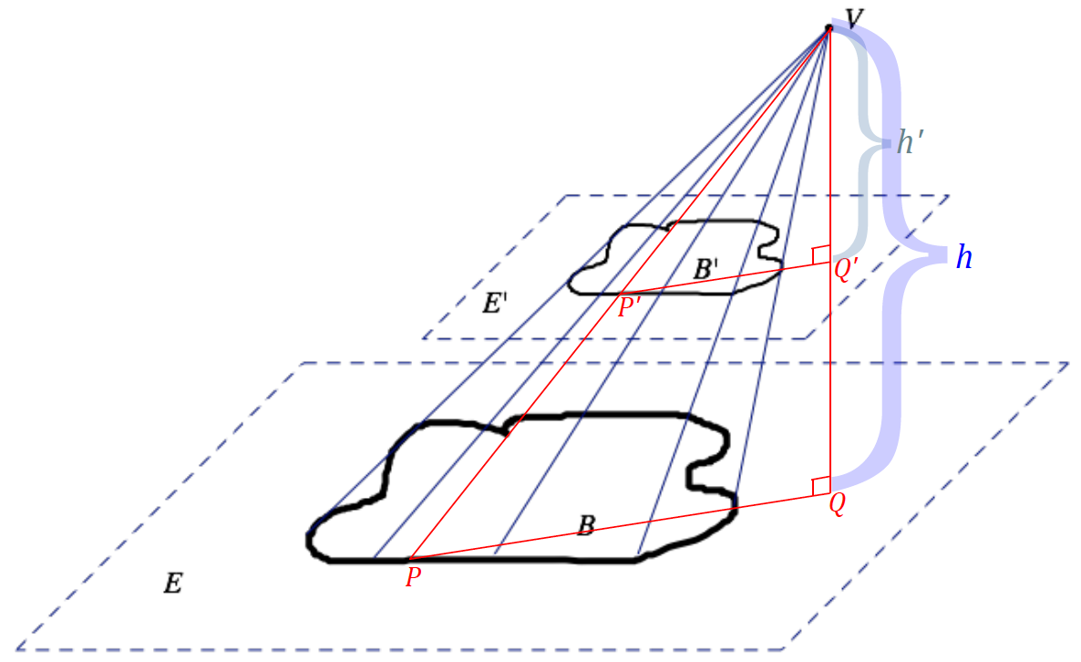

* Use this scale factor to compare the to the .
  + *The area of the similar region should be the area of the original figure times the square of the scale factor: .*

Exercise 1 (3 minutes)

Exercise 1

The area of the base of a cone is and the height is . Find the area of a cross-section that is distance from the vertex.

*; the area of the cross-section that is a distance from the vertex is .*

Example 3 (5 minutes)

Guide students to prove the *general cone cross-section theorem,* using what they have learned regarding the area of the base and the area of a cross-section.

General cone cross-section theorem: If two general cones have the same base area and the same height, then cross-sections for the general cones the same distance from the vertex have the same area.



Figure 8

State the theorem in your own words.

The theorem is saying that if two cones have the same base area and the same height, then cross-sections of both solids that are the same height from the vertex should have the same area.

Use the space below to prove the *general cone cross-section theorem.*

* Let the bases of the cones and in Figure 8 be such that (1) , (2) the height of each cone is , and (3) the distance from each vertex to and to are both .
* How can we show that ?
  + *.*
* Since , then .

Exercise 2 (3 minutes)

Exercise 2

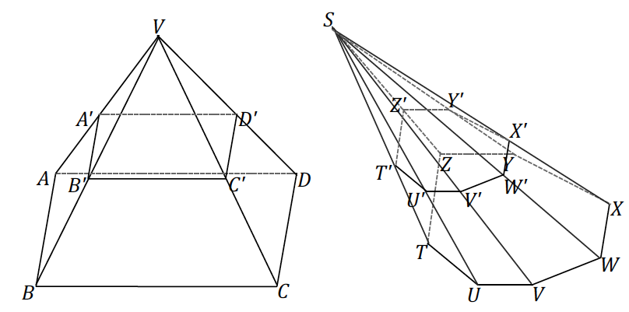The following pyramids have equal altitudes, and both bases are equal in area and are coplanar. Both pyramids’ cross-sections are also coplanar. If and , and the area of is , what is the area of cross-section ?

*; the area of the cross-section is* .

Closing (1 minute)

Ask students to summarize the key points of the lesson. Additionally, consider asking students the following questions independently in writing, to a partner, or to the whole class.

* What distinguishes a pyramid from a general cone?
  + *Pyramids are general cones with polygonal bases.*
* What is the relationship between the base and the cross-section of a general cone? If the height of a general cone is , what is the relationship between the area of a base region and a cross-section taken at a height from the vertex of the general cone?
  + *The cross-section is similar to the base and has an area times that of the area of the base.*
* Restate the *general cone cross-section theorem* in your own words.

Lesson Summary

Cone: Let be a region in a plane and be a point not in . The *cone with base and vertex*  is the union of all segments for all points in .

If the base is a polygonal region, then the *cone* is usually called a *pyramid*.

Rectangular pyramid: Given a rectangular region in a plane and a point not in , the *rectangular pyramid with base and vertex*  is the union of all segments for points in .

Lateral edge and face of a pyramid: Suppose the base of a pyramid with vertex is a polygonal region and is a vertex of . The segment is called a *lateral edge* of the pyramid. If is a base edge of the base (a side of ), and is the union of all segments for in , then is called a *lateral face* of the pyramid. It can be shown that the face of a pyramid is always a triangular region.

Exit Ticket (5 minutes)

Name Date

Lesson 7: General Pyramids and Cones and Their Cross-Sections

Exit Ticket

The diagram below shows a circular cone and a general pyramid. The bases of the cones are equal in area, and the solids have equal heights.

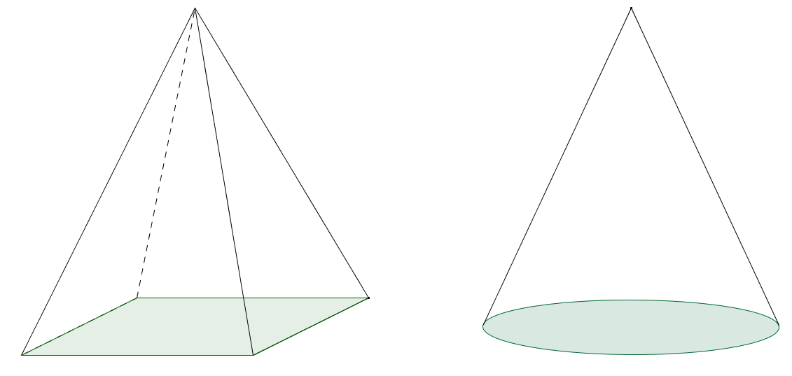

* 1. Sketch a slice in each cone that is parallel to the base of the cone and closer to the vertex than the base plane.
  2. If the area of the base of the circular cone is , find the exact area of the slice drawn in the pyramid.

Exit Ticket Sample Solutions

The diagram below shows a circular cone and a general pyramid. The bases of the cones are equal in area, and the solids have equal heights.

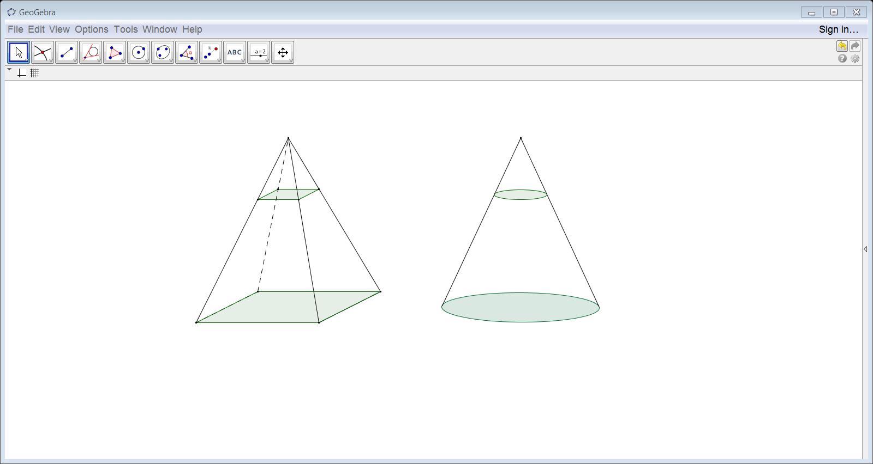

* 1. Sketch a slice in each cone that is parallel to the base of the cone and closer to the vertex than the base plane.
  2. If the area of the base of the circular cone is , find the exact area of the slice drawn in the pyramid.

The distance from the slice to the vertex is the height of the cone, so the scale factor from the base to the slice is . The areas of the planar regions are related by the square of the scale factor, or .

*If two cones have the same base area and the same height, then cross-sections for the cones the same distance from the vertex have the same area, so the area of the slice from the pyramid is* .

Problem Set Sample Solutions

1. The base of a pyramid has area . A cross-section that lies in a parallel plane that is distance of from the base plane has an area of . Find the height, , of the pyramid.

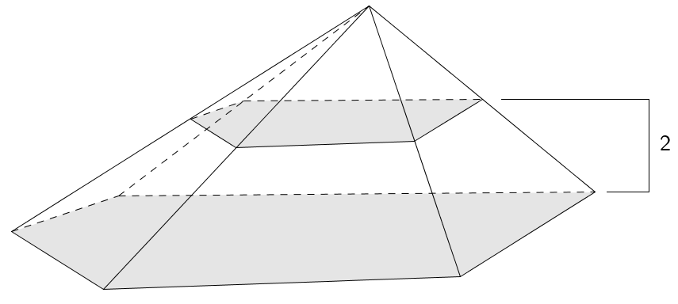The cross-section is similar to the base with scale factor , and the areas of the similar slices are related by the square of the scale factor, .

The scale factor of the cross-section is .

Let the distance from the cross-section (or slice) to the vertex. Then

, and the heights of the slices are also related by the scale factor, so

*The height of the pyramid is* .

1. The base of a pyramid is a trapezoid. The trapezoidal bases have lengths of and , and the trapezoid’s height is . Find the area of the parallel slice that is three-fourths of the way from the vertex to the base.

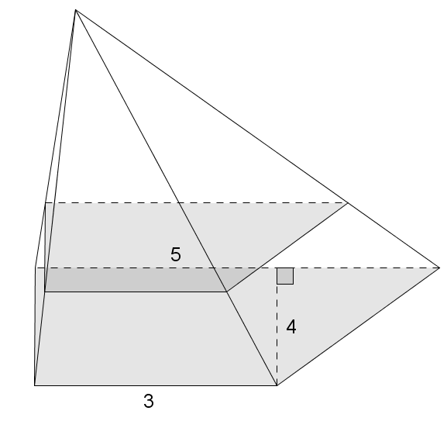The area of the trapezoidal base:

*The area of the base of the pyramid is .*

Let be the height of the pyramid. The distance from the vertex to the given slice is . The slice is similar to the base with scale factor .

The areas of similar figures are related by the square of the scale factor relating their dimensions, so

*The area of the slice is*.

1. A cone has base area . A parallel slice from the vertex has area . Find the height of the cone.

Let be the cone’s height in centimeters.

*The cone has height* .

1. Sketch the figures formed if the triangular regions are rotated around the provided axis:

|  |  |  |  |
| --- | --- | --- | --- |
| a. |  | b. |  |
|  | |  |  |

1. Liza drew the top view of a rectangular pyramid with two cross-sections as shown in the diagram and said that her diagram represents one, and only one, rectangular pyramid. Do you agree or disagree with Liza? Explain.

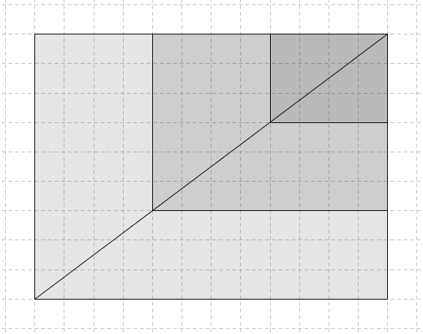Liza’s statement is not valid. As shown, the top cross-section has dimensions that are the corresponding lengths of the base, and the lower cross-section has dimensions that are the corresponding lengths of the base; therefore, the cross-sections are and of the distance from the vertex to the base, respectively. However, since no information was given about the distance between cross-sections or the height of the pyramid, the only conclusion we can draw is that the distance between each given consecutive cross-section is the height of the pyramid.

1. A general hexagonal pyramid has height . A slice above the base has area . Find the area of the base.

Let be the area of the base in square inches. Two inches above the base is from the vertex.

*The base has area* .

1. A general cone has base area . Find the area of the slice of the cone that is parallel to the base and of   
   the way from the vertex to the base.

Let represent the height of the cone. Then the distance from the vertex to the slice of the cone is . The slice is similar to the base with a scale factor of . The area of the slice is equal to the area of the base times the square of the scale factor.

*The area of the slice of the cone is* .

1. A rectangular cone and a triangular cone have bases with the same area. Explain why the cross-sections for the cones halfway between the base and the vertex have the same area.

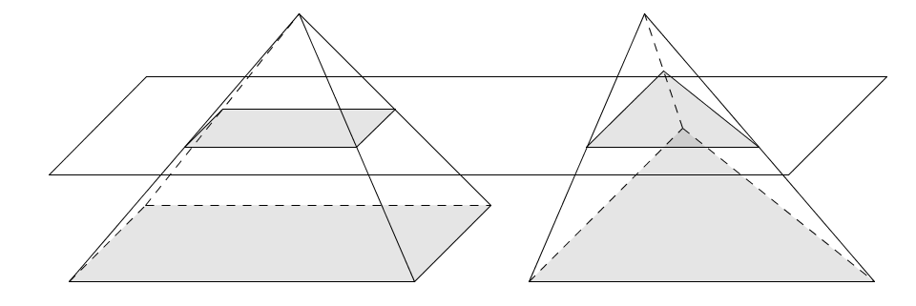

Let be the area of the bases. The cross-sections are each similar to the base with scale factor . So, each has area . Thus, they are equal.

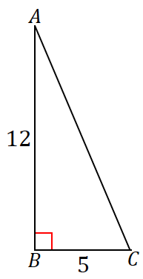

1. The following right triangle is rotated about side . What is the resulting figure, and what are its dimensions?

The resulting figure is a circular cone with radius and height .