Lesson 7: General Pyramids and Cones and Their Cross-Sections

Classwork

Opening Exercise

Group the following images by shared properties. What defines each of the groups you have made?

|  |  |  |  |
| --- | --- | --- | --- |
| cid:1EBD0332-8124-4693-BE2A-9FB32B7832A2@wp.comcast.net |  |  |  |
| 1 | 2 | 3 | 4 |
|  |  |  |  |
| 5 | 6 | 7 | 8 |

**Rectangular pyramid:** Given a rectangular region in a plane and a point not in , the *rectangular pyramid with base and vertex*  is the collection of all segments for any point in

**General cone:**  Let be a region in a plane and be a point not in . The *cone with base and vertex*  is the union of all segments for all points in (See Figures 1 and 2).



Figure 1

Figure 2

Figure 3

Figure 4

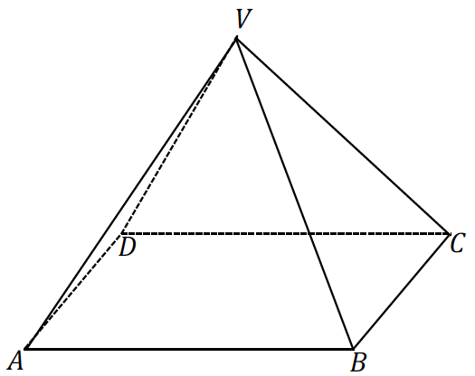

Figure 5

Figure 6



**Example 1**

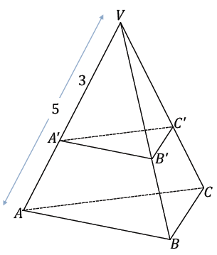In the following triangular pyramid, a plane passes through the pyramid so that it is parallel to the base and results in the cross-section . If the area of is , what is the area of ?

**Example 2**

In the following triangular pyramid, a plane passes through the pyramid so that it is parallel to the base and results in the cross-section . The altitude from is drawn; the intersection of the altitude with the base is , and the intersection of the altitude with the cross-section is . If the distance from to is , the distance from to is , and the area of is , what is the area of ?

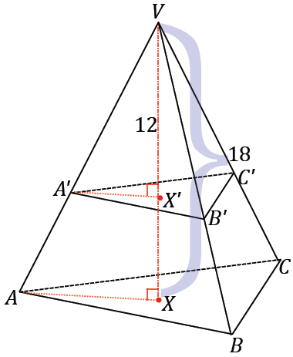

**Extension**

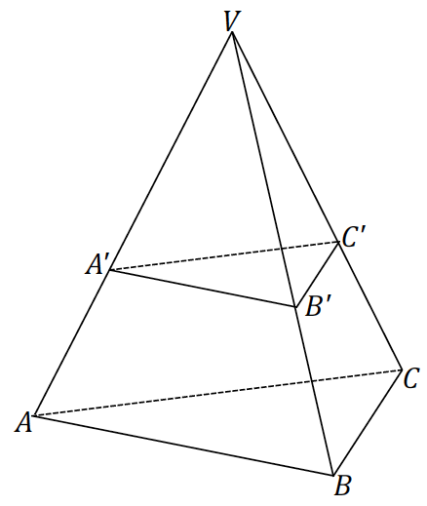

Exercise 1

The area of the base of a cone is and the height is . Find the area of a cross-section that is distance from the vertex.

Example 3

**general cone cross-section theorem:** If two general cones have the same base area and the same height, then cross-sections for the general cones the same distance from the vertex have the same area.

State the theorem in your own words.

Use the space below to prove the *general cone cross-section theorem*.

Exercise 2

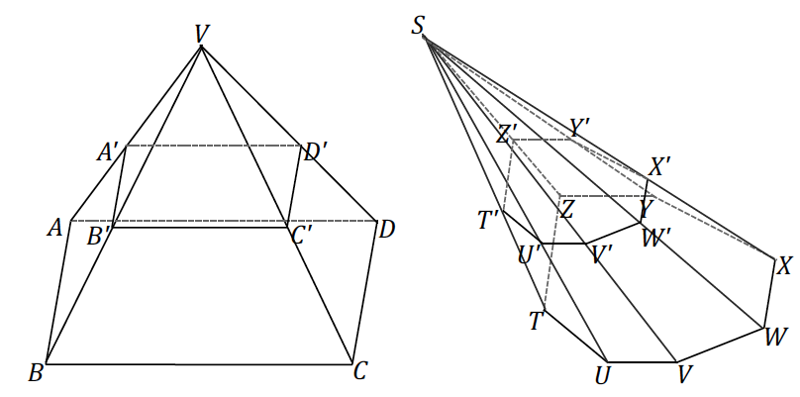The following pyramids have equal altitudes, and both bases are equal in area and are coplanar. Both pyramids’ cross-sections are also coplanar. If and , and the area of is , what is the area of cross-section ?

Lesson Summary

**Cone:** Let be a region in a plane and be a point not in . The *cone with base and vertex*  is the union of all segments for all points in

If the base is a polygonal region, then the *cone* is usually called a *pyramid*.

**Rectangular pyramid:** Given a rectangular region in a plane and a point not in , the *rectangular pyramid with base and vertex*  is the union of all segments for points in

**Lateral edge and face of a pyramid:** Suppose the base of a pyramid with vertex is a polygonal region and is a vertex of . The segment is called a *lateral edge* of the pyramid. If is a base edge of the base (a side of ), and is the union of all segments for in , then is called a *lateral face* of the pyramid. It can be shown that the face of a pyramid is always a triangular region.

Problem Set

1. The base of a pyramid has area . A cross-section that lies in a parallel plane that is distance of from the base plane, has an area of . Find the height, , of the pyramid.

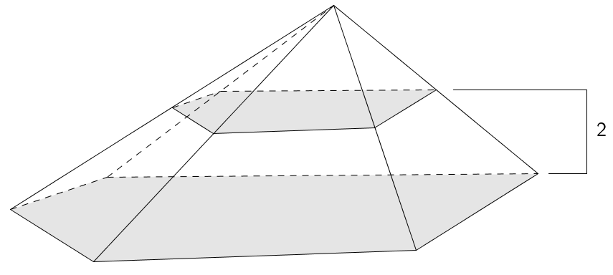

1. The base of a pyramid is a trapezoid. The trapezoidal bases have lengths of and , and the trapezoid’s height is . Find the area of the parallel slice that is three-fourths of the way from the vertex to the base.

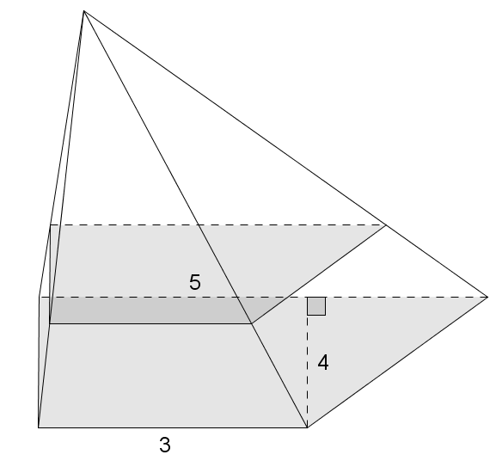

1. A cone has base area . A parallel slice from the vertex has area . Find the height of the cone.
2. Sketch the figures formed if the triangular regions are rotated around the provided axis:

|  |  |
| --- | --- |
|  |  |

1. Liza drew the top view of a rectangular pyramid with two cross-sections as shown in the diagram and said that her diagram represents one, and only one, rectangular pyramid. Do you agree or disagree with Liza? Explain.

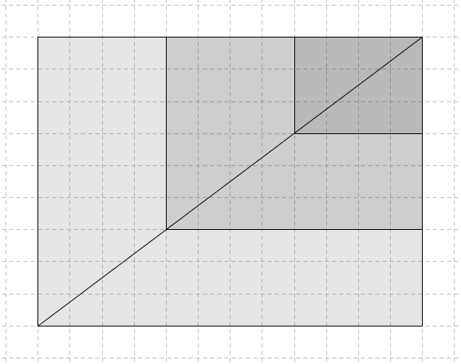

1. A general hexagonal pyramid has height . A slice above the base has area . Find the area of the base.
2. A general cone has base area . Find the area of the slice of the cone that is parallel to the base and of the way from the vertex to the base.
3. A rectangular cone and a triangular cone have bases with the same area. Explain why the cross-sections for the cones halfway between the base and the vertex have the same area.

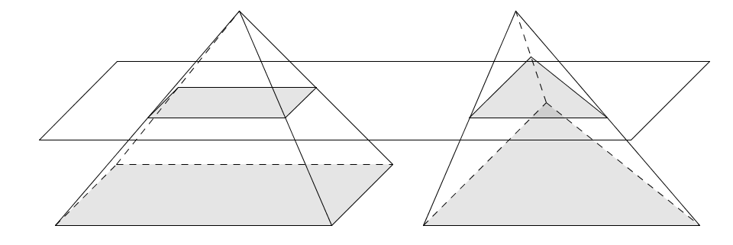

1. 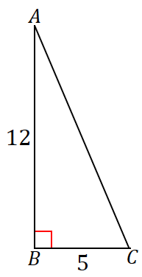The following right triangle is rotated about side . What is the resulting figure, and what are its dimensions?