Lesson 6: General Prisms and Cylinders and Their Cross- Sections

Student Outcomes
- Students understand the definitions of a general prism and a cylinder and the distinction between a cross-section and a slice.

Lesson Notes
In Lesson 6, students are reintroduced to several solids as a lead into establishing the volume formulas for the figures
(G-GMD.A.1). They begin with familiar territory, reexamine a right rectangular prism, and generalize into the idea of general cylinders. Students should feel comfortable with the hierarchy of figures by the close of the lesson, aided by the provided graphic organizer or chart. Students are asked to unpack formal definitions with sketches. Toward the close of the lesson, students learn the difference between a slice and a cross-section and identify two-dimensional cross-sections of three-dimensional objects, as well as identify the three-dimensional object generated by the rotation of a rectangular region about an axis (G-GMD.B.4). Teachers may choose to plan the lesson to accommodate the included Extension, where students use cross-sections to establish why the bases of general cylinders are congruent to each other. This is important to the upcoming work on Cavalieri’s principle in Lesson 10.

Classwork
Scaffolding:
- For struggling learners unfamiliar with the term right rectangular prism, rephrase the prompt to say, “Sketch a box.”
- As an additional step for advanced learners, ask them to sketch a cylinder and to observe similarities and differences in the structures of the two figures.
Opening Exercise (3 minutes)
Opening Exercise
Sketch a right rectangular prism.
Sketches may vary. Note whether students use dotted lines to show hidden edges, and ask students with sketches showing no hidden edges to compare images with students who do have hidden edges shown.

- Is a right rectangular prism hollow? That is, does it include the points inside?
Allow students to share thoughts, and confirm the correct answer in the following Discussion.

Discussion (12 minutes)
- In your study of right rectangular prisms in Grade 6, Module 5 (see the Module Overview), you have examined their properties, interpreted their volume, and studied slices. Let us take a moment to review how we precisely define a right rectangular prism.
Right rectangular prism: Let $E$ and $E'$ be two parallel planes. Let $B$ be a rectangular region in the plane $E$. At each point $P$ of $B$, consider the segment $\overline{PP'}$ perpendicular to $E$, joining $P$ to a point $P'$ of the plane $E'$. The union of all these segments is called a right rectangular prism.

Allow students time to work in partners to unpack the definition by attempting to sketch what is described by the definition. Consider projecting or rewriting the definition in four numbered steps to structure students’ sketches:
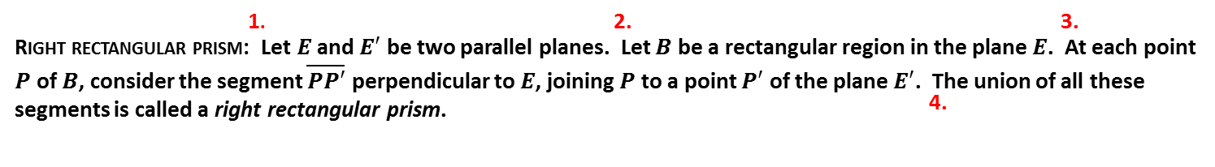
At Step 3, tell students that the regions $B$ and $B'$ are called the base faces (or just bases) of the prism. Then walk around the room and ask pairs to show one example of $\overline{PP'}$. Make sure the whole class agrees what this means and looks like before students show a few more examples of segments to model Step 4.

Step 1 | Step 2
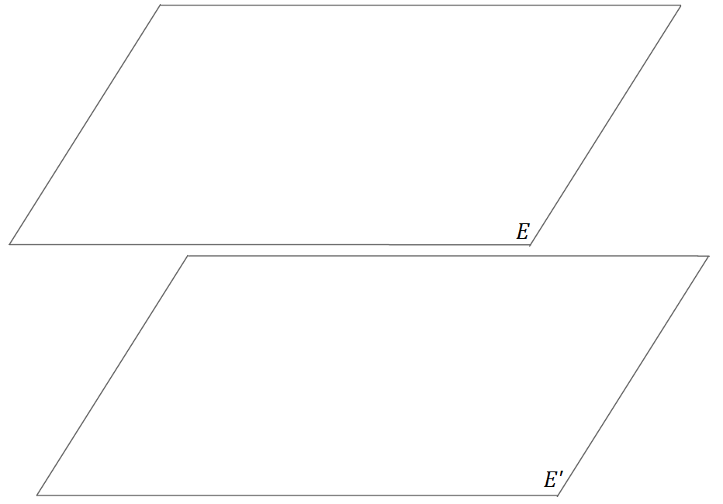 | 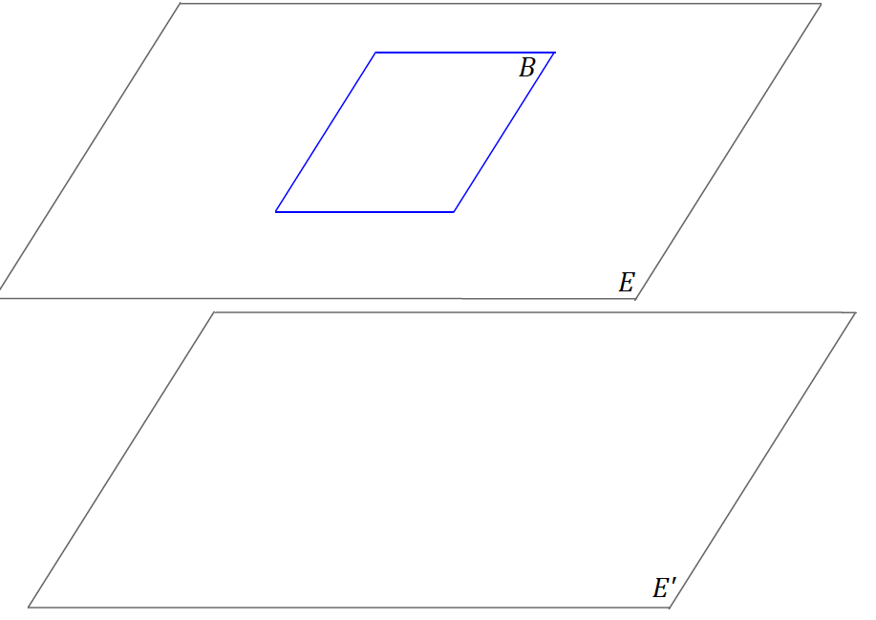
Step 3 | Step 4
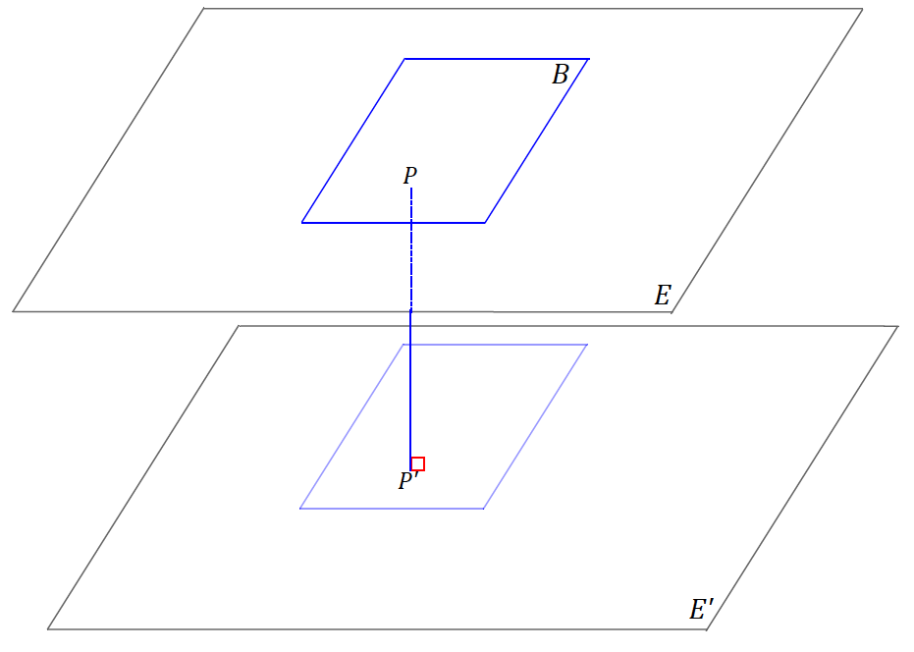 | 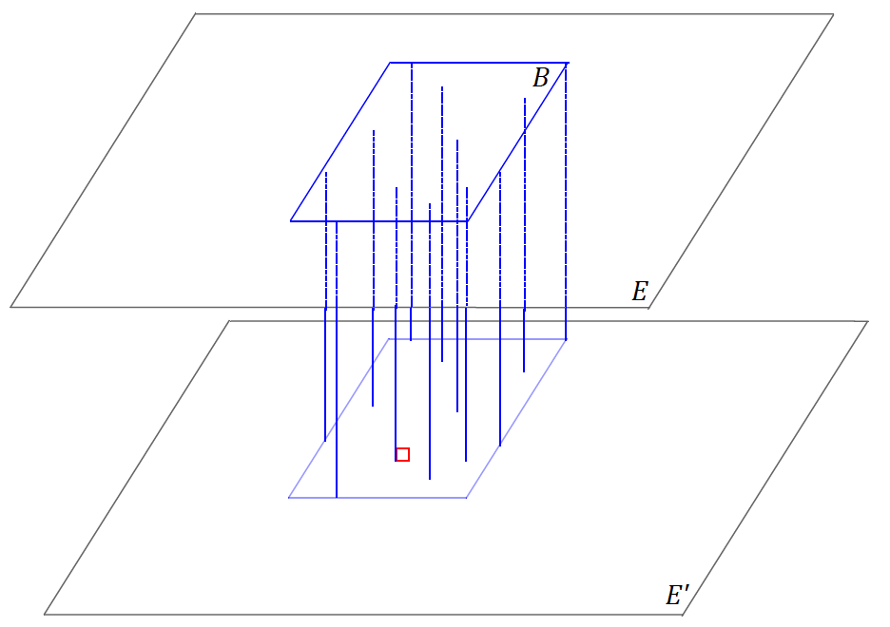

Alternatively, students can build a 3D model based on the definition. Consider providing partner pairs or small groups with a box of angel hair pasta to model the step-by-step process, using the uncooked pasta itself in addition to the box (the box represents the overall frame of the prism, each piece of pasta represents the segment joining the two base regions). Ask students to describe what each part of the model represents: Each piece of paper represents $E$ and $E'$, the intersection of the box and the papers represents $B$ and $B'$, and each piece of pasta represents the segment $\overline{PP'}$. It may be worth gluing pasta along the outside of the box for visual emphasis.
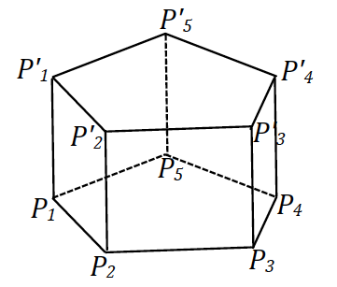
Use the figure to the right to review the terms edge and lateral face of a prism with students.
- Look at segments $\overline{P_{1}P_{2}}$and $\overline{P_{1}{'P}_{2}'}$. If we take these $2$ segments together with all of the vertical segments joining them, we get a lateral face. Similarly, the segment joining $P_{1}$ to $P_{2}$ is called a lateral edge.
After discussing edge and lateral face, the discussion shifts to general cylinders. Prior to this Geometry course, general cylinders are first addressed in Grade 8, Module 5, Lesson 10.
- We will define a more general term under which a right rectangular prism is categorized.

General cylinder: (See Figure 1.) Let $E$ and $E'$ be two parallel planes, let $B$ be a region in the plane $E$, and let $L$ be a line which intersects $E$ and $E'$ but not $B$. At each point $P$ of $B$, consider the segment $\overline{PP'}$ parallel to $L$, joining $P$ to a point $P'$ of the plane $E'$. The union of all these segments is called a general cylinder with base $B$.
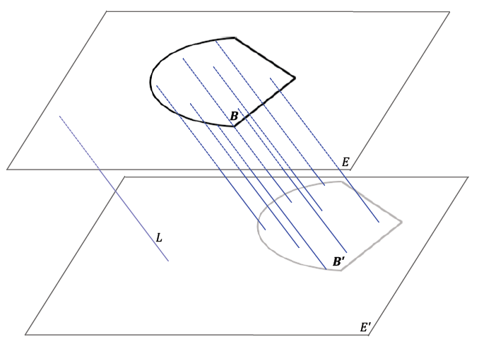
Figure 1

Have students discuss the following question in partner pairs:
- Compare the definitions of right rectangular prism and general cylinder. Are they very different? What is the difference?
  - The definitions are not very different. In the definition of a right rectangular prism, the region $B$ is a rectangular region. In the definition of a general cylinder, the shape of $B$ is not specified.
- As the region $B$ is not specified in the definition of general cylinder, we should understand that to mean that the base can take on a polygonal shape, a curved shape, an irregular shape, etc.
In most calculus courses, we usually drop the word general from the name and just talk about cylinders to refer to all types of bases, circular or not.
- Notice that in a general cylinder, at each point $P$ of $B$, the segment $\overline{PP'}$ is not required to be perpendicular to the base planes. When the segments $\overline{PP'}$ are not perpendicular to the base, the resulting solid is called oblique (slanted). Solids where the segments $\overline{PP'}$ are perpendicular to the base planes are categorized as right (i.e., as in how it is used for right rectangular prism).
- Another way of saying the same thing is to say that if the lateral edges of a general cylinder are perpendicular to the base, the figure is a right figure; if the lateral edges are not perpendicular to the base, the figure is oblique.
- A general cylinder is qualified and named by its base. If the base is a polygonal region, then the general cylinder is usually called a prism.
- A general cylinder with a disk (circle) for a base is called a circular cylinder. We will continue to use the term cylinder to refer to circular cylinder as was done at the elementary level and use general cylinder to specify when the base region is a general region.

Exploratory Challenge (15 minutes)
Teachers may complete this exploration in one of three ways. (1) Use the following series of questions to help guide students into filling out a blank graphic organizer (found at the close of the lesson) on general cylinders. (2) Have students draw a sketch based on the description of each figure in the chart found at the close of the lesson. (3) Have students fill in the description of each figure in the chart found at the close of the lesson.
Option 1. Students will fill in the graphic organizer with any relevant examples per category; the following completed model is a mere model and is not the solution. Ask the following questions as they complete the graphic organizer to help them distinguish how the different types of general cylinders are related to each other.
- Draw an example for each category in the graphic organizer. Write down the qualifiers of each subcategory as shown in the example graphic organizer.
- What is the term that has the broadest meaning in this graphic organizer? What does it imply about the other terms listed on the sheet?
  - The broadest term is general cylinder, and since the other terms are smaller sections of the sheet, they are subcategories of general cylinder.
- What are the other subcategories of the general cylinder listed on the sheet?
  - The subcategories are right general cylinder, circular cylinder (right and oblique), and prism (right and oblique).
- What are major distinguishing properties between a general cylinder and its subcategories?
  - A general cylinder with a polygonal base is called a prism.
  - A general cylinder with a circular base is called a cylinder.
  - A general cylinder with lateral edges perpendicular to the base is a right general cylinder.
  - A general cylinder with lateral edges not perpendicular to the base is an oblique general cylinder.
- What do you know about the shape of the base of a general cylinder?
  - It can be curved or have straight edges or both, or it can be irregular.
Have students draw an example of a general cylinder; share the model’s example if needed. Have students write down a brief descriptor for a general cylinder; for example, “A base can have curves and straight edges.” The example should be oblique since there is a separate space to draw right general cylinders. Ask students to check their neighbor’s drawing and walk around the room to ensure that students are on track.
Next, have students draw an example of a right general cylinder. Consider asking them to use the same base as used for their general cylinder but to now make it a right general cylinder. Ensure that they write a descriptor to qualify the significance of the subcategory.
Then move onto the prism and circular cylinder subcategories. Note that the model shows two sets of examples for the prism subcategory. This is to illustrate that a polygonal base can mean something with a basic shape for a base, such as a triangle, or it can be a composite shape, such as the top two images in the prism subcategory.

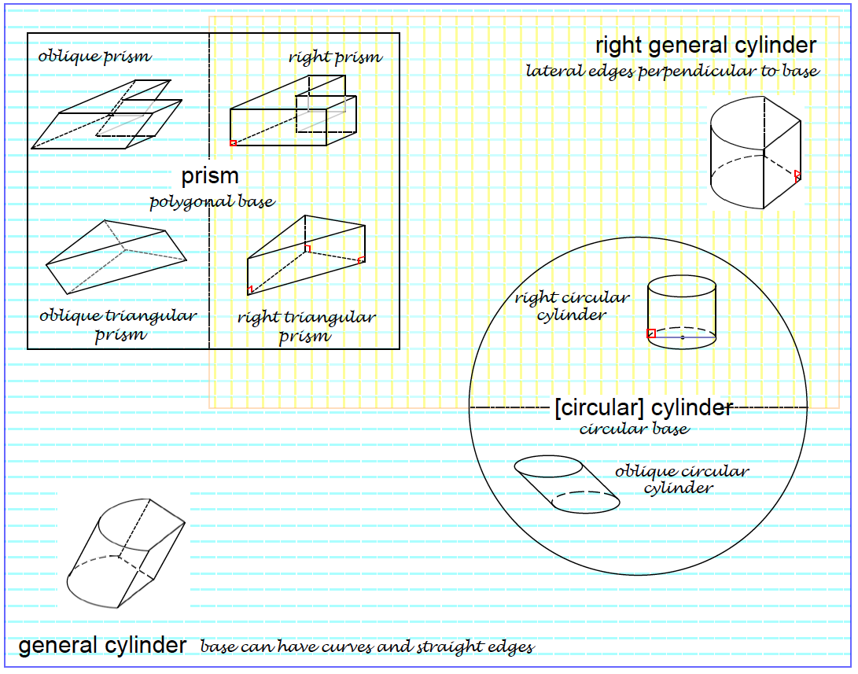

Discussion (3 minutes)
Slices, when a plane intersects with a solid, are first discussed in Grade 7, Module 6, Topic C.
- What is a cross-section of a solid?
  - Students may describe a cross-section as a slice. Accept reasonable responses, and confirm the following answer.
- We describe a cross-section of a general cylinder as the intersection of the general cylinder with a plane parallel to the plane of the base.

Discussion

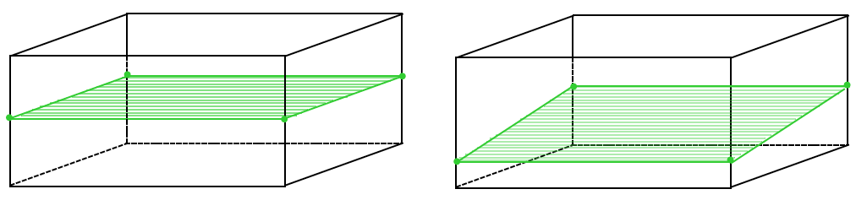
Figure 2 | Figure 3
Example of a cross-section of a prism, where the intersection of a plane with the solid is parallel to the base. | A general intersection of a plane with a prism, which is sometimes referred to as a slice.

Exercise (5 minutes)
Exercise
Sketch the cross-section for the following figures:
a. | b. | c. | d.
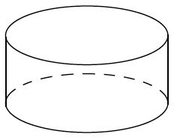 | 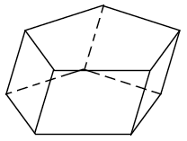 | 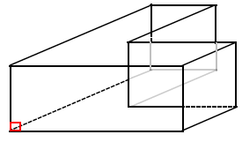 | 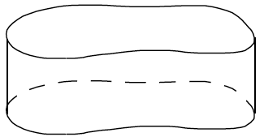
 | 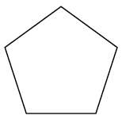 |  | 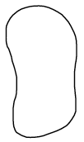

Ask students to draw the cross-section of each figure in their graphic organizer or chart as part of their homework.
Provided any remaining time, continue with a brief discussion on how a cylinder can be generated from rotating a rectangle.
- We close with the idea of, not a cross-section, but in a way, a slice of a figure. What would happen if a rectangle were rotated about one of its sides? What figure would be outlined by this rotation?
Model what this looks like by taping an edge of a rectangular piece of paper (or even an index card) to a pencil and spinning the pencil between the palms of your hands. Students should see that the rotation sweeps out a cylinder. This will prepare students for Problem Set questions 6(a) and 6(b).

Extension
The following Extension prepares students for the informal argument regarding Cavalieri’s Principle in Lesson 10.
- Consider the following general cylinder in Figure 4 and the marked cross-section. Does the cross-section have any relationship with the base of the prism?
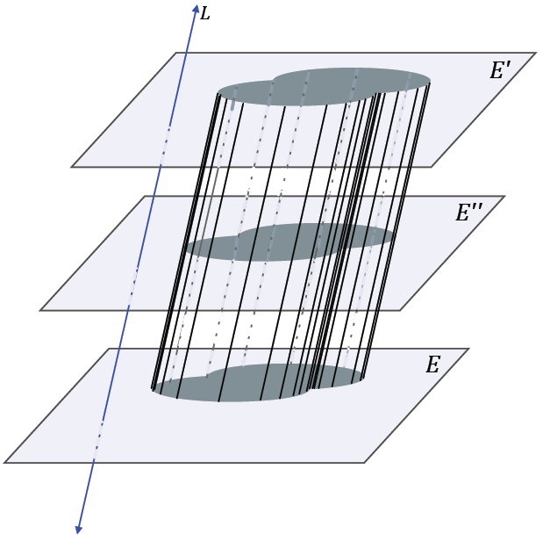
Extension
Figure 4

- They look like they are congruent.
- Let us make the claim that all cross-sections of a general cylinder are congruent to the base. How can we show this to be true?
Allow students time to discuss with a partner how they could demonstrate this (i.e., a rough argument). How can we use what we know about the base regions being congruent to show that a cross-section is congruent to its respective base? Review the following argument after students have attempted the informal proof and shared their ideas:
- Take a plane $E''$ between $E$ and $E'$ so that it is parallel to both.
- The top portion of the cylinder is another cylinder and, hence, has congruent bases.
- Thus, the cross-section lying in $E''$ is congruent to both of the bases.
Consider modeling this idea using a deck of playing cards or a stack of coins. Will a cross-section of either group, whether stacked perpendicularly or skewed, be congruent to a base?
For triangular prisms, we can make the argument more precise.
- How have we determined whether two triangles are congruent or not in the past? What do we know about the parts of each of the triangles in the image, and what more do we need to know?

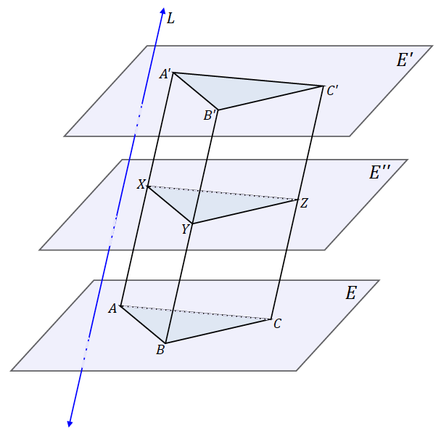
Review the following argument after students have attempted the informal proof and shared their ideas:
Figure 5

- As we know from earlier in the lesson, a prism is the totality of all segments $\overline{PP'}$ parallel to line $L$ from each point $P$ from the base region joining $P$ to a point $P'$ of the plane $E'$.
- Points $X$, $Y$, and $Z$ are the points where $E''$ intersects $\overline{AA'}$, $\overline{BB'}$, and $\overline{CC'}$.
Then $\overline{AX}∥\overline{BY}$ because both segments are parallel to line $L$.
Also, $\overline{AB}∥\overline{XY}$ since lateral face $ABB'A$ intersects parallel planes (i.e., the lateral face intersects parallel planes $E$ and $E''$); the intersection of a plane with two parallel planes is two parallel lines.
- We can then conclude that $ABYX$ is a parallelogram.
Therefore, $AB=XY$.
- We can make similar arguments to show $BC=YZ$, and $AC=XZ$.
By SSS, $△ABC≅△XYZ$.
- How does this argument allow us to prove that any prism, no matter what polygon the base is, has cross-sections congruent to the base?
  - We can decompose the base into triangles and use those triangles to decompose the prism into triangular prisms.

Closing (2 minutes)
Ask students to summarize the key points of the lesson. Additionally, consider asking students the following questions independently in writing, to a partner, or to the whole class.
- Describe how oblique and right prisms and oblique and right cylinders are related to general cylinders. What distinguishes prisms and cylinders from general cylinders?
- What is a cross-section (as opposed to a slice)?

Lesson Summary
Right rectangular prism: Let $E$ and $E'$ be two parallel planes. Let $B$ be a rectangular region in the plane $E$. At each point $P$ of $B$, consider the segment $\overline{PP'}$ perpendicular to $E$, joining $P$ to a point $P'$ of the plane $E'$. The union of all these segments is called a right rectangular prism.
Lateral edge and face of a prism: Suppose the base $B$ of a prism is a polygonal region and $P_{i}$ is a vertex of $B$. Let $P_{ i}^{'}$ be the corresponding point in $B'$ such that $\overline{P_{i}P_{ i}^{'}}$ is parallel to the line $L$ defining the prism. The segment $\overline{P_{i}P_{ i}^{'}}$ is called a lateral edge of the prism. If $\overline{P_{i}P_{i+1}}$ is a base edge of the base $B$ (a side of $B$), and $F$ is the union of all segments $\overline{PP'}$ parallel to $L$ for which $P$ is in $\overline{P_{i}P_{i+1}}$ and $P'$ is in $B'$, then $F$ is a lateral face of the prism. It can be shown that a lateral face of a prism is always a region enclosed by a parallelogram.
General cylinder: Let $E$ and $E'$ be two parallel planes, let $B$ be a region in the plane $E$, and let $L$ be a line which intersects $E$ and $E'$ but not $B$. At each point $P$ of $B$, consider the segment $\overline{PP'}$ parallel to $L$, joining $P$ to a point $P'$ of the plane $E'$. The union of all these segments is called a general cylinder with base $B$.

Exit Ticket (5 minutes)

Name Date
Lesson 6: General Prisms and Cylinders and Their Cross-Sections

Exit Ticket

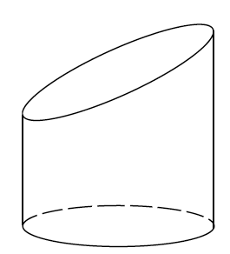
- Is this a cylinder? Explain why or why not.

- For each of the following cross-sections, sketch the figure from which the cross-section was taken.
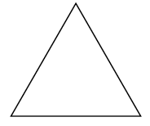

Exit Ticket Sample Solutions
- Is this a cylinder? Explain why or why not.
The figure is not a cylinder because the bases are not parallel to each other.

- For each of the following cross-sections, sketch the figure from which the cross-section was taken.
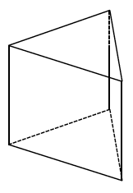 | 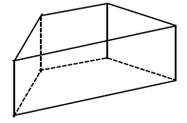

Problem Set Sample Solutions

- Complete each statement below by filling in the missing term(s).
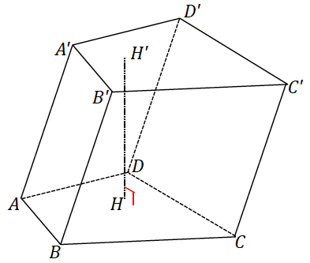
  - The following prism is called a(n) ______ prism.
Oblique

  - If $\overline{AA'}$ were perpendicular to the plane of the base, then the prism would be called a(n) ______ prism.
Right

  - The regions $ABCD$ and $A'B'C'D'$ are called the ______ of the prism.
Bases

  - $\overline{AA'}$ is called a(n) ______.
Edge

  - Parallelogram region $BB'C'C$ is one of four______ ______.
Lateral faces
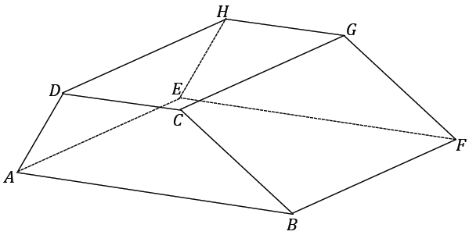
- The following right prism has trapezoidal base regions; it is a right trapezoidal prism. The lengths of the parallel edges of the base are $5$ and $8$, and the nonparallel edges are $4$ and $6$; the height of the trapezoid is $3.7$. The lateral edge length $DH$ is $10$. Find the surface area of the prism.
$$Area(bases)=2 × \left(\frac{5+8}{2}\right)\left(3.7\right)=48.1$$
$$Area(DEGH)=5\left(10\right)=50$$
$$Area(BCGF)=6\left(10\right)=60$$
$$Area(ABFE)=8\left(10\right)=80$$
$$Area(ADHE)=4\left(10\right)=40$$
$$Total Surface Area=48.1+50+60+80+40 \\ =278.1$$

- The base of the following right cylinder has a circumference of $5π$ and a lateral edge of $8$. What is the radius of the base? What is the lateral area of the right cylinder?
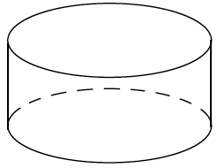
The radius of the base is $2.5.$
The lateral area is $5π\left(8\right)=40π.$

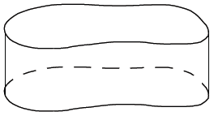
- The following right general cylinder has a lateral edge of length $8$, and the perimeter of its base is $27$. What is the lateral area of the right general cylinder?
The lateral area is $27\left(8\right)=216$.

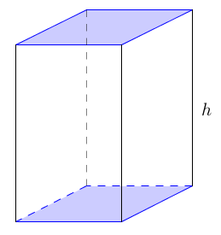
- A right prism has base area $5$ and volume $30$. Find the prism’s height, $h$.
$$Volume=(area of base)×(height) \\ 30=\left(5\right)h \\ 6=h$$
The height of the prism is $6$.

- Sketch the figures formed if the rectangular regions are rotated around the provided axis.
a. |  | b.
 | 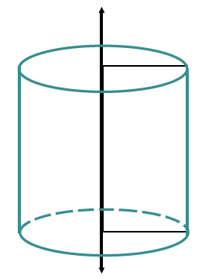 | 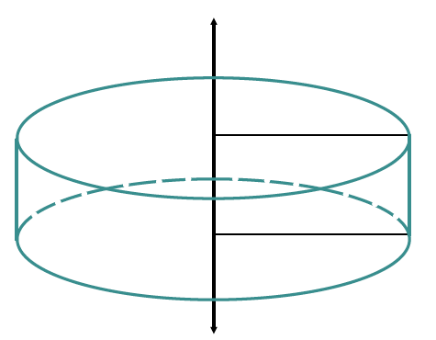

- A cross-section is taken parallel to the bases of a general cylinder and has an area of $18$. If the height of the cylinder is $h$, what is the volume of the cylinder? Explain your reasoning.
If the cross-section is parallel to the bases of the cylinder, then it is congruent to the bases; thus, the area of the base of the cylinder is $18$. The volume of a general cylinder is the product of the area of the cylinder’s base times the height of the cylinder, so the volume of the general cylinder is $18h$.

- A general cylinder has a volume of $144$. What is one possible set of dimensions of the base and height of the cylinder if all cross-sections parallel to its bases are …
  - Rectangles?
Answers will vary.
$$Volume=(Area of base)×(height) \\ Volume=144 \\ Volume=(12)(12) \\ Volume=(4∙3)(12)$$
The base of the cylinder (rectangular prism) could be $4×3$, and the cylinder could have a height of $12$.

  - Right triangles?
Answers will vary.
$$Volume=(area of base)×(height) \\ Volume=144 \\ Volume=(12)(12) \\ Volume=\frac{1}{2}(6∙4)(12)$$
The base of the cylinder (triangular prism) could be a right triangle with legs of length $6$ and $4$, and the cylinder could have a height of $12$.
  - Circles?
Answers will vary.
$$Volume=(area of base)×(height) \\ Volume=144 \\ Volume=(12)(12) \\ Volume=\left(π{\left(\sqrt{\frac{12}{π}}\right)}^{2}\right)×\left(12\right)$$
The base of the cylinder (circular cylinder) could have a radius of $\sqrt{\frac{12}{π}}$, and the cylinder could have a height of $12$.

- A general hexagonal prism is given. If $P$ is a plane that is parallel to the planes containing the base faces of the prism, how does $P$ meet the prism?
If $P$ is between the planes containing the base faces, then $P$ meets the prism in a hexagonal region that is congruent to the bases of the prism; otherwise, $P$ does not meet the prism.

- Two right prisms have similar bases. The first prism has height $5$ and volume $100$. A side on the base of the first prism has length $2$, and the corresponding side on the base of the second prism has length $3$. If the height of the second prism is $6$, what is its volume?
The scale factor of the base of the second prism is $\frac{3}{2}$, so its area is ${\left(\frac{3}{2}\right)}^{2}$, the area of the base of the first prism.
$$Volume=(Area of base)×(height) \\ 100=(Area of base)×(5) \\ Area of base=20$$
The area of the base of the first prism is $20$.
The area of the base of the second prism is then ${\left(\frac{3}{2}\right)}^{2}\left(20\right)=45$.
$$Volume=(Area of base)×(height) \\ Volume=(45)×(6) \\ Volume=270$$
The volume of the second prism is $270$.

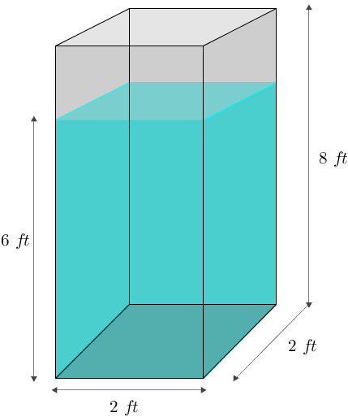
- A tank is the shape of a right rectangular prism with base $2 ft.$ $×2 ft.$ and height $8 ft$. The tank is filled with water to a depth of $6 ft$. A person of height $6 ft.$ jumps in and stands on the bottom. About how many inches will the water be over the person’s head? Make reasonable assumptions.
Model the human as a right cylinder with height $6 ft.$ and base area $\frac{1}{2}ft^{2}$. The volume of the human is then $3 ft^{3}$.
The depth of the water will be increased as the human displaces a volume of $3 ft^{3}$ of the water in the tank.
Let $x$ represent the increase in depth of the water in feet.
$$Volume=(area of base)×(height) \\ 3 ft^{3}=(4 ft^{2})(x) \\ \frac{3}{4}ft.=x$$
The water will rise by $\frac{3}{4}ft.=9 in.$, so the water will be approximately $9 in.$ over the human’s head.

Exploratory Challenge
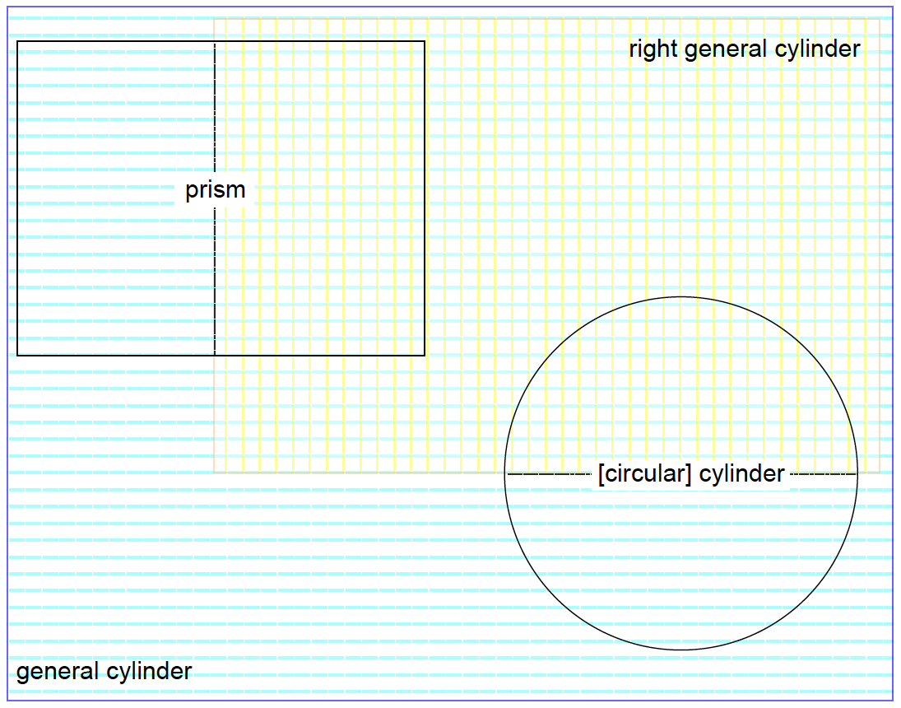
Option 1
Option 2
6.  5.  3.  2. | Figure and Description | Sketch of Figure | Sketch of Cross-Section
1. | General Cylinder
 | Let $E$ and $E'$ be two parallel planes, let $B$ be a region in the plane $E$, and let $L$ be a line which intersects $E$ and $E'$ but not $B$. At each point $P$ of $B$, consider the segment $\overline{PP'}$ parallel to $L$, joining $P$ to a point $P'$ of the plane $E'$. The union of all these segments is called a general cylinder with base $B$.
2. | Right General Cylinder
 | A general cylinder whose lateral edges are perpendicular to the bases.
3. | Right Prism
 | A general cylinder whose lateral edges are perpendicular to a polygonal base.
4. | Oblique Prism
 | A general cylinder whose lateral edges are not perpendicular to a polygonal base.
5. | Right Cylinder
 | A general cylinder whose lateral edges are perpendicular to a circular base.
6. | Oblique Cylinder
 | A general cylinder whose lateral edges are not perpendicular to a circular base.
Option 3
 | Figure and Description | Sketch of Figure | Sketch of Cross-Section
1. | General Cylinder | 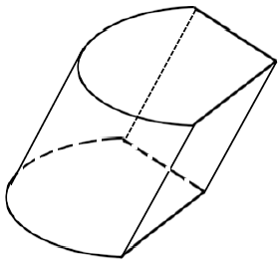
2. | Right General Cylinder | 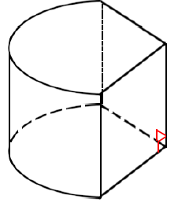
3. | Right Prism | 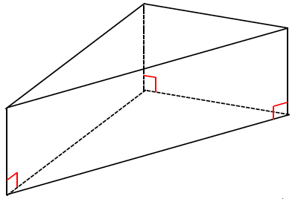
4. | Oblique Prism | 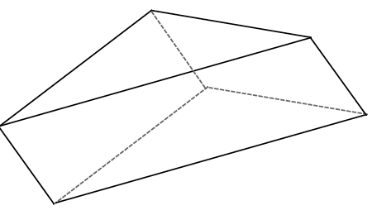
5. | Right Cylinder | 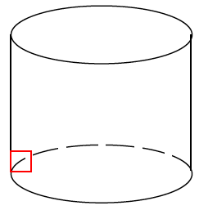
6. | Oblique Cylinder | 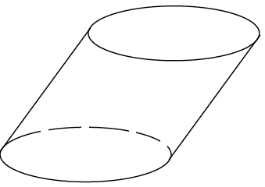

(Fill in the blank.) A rectangular region is the union of a rectangle and its interior .
In Grade 8, a region refers to a polygonal region (triangle, quadrilateral, pentagon, and hexagon) or a circular region, or regions that can be decomposed into such regions.

