Lesson 6: General Prisms and Cylinders and Their Cross-Sections

Classwork
Opening Exercise
Sketch a right rectangular prism.

Right rectangular prism: Let $E$ and $E'$ be two parallel planes. Let $B$ be a rectangular region in the plane $E$. At each point $P$ of $B$, consider the segment $\overline{PP'}$ perpendicular to $E$, joining $P$ to a point $P'$ of the plane $E'$. The union of all these segments is called a right rectangular prism.

General cylinder: (See Figure 1.) Let $E$ and $E'$ be two parallel planes, let $B$ be a region in the plane $E$, and let $L$ be a line which intersects $E$ and $E'$ but not $B$. At each point $P$ of $B$, consider the segment $\overline{PP'}$ parallel to $L$, joining $P$ to a point $P'$ of the plane $E'$. The union of all these segments is called a general cylinder with base $B$.
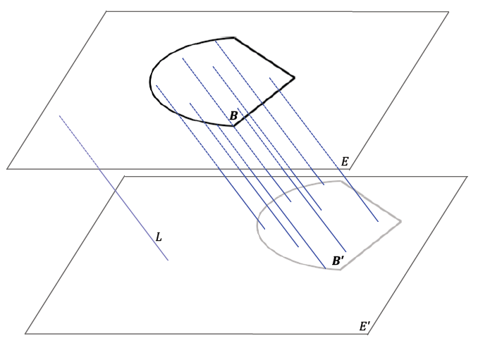
Figure 1

Discussion
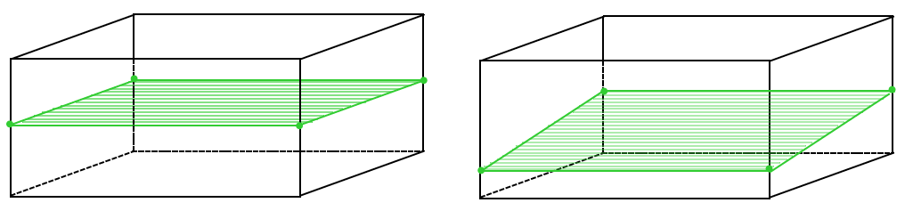
Figure 2 | Figure 3
Example of a cross-section of a prism, where the intersection of a plane with the solid is parallel to the base. | A general intersection of a plane with a prism; sometimes referred to as a slice.

Exercise
Sketch the cross-section for the following figures:
a. | b. | c. | d.
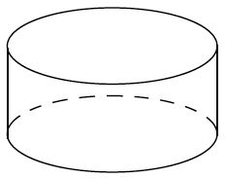 | 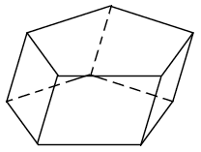 | 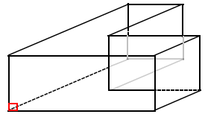 | 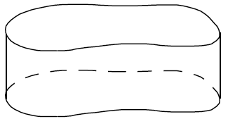

Extension
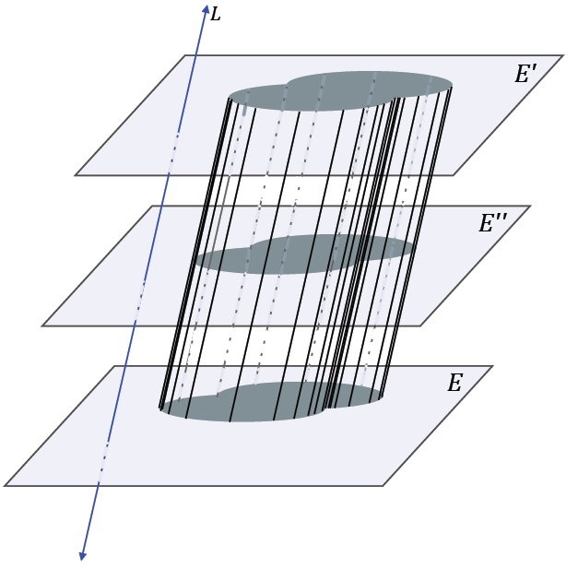
Figure 4

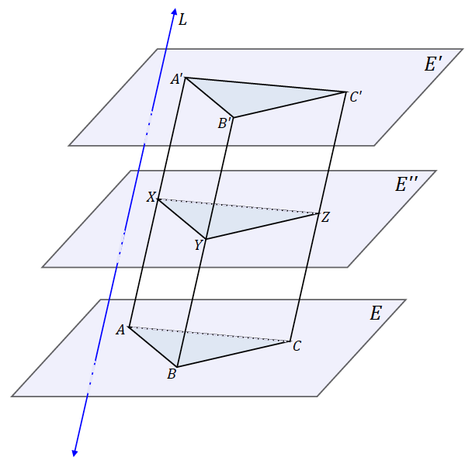
Figure 5

Lesson Summary
Relevant Vocabulary
Right rectangular prism: Let $E$ and $E'$ be two parallel planes. Let $B$ be a rectangular region in the plane $E$. At each point $P$ of $B$, consider the segment $\overline{PP'}$ perpendicular to $E$, joining $P$ to a point $P'$ of the plane $E'$. The union of all these segments is called a right rectangular prism.
Lateral edge and face of a prism: Suppose the base $B$ of a prism is a polygonal region and $P_{i}$ is a vertex of $B$. Let $P_{ i}^{'}$ be the corresponding point in $B'$ such that $\overline{P_{i}P_{ i}^{'}}$ is parallel to the line $L$ defining the prism. The segment $\overline{P_{i}P_{ i}^{'}}$ is called a lateral edge of the prism. If $\overline{P_{i}P_{i+1}}$ is a base edge of the base $B$ (a side of $B$), and $F$ is the union of all segments $\overline{PP'}$ parallel to $L$ for which $P$ is in $\overline{P_{i}P_{i+1}}$ and $P'$ is in $B'$, then $F$ is a lateral face of the prism. It can be shown that a lateral face of a prism is always a region enclosed by a parallelogram.
General cylinder: Let $E$ and $E'$ be two parallel planes, let $B$ be a region in the plane $E$, and let $L$ be a line which intersects $E$ and $E'$ but not $B$. At each point $P$ of $B$, consider the segment $\overline{PP'}$ parallel to $L$, joining $P$ to a point $P'$ of the plane $E'$. The union of all these segments is called a general cylinder with base $B$.

Problem Set

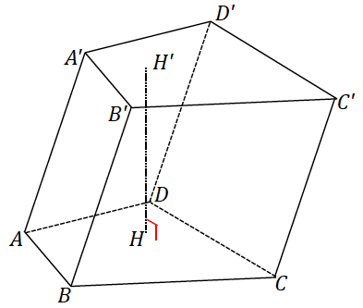
- Complete each statement below by filling in the missing term(s).

  - The following prism is called a(n) ____________ prism.

  - If $\overline{AA'}$ were perpendicular to the plane of the base, then the prism would be called a(n) ____________ prism.

  - The regions $ABCD$ and $A'B'C'D'$ are called the ____________ of the prism.

  - $\overline{AA'}$ is called a(n) ____________.

  - Parallelogram region $BB'C'C$ is one of four ____________ ____________.

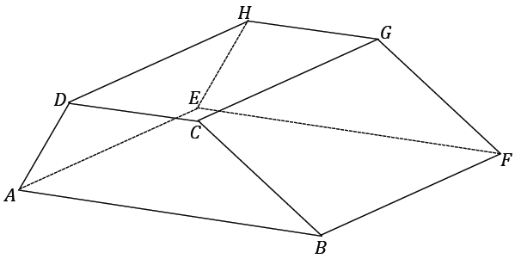
- The following right prism has trapezoidal base regions; it is a right trapezoidal prism. The lengths of the parallel edges of the base are $5$ and $8$, and the nonparallel edges are $4$ and $6$; the height of the trapezoid is $3.7$. The lateral edge length $DH$ is $10$. Find the surface area of the prism.

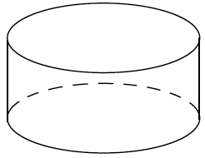
- The base of the following right cylinder has a circumference of $5π$ and a lateral edge of $8$. What is the radius of the base? What is the lateral area of the right cylinder?

- The following right general cylinder has a lateral edge of length $8$, and the perimeter of its base is $27$. What is the lateral area of the right general cylinder?
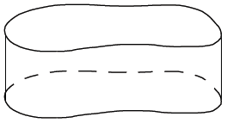

- A right prism has base area $5$ and volume $30$. Find the prism’s height, $h$.

- Sketch the figures formed if the rectangular regions are rotated around the provided axis.

- A cross-section is taken parallel to the bases of a general cylinder and has an area of $18$. If the height of the cylinder is $h$, what is the volume of the cylinder? Explain your reasoning.

- A general cylinder has a volume of $144$. What is one possible set of dimensions of the base and height of the cylinder if all cross-sections parallel to its bases are …
  - Rectangles?
  - Right triangles?
  - Circles?

- A general hexagonal prism is given. If $P$ is a plane that is parallel to the planes containing the base faces of the prism, how does $P$ meet the prism?

- Two right prisms have similar bases. The first prism has height $5$ and volume $100$. A side on the base of the first prism has length $2,$ and the corresponding side on the base of the second prism has length $3$. If the height of the second prism is $6$, what is its volume?

- A tank is the shape of a right rectangular prism with base $2 ft.$ $×2 ft.$ and height $8 ft$. The tank is filled with water to a depth of $6 ft$. A person of height $6 ft.$ jumps in and stands on the bottom. About how many inches will the water be over the person’s head? Make reasonable assumptions.
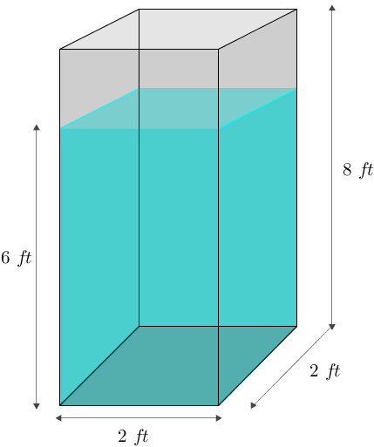

(Fill in the blank.) A rectangular region is the union of a rectangle and ______________________________ .
In Grade 8, a region refers to a polygonal region (triangle, quadrilateral, pentagon, and hexagon) or a circular region, or regions that can be decomposed into such regions.

