|  |
| --- |
|  |

Lesson 5: Three-Dimensional Space

Student Outcomes

* Students describe properties of *points,* *lines,* and *planes* in *three-dimensional space.*

Lesson Notes

A strong intuitive grasp of three-dimensional space, and the ability to visualize and draw, is crucial for upcoming work with volume as described in **G-GMD.A.1**, **G-GMD.A.2**, **G-GMD.A.3**, and **G-GMD.B.4**. By the end of the lesson, we want students to be familiar with some of the basic properties of points, lines, and planes in three-dimensional space. The means of accomplishing this objective: Draw, draw, and draw! The best evidence for success with this lesson is to see students persevere through the drawing process of the properties. No proof is provided for the properties; therefore, it is imperative that students have the opportunity to verify the properties experimentally with the aid of manipulatives such as cardboard boxes and uncooked spaghetti.

In the case that the lesson requires two days, it is suggested that everything that precedes the Exploratory Challenge is covered on the first day and the Exploratory Challenge itself is covered on the second day.

|  |
| --- |
|  |
|  |
|  |
|  |

Classwork

**Opening Exercise (5 minutes)**

The terms *point,* *line,* and *plane* are first introduced in Grade 4. It is worth emphasizing to students that they are undefined terms, meaning they are part of our assumptions as a basis of the subject of geometry, and we can build the subject once we use these terms as a starting place. Therefore, we give these terms intuitive descriptions and should be clear that the concrete representation is just that—a representation.

Have students sketch, individually or with partners, as you call out the following figures. Consider allowing a moment for students to attempt the sketch and following suit and sketching the figure once they are done.

* Sketch a point.
* Sketch a plane containing the point.

If students struggle to draw a plane, observe that just like lines, when we draw a plane on a piece of paper, we can really only represent part of it, since a plane is a flat surface that extends forever in all directions. For that reason, we will show planes with edges to make the illustrations easier to follow.

* Draw a line that lies on the plane.
* Draw a line that intersects the plane in the original point you drew.

Exercise (5 minutes)

*Scaffolding:*

* Consider providing small groups or partner pairs with manipulatives for Exercise 1 and the following Discussion: boxes (for example, a tissue box or a small cardboard box) or nets to build right rectangular prisms (G6-M5-L15) and uncooked spaghetti or pipe cleaners to model lines. Students should use manipulatives to help visualize and respond to Discussion questions.
* Consider listing Discussion questions on the board and allowing for a few minutes of partner conversation to help start the group discussion.

Allow students to wrestle with the Exercise independently or with partners.

Exercise

The following three-dimensional right rectangular prism has dimensions Determine the length of . Show a full solution.

By the Pythagorean theorem, the length of is units long. So, triangle is a right triangle whose legs both have length . In other words, it is -- right triangle. So, has length .

**Discussion (10 minutes)**

Use the figure in Exercise 1 to ask follow-up questions. Allow students to share ideas before confirming answers. The questions are a preview to the properties of points, lines, and planes in three-dimensional space.

Ask the following questions regarding lines in relation to each other as a whole class. Lead students to consider whether each pair of lines is in the same or different planes.

* Would you say that is parallel to ? Why?
  + *Yes, they are parallel; since the figure is a right rectangular prism, and are each perpendicular to and , so must be parallel to .*
* Do and lie in the same plane?
  + *Yes, and lie in the plane .*
* Consider line . Will it ever run into the top face?
  + *No, because lies in the plane , which is a plane parallel to the top plane.*
* Can we say that the faces of the figure are parallel to each other?
  + *Not all the faces are parallel to each other; only the faces directly opposite each other are parallel.*
* Would you say that is perpendicular to the base?
  + *We know that is perpendicular to and , so we are guessing that it is also perpendicular to the base.*
* Is there any way we could draw another line through that would also be perpendicular to the base?
  + *No, because if we tried modeling with a pencil over a piece of paper (the plane), there is only one way to make the pencil perpendicular to the plane.*
* What is the distance between the top face and the bottom face of the figure? How would you measure it?
  + *The distance can be measured by the length of , , , or .*
* Do lines and meet? Would you say that they are parallel?
  + *The lines and do not meet, but they do not appear to be parallel either.*
* Can lines and lie in the same plane?
  + *Both lines cannot lie in the same plane.*
* Name a line that intersects plane *.* 
  + *Answers may vary. One possible line is .*
* Name a line that will not intersect plane *.*
  + *Answers may vary. One possible line is .*

**Exploratory Challenge (18 minutes)**

For each of the properties in the table below, have students draw a diagram to illustrate the property. Students will use their desktops, sheets of papers for planes, and pencils for lines to help model each property as they illustrate it. Consider dividing the class into small groups to sketch diagrams to illustrate a few of the properties, and then have students share their sketches and explanations of the properties with the class. Alternatively, if it is best to facilitate each property, lead students in the review of each property, and have them draw as you do so. By the end of the lesson, students should have completed the table at the end of the lesson with illustrations of each property.

*Scaffolding:*

* For a class struggling with spatial reasoning, consider assigning one to two properties to a small group and having groups present their models and sketches.
* Once each group has presented, review the provided highlights of each property (see Discussion).
* For ELL students, teachers should read the descriptions of each property out loud and encourage students to rehearse the important words in each example chorally (such as point, collinear, plane, etc.).
* We are now ready to give a summary of properties of points, lines, and planes in three-dimensional space.

See the Discussion following the table for points to address as students complete the table. This could begin with questions as simple as, “What do you notice?” or “What do you predict will be true about this diagram?”

An alternative table (Table 2) is provided following the lesson. In Table 2, several images are filled in, and the description of the associated property is left blank. If the teacher elects to use Table 2, the goal will be to elicit descriptions of the property illustrated in the table.

Exploratory Challenge

Table 1: Properties of Points, Lines, and Planes in Three-Dimensional Space

|  |  |  |  |  |  |
| --- | --- | --- | --- | --- | --- |
|  | Property | Diagram | | | |
| 1 | Two points and determine a distance , a line segment , a ray , a vector , and a line . |  | | | |
| 2 | Three non-collinear points , , and determine a plane and, in that plane, determine a triangle . | Given a picture of the plane below, sketch a triangle in that plane. | | | |
| 3 | Two lines either meet in a single point or they do not meet. Lines that do not meet and lie in a plane are called *parallel*. Skew lines are lines that do not meet and are not parallel. | 1. Sketch two lines that meet in a single point. | 1. Sketch lines that do not meet and lie in the same plane; i.e., sketch parallel lines. | | 1. Sketch a pair of skew lines. |
| 4 | Given a line and a point not on , there is a unique line through the point that is parallel to . |  | | | |
| 5 | Given a line and a plane , then lies in , meets in a single point, or does not meet , in which case we say is *parallel* to . (Note: This implies that if two points lie in a plane, then the line determined by the two points is also in the plane.) | 1. Sketch a line that lies in plane . | 1. Sketch a line that meets in a single point. | | 1. Sketch a line that does not meet ; i.e., sketch a line parallel to . |
| 6 | Two planes either meet in a line or they do not meet, in which case we say the planes are *parallel.* | 1. Sketch two planes that meet in a line. | | 1. Sketch two planes that are parallel. | |
| 7 | Two rays with the same vertex form an *angle.* The angle lies in a plane and can be measured by degrees. | Sketch the example in the following plane: | | | |
| 8 | Two lines are *perpendicular* if they meet, and any of the angles formed between the lines is a *right angle.* Two segments or rays are perpendicular if the lines containing them are perpendicular lines. |  | | | |
| 9 | A line is perpendicular to a plane if they meet in a single point, and the plane contains two lines that are perpendicular to , in which case every line in that meets is perpendicular to . A segment or ray is perpendicular to a plane if the line determined by the ray or segment is perpendicular to the plane. | Draw an example of a line that is perpendicular to a plane. Draw several lines that lie in the plane that pass through the point where the perpendicular line intersects the plane. | | | |
| 10 | Two planes perpendicular to the same line are parallel. |  | | | |
| 11 | Two lines perpendicular to the same plane are parallel. | Sketch an example that illustrates this statement using the following plane: | | | |
| 12 | Any two line segments connecting parallel planes have the same length if they are each perpendicular to one (and hence both) of the planes. | Sketch an example that illustrates this statement using parallel planes and . | | | |
| 13 | The *distance between a point and a plane* is the length of the perpendicular segment from the point to the plane. The distance is defined to be zero if the point is on the plane. The *distance between two planes* is the distance from a point in one plane to the other. | Sketch the segment from that can be used to measure the distance between and the plane . | | | |

**Discussion (simultaneous with Exploratory Challenge):**

Pause periodically to discuss the properties as students complete diagrams in the table.

**Regarding Properties 1 and 2:** Make sure students understand what it means for *three points to determine a plane*. Consider having two students each hold a cotton ball (or an eraser, candy, etc.) to represent two points, and demonstrate how a sheet of paper can pass through the two points in an infinite number of ways. Note that in two-dimensional space, the fact that three points determine a plane is not a very interesting property to discuss because the plane is all that exists anyway, but in three-dimensional space this fact is quite important!

**Regarding Property 3:** Again, contrast two-dimensional versus three-dimensional context: In two dimensions, do two lines have to intersect? What do we call lines that do not intersect? How is this different in *three-dimensional space*? If two lines do *not* intersect, does the same set of possible situations exist in three dimensions as in two dimensions?

**Regarding Property 4:** Consider a model of this property in two dimensions (all modeling objects lying flat on the desk) as opposed to a model in three dimensions (say a piece of spaghetti modeling the line lays on the desk and a marble is held above it). When the parallel line through the point is found, a sheet of paper (a plane) can be passed through the two parallel lines—in two dimensions or three dimensions.

**Regarding Property 5:** In the universe of two dimensions, a line always lies in the plane. In three dimensions, we have these other situations, where the line can intersect the plane in one point or not at all, in which case it is parallel to the plane.

**Regarding Property 6:** Students may want to cut a notch in a sheet of paper so that another sheet can be placed into the notch, and the intersection can be easily observed.

**Regarding Property 9:** Consider modeling this by holding a pencil (representing a line) perpendicular to a piece of paper (representing the plane) and showing that any other standard piece of paper (such as an index card or anything with a right angle corner) fits into the angle formed by the pencil and the paper. Compare this property to the Discussion question regarding and whether it was perpendicular to the base of the right rectangular prism.

**Regarding Properties 10 and 11:** In two dimensions, we saw a similar situation when we considered two lines perpendicular to the same line. Now we see in three dimensions where two parallel planes are perpendicular to the same line, and two parallel lines are perpendicular to the same plane.

**Regarding Property 12:** Consider a similar context in two dimensions. Imagine two parallel lines. If each line were perpendicular to one (and hence both) of the lines, would any two line segments have the same length?

**Regarding Property 13:** Again, imagine a similar situation in two dimensions: Instead of the distance between a point and a plane, imagine the distance between a line and a point not on the line.

Closing (2 minutes)

Ask students to summarize the key points of the lesson. Additionally, consider asking students the following questions independently in writing, to a partner, or to the whole class.

Consider sketching a property on the board and asking students to identify the property that describes the illustration.

* How did your knowledge of the properties of points and lines in the plane help you understand points and lines in three-dimensional space?
* Observe that points still determine a line, points determine a triangle, and that for many of the other properties, the relationship hinges on whether or not two objects (such as lines) are contained in a common plane. For example, two lines are parallel if they do not intersect and lie in a common plane.

Lesson Summary

Segment: The *segment* *between points and* is the set consisting of , , and all points on the line between and . The segment is denoted by *,* and the points and are called the *endpoints.*

Line Perpendicular to a Plane:A line intersecting a plane at a point is said to be *perpendicular to the plane*  if is perpendicular to every line that (1) lies in and (2) passes through the point . A segment is said to be perpendicular to a plane if the line that contains the segment is perpendicular to the plane.

Exit Ticket (5 minutes)

Name Date

Lesson 5: Three-Dimensional Space

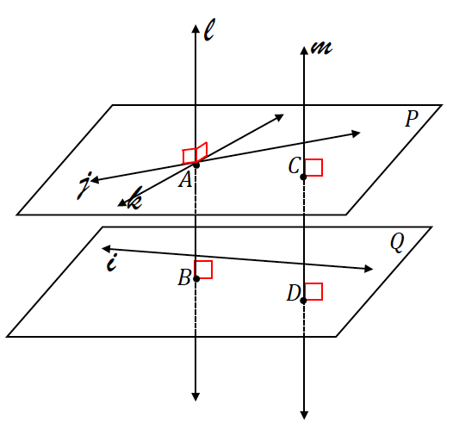Exit Ticket

1. What can be concluded about the relationship between line and plane ? Why?
2. What can be concluded about the relationship between planes and ? Why?
3. What can be concluded about the relationship between lines and ? Why?
4. What can be concluded about segments and ?
5. Line lies in plane and line lies in plane . What can be concluded about the relationship between lines and ?

Exit Ticket Sample Solutions

1. What can be concluded about the relationship between line and plane ? Why?

Since line is perpendicular to two lines that lie in plane , line must be perpendicular to plane .

1. What can be concluded about the relationship between planes and ? Why?

Since line is perpendicular to both planes and , planes and must be parallel to each other.

1. What can be concluded about the relationship between lines and ? Why?

Since lines and are both perpendicular to both planes and , lines and must be parallel to each other.

1. What can be concluded about segments and ?
2. Line lies in plane , and line lies in plane . What can be concluded about the relationship between lines and ?

Lines and are skew lines.

Problem Set Sample Solutions

1. Indicate whether each statement is always true (A), sometimes true (S), or never true (N).
   1. If two lines are perpendicular to the same plane, the lines are parallel. *A*
   2. Two planes can intersect in a point. *N*
   3. Two lines parallel to the same plane are perpendicular to each other. *S*
   4. If a line meets a plane in one point, then it must pass through the plane. *A*
   5. Skew lines can lie in the same plane. *N*
   6. If two lines are parallel to the same plane, the lines are parallel. *S*
   7. If two planes are parallel to the same line, they are parallel to each other. *A*
   8. If two lines do not intersect, they are parallel. *S*
2. Consider the right hexagonal prism whose bases are regular hexagonal regions. The top and the bottom hexagonal regions are called the *base faces*, and the side rectangular regions are called the *lateral faces*.
   1. **List a plane that is parallel to plane .**

Plane

* 1. **List all planes shown that are not parallel to plane .**

Students may define planes using different points. A correct sample response is shown:

Planes , , , , , , and .

* 1. **Name a line perpendicular to plane .**

, , , , , or .

* 1. **Explain why .**

The bases of the right prism are parallel planes, which means that the lateral faces are perpendicular to the bases; hence, the lines contained in the lateral faces are perpendicular to the base planes. Any two line segments connecting parallel planes have the same length if they are each perpendicular to one (and hence both) of the planes.

* 1. **Is parallel to ? Explain.**

Yes. and lie in the same base plane and are opposite sides of a regular hexagon.

* 1. **Is parallel to ? Explain.**

No. The lines do not intersect; however, they are not in the same plane and are, therefore, skew.

* 1. **Is parallel to ? Explain.**

is parallel to since the lines contain opposite sides of a parallelogram (or rectangle). Together with the result of part (e), if two lines are parallel to the same line, then those two lines are also parallel. Even though the lines do not appear to be on the same plane in the given figure, there is a plane that is determined by points ,,, and .

* 1. **If line segments and are perpendicular, then is perpendicular to plane ? Explain.**

No. For a line to be perpendicular to a plane, it must be perpendicular to two (and thus all) lines in the plane. The given information only provides one pair of perpendicular lines.

* 1. **One of the following statements is false. Identify which statement is false and explain why.**

1. is perpendicular to .
2. is perpendicular to .
3. is perpendicular to .
4. is parallel to .

***Statement (iii) is incorrect because even though and lie in perpendicular planes, the lines do not intersect, so the lines are skew.***

1. 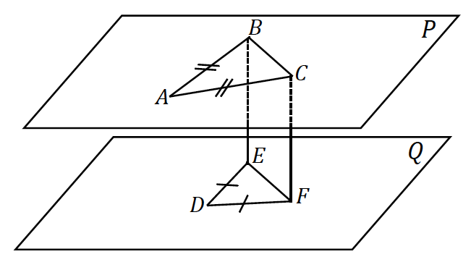In the following figure, is in plane , is in plane , and is a rectangle. Which of the following statements are true?
   1. is perpendicular to plane . *True*
   2. . *True*
   3. Plane is parallel to plane . *True*
   4. . *False*
   5. . *True*
2. 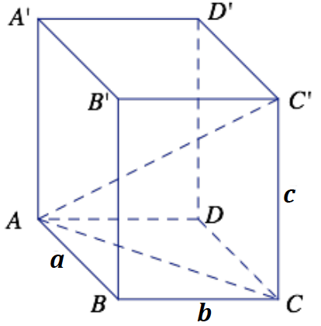Challenge: The following three-dimensional right rectangular prism has dimensions . Determine the length of .

By the Pythagorean theorem, the length of is units long.

is a right triangle with and .

Then,

or

.

1. A line is perpendicular to plane . The line and plane meet at point . If is a point on different from , and is a point on different from , show that .

Consider . Since is perpendicular to , is a right angle no matter where and lie on the plane. So, is the hypotenuse of a right triangle, and is a leg of the right triangle. By the Pythagorean theorem, the length of either leg of a right triangle is less than the length of the hypotenuse. Thus, .

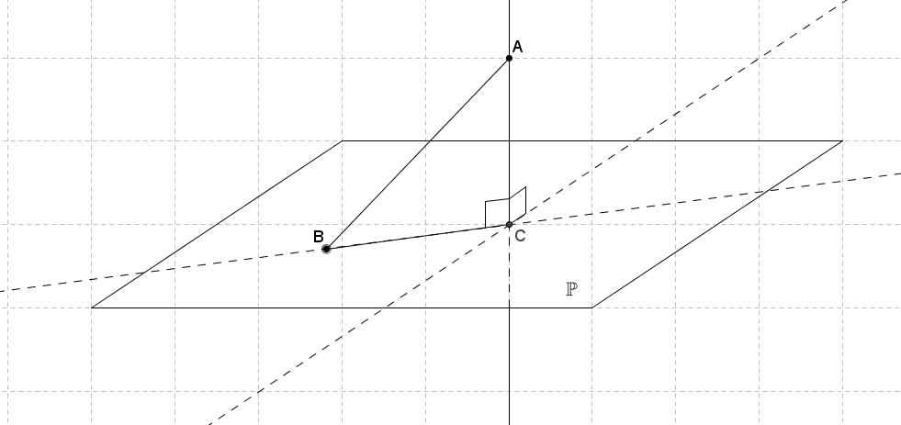

1. Given two distinct parallel planes and , in with , point in , , and , find the minimum and maximum distances between planes and , and explain why the actual distance is unknown.

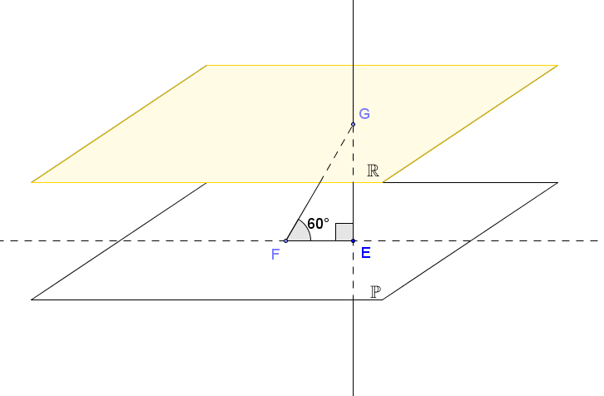Triangle is a -- triangle with its short leg of length units. The length of the longer leg must be , or approximately . The maximum distance between the planes is approximately .

If plane is perpendicular to plane , then the distance between the planes is equal to the length of the longer leg of the right triangle. If plane is not perpendicular to plane (and plane ), then the distance between the planes must be less than . Furthermore, the distance between the distinct parallel planes must be greater than zero, or the planes would coincide.

The actual distance is unknown because the plane determined by points , , and may or may not be perpendicular to planes and .

1. The diagram below shows a right rectangular prism determined by vertices ,, ,,,,, and. Square has sides with length , and . Find .

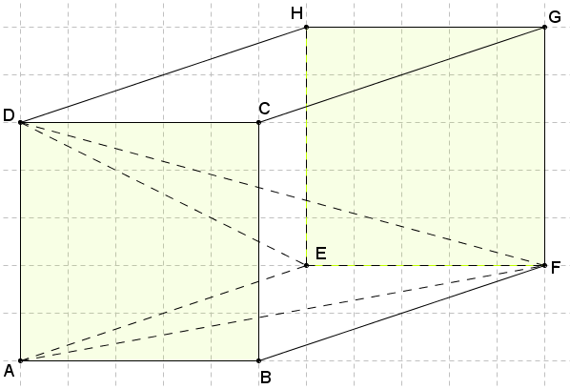The adjacent faces on a right rectangular prism are perpendicular, so angle must then be a right angle.

Using the Pythagorean theorem:

is perpendicular to plane since it is perpendicular to both and ; therefore, it is perpendicular to all lines in plane . Then triangle is a right triangle with legs of length and .

Using the Pythagorean theorem:

The distance is approximately .

Table 2: Properties of Points, Lines, and Planes in Three-Dimensional Space

|  |  |  |  |  |  |
| --- | --- | --- | --- | --- | --- |
|  | Property | Diagram | | | |
| 1 |  |  | | | |
| 2 |  |  | | | |
| 3 |  | (a) | (b) | | (c) |
| 4 |  |  | | | |
| 5 |  | (a) | (b) | | (c) |
| 6 |  | (a) | | (b) | |
| 7 |  |  | | | |
| 8 |  |  | | | |
| 9 |  |  | | | |
| 10 |  |  | | | |
| 11 |  |  | | | |
| 12 |  |  | | | |
| 13 |  |  | | | |