Lesson 5: Three-Dimensional Space

Classwork

Exercise

The following three-dimensional right rectangular prism has dimensions Determine the length of . Show a full solution.



Exploratory Challenge

Table 1: Properties of Points, Lines, and Planes in Three-Dimensional Space

|  |  |  |  |  |  |
| --- | --- | --- | --- | --- | --- |
|  | Property | Diagram | | | |
| 1 | Two points and determine a distance , a line segment , a ray , a vector , and a line . |  | | | |
| 2 | Three non-collinear points , , and determine a plane and, in that plane, determine a triangle . | Given a picture of the plane below, sketch a triangle in that plane. | | | |
| 3 | Two lines either meet in a single point or they do not meet. Lines that do not meet and lie in a plane are called *parallel*. *Skew* lines are lines that do not meet and are not parallel. | 1. Sketch two lines that meet in a single point. | 1. Sketch lines that do not meet and lie in the same plane; i.e., sketch parallel lines. | | 1. Sketch a pair of skew lines. |
| 4 | Given a line and a point not on , there is a unique line through the point that is parallel to . |  | | | |
| 5 | Given a line and a plane , then lies in , meets in a single point, or does not meet , in which case we say is *parallel* to . (Note: This implies that if two points lie in a plane, then the line determined by the two points is also in the plane.) | 1. Sketch a line that lies in plane . | 1. Sketch a line that meets in a single point. | | 1. Sketch a line that does not meet ; i.e., sketch a line parallel to . |
| 6 | Two planes either meet in a line or they do not meet, in which case we say the planes are *parallel*. | 1. Sketch two planes that meet in a line. | | 1. Sketch two planes that are parallel. | |
| 7 | Two rays with the same vertex form an angle. The angle lies in a plane and can be measured by degrees. | Sketch the example in the following plane: | | | |
| 8 | Two lines are *perpendicular* if they meet, and any of the angles formed between the lines is a right angle. Two segments or rays are perpendicular if the lines containing them are perpendicular lines. |  | | | |
| 9 | A line is perpendicular to a plane if they meet in a single point, and the plane contains two lines that are perpendicular to , in which case every line in that meets is perpendicular to . A segment or ray is perpendicular to a plane if the line determined by the ray or segment is perpendicular to the plane. | Draw an example of a line that is perpendicular to a plane. Draw several lines that lie in the plane that pass through the point where the perpendicular line intersects the plane. | | | |
| 10 | Two planes perpendicular to the same line are parallel. |  | | | |
| 11 | Two lines perpendicular to the same plane are parallel. | Sketch an example that illustrates this statement using the following plane: | | | |
| 12 | Any two line segments connecting parallel planes have the same length if they are each perpendicular to one (and hence both) of the planes. | Sketch an example that illustrates this statement using parallel planes and . | | | |
| 13 | The *distance between a point and a plane* is the length of the perpendicular segment from the point to the plane. The distance is defined to be zero if the point is on the plane. The *distance between two planes* is the distance from a point in one plane to the other. | Sketch the segment from that can be used to measure the distance between and the plane . | | | |

Lesson Summary

**Segment:** The *segment* *between points and* is the set consisting of , , and all points on the line between and . The segment is denoted by *,* and the points and are called the *endpoints.*

**Line perpendicular to a plane:**A line intersecting a plane at a point is said to be *perpendicular to the plane*  if is perpendicular to every line that (1) lies in and (2) passes through the point . A segment is said to be perpendicular to a plane if the line that contains the segment is perpendicular to the plane.

Problem Set

1. Indicate whether each statement is always true (A), sometimes true (S), or never true (N).
   1. If two lines are perpendicular to the same plane, the lines are parallel.
   2. Two planes can intersect in a point.
   3. Two lines parallel to the same plane are perpendicular to each other.
   4. If a line meets a plane in one point, then it must pass through the plane.
   5. Skew lines can lie in the same plane.
   6. If two lines are parallel to the same plane, the lines are parallel.
   7. If two planes are parallel to the same line, they are parallel to each other.
   8. If two lines do not intersect, they are parallel.
2. Consider the right hexagonal prism whose bases are regular hexagonal regions. The top and the bottom hexagonal regions are called the *base faces*, and the side rectangular regions are called the *lateral faces*.
   1. List a plane that is parallel to plane .
   2. List all planes shown that are not parallel to plane .
   3. Name a line perpendicular to plane .
   4. Explain why .
   5. Is parallel to ? Explain.
   6. Is parallel to ? Explain.
   7. Is parallel to ? Explain.
   8. If line segments and are perpendicular, then is perpendicular to plane ? Explain.
   9. One of the following statements is false. Identify which statement is false and explain why.
3. is perpendicular to .
4. is perpendicular to .
5. is perpendicular to .
6. is parallel to .
7. In the following figure, is in plane , is in plane , and is a rectangle. Which of the following statements are true?
   1. is perpendicular to plane .
   2. .
   3. Plane is parallel to plane .
   4. .
   5. .
8. 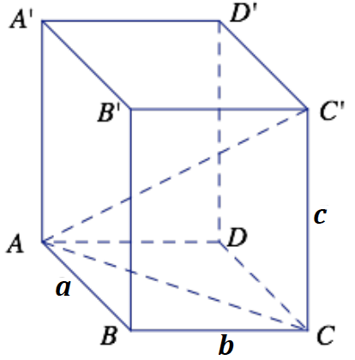Challenge: The following three-dimensional right rectangular prism has dimensions Determine the length of .
9. A line is perpendicular to plane . The line and plane meet at point . If is a point on different from , and is a point on different from , show that .
10. Given two distinct parallel planes and , in with , point in , , and , find the minimum and maximum distances between planes and and explain why the actual distance is unknown.
11. 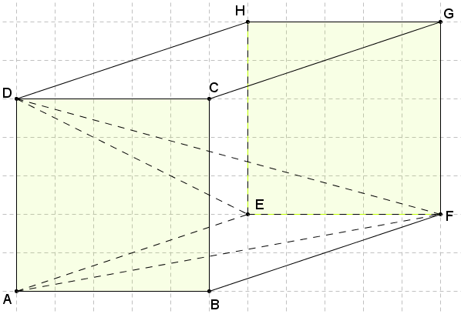The diagram shows a right rectangular prism determined by vertices ,, ,,,,, and. Square has sides with length , and . Find .