Lesson 4: Proving the Area of a Disk

Student Outcomes
- Students use inscribed and circumscribed polygons for a circle (or disk) of radius $r$ and circumference $C$ to show that the area of a circle is $\frac{1}{2}Cr$ or, as it is usually written, $πr^{2}$.

Lesson Notes
In Grade 7, students studied an informal proof for the area of a circle. In this lesson, students use informal limit arguments to find the area of a circle using (1) a regular polygon inscribed within the circle and (2) a polygon similar to the inscribed polygon that circumscribes the circle (G-GMD.A.1). The goal is to show that the areas of the inscribed polygon and outer polygon act as upper and lower approximations for the area of the circle. As the number of sides of the regular polygon increases, each of these approximations approaches the area of the circle.
Question 6 of the Problem Set steps students through the informal proof of the circumference formula of a circle–another important aspect of G-GMD.A.1.
To plan this lesson over the course of two days, consider covering the Opening Exercise and the Example in the first day’s lesson and completing the Discussion and Discussion Extension, or alternatively Problem Set 6 (derivation of circumference formula), during the second day’s lesson.

Classwork
Scaffolding:
- Consider providing numeric dimensions for the hexagon (e.g., $s=4$; therefore, $h=2\sqrt{3}$) to first find a numeric area ($Area=24\sqrt{3}$ provided the values above) and to generalize to the formula using variables.
- Have students (1) sketch an image and (2) write an area expression for $P_{n}$ when $n=4$ and $n=5$.
- Example: $Area\left(P_{4}\right)=2sh$
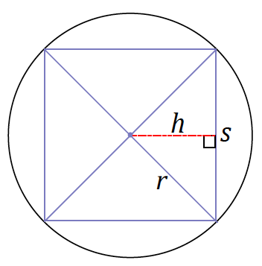
Opening Exercise (7 minutes)
Students derive the area formula for a regular hexagon inscribed within a circle in terms of the side length and height provided in the image. Then, lead them through the steps that describe the area of any regular polygon inscribed within a circle in terms of the polygon’s perimeter. This will be used in the proof for the area formula of a circle.
Opening Exercise
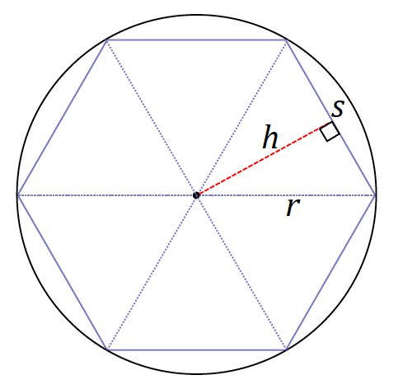
The following image is of a regular hexagon inscribed in circle $C$ with radius $r$. Find a formula for the area of the hexagon in terms of the length of a side, $s,$ and the distance from the center to a side.
MP.2
&
MP.7

C

The area formula for each of the congruent triangles is $\frac{1}{2}sh$. The area of the entire regular hexagon, which consists of $6$ such triangles, is represented by the formula $3sh$.
Since students have found an area formula for the hexagon, lead them through the steps to write an area formula of the hexagon using its perimeter.
- The inscribed hexagon can be divided into six congruent triangles as shown in the image above. Let us call the area of one of these triangles $T.$
- Then the area of the regular hexagon, $H$, is
$$6×Area\left(T\right)=6×\left(\frac{1}{2}s×h\right)$$
- With some regrouping, we have
Scaffolding:
- Consider asking students that may be above grade level to write a formula for the area outside $P_{n}$ but inside the circle.
$$6×Area\left(T\right)=(6×s)×\frac{h}{2} \\ =Perimeter\left(H\right)×\frac{h}{2}$$
- We can generalize this area formula in terms of perimeter for any regular inscribed polygon $P_{n}$. Regular polygon $P_{n}$ has $n$ sides, each of equal length, and the polygon can be divided into $n$ congruent triangles as in the Opening Exercise, each with area $T$.
Scaffolding:
- Consider keeping a list of notation on the board to help students make quick references as the lesson progresses.
- Then the area of $P_{n}$ is
MP.2
&
MP.7
$$Area\left(P_{n}\right)=n×Area(T_{n}) \\ =n×\left(\frac{1}{2}s_{n}×h_{n}\right) \\ =(n×s_{n})×\frac{h_{n}}{2} \\ =Perimeter\left(P_{n}\right)×\frac{h_{n}}{2}$$

Example (17 minutes)
The Example shows how to approximate the area of a circle using inscribed and circumscribed polygons. Pose the following questions and ask students to consult with a partner and then share out responses.
- How can we use the ideas discussed so far to determine a formula for the area of a circle? How is the area of a regular polygon inscribed within a circle related to the area of that circle?
The intention of the questions is to serve as a starting point to the material that follows. Consider prompting students further by asking them what they think the regular inscribed polygon looks like as the number of sides increases (e.g., What would $P_{100}$ look like?).

Example
- Begin to approximate the area of a circle using inscribed polygons.
How well does a square approximate the area of a disk? Create a sketch of $P_{4}$ (a regular polygon with $4$ sides, a square) in the following circle. Shade in the area of the disk that is not included in $P_{4}$.
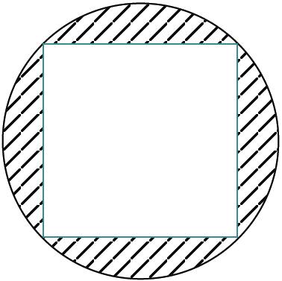
$$P_{4}$$

- Next, create a sketch of $P_{8}$ in the following circle.

Guide students in how to locate all the vertices of $P_{8}$ by resketching a square, and then marking a point equally spaced between each pair of vertices; join the vertices to create a sketch of regular octagon$P_{8}$.

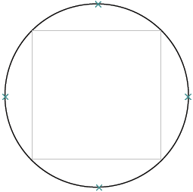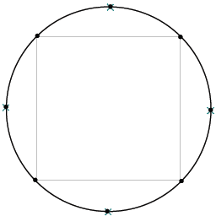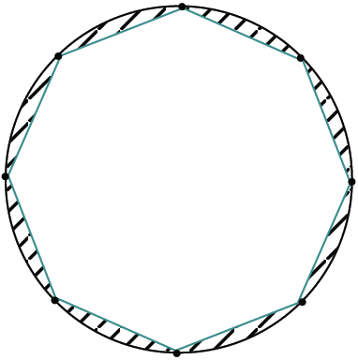
$$P_{8}$$

Have students indicate which area is greater in part (c).

- Indicate which polygon has a greater area.

$Area\left(P_{4}\right)$ $<$ $Area\left(P_{8}\right)$

- Will the area of inscribed regular polygon $P_{16}$ be greater or less than the area of $P_{8}$? Which is a better approximation of the area of the disk?
$Area(P_{8})<Area(P_{16})$; the area of $P_{16}$ is a better approximation of the area of the disk.

Share a sketch of the following portion of the transition between $P_{8}$ and $P_{16}$ in a disk with students. Ask students why the area of $P_{16}$ is a better approximation of the area of the circle.
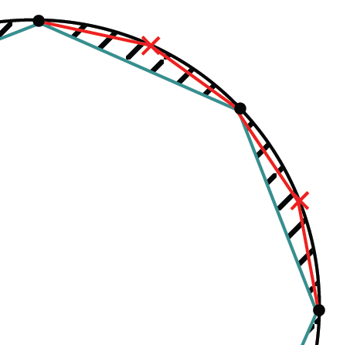
A portion of polygon $P_{16}$

- We noticed that the area of $P_{4}$ was less than the area of $P_{8}$ and that the area of $P_{8}$ was less than the area of
$P_{16}$. In other words, $Area\left(P_{n}\right)$ $<$ $Area\left(P_{2n}\right)$. Why is this true?
MP.3
We are using the $n$-polygon to create the $2n$-polygon. When we draw the segments that join each new vertex in between a pair of existing vertices, the resulting $2n$-polygon has a greater area than that of the $n$-polygon.

- Now we will approximate the area of a disk using circumscribed (outer) polygons.
Now circumscribe, or draw a square on the outside of, the following circle such that each side of the square intersects the circle at one point. We will denote each of our outer polygons with prime notation; we are sketching ${P'}_{4}$ here.
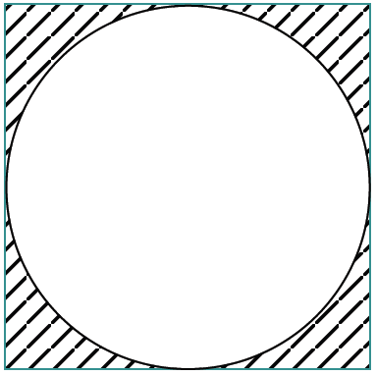
$${P'}_{4}$$

- Create a sketch of ${P'}_{8}$.

- How can we create a regular octagon using the square?
Allow students a moment to share out answers and drawings of how to create the regular octagon. Provide them with the following steps if the idea is not shared out.
  - Draw rays from the center of the square to its vertices. Mark the points where the rays intersect the circle. Then draw the line that intersects the circle once through that point and only that point.

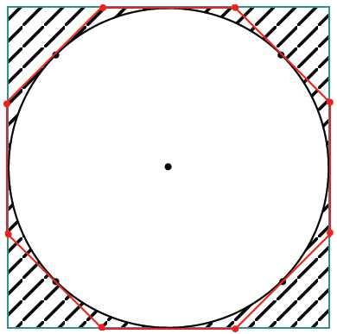
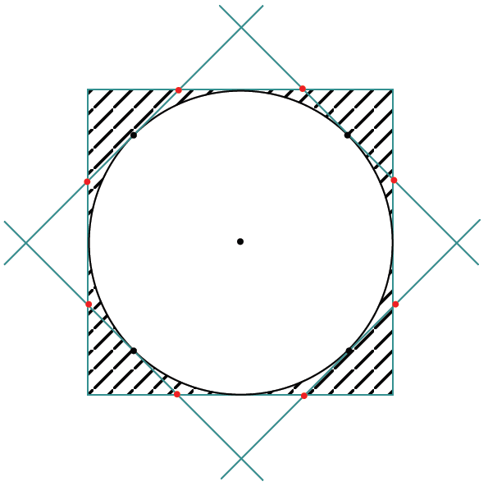
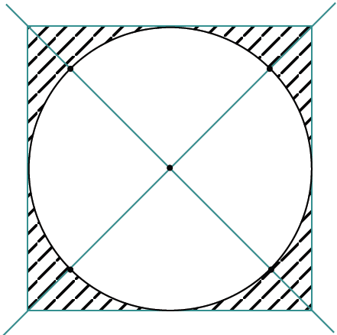
Erase these corner triangles.

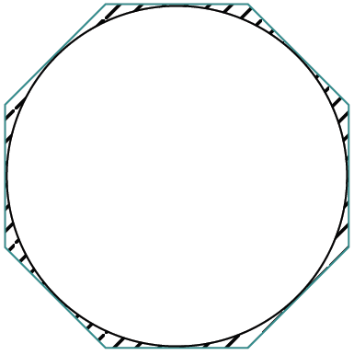
$${P'}_{8}$$

- Indicate which polygon has a greater area.

$Area\left({P^{'}}_{4}\right)$ $>$ $Area\left({P^{'}}_{8}\right)$.

- Which is a better approximation of the area of the circle, ${P'}_{4}$ or ${P'}_{8}$? Explain why.
${P'}_{8}$ is a better approximation of the area of the circle relative to ${P'}_{4}$ because it is closer in shape to the circle than ${P'}_{4}$.

- How will $Area\left({P^{'}}_{n}\right)$ compare to$Area({P'}_{2n})$? Explain.
$Area\left({P^{'}}_{n}\right)$ $>$ $Area\left({P^{'}}_{2n}\right).$ ${P'}_{2n}$ can be created by chipping off its vertices; therefore, the area of ${P'}_{2n}$ will always be less than the area of ${P'}_{n}$.

Discussion (10 minutes)
- How will the area of ${P'}_{2n}$ compare to the area of the circle? Remember that the area of the polygon includes the area of the inscribed circle.
  - $Area(circle)<Area({P^{'}}_{2n})$
- In general, for any positive integer $n≥3$,
$$Area\left(P_{n}\right)<Area\left(circle\right)<Area\left({P^{'}}_{n}\right).$$
- For example, examine $P_{16}$ and ${P'}_{16}$, which sandwich the circle between them.
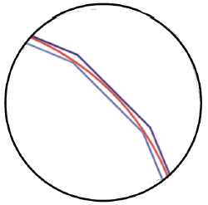
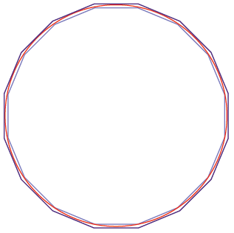

$${P'}_{16}$$
$$P_{16}$$

Furthermore, as $n$ gets larger and larger, or as it grows to infinity (written as $n→∞$ and typically read, “as $n$ approaches infinity”) the difference of the area of the outer polygon and the area of the inner polygon goes to zero. An explanation of this is provided at the end of the lesson and can be used as an extension to the lesson.
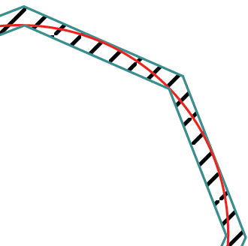
- Therefore, we have trapped the area of the circle between the areas of the outer and inner polygons for all $n$. Since this inequality holds for every $n$, and the difference in areas between the outer and inner polygons goes to zero as $n→∞$, we can define the area of the circle to be the number (called the limit) that the areas of the inner polygons converge to as $n→∞$.

Limit (description): Given an infinite sequence of numbers, $a_{1},a_{2},a_{3},…$, to say that the limit of the sequence is $A$ means, roughly speaking, that when the index $n$ is very large, then $a_{n}$ is very close to $A$. This is often denoted as, “As $n→∞$,
$a_{n}→A$.”
Area of a circle (description): The area of a circle is the limit of the areas of the inscribed regular polygons as the number of sides of the polygons approaches infinity.

For example, a selection of the sequence of areas of regular $n$-gons’ regions (starting with an equilateral triangle) that are inscribed in a circle of radius $1$ are as follows:
$$a_{3}≈1.299 \\ a_{4}=2 \\ a_{5}≈2.377 \\ a_{6}≈2.598 \\ a_{7}≈2.736 \\ a_{100}≈3.139 \\ a_{1000}≈3.141.$$
The limit of the areas is $π$. In fact, an inscribed regular $1000$-gon has an area very close to the area we expect to see for the area of a unit disk.
- We will use this definition to find a formula for the area of a circle.
- Recall the area formula for a regular $n$-gon:
$$Area\left(P_{n}\right)=\left[Perimeter\left(P_{n}\right)\right]\left(\frac{h_{n}}{2}\right).$$
- Think of the regular polygon when it is inscribed in a circle. What happens to $h_{n}$ and $Perimeter\left(P_{n}\right)$ as $n$ approaches infinity ($n→∞$) in terms of the radius and circumference of the circle?
Students can also refer to their sketches in part (b) of the Example for a visual of what happens as the number of sides of the polygon increases. Alternatively, consider sharing the following figures for students struggling to visualize what happens as the number of sides increases.
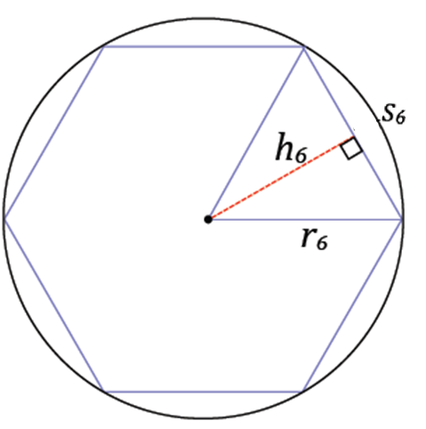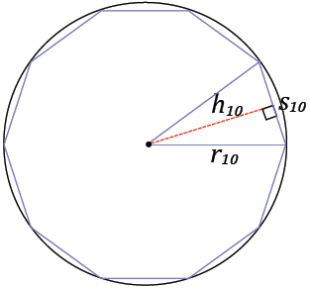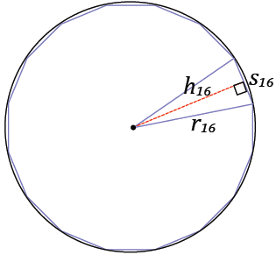

  - As $n$ increases and approaches infinity, the height $h_{n}$ becomes closer and closer to the length of the radius (as $n→∞$, $h_{n}→r$).
  - As $n$ increases and approaches infinity, $Perimeter\left(P_{n}\right)$ becomes closer and closer to the circumference of the circle (as $n→∞$, $Perimeter\left(P_{n}\right)→C$).
- Since we are defining the area of a circle as the limit of the areas of the inscribed regular polygon, substitute $r$ for $h_{n}$ and $C$ for $Perimeter\left(P_{n}\right)$ in the formulation for the area of a circle:
$$Area\left(circle\right)=\frac{1}{2}rC.$$
- Since $C=2πr$, the formula becomes
$$Area(circle)=\frac{1}{2}r(2πr) \\ Area\left(circle\right)=πr^{2}.$$
- Thus, the area formula of a circle with radius $r$ is $πr^{2}$.

Discussion (Extension)
Here we revisit the idea of trapping the area of the circle between the limits of the areas of the inscribed and outer polygons.
- As we increase the number of sides of both the inscribed and outer regular polygon, both polygons become better approximations of the circle, or in other words, each looks more and more like the circle. Then the difference of the limits of their areas should be $0$:
As $n→∞$, $[Area\left({P^{'}}_{n}\right)-Area\left(P_{n}\right)]→0$.
- Let us discover why.
  - Upon closer examination, we see that ${P^{'}}_{n}$ can be obtained by a dilation of $P_{n}$.
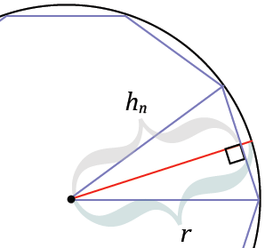

- What is the scale factor that takes $P_{n}$ to $P_{ n}^{'}$?
  - $\frac{r}{h_{n}}$
- Since the area of the dilated figure is the area of the original figure times the square of the scale factor, then
$$Area\left({P^{'}}_{n}\right)={\left(\frac{r}{h_{n}}\right)}^{2}Area\left(P_{n}\right).$$
- Now let us take the difference of the areas:
$$Area\left({P^{'}}_{n}\right)-Area\left(P_{n}\right)={\left(\frac{r}{h_{n}}\right)}^{2}Area\left(P_{n}\right)-Area\left(P_{n}\right) \\ Area\left({P^{'}}_{n}\right)-Area\left(P_{n}\right)=Area\left(P_{n}\right)\left[{\left(\frac{r}{h_{n}}\right)}^{2}-1\right].$$
- Let’s consider what happens to each of the two factors on the right-hand side of the equation as $n$ gets larger and larger and approaches infinity.
- The factor $Area\left(P_{n}\right)$: As $n$ gets larger and larger, this value is increasing, but we know it must be less than some value. Since for every $n$, $P_{n}$ is contained in the square $P_{ 4}^{'}$, its area must be less than that of $P_{ 4}^{'}$. We know it is certainly not greater than the area of the circle (we also do not want to cite the area of the circle as this value we are approaching, since determining the area of the circle is the whole point of our discussion to begin with). So, we know the value of $Area\left(P_{n}\right)$ bounded by some quantity; let us call this quantity $B$:
As $n→∞$,$Area\left(P_{n}\right)→B$.
- What happens to the factor $\left[{\left(\frac{r}{h_{n}}\right)}^{2}-1\right]$ as $n$ approaches infinity?
MP.1
Allow students time to wrestle with this question before continuing.
- The factor $\left[{\left(\frac{r}{h_{n}}\right)}^{2}-1\right]$: As $n$ gets larger and larger, the value of $\frac{r}{h_{n}}$ gets closer and closer to $1$. Recall that the radius is a bit more than the height, so the value of $\frac{r}{h_{n}}$ is greater than $1$ but shrinking in value as $n$increases. Therefore, as $n$ approaches infinity, the value of $\left[{\left(\frac{r}{h_{n}}\right)}^{2}-1\right]$ is approaching $\left[{\left(1\right)}^{2}-1\right]$, or in other words, the value of $\left[{\left(\frac{r}{h_{n}}\right)}^{2}-1\right]$ is approaching $0$:
As $n→∞$, $\left[{\left(\frac{r}{h_{n}}\right)}^{2}-1\right] →0$.
- Then, as $n$ approaches infinity, one factor is never larger than $B$, while the other factor is approaching $0$. The product of these factors as $n$ approaches infinity is then approaching $0$:
As $n→∞$, $Area\left(P_{n}\right)[{\left(\frac{r}{h_{n}}\right)}^{2}-1] →0$
or
As $n→∞$, $[Area\left({P^{'}}_{n}\right)-Area\left(P_{n}\right)]→0$.
- Since the difference approaches $0$, each term must in fact be approaching the same thing, i.e., the area of the circle.

Closing (3 minutes)
Ask students to summarize the key points of the lesson. Additionally, consider asking students the following questions independently in writing, to a partner, or to the whole class.
- The area of a circle can be determined by taking the limit of the area of either inscribed regular polygons or circumscribed polygons, as the number of sides $n$ approaches infinity.
- The area formula for an inscribed regular polygon is $Perimeter\left(P_{n}\right) ×\frac{h_{n}}{2}$. As the number of sides of the polygon approaches infinity, the area of the polygon begins to approximate the area of the circle of which it is inscribed. As $n$ approaches infinity, $h_{n}$ approaches $r$, and $Perimeter\left(P_{n}\right)$ approaches $C$.
- Since we are defining the area of a circle as the limit of the area of the inscribed regular polygon, we substitute $r$ for $h_{n}$ and $C$ for $Perimeter\left(P_{n}\right)$ in the formulation for the area of a circle:
$$Area\left(circle\right)=\frac{1}{2}rC.$$
- Since $C=2πr$, the formula becomes
$$Area(circle)=\frac{1}{2}r(2πr) \\ Area\left(circle\right)=πr^{2}.$$

Exit Ticket (8 minutes)
Name Date
Lesson 4: Proving the Area of a Disk

Exit Ticket
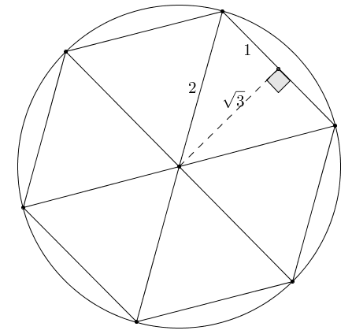
- Approximate the area of a disk of radius $2$ using an inscribed regular hexagon.

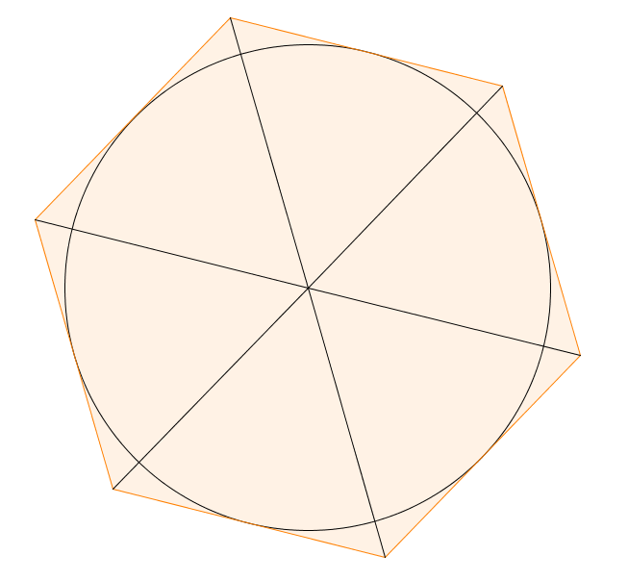
- Approximate the area of a disk of radius $2$ using a circumscribed regular hexagon.

- Based on the areas of the inscribed and circumscribed hexagons, what is an approximate area of the given disk? What is the area of the disk by the area formula, and how does your approximation compare?
Exit Ticket Sample Solutions

- Approximate the area of a disk of radius $2$ using an inscribed regular hexagon.
The interior of a regular hexagon can be divided into $6$ equilateral triangles, each of which can be split into two $30$-$60$-$90$ triangles by drawing an altitude. Using the relationships of the sides in a
$30$-$60$-$90$ triangle, the height of each triangle is $\sqrt{3}$.
$Area=\frac{1}{2}ph$
$Area=\frac{1}{2}(2∙6)∙\sqrt{3}$
$Area=6\sqrt{3}$
The area of the inscribed regular hexagon is $6\sqrt{3}$.

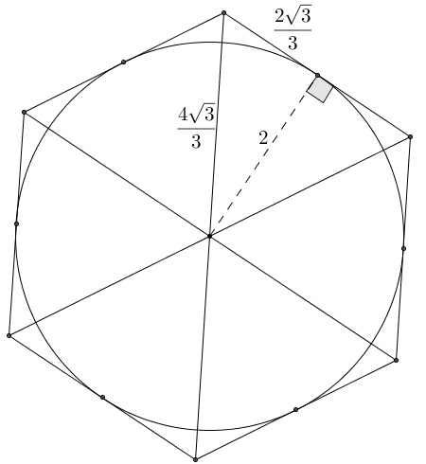
- Approximate the area of a disk of radius $2$ using a circumscribed regular hexagon.
Using the same reasoning for the interior of the hexagon, the height of the equilateral triangles contained in the hexagon is $2$, while the lengths of their sides are $\frac{4\sqrt{3}}{3}$.
$Area=\frac{1}{2}ph$
$Area=\frac{1}{2}\left(\frac{4\sqrt{3}}{3}∙6\right)∙2$
$Area=\left(4\sqrt{3}∙2\right)$
$Area=8\sqrt{3}$
The area of the circumscribed regular hexagon is $8\sqrt{3}$.

- Based on the areas of the inscribed and circumscribed hexagons, what is an approximate area of the given disk? What is the area of the disk by the area formula, and how does your approximation compare?
Average approximate area: Area formula:
$A =\frac{1}{2}\left(6\sqrt{3}+8\sqrt{3}\right)$ $A=π{\left(2\right)}^{2}$
$A=\frac{1}{2}\left(14\sqrt{3}\right)$ $A=π(4)$
$A=7\sqrt{3}≈12.12$ $A=4π≈12.57$
The approximated area is close to the actual area but slightly less.

Problem Set Sample Solutions

- Describe a method for obtaining closer approximations of the area of a circle. Draw a diagram to aid in your explanation.
The area of a disk can be approximated to a greater degree of accuracy by squeezing the circle between regular polygons whose areas closely resemble that of the circle. The diagrams below start on the left with inscribed and circumscribed equilateral triangles. The areas of the triangles appear to be quite different, but the disk appears to be somewhere between the area of the larger triangle and the smaller triangle.
Next, double the number of sides of the inscribed and circumscribed polygons, forming inscribed and circumscribed regular hexagons, whose areas are closer to that of the disk (see the center diagram). Continue the process to create inscribed and circumscribed regular dodecagons, whose areas appear even closer yet to that of the disk (see the right diagram). The process can be performed on the dodecagons to produce regular $24$-gons, then regular
$48$-gons, etc. As the number of sides of the regular inscribed and circumscribed polygons increases, the polygonal regions more closely approach the area of the disk, squeezing the area of the disk between them.
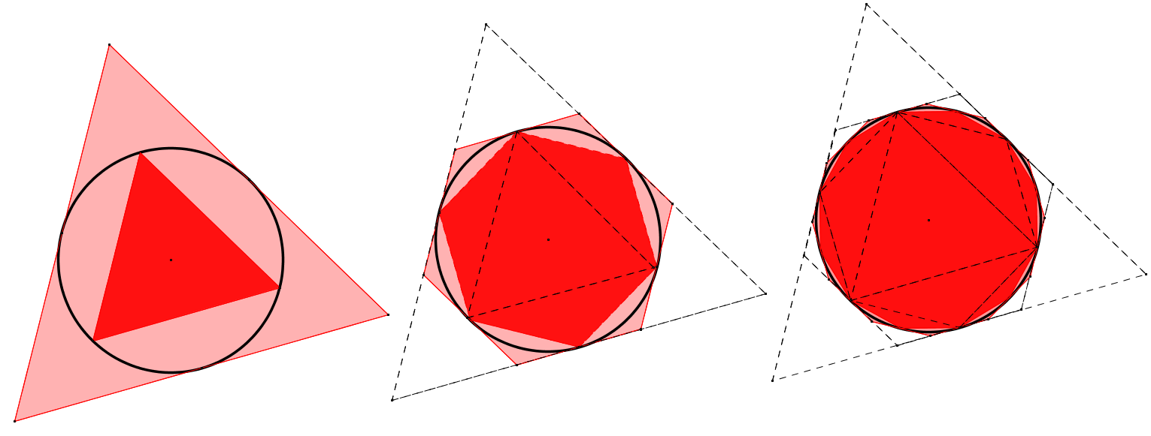

- What is the radius of a circle whose circumference is $π$?
The radius is $\frac{1}{2}$.

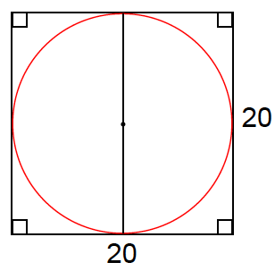
- The side of a square is $20 cm$ long. What is the circumference of the circle when …
  - The circle is inscribed within the square?
The diameter of the circle must be $20$, so the circumference is $20π$.

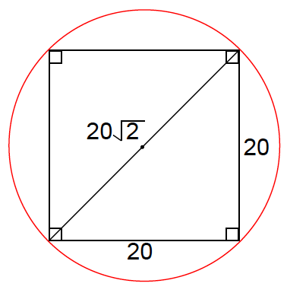
  - The square is inscribed within the circle?
The diameter of the circle must be $20\sqrt{2}$, so the circumference is $20π\sqrt{2}$.

- The circumference of circle $C_{1}=9 cm$, and the circumference of $C_{2}=2π cm$. What is the value of the ratio of the areas of $C_{1}$ to $C_{2}$?
$$C_{1}=2πr_{1}=9 \\ r_{1}=\frac{9}{2π}$$  $$Area\left(C_{1}\right)=π{\left(\frac{9}{2π}\right)}^{2}$$  $$Area\left(C_{1}\right)=\frac{81}{4π}Area\left(C_{2}\right)=π{(1)}^{2}$$ | $$C_{2}=2πr_{2}=2π \\ r_{2}=1$$  $$Area\left(C_{2}\right)=π$$

$$\frac{Area\left(C_{1}\right)}{Area\left(C_{2}\right)}=\frac{\frac{81}{4π}}{π}=\frac{81}{{4π}^{2}}$$

- The circumference of a circle and the perimeter of a square are each $50$cm. Which figure has the greater area?
$P_{square}=50$; then a side has length$12.5$. | $C_{circle}=50$; then radius is $\frac{25}{π}$.
$Area\left(square\right)={(12.5)}^{2}=156.25$ | $$Area\left(circle\right)=π{\left(\frac{25}{π}\right)}^{2}$$  $$Area\left(circle\right)=\frac{625}{π}≈198$$
The area of the square is $156.25 cm^{2}$.  The circle has a greater area. | The area of the circle is $198 cm^{2}$.

- Let us define $π$ to be the circumference of a circle whose diameter is $1$.
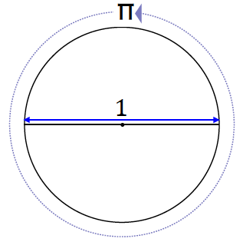
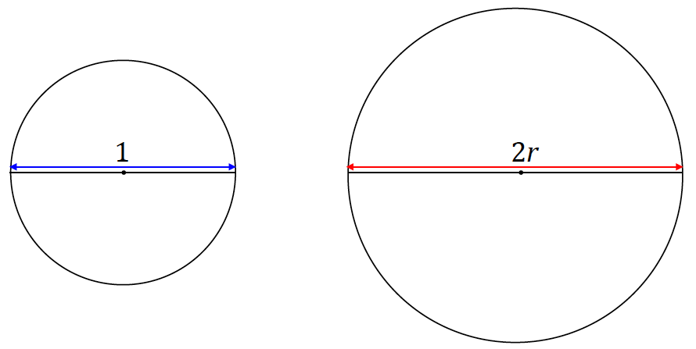
We are going to show why the circumference of a circle has the formula $2πr$. Circle $C_{1}$ below has a diameter of
$d=1$, and circle $C_{2}$ has a diameter of $d=2r$.
  - All circles are similar (proved in Module 2). What scale factor of the similarity transformation takes $C_{1}$ to $C_{2}$?
A scale factor of $2r$.

  - Since the circumference of a circle is a one-dimensional measurement, the value of the ratio of two circumferences is equal to the value of the ratio of their respective diameters. Rewrite the following equation by filling in the appropriate values for the diameters of $C_{1}$ and $C_{2}$:
$$\frac{Circumference(C_{2})}{Circumference(C_{1})}=\frac{diameter(C_{2})}{diameter(C_{1})}\text{ .}$$
$$\frac{Circumference(C_{2})}{Circumference(C_{1})}=\frac{2r}{1}$$

  - Since we have defined $π$ to be the circumference of a circle whose diameter is $1$, rewrite the above equation using this definition for $C_{1}$.
$$\frac{Circumference(C_{2})}{π}=\frac{2r}{1}$$

  - Rewrite the equation to show a formula for the circumference of $C_{2}$.
$$Circumference(C_{2})=2πr$$

  - What can we conclude?
Since $C_{2}$ is an arbitrary circle, we have shown that the circumference of any circle is $2π$r.

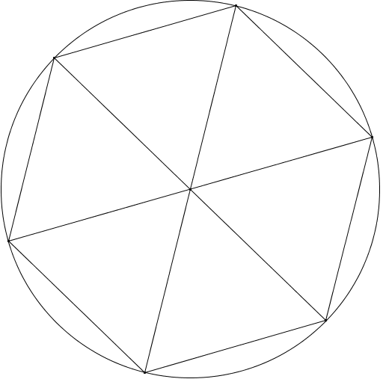
  - Approximate the area of a disk of radius$1$ using an inscribed regular hexagon. What is the percent error of the approximation?
(Remember that percent error is the absolute error as a percent of the exact measurement.)
The inscribed regular hexagon is divided into six equilateral triangles with side lengths equal to the radius of the circle, $1$. By drawing the altitude of an equilateral triangle, it is divided into two $30$-$60$-$90$ right triangles. By the Pythagorean theorem, the altitude, $h$, has length $\frac{\sqrt{3}}{2}$.
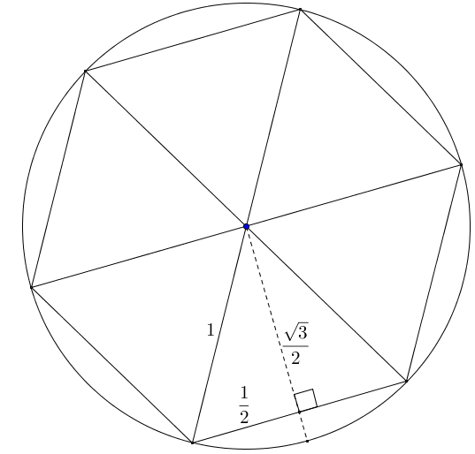
The area of the regular hexagon:
$$Area=\frac{1}{2}ph \\ Area=\frac{1}{2}\left(6∙1\right)∙\frac{\sqrt{3}}{2} \\ Area=\frac{3}{2}\sqrt{3}≈2.60$$
$$Percent Error=\frac{\left|x-a\right|}{a} \\ Percent Error=\frac{π-\frac{3}{2}\sqrt{3}}{π}≈17.3\%$$
The estimated area of the disk using the inscribed regular hexagon is approximately $2.60$ square units with a percent error of approximately $17.3\%$.
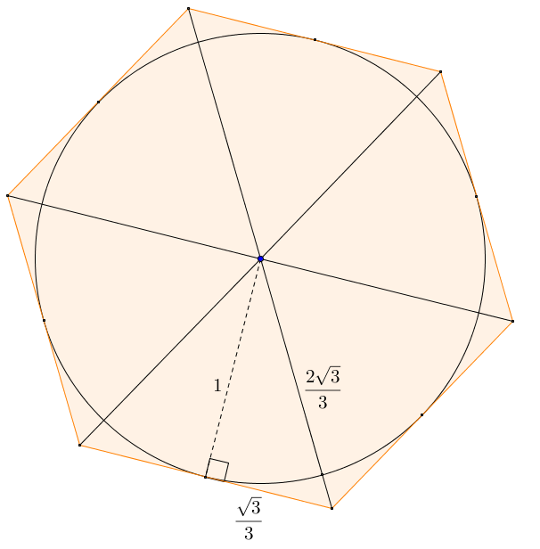
  - Approximate the area of a circle of radius $1$ using a circumscribed regular hexagon. What is the percent error of the approximation?
The circumscribed regular hexagon can be divided into six equilateral triangles, each having an altitude equal in length to the radius of the circle. By the Pythagorean theorem, the sides of the equilateral triangles are $\frac{2\sqrt{3}}{3}$.
$$Area=\frac{1}{2}ph \\ Area=\frac{1}{2}\left(6∙\frac{2\sqrt{3}}{3}\right)∙1 \\ Area=2\sqrt{3}≈3.46$$
$$Percent Error=\frac{\left|x-a\right|}{a} \\ Percent Error=\frac{2\sqrt{3}-π}{π}≈10.3\%$$
The estimated area of the disk using the circumscribed regular hexagon is approximately $3.46$ square units with a percent error of approximately $10.3\%$.

  - Find the average of the approximations for the area of a circle of radius $1$ using inscribed and circumscribed regular hexagons. What is the percent error of the average approximation?
Let $A_{v}$ represent the average approximation for the area of the disk, and let $A_{X}$ be the exact area of the disk using the area formula.
$A_{v}≈\frac{1}{2}\left(\frac{3}{2}\sqrt{3}+2\sqrt{3}\right)$ $A_{X}=π{\left(1\right)}^{2}$
$A_{v}≈\frac{7}{4}\sqrt{3}≈3.03$ $A_{X}=π≈3.14$
$$Percent Error=\frac{Absolute Error}{Exact Area} \\ Percent Error≈\frac{\left|3.14-3.03\right|}{3.14}×100\% \text{ (}\text{using} π≈3.14\text{)} \\ Percent Error≈\frac{0.11}{3.14}×100\% \\ Percent Error≈3.5\%$$

- A regular polygon with $n$ sides each of length $s$ is inscribed in a circle of radius $r$. The distance $h$ from the center of the circle to one of the sides of the polygon is over $98\%$ of the radius. If the area of the polygonal region is $10$, what can you say about the area of the circumscribed regular polygon with $n$ sides?
The circumscribed polygon has area ${\left(\frac{r}{h}\right)}^{210}$.
Since $0.98r<h<r$, by inversion $\frac{1}{0.98r}>\frac{1}{h}>\frac{1}{r}$.
By multiplying by $r$, $\frac{r}{0.98r}=\frac{1}{0.98}>\frac{r}{h}>1$.
The area of the circumscribed polygon is ${\left(\frac{r}{h}\right)}^{2}10<{\left(\frac{1}{0.98}\right)}^{2}10<10.42$.
The area of the circumscribed polygon is less than $10.42$ square units.

