Lesson 4: Proving the Area of a Disk

Classwork
Opening Exercise
The following image is of a regular hexagon inscribed in circle $C$ with radius $r$. Find a formula for the area of the hexagon in terms of the length of a side, $s,$ and the distance from the center to a side.
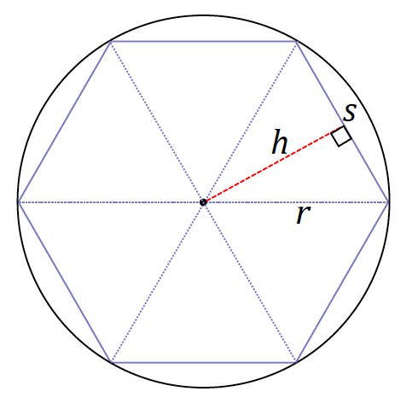
C

Example
- Begin to approximate the area of a circle using inscribed polygons.
How well does a square approximate the area of a disk? Create a sketch of $P_{4}$ (a regular polygon with $4$ sides, a square) in the following circle. Shade in the area of the disk that is not included in $P_{4}$.

- Next, create a sketch of $P_{8}$ in the following circle.

- Indicate which polygon has a greater area.

$Area\left(P_{4}\right)$ $Area\left(P_{8}\right)$

- Will the area of inscribed regular polygon $P_{16}$ be greater or less than the area of $P_{8}$? Which is a better approximation of the area of the disk?

- We noticed that the area of $P_{4}$ was less than the area of $P_{8}$ and that the area of $P_{8}$ was less than the area of
$P_{16}$. In other words, $Area\left(P_{n}\right)$ _______ $Area\left(P_{2n}\right)$. Why is this true?

- Now we will approximate the area of a disk using circumscribed (outer) polygons.
Now circumscribe, or draw a square on the outside of, the following circle such that each side of the square intersects the circle at one point. We will denote each of our outer polygons with prime notation; we are sketching ${P'}_{4}$ here.

- Create a sketch of ${P'}_{8}$.

- Indicate which polygon has a greater area.

$Area\left({P^{'}}_{4}\right)$ $Area\left({P^{'}}_{8}\right).$

- Which is a better approximation of the area of the circle, ${P'}_{4}$ or ${P'}_{8}$? Explain why.

- How will $Area\left({P^{'}}_{n}\right)$ compare to $Area\left({P^{'}}_{2n}\right)$? Explain.

Limit (description): Given an infinite sequence of numbers, $a_{1},a_{2},a_{3},…$, to say that the limit of the sequence is $A$ means, roughly speaking, that when the index $n$ is very large, then $a_{n}$ is very close to $A$. This is often denoted as, “As $n→∞$, $a_{n}→A$.”
Area of a circle (description): The area of a circle is the limit of the areas of the inscribed regular polygons as the number of sides of the polygons approaches infinity.

Problem Set

- Describe a method for obtaining closer approximations of the area of a circle. Draw a diagram to aid in your explanation.

- What is the radius of a circle whose circumference is $π$?

- The side of a square is $20 cm$ long. What is the circumference of the circle when …
  - The circle is inscribed within the square?
  - The square is inscribed within the circle?

- The circumference of circle $C_{1}=9 cm$, and the circumference of $C_{2}=2π cm$. What is the value of the ratio of the areas of $C_{1}$to $C_{2}$?

- The circumference of a circle and the perimeter of a square are each $50 cm$. Which figure has the greater area?

- Let us define $π$ to be the circumference of a circle whose diameter is $1.$
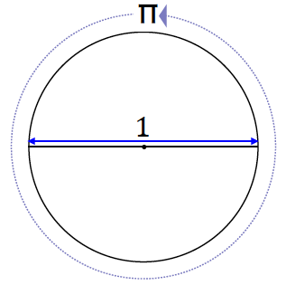
We are going to show why the circumference of a circle has the formula $2πr$. Circle $C_{1}$ below has a diameter of
$d=1$, and circle $C_{2}$ has a diameter of $d=2r$.
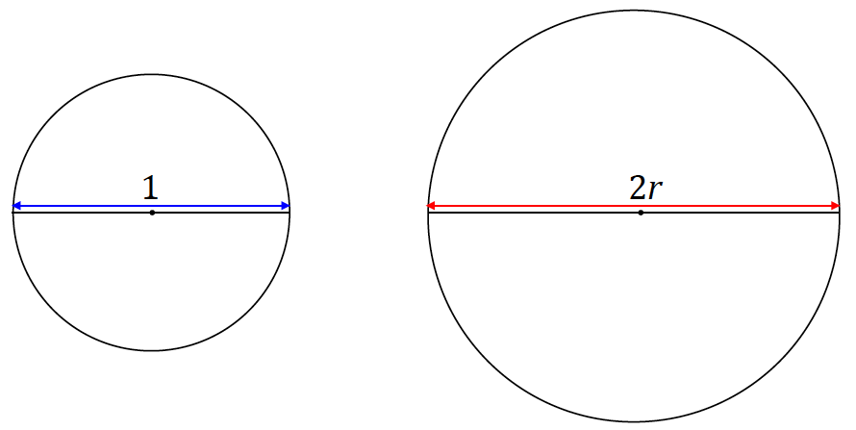
  - All circles are similar (proved in Module 2). What scale factor of the similarity transformation takes $C_{1}$ to $C_{2}$?
  - Since the circumference of a circle is a one-dimensional measurement, the value of the ratio of two circumferences is equal to the value of the ratio of their respective diameters. Rewrite the following equation by filling in the appropriate values for the diameters of $C_{1}$ and $C_{2}$:
$$\frac{Circumference(C_{2})}{Circumference(C_{1})}=\frac{diameter(C_{2})}{diameter(C_{1})} .$$
  - Since we have defined $π$ to be the circumference of a circle whose diameter is $1$, rewrite the above equation using this definition for $C_{1}$.
  - Rewrite the equation to show a formula for the circumference of $C_{2}$.
  - What can we conclude?

  - Approximate the area of a disk of radius$1$ using an inscribed regular hexagon. What is the percent error of the approximation?
(Remember that percent error is the absolute error as a percent of the exact measurement.)
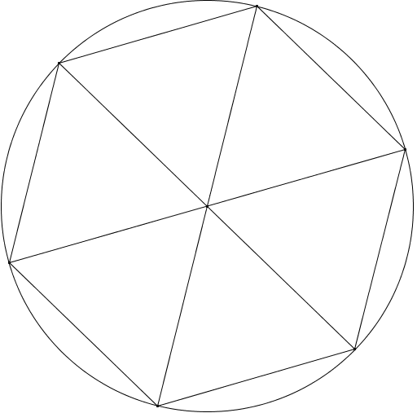

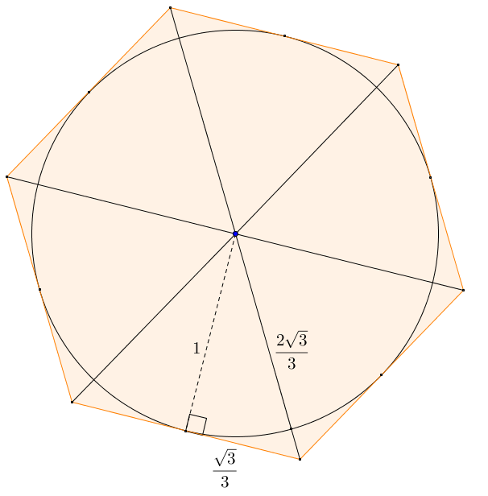
  - Approximate the area of a circle of radius 1 using a circumscribed regular hexagon. What is the percent error of the approximation?

  - Find the average of the approximations for the area of a circle of radius $1$ using inscribed and circumscribed regular hexagons. What is the percent error of the average approximation?

- A regular polygon with $n$ sides each of length $s$ is inscribed in a circle of radius $r$. The distance $h$ from the center of the circle to one of the sides of the polygon is over $98\%$ of the radius. If the area of the polygonal region is $10$, what can you say about the area of the circumscribed regular polygon with $n$ sides?

