|  |
| --- |
|  |

Lesson 3: The Scaling Principle for Area

Student Outcomes

* Students understand that a similarity transformation with scale factor multiplies the area of a planar region by a factor of
* Students understand that if a planar region is scaled by factors of and in two perpendicular directions, then its area is multiplied by a factor of .

Lesson Notes

In Lesson 3, students experiment with figures that have been dilated by different scale factors and observe the effect that the dilation has on the area of the figure (or pre-image) as compared to its image. In Topic B, the move will be made from the *scaling principle for area* to the *scaling principle for volume.* This shows up in the use of the formula  
; more importantly, it is the way we establish the volume formula for pyramids and cones. The scaling principle for area helps us to develop the scaling principle for volume, which in turn helps us develop the volume formula for general cones (**G-GMD.A.1**).

Classwork

Exploratory Challenge (10 minutes)

In the Exploratory Challenge, students determine the area of similar triangles and similar parallelograms and then compare the scale factor of the similarity transformation to the value of the ratio of the area of the image to the area of the pre-image. The goal is for students to see that the areas of similar figures are related by the square of the scale factor. It may not be necessary for students to complete all of the exercises in order to see this relationship. As you monitor the class, if most students understand it, move into the Discussion that follows.

Exploratory Challenge

Complete parts (i)–(iii) of the table for each of the figures in questions (a)–(d): (i) Determine the area of the figure (pre-image), (ii) determine the scaled dimensions of the figure based on the provided scale factor, and (iii) determine the area of the dilated figure. Then, answer the question that follows.

In the final column of the table, find the value of the ratio of the area of the similar figure to the area of the original figure.

|  |  |  |  |  |
| --- | --- | --- | --- | --- |
| **(i)**  **Area of Original Figure** | **Scale Factor** | **(ii)**  **Dimensions of Similar Figure** | **(iii)**  **Area of Similar Figure** | **Ratio of Areas** |
|  |  |  |  |  |
|  |  |  |  |  |
|  |  |  |  |  |
|  |  |  |  |  |

* 1. 

*Scaffolding:*

* Consider dividing the class and having students complete two of the four problems, and then share their results before making the conjecture in Exploratory Challenge, part (e).
* Model the process of determining the dimensions of the similar figure for the whole class or a small group.
  + 2. The base of the similar triangle is , and the height of the similar triangle is .



* + 2. The base of the similar triangle is , and the height of the similar triangle is .
  1. 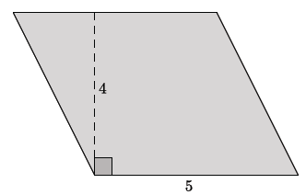
     1. The base of the similar parallelogram is , and the height of the similar parallelogram is .
  2. 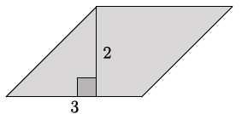
     1. The base of the **similar** parallelogram is , and the height of the similar parallelogram is .
     2. **.**

**MP.3**

**&**

**MP.8**

* 1. Make a conjecture about the relationship between the areas of the original figure and the similar figure with respect to the scale factor between the figures.

It seems as though the value of the ratio of the area of the similar figure to the area of the original figure is the square of the scale factor of dilation.

**Discussion (13 minutes)**

Select students to share their conjecture from Exploratory Challenge, part (e). Then formalize their observations with the Discussion below about the scaling principle of area.

* We have conjectured that the relationship between the area of a figure and the area of a figure similar to it is the square of the scale factor.
* Polygon is the image of Polygon under a similarity transformation with scale factor . How can we show that our conjecture holds for a polygon such as this?

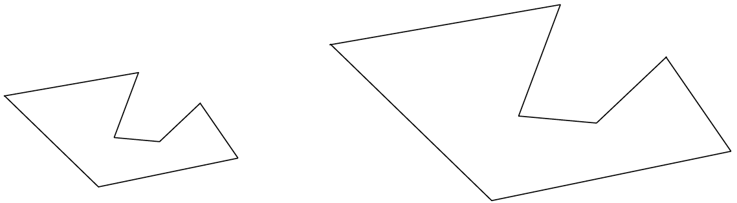

Polygon

Polygon

* Polygon is the image of Polygon under a similarity transformation with scale factor . How can we show that our conjecture holds for a polygon such as this?
  + *We can find the area of each and compare the areas of the two figures.*
* How can we compute the area of a polygon like this?
  + *We can break it up into triangles.*
* Can any polygon be decomposed into non-overlapping triangles?
  + *Yes.*
* If we can prove that the relationship holds for any triangle, then we can extend the relationship to any polygon.

The scaling principle for triangles:

If similar triangles and are related by a scale factor of , then the respective areas are related by a factor of .

* To prove the *scaling principle for triangles,* consider a triangle with base and height, and , respectively. Then the base and height of the image of are and , respectively.

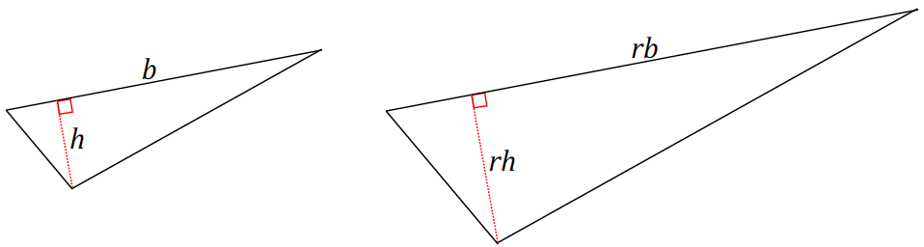

Triangle

Triangle

* + *The area of is , and the area of is*
* How could we show that the ratio of the areas of and is equal to ?

**MP.3**

*Therefore, we have proved the scaling principle for triangles.*

* Given the scaling principle for triangles, can we use that to come up with a *scaling principle for any polygon*?
  + *Any polygon can be subdivided into non-overlapping triangles. Since each area of a scaled triangle is times the area of its original triangle, then the sum of all the individual, scaled areas of triangles should be the area of the scaled polygon.*

The scaling principle for polygons:

If similar polygons and are related by a scale factor of , then their respective areas are related by a factor of .

* Imagine subdividing similar polygons and into non-overlapping triangles.

Polygon

Polygon

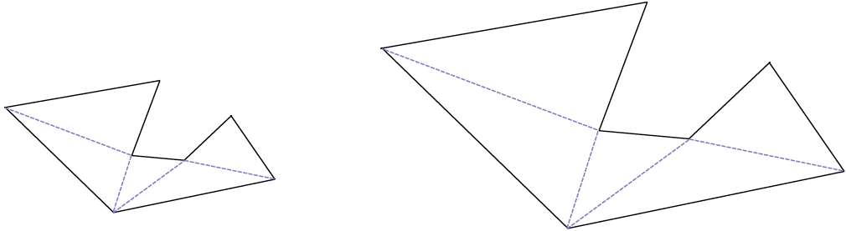

* Each of the lengths in polygon is times the corresponding lengths in polygon .
* The area of polygon is,

where is the area of the th triangle, as shown.

* By the scaling principle of triangles, the areas of each of the triangles in is times the areas of the corresponding triangles in .
* Then the area of polygon is,

Polygon

Polygon

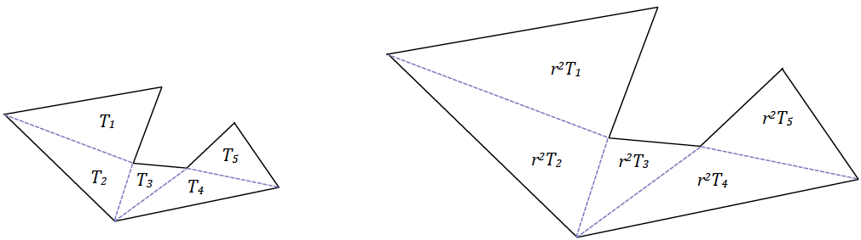

* Since the same reasoning will apply to any polygon, we have proven the scaling principle for polygons.

Exercises 1–2 (8 minutes)

Students apply the scaling principle for polygons to determine unknown areas.

Exercises 1–2

1. 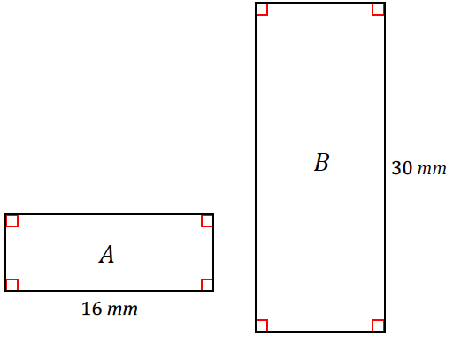Rectangles and are similar and are drawn to scale. If the area of rectangle is , what is the area of rectangle ?

Length scale factor:

Area scale factor:

*The area of rectangle is* .

1. 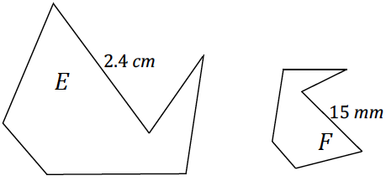Figures and are similar and are drawn to scale. If the area of figure is , what is the area of figure ?

Length scale factor:

Area scale factor:

*The area of figure is* .

**Discussion (7 minutes)**

* How can you describe the scaling principle for area?

Allow students to share ideas out loud before confirming with the formal principle below.

The scaling principle for area:

If similar figures and are related by a scale factor of , then their respective areas are related by a factor of .

* The following example shows another circumstance of scaling and its effect on area:

Give students seconds to discuss the following sequence of images with a partner. Then ask for an explanation of what they observe.

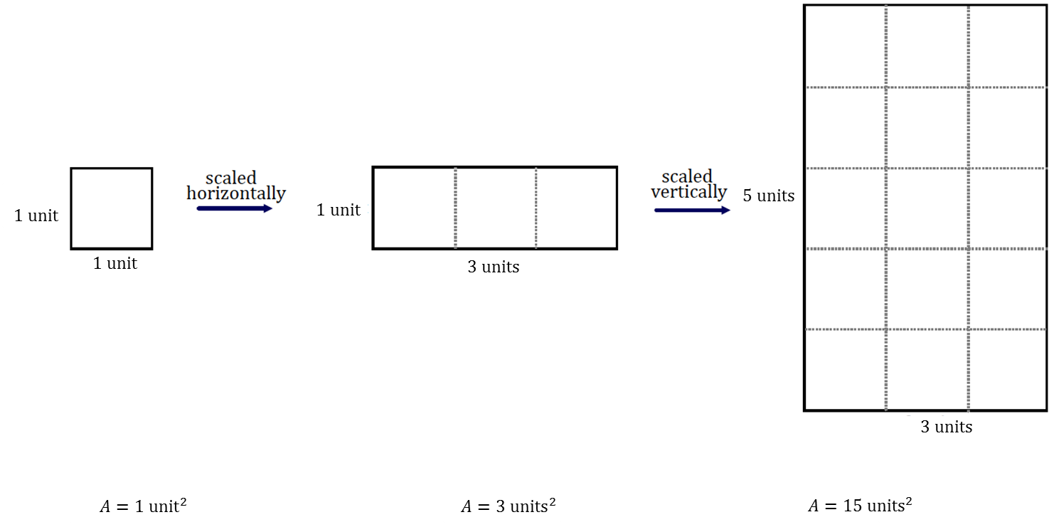

Ask follow-up questions such as the following to encourage students to articulate what they notice:

* Is the unit square scaled in both dimensions?
  + *No, only the length was scaled and, therefore, affects the area by only the scale factor.*
* By what scale factor was the unit square scaled horizontally? How does the area of the resulting rectangle compare to the area of the unit square?
  + *The unit square was scaled horizontally by a factor of , and the area is three times as much as the area of the unit square.*
* What is happening between the second image and the third image?
  + *The horizontally scaled figure is now scaled vertically by a factor of . The area of the new figure is times as much as the area of the second image.*
* Notice that the directions of scaling applied to the original figure, the horizontal and vertical scaling, are perpendicular to each other. Furthermore, with respect to the first image of the unit square, the third image has times the area of the unit square. How is this related to the horizontal and vertical scale factors?
  + *The area has changed by the same factor as the product of the horizontal and vertical scale factors.*
* We generalize this circumstance: When a figure is scaled by factors and in two perpendicular directions, then its area is multiplied by a factor of :

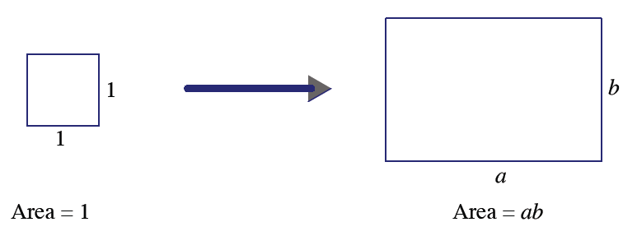

* We see this same effect when we consider a triangle with base and height , as shown below.

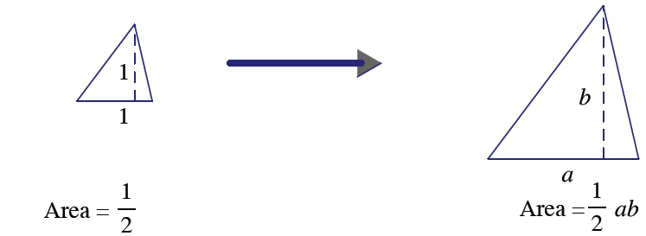

* We can observe this same effect with non-polygonal regions. Consider a unit circle, as shown below.

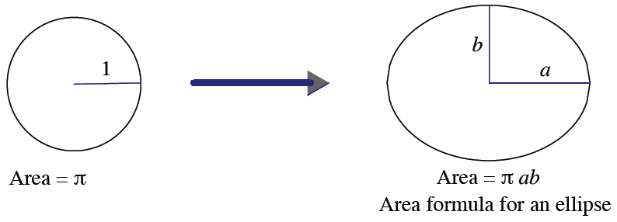

* Keep in mind that scale factors may have values between and ; had that been the case in the above examples, we could have seen reduced figures as opposed to enlarged ones.
* Our work in upcoming lessons will be devoted to examining the effect that dilation has on three-dimensional figures.

Closing (2 minutes)

Ask students to summarize the key points of the lesson. Additionally, consider asking students the following questions independently in writing, to a partner, or to the whole class.

* If the scale factor between two similar figures is , what is the scale factor of their respective areas?
  + *The scale factor of the respective areas is .*
* If the scale factor between two similar figures is , what is the scale factor of their respective areas?
  + *The scale factor of the respective areas is .*
* Explain why the scaling principle for triangles is necessary to generalize to the scaling principle for polygonal regions.
  + *Each polygonal region is comprised of a finite number of non-overlapping triangles. If we know the scaling principle for triangles, and polygonal regions are comprised of triangles, then we know that what we observed for scaled triangles applies to polygonal regions in general.*

Lesson Summary

The scaling principle for triangles: If similar triangles and are related by a scale factor of , then the respective areas are related by a factor of .

The scaling principle for polygons: If similar polygons and are related by a scale factor of , then their respective areas are related by a factor of .

The scaling principle for area: If similar figures and are related by a scale factor of , then their respective areas are related by a factor of .

Exit Ticket (5 minutes)

Name Date

Lesson 3: The Scaling Principle for Area

Exit Ticket

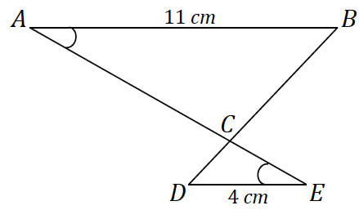In the following figure, and are segments.

* 1. and are similar. How do we know this?
  2. What is the scale factor of the similarity transformation that takes to ?
  3. What is the value of the ratio of the area of to the area of ? Explain how you know.
  4. If the area of is , what is the area of ?

Exit Ticket Sample Solutions

In the following figure, and are segments.

* 1. and are similar. How do we know this?

The triangles are similar by the AA criterion.

* 1. What is the scale factor of the similarity transformation that takes to ?
  2. What is the value of the ratio of the area of to the area of ? Explain how you know.

, or by the scaling principle for triangles.

* 1. If the area of is , what is the approximate area of ?

Problem Set Sample Solutions

1. A rectangle has an area of . Fill in the table below by answering the questions that follow. Part of the first row has been completed for you.

|  |  |  |  |  |  |
| --- | --- | --- | --- | --- | --- |
|  |  |  |  |  |  |
| Original Dimensions | Original Area | Scaled Dimensions | Scaled Area |  | Area ratio in terms of the scale factor |
|  |  |  |  |  |  |
|  |  |  |  |  |  |
|  |  |  |  |  |  |
|  |  |  |  |  |  |
|  |  |  |  |  |  |

* 1. List five unique sets of dimensions of your choice that satisfy the criterion set by the column 1 heading and enter them in column 1.
  2. If the given rectangle is dilated from a vertex with a scale factor of , what are the dimensions of the images of each of your rectangles? Enter the scaled dimensions in column 3.
  3. What are the areas of the images of your rectangles? Enter the areas in column 4.
  4. How do the areas of the images of your rectangles compare to the area of the original rectangle? Write the value of each ratio in simplest form in column 5.
  5. Write the values of the ratios of area entered in column 5 in terms of the scale factor . Enter these values in column 6.
  6. If the areas of two unique rectangles are the same, , and both figures are dilated by the same scale factor , what can we conclude about the areas of the dilated images?

The areas of the dilated images would both be and thus equal.

1. Find the ratio of the areas of each pair of similar figures. The lengths of corresponding line segments are shown.
   1. 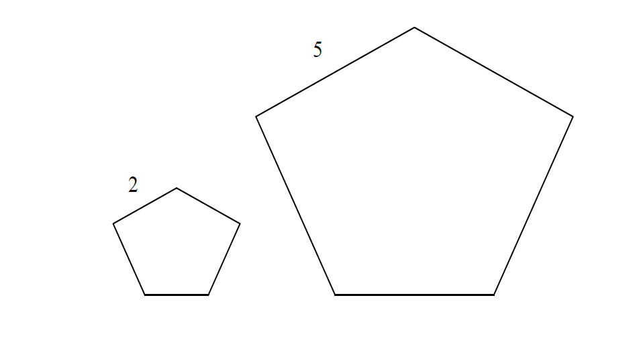

The scale factor from the smaller pentagon to the larger pentagon is . The area of the larger pentagon is equal to the area of the smaller pentagon times . Therefore, the ratio of the area of the smaller pentagon to the larger pentagon is .

* 1. 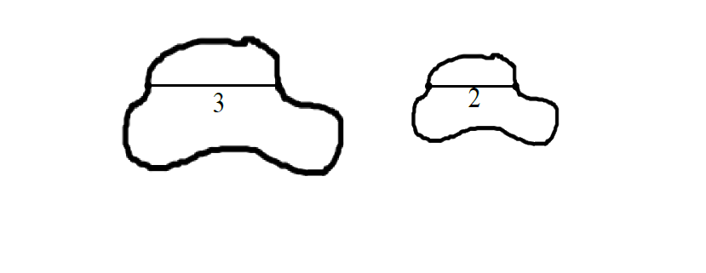

The scale factor from the smaller region to the larger region is . The area of the smaller region is equal to the area of the larger region times . Therefore, the ratio of the area of the larger region to the smaller region is .

* 1. 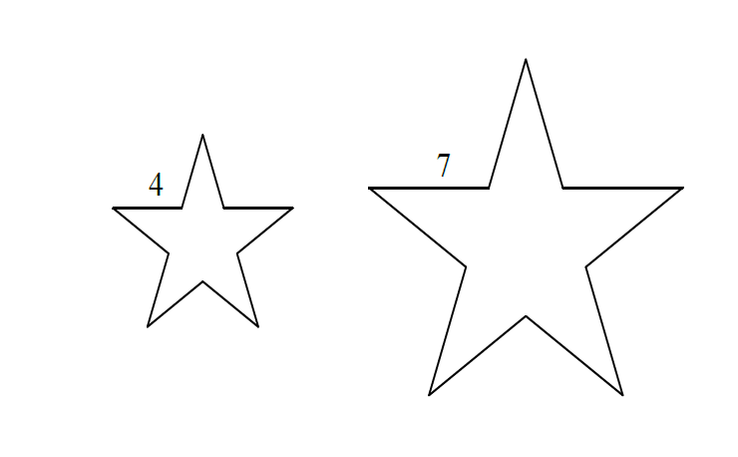

The scale factor from the small star to the large star is . The area of the large star is equal to the area of the small star times . Therefore, the ratio of the area of the small star to the area of the large star is .

1. In , line segment connects two sides of the triangle and is parallel to line segment . If the area of   
    is and , find the area of .

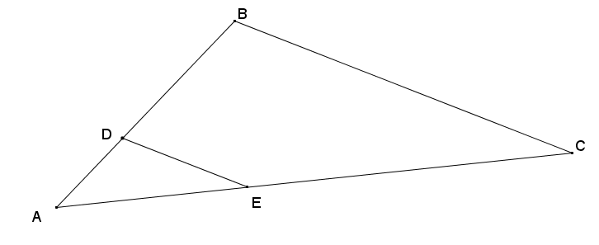The smaller triangle is similar to the larger triangle with a scale factor of . So, the area of the small triangle is the area of the large triangle.

The area of is square units.

1. The small star has an area of . The large star is obtained from the small star by stretching by a factor of in the horizontal direction and by a factor of in the vertical direction. Find the area of the large star.

The area of a figure that is scaled in perpendicular directions is equal to the area of the original figure times the product of the scale factors for each direction. The large star therefore has an area equal to the original star times the product .

The area of the large star is square units.

1. A piece of carpet has an area of . How many square inches will this be on a scale drawing that has represent ?

One square yard will be represented by one square inch. So, square yards will be represented by square inches.

1. An isosceles trapezoid has base lengths of and . If the area of the larger shaded triangle is , find the area of the smaller shaded triangle.

The triangles must be similar by AA criterion, so the smaller triangle is the result of a similarity transformation of the larger triangle including a dilation with a scale factor of. By the scaling principle for area, the area of the smaller triangle must be equal to the area of the larger triangle times the square of the scale factor used:

*The area of the smaller triangle with base is* .

1. Triangle has a line segment connecting two of its sides so that . The lengths of certain segments are given. Find the ratio of the area of triangle to the area of the quadrilateral .



. The area of isof the area of the area of because .   
So, the area of the quadrilateral is of the area of . The ratio of the area of triangle to the area of the quadrilateral is , or .

1. A square region is scaled parallel to one side by a scale factor , , and is scaled in a perpendicular direction by a scale factor one-third of to yield its image . What is the ratio of the area of to the area of ?

Let the sides of square be . Therefore, the resulting scaled image would have lengths and. Then the area of square would be , and the area of would be.

The ratio of areas of to is then ; or , or .

1. Figure is the image of figure that has been scaled horizontally by a scale factor of , and vertically by a scale factor of. If the area of is square units, what is the area of figure ?

The area of is square units.

1. What is the effect on the area of a rectangle if …
   1. Its height is doubled and base left unchanged?

The area would double.

* 1. If its base and height are both doubled?

The area would quadruple.

* 1. If its base were doubled and height cut in half?

The area would remain unchanged.