Lesson 3: The Scaling Principle for Area

Classwork

Exploratory Challenge

Complete parts (i)–(iii) of the table for each of the figures in questions (a)–(d): (i) Determine the area of the figure (pre-image), (ii) Determine the scaled dimensions of the figure based on the provided scale factor, (iii) Determine the area of the dilated figure. Then, answer the question that follows.

In the final column of the table, find the value of the ratio of the area of the similar figure to the area of the original figure.

|  |  |  |  |  |
| --- | --- | --- | --- | --- |
| (i)  Area of Original Figure | Scale Factor | (ii)  Dimensions of Similar Figure | (iii)  Area of Similar Figure | Ratio of Areas |
|  |  |  |  |  |
|  |  |  |  |  |
|  |  |  |  |  |
|  |  |  |  |  |

1. 
2. 

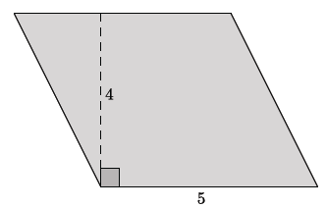

1. 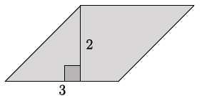
2. Make a conjecture about the relationship between the areas of the original figure and the similar figure with respect to the scale factor between the figures.

**The scaling principle for triangles:**

**The scaling principle for polygons:**

Exercises 1–2

1. Rectangles and are similar and are drawn to scale. If the area of rectangle is , what is the area of rectangle ?

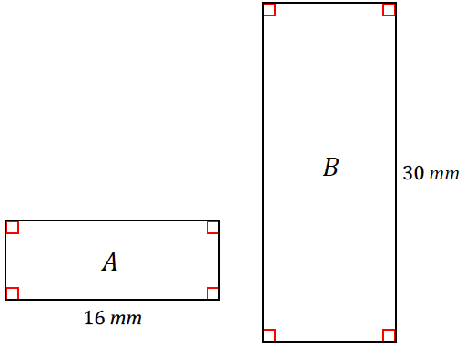

1. Figures and are similar and are drawn to scale. If the area of figure is , what is the area of figure ?

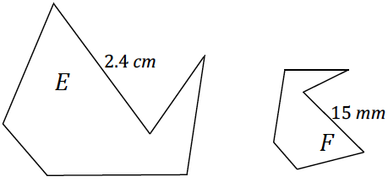

**The scaling principle for area:**

Problem Set

Lesson Summary

**The scaling principle for triangles:** If similar triangles and are related by a scale factor of , then the respective areas are related by a factor of .

**The scaling principle for polygons:**  If similar polygons and are related by a scale factor of , then their respective areas are related by a factor of .

**The scaling principle for area:** If similar figures and are related by a scale factor of , then their respective areas are related by a factor of .

1. A rectangle has an area of . Fill in the table below by answering the questions that follow. Part of the first row has been completed for you.

|  |  |  |  |  |  |
| --- | --- | --- | --- | --- | --- |
| **1** | **2** | **3** | **4** | **5** | **6** |
| **Original Dimensions** | **Original Area** | **Scaled Dimensions** | **Scaled Area** |  | **Area ratio in terms of the scale factor** |
|  |  |  |  |  |  |
|  |  |  |  |  |  |
|  |  |  |  |  |  |
|  |  |  |  |  |  |
|  |  |  |  |  |  |

* 1. List five unique sets of dimensions of your choice that satisfy the criterion set by the column 1 heading and enter them in column 1.
  2. If the given rectangle is dilated from a vertex with a scale factor of , what are the dimensions of the images of each of your rectangles? Enter the scaled dimensions in column 3.
  3. What are the areas of the images of your rectangles? Enter the areas in column 4.
  4. How do the areas of the images of your rectangles compare to the area of the original rectangle? Write the value of each ratio in simplest form in column 5.
  5. Write the values of the ratios of area entered in column 5 in terms of the scale factor . Enter these values in column 6.
  6. If the areas of two unique rectangles are the same, , and both figures are dilated by the same scale factor , what can we conclude about the areas of the dilated images?

1. Find the ratio of the areas of each pair of similar figures. The lengths of corresponding line segments are shown.
   1. 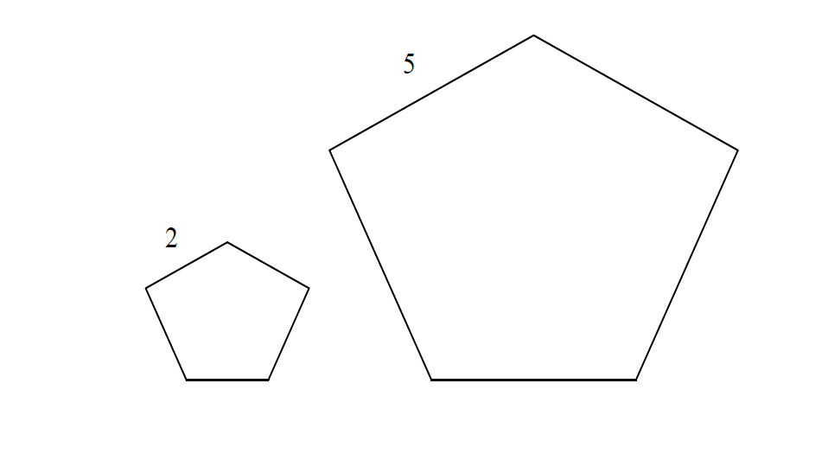

* 1. 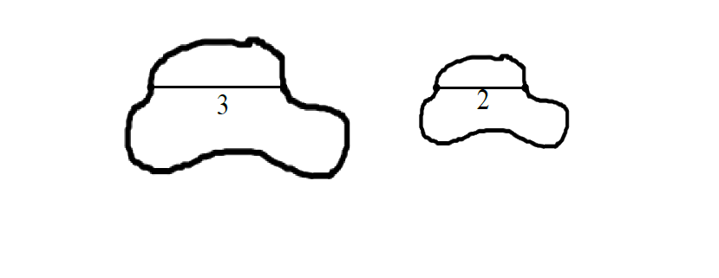

* 1. 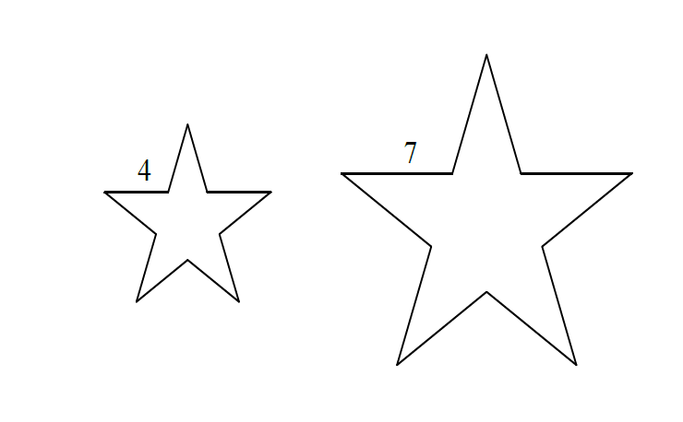

1. 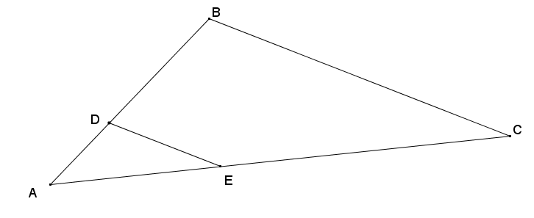In , line segment connects two sides of the triangle and is parallel to line segment . If the area of is and , find the area of .
2. The small star has an area of . The large star is obtained from the small star by stretching by a factor of in the horizontal direction and by a factor of in the vertical direction. Find the area of the large star.
3. A piece of carpet has an area of . How many square inches will this be on a scale drawing that has represent ?
4. An isosceles trapezoid has base lengths of and . If the area of the larger shaded triangle is , find the area of the smaller shaded triangle.
5. Triangle has a line segment connecting two of its sides so that . The lengths of certain segments are given. Find the ratio of the area of triangle to the area of the quadrilateral .



1. A square region is scaled parallel to one side by a scale factor , , and is scaled in a perpendicular direction by a scale factor one-third of to yield its image . What is the ratio of the area of to the area of ?
2. Figure is the image of figure that has been scaled horizontally by a scale factor of , and vertically by a scale factor of . If the area of is square units, what is the area of figure ?
3. What is the effect on the area of a rectangle if …
   1. Its height is doubled and base left unchanged?
   2. If its base and height are both doubled?
   3. If its base were doubled and height cut in half?