|  |
| --- |
|  |

Lesson 2: Properties of Area

Student Outcomes

* Students understand properties of area:

1. Students understand that the area of a set in the plane is a number greater than or equal to zero that measures the size of the set and not the shape.
2. The area of a rectangle is given by the formula . The area of a triangle is given by the formula . A polygonal region is the union of finitely many non-overlapping triangular regions; its area is the sum of the areas of the triangles.
3. Congruent regions have the same area.
4. The area of the union of two regions is the sum of the areas minus the area of the intersection.
5. The area of the difference of two regions, where one is contained in the other, is the difference of the areas.

Lesson Notes

In this lesson, we make precise what we mean about area and the properties of area. We already know the area formulas for rectangles and triangles; this will be our starting point. In fact, the basic definition of area and most of the area properties listed in the student outcomes above were first explored by students in third grade (**3.MD.C.3  
3.MD.C.6**, **3.MD.C.7**). Since their introduction, students have had continuous exposure to these properties in a variety of situations involving triangles, circles, etc. (**4.MD.A.2**, **5.NF.B.4b**, **6.G.A.1**, **6.G.A.4**). It is the goal of this lesson to state the properties learned in earlier grades explicitly. In that sense, this lesson is a summative experience for students rather than an introductory experience. Furthermore, the review is preparatory to the exploration of volume, which will come later. The examination will allow us to show the parallels between area and volume more explicitly, which helps set the stage for understanding why volume formulas for cylinders, pyramids, and cones work and, consequently, the application of each of those formulas (**G-GMD.A.1**, **G-GMD.A.3**).

If these facts seem brand new to students, please refer to the following lessons:

* Property 1, Grade 3, Module 4, Lessons 1–4
* Property 2, Grade 3, Module 4, Topic B focuses on rectangles. Triangles are not studied in Grade 3, Module 4, but there is practice decomposing regions into rectangles and adding up areas of smaller rectangles in Lesson 13. Introduction of happens in Grade 4, Module 3, Lesson 1.
* Property 3, though not addressed explicitly, is observed in Grade 3, Module 4, Lesson 5, Problem 1(a) and 1(c).
* Property 4, Grade 3, Module 4, Lesson 13
* Property 5, Grade 3, Module 4, Lesson 13, Problem 3

This lesson does cover some new material. We introduce some notation for set operations for regions in the plane: specific notation related to a union of two regions, ; an intersection of two regions, ; and a subset of a region . Students begin by exploring the properties of area, which are then solidified in a whole-class discussion.

This treatment of area and area properties in this lesson is usually referred to as Jordan measure by mathematicians. It is part of the underlying *theory of area* needed by students for learning integral calculus. While it is not necessary to bring up this term with your students, we encourage you to read up on it by searching for it on the Internet (the brave of heart might find Terence Tao’s online book on *measure theory* fascinating, even if it is just to ponder the questions he poses in the opening to Chapter 1).

If more time is needed for students to relate their previous experience working with area with these explicit properties, consider splitting the lesson over two days. This means a readjustment of pacing so as not to address all five properties in one day.

Classwork

Exploratory Challenge/Exercises 1–4 (15 minutes)

The exercises below relate to the properties of area that students know; these exercises facilitate the conversation around the formal language of the properties in the following Discussion. The exercises are meant to be quick; divide the class into groups so that each group works on a separate problem. Then have each group present their work.

Exploratory Challenge/Exercises 1–4

1. Two congruent triangles are shown below.

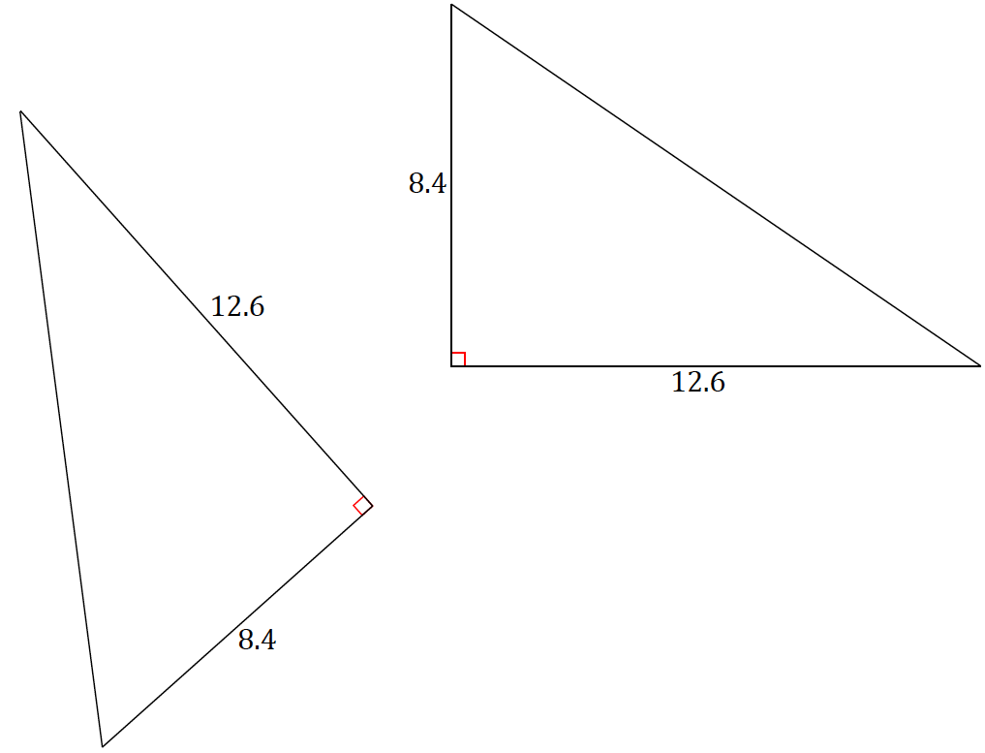

* 1. Calculate the area of each triangle.
  2. Circle the transformations that, if applied to the first triangle, would always result in a new triangle with the same area:

Translation Rotation Dilation Reflection

* 1. Explain your answer to part (b).

Two congruent figures have equal area. If two figures are congruent, it means that there exists a transformation that maps one figure onto the other completely. For this reason, it makes sense that they would have equal area because the figures would cover the exact same region.

* 1. 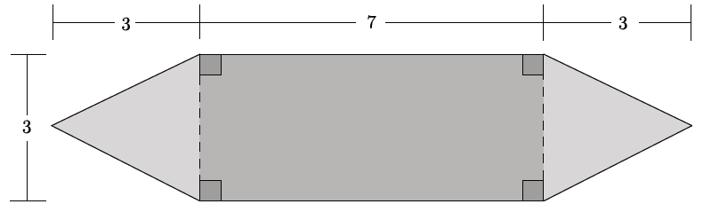Calculate the area of the shaded figure below.

The area of the figure is .

* 1. Explain how you determined the area of the figure.

First, I realized that the two shapes at the ends of the figure were triangles with a base of and a height of and the shape in the middle was a rectangle with dimensions . To find the area of the shaded figure, I found the sum of all three shapes.

1. 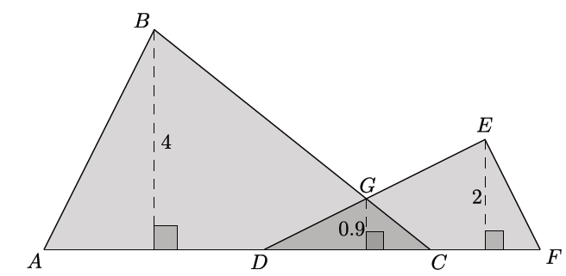Two triangles and are shown below. The two triangles overlap forming .

**MP.7**

* 1. The base of figure is comprised of segments of the following lengths: ,, and . Calculate the area of the figure .

The area of

The area of

The area of

The area of figure is .

* 1. Explain how you determined the area of the figure.

**MP.7**

Since the area of is counted twice, it needs to be subtracted from the sum of the overlapping triangles.

1. 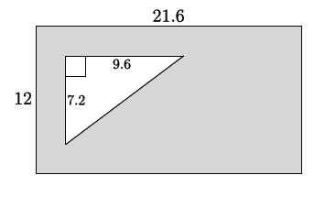A rectangle with dimensions has a right triangle with a base and a height of cut out of the rectangle.
   1. Find the area of the shaded region.

The area of the rectangle:

The area of the triangle:

The area of the shaded region is .

* 1. Explain how you determined the area of the shaded region.

I subtracted the area of the triangle from the area of the rectangle to determine the shaded region.

**Discussion (20 minutes)**

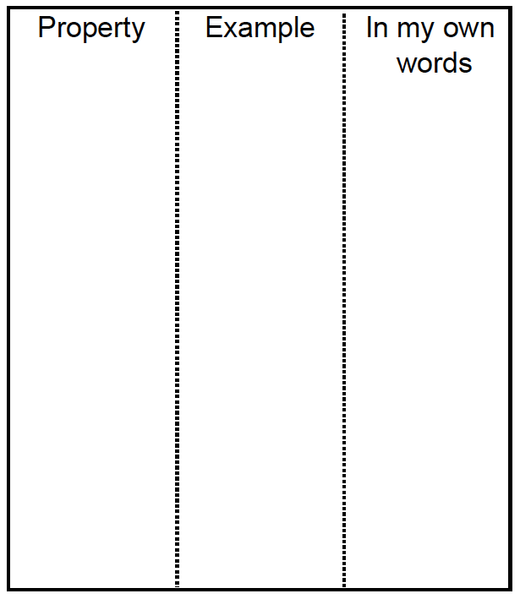The Discussion formalizes the properties of area that students have been studying since Grade 3, debriefs the exercises in the Exploratory Challenge, and introduces set notation appropriate for discussing area. Have the properties displayed in a central location as you refer to each one; and have students complete a foldable organizer on an sheet of paper like the example here, where they record each property, and new set notation and definitions, as it is discussed.

* (**Property 1**) We describe area of a set in the plane as a number, greater than or equal to zero, that measures the size of the set and not the shape. How would you describe area in your own words?

Prompt students to think back to Lesson 1, where this question was asked and reviewed as part of the Discussion.

* + *Area is a way of quantifying the size of a region without any reference to the shape of the region.*
* (**First half of Property 2**) The area of a rectangle is given by the formula . The area of a triangle is given by the formula . How can we use Exercise 1 to support this?
  + *The two congruent right triangles can be fitted together to form a rectangle with dimensions  
    . These dimensions are the length and width, or base and height, of the rectangle.*
  + *Since the two right triangles are congruent, each must have half the area of the entire rectangle or an area described by the formula .*
* (**Property 3**) Notice that the congruent triangles in the Exercise 1 each have the same area as the other.
* (**Second half of Property 2**)We describe a polygonal region as the union of finitely many non-overlapping triangular regions. The area of the polygonal region is the sum of the areas of the triangles. Let’s see what this property has to do with Exercise 2.
* Explain how you calculated the area for the figure in Exercise 2.

Select students to share their strategies for calculating the area of the figure. Sample responses are noted in the exercise. Most students will likely find the sum of the area of the rectangle and the area of the two triangles.

* Would your answer be any different if we divided the rectangle into two congruent triangles?

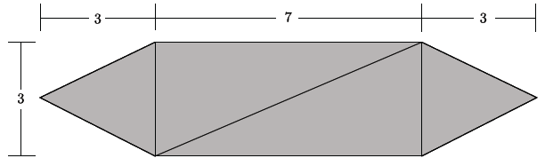Show the figure below. Provide time for students to check via calculation or discuss in pairs.

* + *No, the area of the figure is the same whether we consider the middle portion of the figure as a rectangle or two congruent triangles.*
* Triangular regions *overlap* if there is a point that lies in the interior of each. One way to find the area of such a region is to split it into non-overlapping triangular regions and add the areas of the resulting triangular regions as shown below. Figure 2 is the same region as Figure 1 but is one (of many) possible decomposition into non-overlapping triangles.

Figure 1

Figure 2



* This mode of determining area can be done for *any* polygonal region.

Provide time for students to informally verify this fact by drawing quadrilaterals and pentagons (ones that are not regular) and showing that each is the union of triangles.

* (**Property 4**) The area of the union of two regions is the sum of the areas minus the area of the intersection. Exercise 3 can be used to break down this property, particularly the terms *union* and *intersection*. How would you describe these terms?

Take several responses from students; some may explain their calculation by identifying the overlapping region of the two triangles as the intersection and the union as the region defined by the boundary of the two shapes. Then use the points below to explicitly demonstrate each union and intersection and what they have to do with determining the area of a region.

* 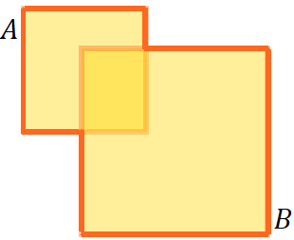If and are regions in the plane, then denotes the union of the two regions; that is, all points that lie in or in , including points that lie in both and .
* Notice that the area of the union of the two regions is not the sum of the areas of the two regions, which would count the overlapping portion of the figure twice.
* 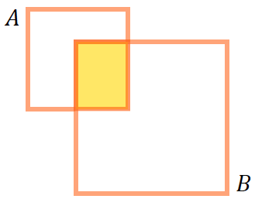If and are regions in the plane, then denotes the intersection of the two regions; that is, all points that lie in both and

*Scaffolding:*

* As notation is introduced, have students make a chart that includes the name, symbol, and simple drawing that represents each term.
* Consider posting a chart in the classroom for students to reference throughout the module.
* (**Property 4**) Use this notation to show that the area of the union of two regions is the sum of the areas minus the area of the intersection.

Discuss Property 4 in terms of two regions that coincide at a vertex or an edge. This elicits the idea that the area of a segment must be , since there is nothing to subtract when regions overlap at a vertex or an edge.

Here is an optional proof:

Two squares and meet along a common edge , or .

Since is a rectangle, its area is . The area of each of the squares is .

Since

we get

.

Solving for shows that .

It is further worth mentioning that when we discuss the area of a triangle or rectangle (or mention the area of any polygon as such), we really mean the area of the triangular region because the area of the triangle itself is zero since it is the area of three line segments, each being zero.

* (**Property 5**) The area of the difference of two regions where one is contained in the other is the difference of the areas. In which exercise was one area *contained* in the other?
  + *Exercise 4*



* If *is contained in* , or in other words is *a subset of* , denoted as , it means that all of the points in are also points in

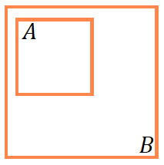

* What does Property 5 have to do with Exercise 4?
  + *In Exercise 4, all the points of the triangle are also points in the rectangle. That is why the area of the shaded region is the difference of the areas.*
* (**Property 5**) Use set notation to state Property 5: The area of the difference of two regions where one is contained in the other is the difference of the areas.
  + *When* , *then* *is the difference of the areas*.

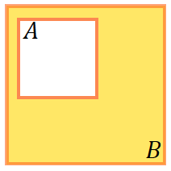

Closing (5 minutes)

Have students review the properties in partners. Ask them to paraphrase each one and to review the relevant set notation and possibly create a simple drawing that helps illustrate each property. Select students to share their paraphrased versions of the properties with the whole class.

1. Students understand that the area of a set in the plane is a number, greater than or equal to zero, that measures the size of the set and not the shape.
2. The area of a rectangle is given by the formula . The area of a triangle is given by the formula . A polygonal region is the union of finitely many non-overlapping triangular regions and has area the sum of the areas of the triangles.
3. Congruent regions have the same area.
4. The area of the union of two regions is the sum of the areas minus the area of the intersection.
5. The area of the difference of two regions where one is contained in the other is the difference of the areas.

Lesson Summary

Set (description): A *set* is a well-defined collection of objects. These objects are called *elements* or *members* of the set.

Subset: A set is a *subset* of a set if every element of is also an element of . The notation indicates that the set is a subset of set .

Union: The *union* of and is the set of all objects that are either elements of or of , or of both. The union is denoted .

Intersection: The *intersection* of and is the set of all objects that are elements of and also elements of . The intersection is denoted .

Exit Ticket (5 minutes)

Name Date

Lesson 2: Properties of Area

Exit Ticket

1. Wood pieces in the following shapes and sizes are nailed together in order to create a sign in the shape of an arrow. The pieces are nailed together so that the rectangular piece overlaps with the triangular piece by . What is the area of the region in the shape of the arrow?

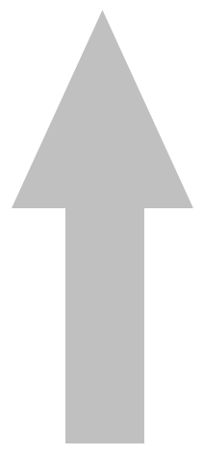

arrow-shaped sign

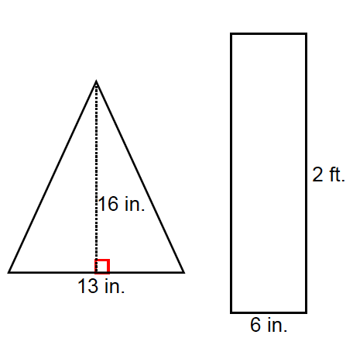

1. A quadrilateral is the union of two triangles and that meet along a common side as shown in the diagram. Explain why



Exit Ticket Sample Solutions

1. Wooden pieces in the following shapes and sizes are nailed together in order to create a sign in the shape of an arrow. The pieces are nailed together so that the rectangular piece overlaps with the triangular piece by . What is the area of the region in the shape of the arrow?

arrow-shaped sign



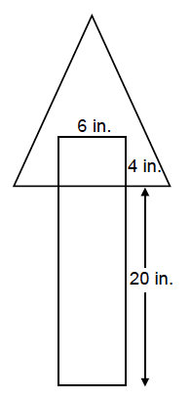

***The area of the region in the shape of the arrow is*** .

1. A quadrilateral is the union of two triangles and that meet along a common side as shown in the diagram. Explain why

*, so.*

*Since is a line segment, the area of is .*

Problem Set Sample Solutions

1. Two squares with side length meet at a vertex and together with segment form a triangle with base as shown. Find the area of the shaded region.

The altitude of the isosceles triangle splits it into two right triangles, each having a base of units in length and hypotenuse of units in length. By the Pythagorean theorem, the height of the triangles must be units in length. The area of the isosceles triangle is square units. Since the squares and the triangle share sides only, the sum of their areas is the area of the total figure. The areas of the square regions are each square units, making the total area of   
the shaded region square units.

1. If two square regions and meet at midpoints of sides as shown, find the area of the square region, .

The area of because it is a square region.

.

By Property 3, the area of .

1. 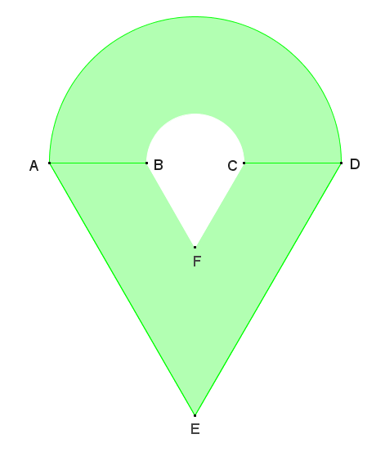The figure shown is composed of a semicircle and a non-overlapping equilateral triangle, and contains a hole that is also composed of a semicircle and a non-overlapping equilateral triangle. If the radius of the larger semicircle is , and the radius of the smaller semicircle is that of the larger semicircle, find the area of the figure.

*The area of the large semicircle:*

*The area of the smaller semicircle:*

*The area of the large equilateral triangle:*

*The area of the smaller equilateral triangle:*

*Total Area:*

*The area of the figure is approximately .*

1. Two square regions and each have . One vertex of square is the center point of square . Can you find the area of and without any further information? What are the possible areas?

*Rotating the shaded area about the center point of square by a quarter turn three times gives four congruent non-overlapping regions. Each region must have area one-fourth the area of the square. So, the shaded region has .*

1. Four congruent right triangles with leg lengths and and hypotenuse length are used to enclose the green region in Figure 1 with a square and then are rearranged inside the square leaving the green region in Figure 2.
   1. Use Property 4 to explain why the green region in Figure 1 has the same area as the green region in Figure 2.

The white polygonal regions in each figure have the same area, so the green region (difference of the big square and the four triangles) has the same area in each figure.

* 1. Show that the green region in Figure 1 is a square and compute its area.

Each vertex of the green region is adjacent to the two acute angles in the congruent right triangles whose sum is . The adjacent angles also lie along a line (segment), so their sum must be . By addition, it follows that each vertex of the green region in Figure 1 has a degree measure of . This shows that the green region is at least a rectangle.

The green region was given as having side lengths of , so together with having four right angles, the green region must be a square.

* 1. Show that the green region in Figure 2 is the union of two non-overlapping squares and compute its area.

The congruent right triangles are rearranged such that their acute angles are adjacent, forming a right angle. The angles are adjacent to an angle at a vertex of an green region, and since the angles are all adjacent along a line (segment), the angle in the green region must then be . If the green region has four sides of length , and one angle is , the remaining angles must also be , and the region a square.

A similar argument shows that the green region is also a square. Therefore, the green region in Figure 2 is the union of two non-overlapping squares. The area of the green region is then .

* 1. How does this prove the *Pythagorean theorem*?

Because we showed the green regions in Figures 1 and 2 to be equal in area, the sum of the areas in Figure 2 being , therefore, must be equal to the area of the green square region in Figure 1, . The lengths , , and were given as the two legs and hypotenuse of a right triangle, respectively, so the above line of questions shows that the sum of the squares of the legs of a right triangle is equal to the square of the hypotenuse.