Lesson 2: Properties of Area

Classwork

Exploratory Challenge/Exercises 1–4

1. Two congruent triangles are shown below.

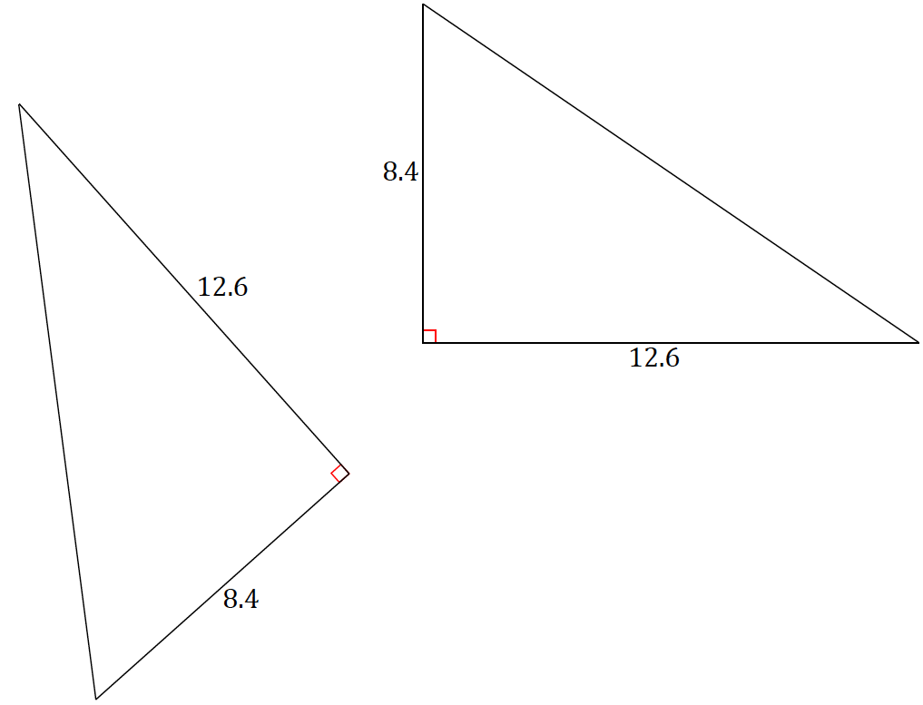

* 1. Calculate the area of each triangle.
  2. Circle the transformations that, if applied to the first triangle, would always result in a new triangle with the same area:

Translation Rotation Dilation Reflection

* 1. Explain your answer to part (b).
  2. 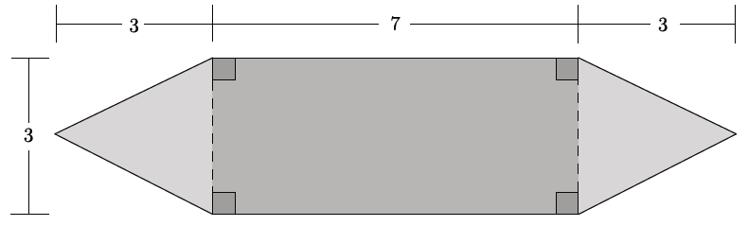Calculate the area of the shaded figure below.
  3. Explain how you determined the area of the figure.

1. Two triangles and are shown below. The two triangles overlap forming .

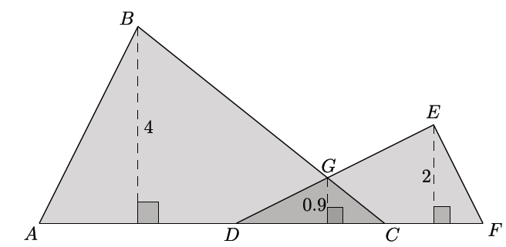

* 1. The base of figure is comprised of segments of the following lengths: ,, and Calculate the area of the figure
  2. Explain how you determined the area of the figure.

1. 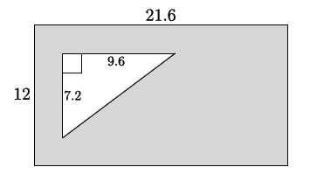A rectangle with dimensions has a right triangle with a base and a height of cut out of the rectangle.
   1. Find the area of the shaded region.
   2. Explain how you determined the area of the shaded region.

Lesson Summary

Set (description): A *set* is a well-defined collection of objects. These objects are called elements or members of the set.

**Subset:**  A set is a *subset* of a set if every element of is also an element of . The notation indicates that the set is a subset of set .

**Union:**  The *union* of and is the set of all objects that are either elements of or of , or of both. The union is denoted .

**Intersection:** The *intersection* of and is the set of all objects that are elements of and also elements of . The intersection is denoted .

Problem Set

1. Two squares with side length meet at a vertex and together with segment form a triangle with base as shown. Find the area of the shaded region.
2. If two square regions and meet at midpoints of sides as shown, find the area of the square region, .
3. 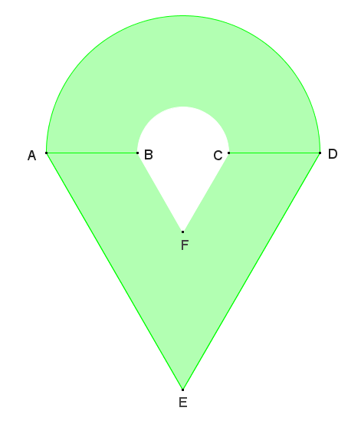The figure shown is composed of a semicircle and a non-overlapping equilateral triangle, and contains a hole that is also composed of a semicircle and a non-overlapping equilateral triangle. If the radius of the larger semicircle is , and the radius of the smaller semicircle is that of the larger semicircle, find the area of the figure.
4. Two square regions and each have area 8. One vertex of square is the center point of square. Can you find the area of and without any further information? What are the possible areas?
5. Four congruent right triangles with leg lengths and and hypotenuse length are used to enclose the green region in Figure 1 with a square and then are rearranged inside the square leaving the green region in Figure 2.
   1. Use Property 4 to explain why the green region in Figure 1 has the same area as the green region in Figure 2.
   2. Show that the green region in Figure 1 is a square and compute its area.
   3. Show that the green region in Figure 2 is the union of two non-overlapping squares and compute its area.
   4. How does this prove the Pythagorean theorem?