|  |
| --- |
|  |

Lesson 1: What Is Area?

Student Outcomes

* Students review the area formula for rectangles with rational side lengths and prove the area formula for an arbitrary rectangle.
* Students use a square grid to estimate the area of a curved region using lower approximations, upper approximations, and average approximations.

Lesson Notes

In Grade 8, Module 7, Lesson 11, we approximated the value of an irrational number, and in Lesson 14 of the same module, we approximated the decimal expansion of ; both lessons used the idea of upper and lower approximations. We use the strategy of upper and lower approximations in this lesson. In fact, we see this theme repeatedly throughout the module; for the area of a region we do not normally have a method to compute, we can approximate the area by using areas of regions larger and smaller than the target region that we *do* know how to compute. These larger and smaller areas act as upper and lower approximations, respectively. This work provides the foundation for using informal limits to describe the area of a circle (**G-GMD.A.1**) and foreshadows what students will see in integral calculus.

Exploratory Challenge 1 reminds students of what area is and why we can use the formula to compute the area of a rectangle. Students use what they know about determining the area of a rectangle with whole number and rational side lengths to justify why the formula holds when the side lengths are irrational. The Discussion extends what students have learned about area in Grade 3, Module 4 regarding multiplication and area in general as well as in Grade 5, Module 5 where students use area models to multiply fractions and interpret the work as multiplying side lengths of a rectangle to find area.

Classwork

Exploratory Challenge 1 (4 minutes)

Use the Exploratory Challenge to get students thinking about how and why they calculate the area of a rectangular region.

Exploratory Challenge 1

1. What is area?

**Responses will vary. Expect a variety of descriptions of area. For example, “it is a space, like a picnic area” or “it is .” Take a few responses and move on, as this question is more precisely answered in the Discussion following Exploratory Challenge 1.**

Consider prompting students further with the following questions:

* Give an example of when you would need to know area.
* Use the word area in a sentence.
* What are the units associated with area?

1. What is the area of the rectangle below whose side lengths measure units by units?

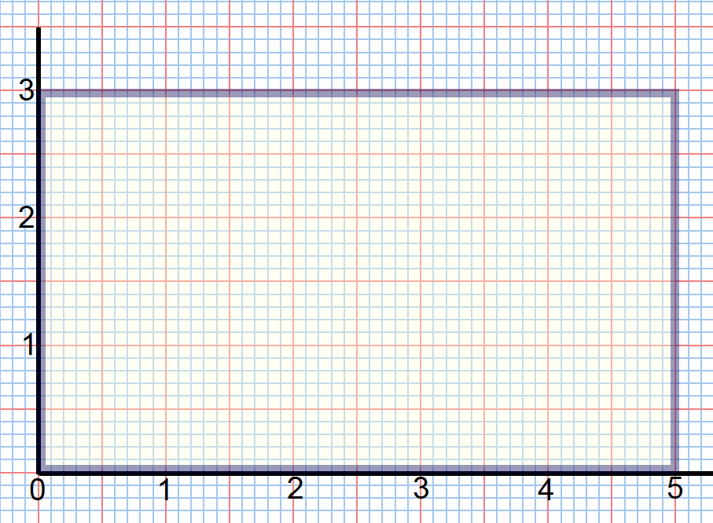

**The area is square units.**

1. What is the area of the rectangle below?

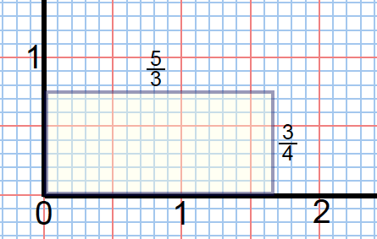

**The area is square units.**

Once students have answered and shared out responses for parts (b) and (c), pose the question below as a starting point to the Discussion. Allow them to express ideas, but confirm the concept in the Discussion.

* Why can we use the formula to calculate area of a rectangular region with whole number and rational side lengths?

It should be noted that when we discuss area of a region, the area is a quantity that measures the region. It is common practice to accept the phrase *area of a rectangle* to be synonymous with area of a rectangular region, but students should be aware of the distinction.

Students begin their study of area with whole numbers in Grade 3 and progress to the use of rational side lengths in Grade 5. Here in this lesson, they will see why the area formula for a rectangle with *irrational* side lengths is the same as that of the formula for rectangles with whole number and rational side lengths.

Discussion (5 minutes)

The purpose of the following discussion is to prepare students for working with rectangles with irrational side lengths and ultimately finding the area under a curve.

* Area is a way of associating to any region a quantity that reflects our intuitive sense of how big the region is, without reference to the shape of the region.
* Recall that we measure area by fixing a unit square and defining the area of a region as the number of unit squares (and partial unit squares) needed to fill or tile the region.
* Whether we can see the grid lines of such unit squares, we know that if we were to place a rectangular region on a grid of unit squares, we could count the number of unit squares, or use multiplication since it is simply an expedited means of counting (repeated addition). Therefore, we know the area of a rectangle can be determined by the formula .
* Thus, the area of the rectangle in part (b), filled with three rows of unit squares each, is .

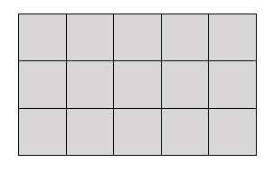  
Area

* The formula can be extended to rectangles with rational side lengths. For example, consider a rectangle that is . The area of this rectangle is the same as copies of smaller rectangles, each of which has area square units. To find the area of the rectangle we can divide one unit square into , or smaller rectangles:

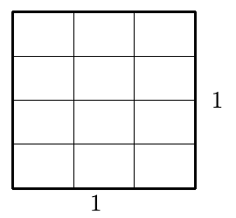

* What is the area of each smaller rectangular region?
  + *square units.*
* Now we can define a rectangle that is or twelfths:

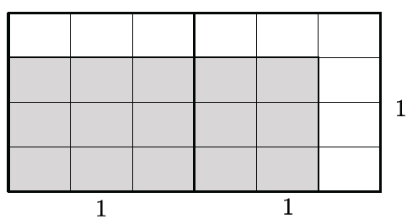

* Notice that the calculation process that yields an area twelfths, or , is relative to square unit.

For more on how this content has been addressed in earlier grade levels, please review Grade 5, Module 4 (the content is spread over several topics) and Topic C of Grade 5, Module 4. Module 4 develops the rules of fraction multiplication using area models but does not explicitly connect the arithmetic with finding the area of the figure in square units. The content in Module 5 makes the area connection explicit.

Exploratory Challenge 2 (5 minutes)

In Exploratory Challenge 2, students are prompted to consider irrational side lengths of a rectangular region and how that impacts the calculation of its area. As students approximate the area in part (a), prompt them to justify their answer by counting how many of the small squares are in square unit and predicting how many small squares should then be in square units. Have them verify this by counting squares in the rectangle.

Exploratory Challenge 2

* 1. What is the area of the rectangle below whose side lengths measure units by units? Use the unit squares on the graph to guide your approximation. Explain how you determined your answer.

*Scaffolding:*

* Use scaffolded questions with the whole class or a small group.
* Count the boxes to come up with an approximation that you know is too big. Count the boxes to come up with an approximation that you know is too small. Use your predictions to check if your final answer makes sense.

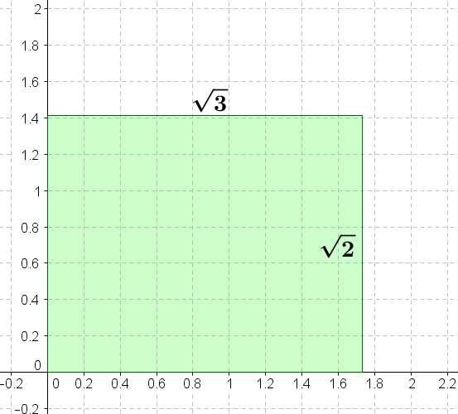

**Answers will vary; some students may respond with a decimal approximation, such as approximately square units. Others might respond with the answer square units; ask students how they know in this case.**

* 1. Is your answer precise?

**Students who offered decimal answers should recognize that their results are not precise because their side length estimations are just that: estimations of irrational values. A precise answer would be square units, but again, press students for a justification for this answer.**

**Discussion (15 minutes)**

We use Exploratory Challenge 2 to continue the discussion on area but now with rectangles with irrational side lengths. The overarching goal is to show that even with irrational side lengths the area of a rectangle can be calculated using the formula.

There are two additional sub-goals: (1) The Discussion is an opportunity to understand the process of multiplying two irrational numbers in the context of approximating the area of a rectangle with two irrational side lengths. Teachers should note to their students that this process works in general and is one way to visualize the meaning of products like or . (2) The refinement of the underestimates and overestimates of area we derive in this example will be a theme that we will keep coming back to throughout this entire module.

* Do you think we can give the same explanation for a rectangle with irrational side lengths like the rectangle in Exploratory Challenge 1, part (c)?
  + *Student responses will vary. Students should reason that we cannot use the same explanation because we typically approximate the value of irrational numbers using finite decimals in order to compute with them. Therefore, the area of any rectangle with irrational side lengths, given in decimal or fractional form, can only be approximated.*
* Now, we will use a strategy that allows us to approximate the area of a rectangle with irrational side lengths more accurately. We start by trying to show that the area of a rectangle with irrational side lengths can be found using the formula

Allow students the opportunity to wrestle with the following question:

*Scaffolding:*

* For grade-level students, ask them to find fraction representations of and . The idea is to remind students that rational values can be written as both fractions (as in the Exploratory Challenges) and as decimals.
* Provide struggling learners with the fractions and , and ask them how they are related to the upper approximation of the area, , in this step.

**MP.1**

* Consider the rectangle that is . How can we approximate its area, ?
  + *Have students share their responses to Exploratory Challenge 2, part (a).*
* Since … and … then the area, , of the rectangle (shown below in green) is greater than the area of a rectangle that is (shown below in blue) but less than the area of a rectangle that is (shown below in red). This is our first, very rough, upper and lower approximations of the area, .

Discussion

Use Figures 1, 2, and 3 to find upper and lower approximations of the given rectangle.

Figure 1

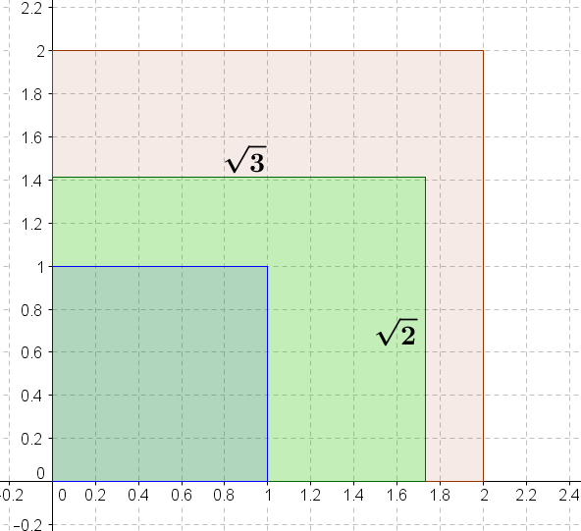

* We can make a more precise estimate of the area, , by looking at side lengths that are more precise. Since we know how to find the area of rectangles with rational side lengths, let us pick more precise side lengths that are closer in value to ; we will select arbitrary, but appropriate, rational values. Let us create an upper approximation of the area, , by using a rectangle with dimensions (shown in red) and a lower approximation by using a rectangle with dimensions (shown in blue).

Figure 2

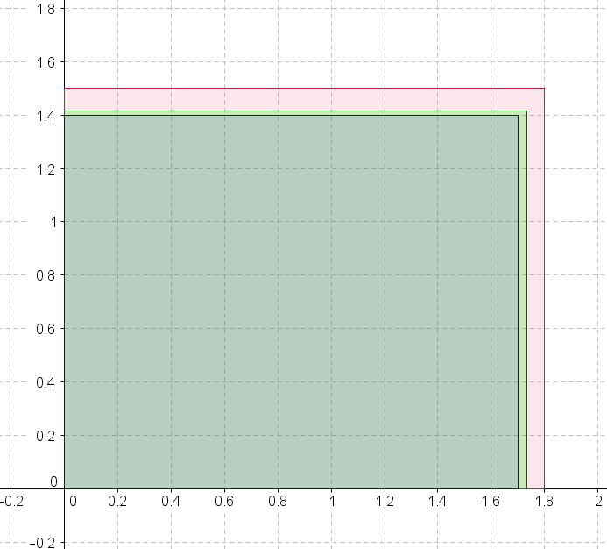

* Can we make a more precise approximation? Describe dimensions of a possible lower approximation for that is more precise than .

Allow students to share out possible values. Remind them of the values of the dimensions they are targeting and that the goal is to use approximate dimensions that are closer to the true values:… by . Guide students toward the idea that the way to refine the dimensions is to rely on the digits directly from the decimal values of and . For the lower approximation dimensions, the exact digits are selected but truncated from the expansion. With the upper approximation dimensions, for each successive dimension, and each additional place value, one digit greater than the digit in place of the actual expansion is taken.

* The area, , of the rectangle is greater than the area of a rectangle that is (shown in blue) but less than the area of a rectangle that is (shown in red).

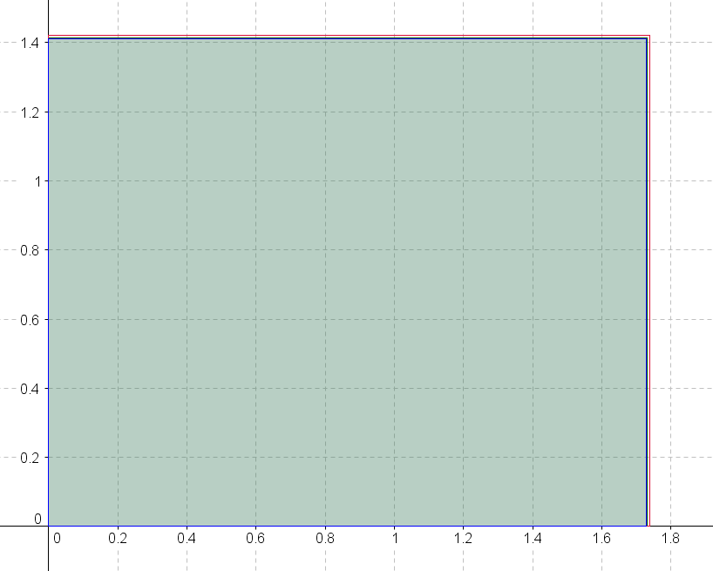

Figure 3

* We can continue to refine the approximations. The area, (shown in green), of the rectangle is greater than the area of a rectangle that is (shown below in blue) but less than the area of a rectangle that is (shown below in red). Notice now that, even as we zoom in, it is difficult to distinguish between the red, black, and blue rectangles because they are so close in size.

Figure 4

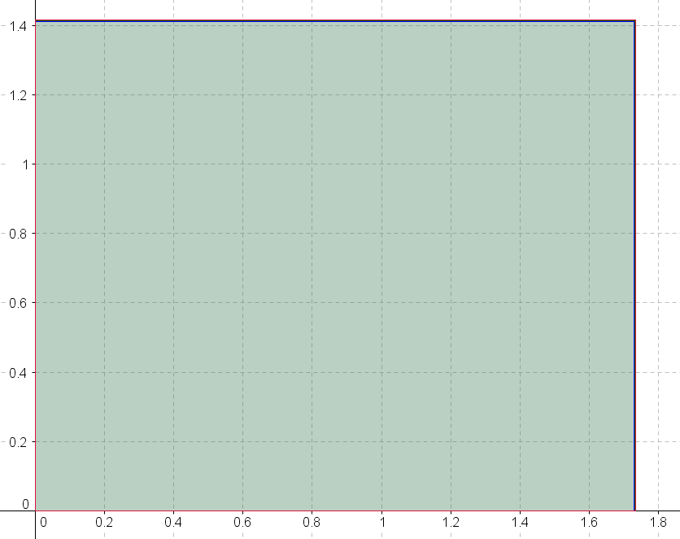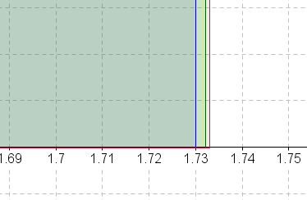

* The following tables summarize our observations so far and include a few additional values. The following table shows lower approximations first (blue rectangles).

|  |  |  |  |
| --- | --- | --- | --- |
| Lower Approximations | | | |
| Less than | Less than | Less than or equal to | |
|  |  |  |  |
|  |  |  |  |
|  |  |  |  |
|  |  |  |  |
|  |  |  |  |
|  |  |  |  |
|  |  |  |  |

Provide time for students to make sense of the data in the table. Ask the following questions to ensure students understand the data table:

* What do you notice happening in the first column as you go down the rows?
  + *We are using approximations of that are less than the actual value but becoming closer and closer to the actual value.*
* What do you notice happening in the second column as you go down the rows?
  + *We are using approximations of that are less than the actual value but becoming closer and closer to the actual value.*
* What impact do these approximations have on the area, , as you go down the rows in the third column?
  + *The more precise of an estimate we use for and , the closer we get to the precise area of the rectangle.*
* What do you notice about decimal expansions of the product?
  + *More and more of the digits in the expansion of the product are the same.*
* Why are all of these calculations less than ? When will it be equal to ?
  + *Students may not have precise answers to these questions. They are prompts to help shape their number sense.*
* Find the decimal value of . How do the decimal expansions of the product relate to ?
  + *They are getting closer to the decimal expansion of .*
* What does have to do with  *and* ?
  + *is the product of and .*
* In the table above, we underestimate the side lengths so the area estimate is less than the actual area of the rectangle. Similarly, in the table below, we overestimate the side lengths (red rectangles) so our area estimate is greater than the actual area. Again, a few additional values beyond those we discussed have been added.

|  |  |  |  |
| --- | --- | --- | --- |
| Upper Approximations | | | |
| Greater than | Greater than | Greater than or equal to | |
|  |  |  |  |
|  |  |  |  |
|  |  |  |  |
|  |  |  |  |
|  |  |  |  |
|  |  |  |  |
|  |  |  |  |

* Does the relationship with still seem to hold relative to the upper approximation of the area as it did with the lower approximation?
  + *Yes, each successive upper approximation of is closer and closer to .*
* Putting these two tables together we can get two estimates for the area : one that is less than and one that is greater than .
* Recall that if we know that the true value of the area is a number between and , then we know that the absolute value of the error is less than and that . Then the upper bound on the error using the numbers and as an approximation for is found by , and the percent error is approximately
* If we continue the lower and upper estimates for the area , we would find that there is only one number that is greater than or equal to all of the lower estimates and less than or equal to all of the upper estimates: .
* Thus, we say that the area of the rectangle is because this number is the only number that is always between the lower and upper estimates using rectangles with rational side lengths. Using this reasoning, we can say that the area of any rectangle is given by .

**Discussion (10 minutes)**

In the last example, we approximated the area of a rectangle with irrational length sides to get better and better approximations of its area. We extend this idea in the next example to show that the same procedure can also be done with regions that are bounded by curves. Present the question to students, and then allow them time to develop strategies in partners or small groups.

*Scaffolding:*

* Teachers may choose to use a circle instead of an ellipse for this Discussion.

Discussion

If it takes one can of paint to cover a unit square in the coordinate plane, how many cans of paint are needed to paint the region within the curved figure?



**MP.1**

**&**

**MP.3**

Provide time for students to discuss the problem with partners or in small groups. Then have students share their strategies with the whole class. If necessary, the bullet points below can be used to guide students’ thinking.

Strategies developed by students will vary. Encourage those strategies that approximate the area of the curved region by making approximations first with whole squares, then partial squares, and finally comparing the area of regions outside the curve and inside the curve, as close to the actual area as possible.

* First, find how many squares and half squares (since we know how to find the area of a half square region) fit inside the region.

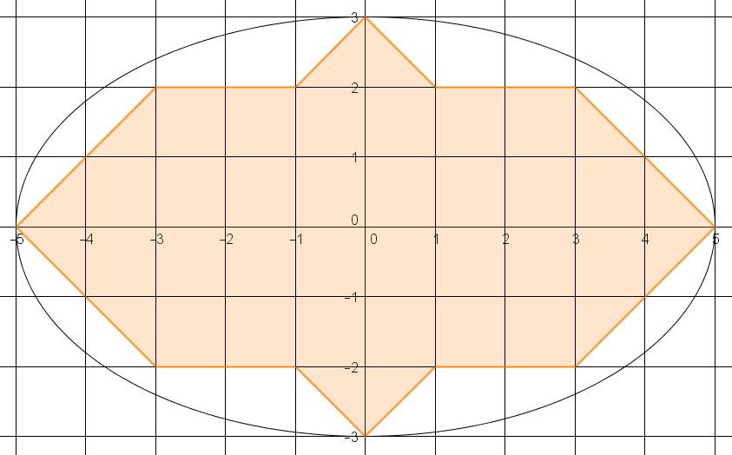

* + *This strategy gives us the answer that it will take more than cans of paint.*
* Now consider the area of the region just outside the curve. How many cans of paint will it take if we count the squares and half squares?

Point out to students that the shaded area is the minimum area needed to fill the ellipse, comprised of whole and half squares, completely.

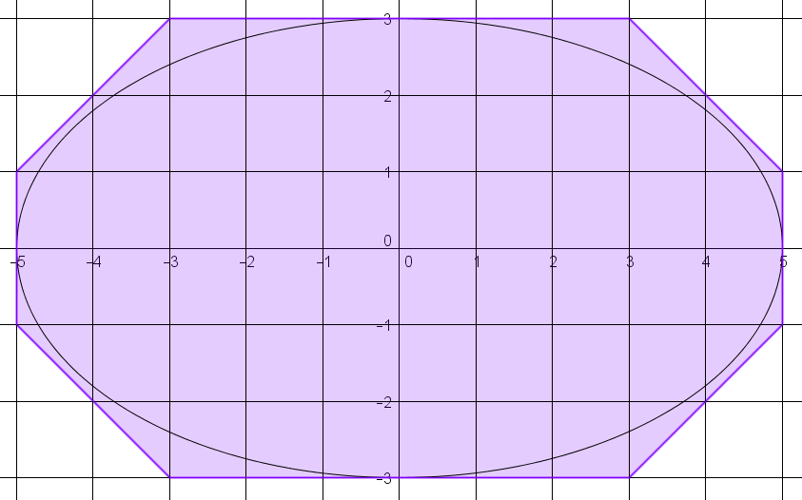

* + *This strategy gives us the answer that it will take less than cans of paint.*
* An estimate of the area is the average of and , or cans of paint. How can we improve the accuracy of our estimate?
  + *If we used smaller square units, we could make a more accurate estimate of the area.*
* If we divide each unit square into four smaller squares and count all of the squares and half squares, how many cans of paint will it take to cover the region inside the curve?

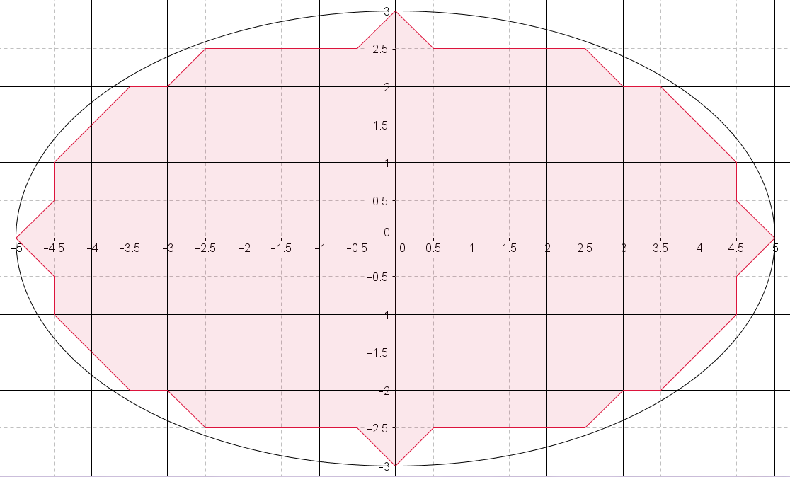

*Scaffolding:*

* For struggling learners, teachers may choose to tile the figure with manipulative units so that students can easily rearrange them into whole unit squares.
* Ask students who may be above grade level to make and justify an estimate of the area independently.
  + *There are squares and half squares in the region inside the curve. Since it takes can of paint to cover every of these squares, then it will take more than cans of paint to cover this region.*
* Now consider the area of the region just outside the curve. How many cans of paint will it take if we count the squares and half squares?

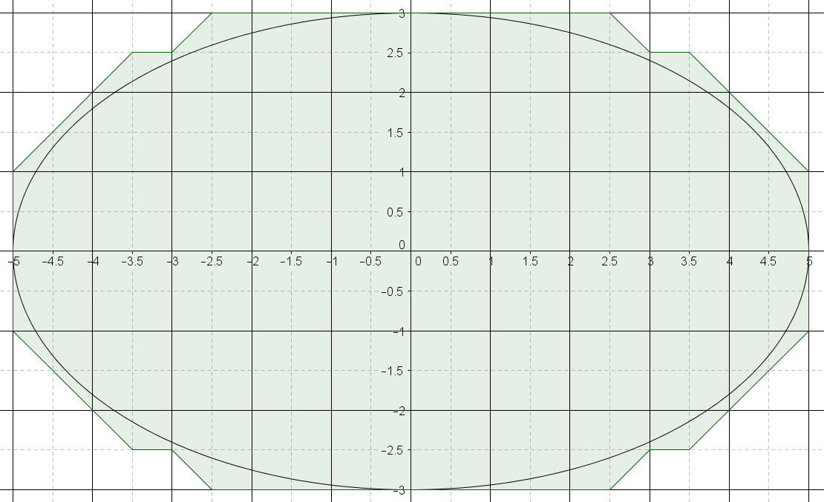

*Scaffolding:*

* If time is an issue, arrange for some groups to work on the over approximation using squares, while some work on the under approximation; do the same for the squares.
  + *There are squares and half squares covered, so it will take less than cans of paint to cover the region inside the curve.*
* What is a good estimate for the area of the region? Explain how you know.

**MP.3**

* + *An estimate of the area is the average of and , or about cans of paint.*
* There are ways to determine the precise area of the curved region. We have not learned them yet so I will just tell you that the precise area of the region is . If the area is known to be , which estimate is better? How do you know?
* This is the unique number that is greater than every lower approximation and less than every upper approximation. The first estimate of cans of paint had an error of about The second estimate, had an error of about . We could continue to improve the accuracy of our estimate by using even smaller squares in the grid.

Closing (1 minute)

Ask students the following questions. You may choose to have students respond in writing, to a partner, or to the whole class.

* Explain a method for approximating the interior region bounded by a curve.
  + *We can make a rough estimate by underestimating the region with a polygonal region that lies within the region and by overestimating the region with a polygonal region that contains the region.*
* How can we improve the accuracy of our estimation of area?
  + *The accuracy of our estimate can be improved by approximating the region with better and better polygonal regions (those which we have the means to calculate the area of). For example, if using a grid, we can look at smaller and smaller squares. If using the decimal approximation of an irrational number, we can improve the accuracy of the estimate of area by using values with more decimal digits.*

Exit Ticket (5 minutes)

Name Date

Lesson 1: What Is Area?

Exit Ticket

1. 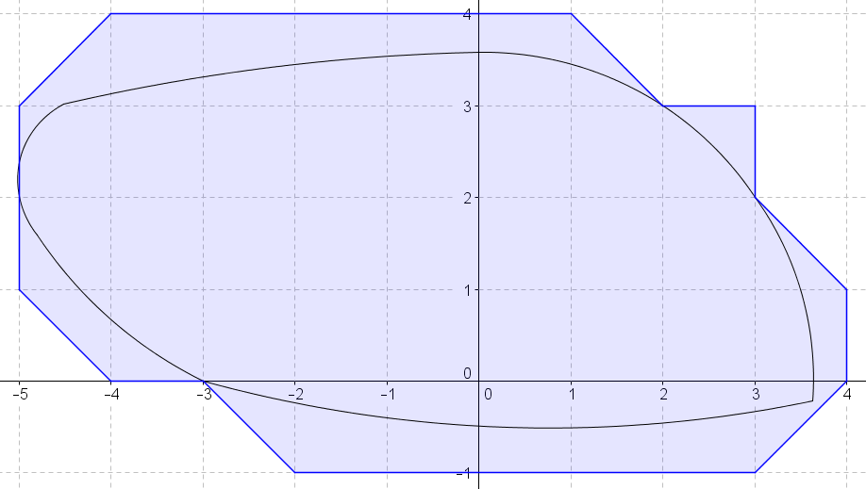Explain how to use the shaded polygonal regions shown to estimate the area inside the curve.

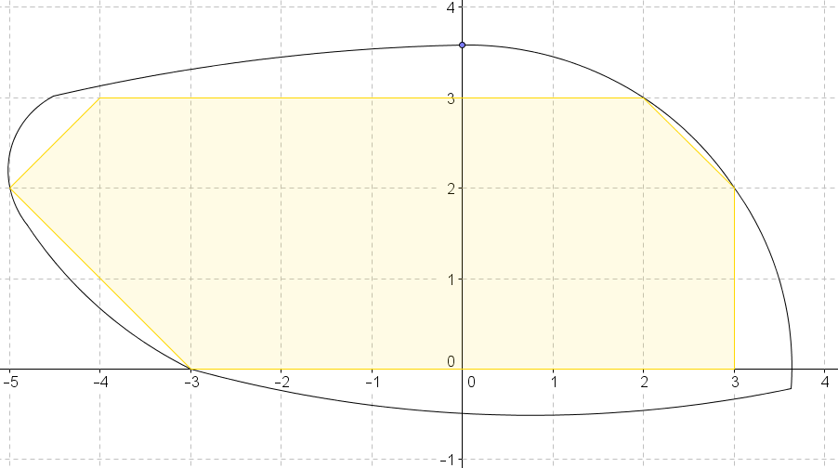

1. Use Problem 1 to find an average estimate for the area inside the curve.

Exit Ticket Sample Solutions

1. Explain how to use the shaded polygonal regions shown to estimate the area inside the curve.

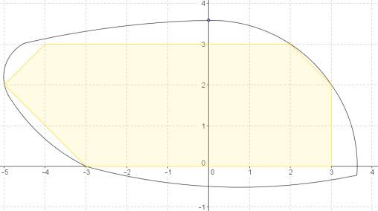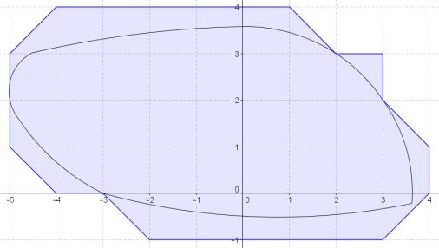

I can use whole and half squares to determine a lower estimate of square units and an upper estimate of square units.

1. **Use Problem 1 to find an average estimate for the area inside the curve.**

Solution:

An average estimate for the area inside the curve is square units.

Problem Set Sample Solutions

1. Use the following picture to explain why is the same as .



b

Rectangles , , and can be used to fill in the first unit square. That leaves rectangles , , and , which make up one quarter of a unit square. Thus, is the same as .

1. Figures 1 and 2 below show two polygonal regions used to approximate the area of the region inside an ellipse and above the -axis.

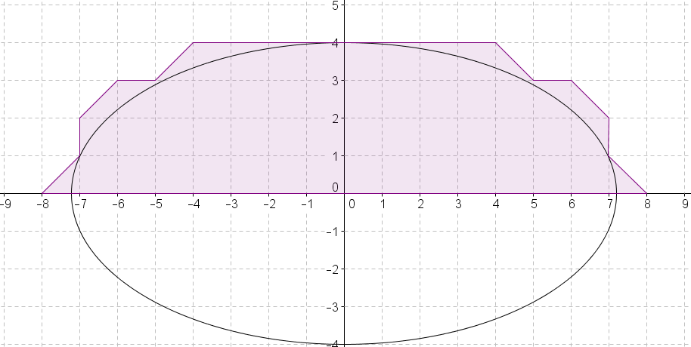

Figure 1

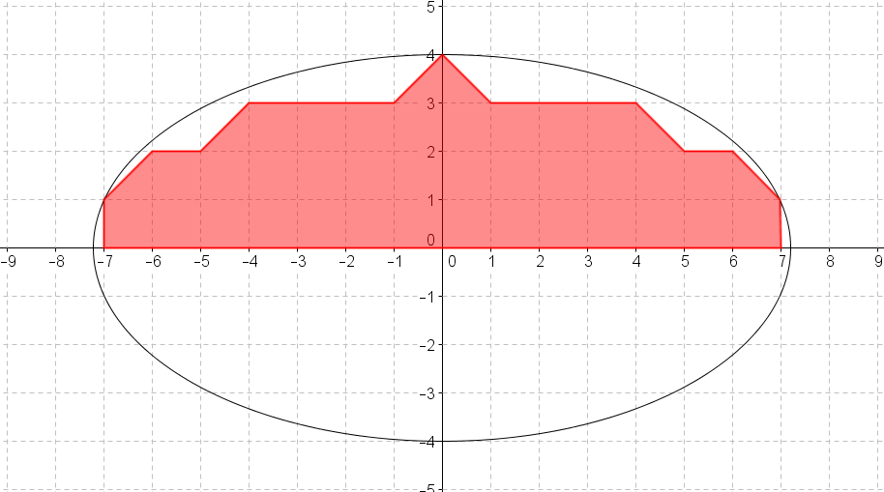

Figure 2

* 1. Which polygonal region has a greater area? Explain your reasoning.

The area of the polygon in Figure 1 has a greater area because it includes all of the area inside the ellipse (above the -axis) plus some area outside of the ellipse. The polygon in Figure 2 does not even fill the region inside the ellipse (above the -axis).

* 1. Which, if either, of the polygonal regions do you believe is closer in area to the region inside the ellipse and above the -axis?

Answers will vary.

1. Figures 1 and 2 below show two polygonal regions used to approximate the area of the region inside a parabola and above the -axis.



* 1. Use the shaded polygonal region in Figure 1 to give a lower estimate of the area under the curve and above the -axis.

Lower estimate: square units.

* 1. Use the shaded polygonal region to give an upper estimate of the area under the curve and above the -axis.

Upper estimate: square units.

* 1. Use (a) and (b) to give an average estimate of the area .

Average estimate

Average estimate

Average estimate

An average estimate of the area under the given curve above the -axis is square units.

1. 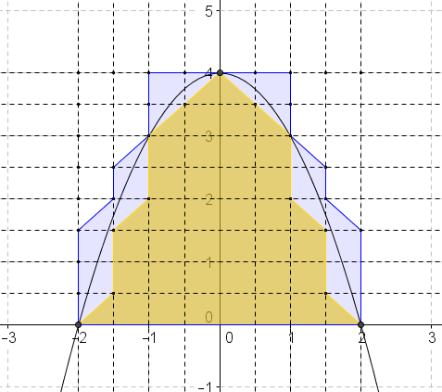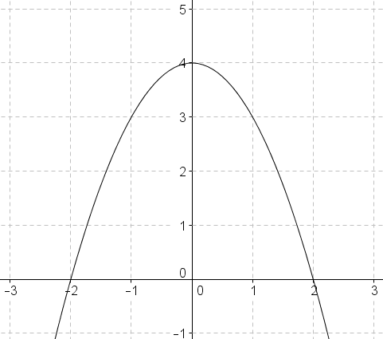Problem 4 is an extension of Problem 3. Using the diagram, draw grid lines to represent each unit.
   1. What do the new grid lines divide each unit square into?

Each unit square is divided into quarter-unit squares.

* 1. Use the squares described in part (a) to determine a lower estimate of area in the diagram.

Lower estimate: quarter-square units or square units.

* 1. Use the squares described in part (a) to determine an upper estimate of area in the diagram.

Upper estimate: quarter-square units or square units.

* 1. Calculate an average estimate of the area under the curve and above the -axis based on your upper and lower estimates in parts (b) and (c).

Average estimate

Average estimate

Average estimate

An average estimate of the area under the curve and above the -axis is square units.

* 1. Do you think your average estimate in Problem 4 is more or less precise than your estimate from Problem 3? Explain.

Student answers will vary. Possible student answer: The areas of the lower and upper estimates in Problem 2 are closer to one another than the estimates found in Problem 1, so I think that the average estimate for the area under the curve in Problem 2 is more precise than the average estimate in Problem 1.