Lesson 1: What Is Area?

Classwork

Exploratory Challenge 1

* 1. What is area?
  2. What is the area of the rectangle below whose side lengths measure by ?

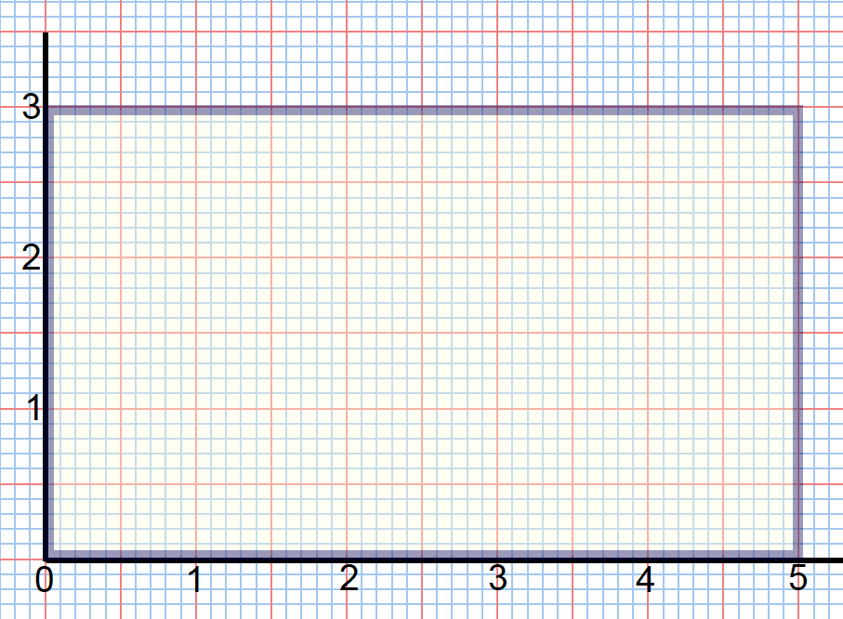

* 1. What is the area of the rectangle below?

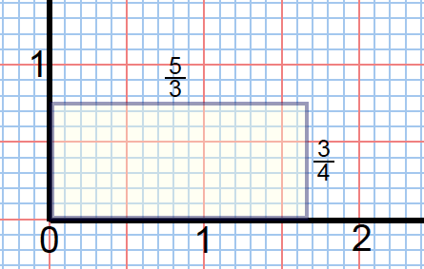

Exploratory Challenge 2

1. What is the area of the rectangle below whose side lengths measure units by units? Use the unit squares on the graph to guide your approximation. Explain how you determined your answer.

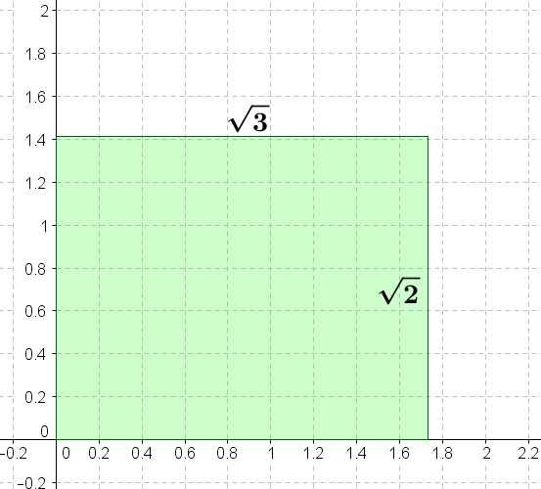

1. Is your answer precise?

Discussion

Use Figures 1, 2, and 3 to find upper and lower approximations of the given rectangle.

Figure 1



Figure 2

 Figure 3

|  |  |  |  |
| --- | --- | --- | --- |
| **Lower Approximations** | | | |
| Less than | Less than | Less than or equal to | |
|  |  |  |  |
|  |  |  |  |
|  |  |  |  |
|  |  |  |  |
|  |  |  |  |
|  |  |  |  |
|  |  |  |  |

|  |  |  |  |
| --- | --- | --- | --- |
| **Upper Approximations** | | | |
| Greater than | Greater than | Greater than or equal to | |
|  |  |  |  |
|  |  |  |  |
|  |  |  |  |
|  |  |  |  |
|  |  |  |  |
|  |  |  |  |
|  |  |  |  |

Discussion

If it takes one can of paint to cover a unit square in the coordinate plane, how many cans of paint are needed to paint the region within the curved figure?



Problem Set

1. Use the following picture to explain why is the same as .

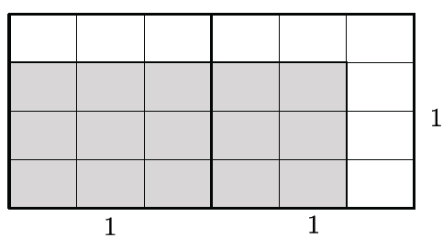

1. Figures 1 and 2 below show two polygonal regions used to approximate the area of the region inside an ellipse and above the -axis.



* 1. Which polygonal region has a greater area? Explain your reasoning.
  2. Which, if either, of the polygonal regions do you believe is closer in area to the region inside the ellipse and above the -axis?

1. Figures 1 and 2 below show two polygonal regions used to approximate the area of the region inside a parabola and above the -axis.



* 1. Use the shaded polygonal region in Figure 1 to give a lower estimate of the area under the curve and above the -axis.
  2. Use the shaded polygonal region to give an upper estimate of the area under the curve and above the -axis.
  3. Use (a) and (b) to give an average estimate of the area .

1. 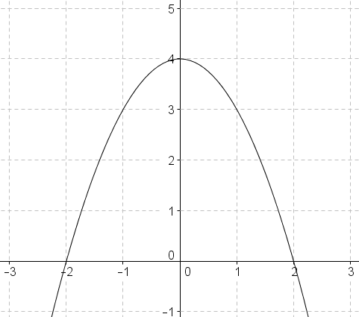Problem 4 is an extension of Problem 3. Using the diagram, draw grid lines to represent each.
   1. What do the new grid lines divide each unit square into?
   2. Use the squares described in part (a) to determine a lower estimate of area in the diagram.
   3. Use the squares described in part (a) to determine an upper estimate of area in the diagram.
   4. Calculate an average estimate of the area under the curve and above the -axis based on your upper and lower estimates in parts (b) and (c).
   5. Do you think your average estimate in Problem 4 is more or less precise than your estimate from Problem 3? Explain.