Lesson 34: Unknown Angles

Student Outcomes
- Students develop an understanding of how to determine a missing angle in a right triangle diagram and apply this to real world situations.

Lesson Notes
This lesson introduces the students to the use of reasoning based on trigonometric ratios to determine an unknown angle in a right triangle (G-SRT.C.8). At this stage, students are limited to understanding trigonometry in terms of ratios, rather than functions. However, the concept of an inverse is not dealt with in this course; this is left until Algebra II
(F-BF.B.4). Therefore, we introduce these ideas carefully and without the formalism of inverses, based on students’ existing understanding of trigonometric ratios. It is important not to introduce the idea of inverses at this juncture, without care, which is why the lesson refers more generally to arcsin, arccos, and arctan as “words” that mathematicians have used to “name,” “identify,” or “refer to” the degree measures that give a certain trigonometric ratio.

Opening Exercise (12 minutes)
Ask students to complete this exercise independently or with a partner. Circulate and then discuss strategies.
Opening Exercise
  - Dan was walking through a forest when he came upon a sizable tree. Dan estimated he was about $40$ meters away from a tree when he measured the angle of elevation between the horizontal and the top of the tree to be $35$ degrees. If Dan is about $2$ meters tall, about how tall is the tree?
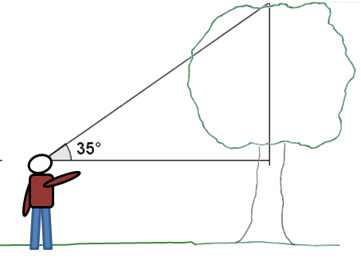
Let$x$ represent the vertical distance from Dan’s eye level to the top of the tree.
$$\tan{35}=\frac{x}{40} \\ 40\tan{35=x} \\ 28≈x$$
The height of the tree is approximately $30$m.
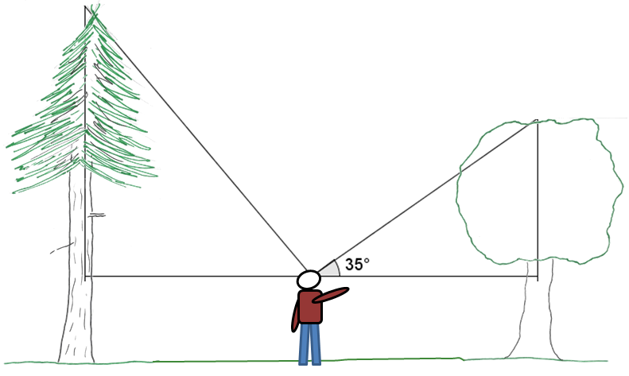
  - Dan was pretty impressed with this tree … until he turned around and saw a bigger one, also $40$ meters away in the other direction. “Wow,” he said. “I bet that tree is at least $50$ meters tall!” Then he thought a moment. “Hmm … if it is $50$ meters tall, I wonder what angle of elevation I would measure from my eye level to the top of the tree?” What angle will Dan find if the tree is $50$ meters tall? Explain your reasoning.

Let$x$ represent the angle measure from the horizontal to the top of the tree.
$$\tan{x}=\frac{48}{40} \\ \tan{x=\frac{6}{5}} \\ \tan{x}=1.2$$
Encourage students to develop conjectures about what the number of degrees will be. Consider selecting some or all of the measures, placing them in a central visible location, and discussing which are the most reasonable and which are the least reasonable. Ideally, some students will reason that measures less than $35$ degrees would be unreasonable; some may draw “hypothetical” angles and use these to compute the tangent ratios; still others may use the table of values for tangent given in Lesson 29 to see that the angle would be slightly greater than $50°$.

Discussion (15 minutes)
Just like in the second exercise, sometimes we are confronted with diagrams or problems where we are curious about what an angle measure might be.
In the same way that mathematicians have named certain ratios within right triangles, they have also developed terminology for identifying angles in a right triangle, given the ratio of the sides. Mathematicians often use the prefix “arc” to define these. The prefix “arc” is used because of how angles were measured; not just as an angle but also as the length of an arc on the unit circle. We will learn more about arc lengths in Module 5.

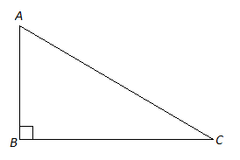

- Write ratios for sin, cos, and tan of angle $C$:
  - $\sin{C}=\frac{AB}{AC}, \cos{C=\frac{BC}{AC},} \tan{C=\frac{AB}{BC}}$
- Write ratios for sin, cos, and tan of angle $A$:
  - $\sin{A=\frac{BC}{AC}, }\cos{A=\frac{AB}{AC}}, \tan{A=\frac{BC}{AB}}$

- Mathematicians have developed some additional terms to describe the angles and side ratios in right triangles. Examine the statements below and see if you can determine the meaning of each one.
One by one, show each statement. Ask students to make and explain a guess about what these statements mean.

- $\arcsin\left(\frac{AB}{AC}\right)=m∠C$
- $\arccos\left(\frac{BC}{AC}\right)=m∠C$
- $\arctan\left(\frac{AB}{BC}\right)=m∠C$

Once students have shared their guesses, formalize the ideas with a discussion:
- Mathematicians use “arcsin,” “arccos,” and “arctan” to refer to the angle measure that results in the given sin, cos, or tan ratio. For example, for this triangle mathematicians would say, “$\arcsin\left(\frac{AB}{AC}\right)=m∠C$.” Explain the meaning of this in your own words.
  - This means that the angle that has a sine ratio equal to $\frac{AB}{AC}$ is $m∠C$.
- Explain the meaning of $\arccos\left(\frac{BC}{AC}\right)=m∠C$.
  - This means that the angle that has a cosine ratio equal to $\frac{BC}{AC}$ is $m∠C$.
- Explain the meaning of $\arctan\left(\frac{AB}{BC}\right)=m∠C$.
  - This means that the angle that has a tangent ratio equal to $\frac{AB}{BC}$ is $m∠C.$
- We can use a calculator to help us determine the values of arcsin, arccos, and arctan. On most calculators these are represented by buttons that look like “sin⁻¹,” “cos⁻¹,” and “tan⁻¹.”
- Let’s revisit the example from the opening. How could we determine the angle of elevation that Dan would measure if he is $40$ meters away and the tree is $50$ meters tall?

  - Let $x$ represent the angle measure from the horizontal to the top of the tree.
$$\tan{x}=\frac{48}{40} \\ \tan{x=\frac{6}{5}} \\ \tan{x}=1.2 \\ x≈50$$

Exercises 1–5 (10 minutes)
Students complete the exercises independently or in pairs.
Exercises 1–5
- Find the measure of angles a–d to the nearest degree.
a.
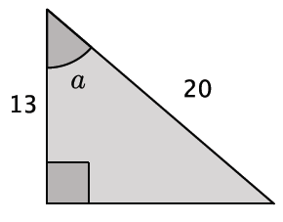
$$arccos \left(\frac{13}{20}\right)≈49$$
$$m∠a=49$$

b.
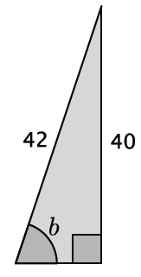
$$arcsin \left(\frac{40}{42}\right)≈72$$
$$m∠b=72$$

c.
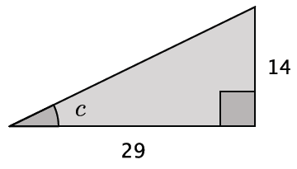
$$arctan \left(\frac{14}{29}\right)≈26$$
$$m∠c=26$$

d.
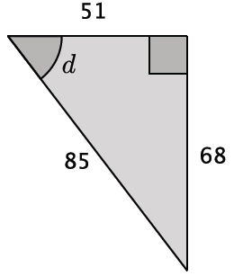
Several solutions are acceptable. One is shown below.
$$arccos \left(\frac{51}{85}\right)≈53$$
$$m∠d=53$$

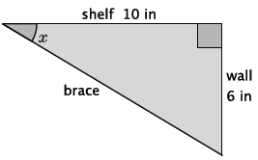
- Shelves are being built in a classroom to hold textbooks and other supplies. The shelves will extend $10$ in from the wall. Support braces will need to be installed to secure the shelves. The braces will be attached to the end of the shelf and secured $6$ in below the shelf on the wall. What angle measure will the brace and the shelf make?
$$arctan\left(\frac{6}{10}\right)≈31$$
The angle measure between the brace and the shelf is $31˚$.

- A $16$ ft ladder leans against a wall. The foot of the ladder is $7$ ft from the wall.
  - Find the vertical distance from the ground to the point where the top of the ladder touches the wall.
Let $x$ represent the distance from the ground to the point where the top of the ladder touches the wall.
$$16^{2}=7^{2}+x^{2} \\ 16^{2}-7^{2}=x^{2} \\ 207=x^{2} \\ 14≈x$$
The top of the ladder is $14$ ft above the ground.
  - Determine the measure of the angle formed by the ladder and the ground.
$$arccos \left(\frac{7}{16}\right)≈64$$
The angle formed by the ladder and the ground is approximately $64˚.$

- A group of friends have hiked to the top of the Mile High Mountain. When they look down, they can see their campsite, which they know is approximately $3$ miles from the base of the mountain.
  - Sketch a drawing of the situation.

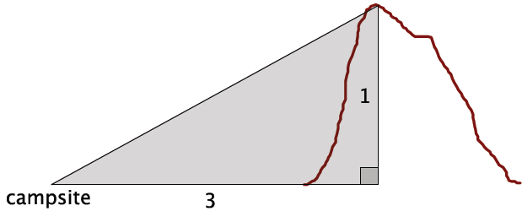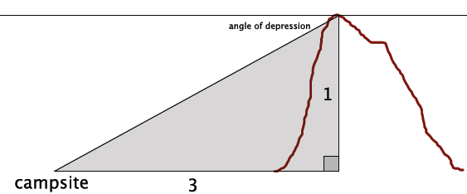

  - What is the angle of depression?
$$arctan \left(\frac{3}{1}\right)≈72$$
The angle of depression is approximately $18˚.$

- A roller coaster travels $80$ ft of track from the loading zone before reaching its peak. The horizontal distance between the loading zone and the base of the peak is $50$ ft.
  - Model the situation using a right triangle.
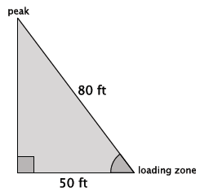
  - At what angle is the roller coaster rising according to the model?
$$arccos \left(\frac{50}{80}\right)≈51$$
The roller coaster is rising at approximately $51˚.$

Closing (3 minutes)
Ask students to summarize the key points of the lesson, and consider asking them the following questions. You may choose to have students respond in writing, to a partner or to the whole class.
- Explain the meaning of $\arccos\left(\frac{8}{9}\right)≈27˚$.
- Explain how to find the unknown measure of angle given information about only two of the sides of a right triangle.
Lesson Summary
In the same way that mathematicians have named certain ratios within right triangles, they have also developed terminology for identifying angles in a right triangle, given the ratio of the sides. Mathematicians will often use the prefix “arc” to define these because an angle is not just measured as an angle, but also as a length of an arc on the unit circle.

Given a right triangle $△ABC$, the measure of angle $C$ can be found in the following ways:
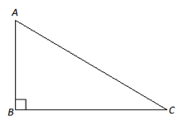

We can write similar statements to determine the measure of angle $A$.

We can use a calculator to help us determine the values of arcsin, arccos, and arctan. Most calculators show these buttons as “sin⁻¹,” “cos⁻¹,” and “tan⁻¹.” This subject will be addressed again in future courses.

- $\arcsin\left(\frac{AB}{AC}\right)=m∠C$
- $\arccos\left(\frac{BC}{AC}\right)=m∠C$
- $\arctan\left(\frac{AB}{BC}\right)=m∠C$

Exit Ticket (5 minutes)
Name ___________________________________________________ Date____________________
Lesson 34: Unknown Angles

Exit Ticket
- Explain the meaning of the statement “$\arcsin\left(\frac{1}{2}\right)=30°$.” Draw a diagram to support your explanation.

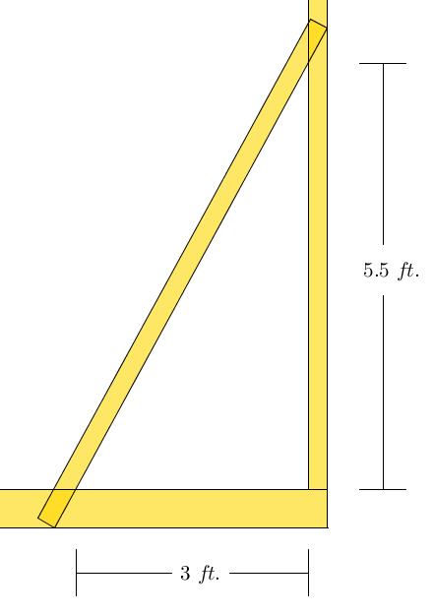
- Gwen has built and raised a wall of her new house. To keep the wall standing upright while she builds the next wall, she supports the wall with a brace, as shown in the diagram below. What is value of $p$, the measure of the angle formed by the brace and the wall?
$$p°$$
Brace

Wall

Exit Ticket Sample Solutions

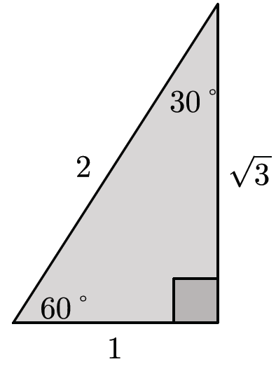
- Explain the meaning of the statement “$arcsin \left(\frac{1}{2}\right)=30°$.” Draw a diagram to support your explanation.
This means that the measure of the angle that has a sine ratio equal to $\frac{1}{2}$ is $30$˚.

- Gwen has built and raised a wall of her new house. To keep the wall standing upright while she builds the next wall, she supports the wall with a brace, as shown in the diagram below. What is value of $p$, the measure of the angle formed by the brace and the wall?

$$\arctan{\begin{aligned}\frac{5.5}{3}=p \\ 61≈p\end{aligned}}$$
The measure of the angle formed by the brace and the wall is approximately $61˚$.

Problem Set Sample Solutions

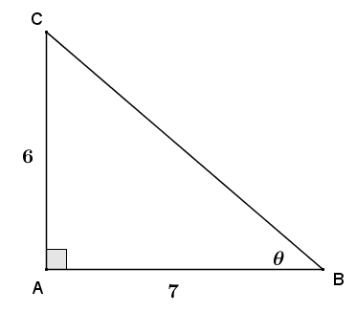
- For each triangle shown, use the given information to find the indicated angle to the nearest degree.

$$\tan{θ}=\frac{6}{7}$$
$$arctan\left(\frac{6}{7}\right)=θ$$
$$θ≈41°$$

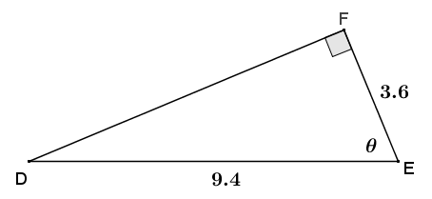
$$\cos{θ}=\frac{3.6}{9.4}$$
$$arccos\left(\frac{3.6}{9.4}\right)=θ$$
$$θ≈67°$$

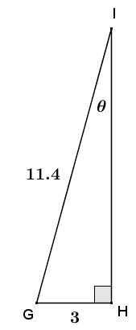
$$\sin{θ}=\frac{3}{11.4}$$
$$arcsin\left(\frac{3}{11.4}\right)=θ$$
$$θ≈15°$$

- Solving a right triangle means using given information to find all the angles and side lengths of the triangle. Use $arcsin$ and $arccos$, along with the given information, to solve right triangle $ABC$ if leg $AC=12$ and hypotenuse $AB=15$.
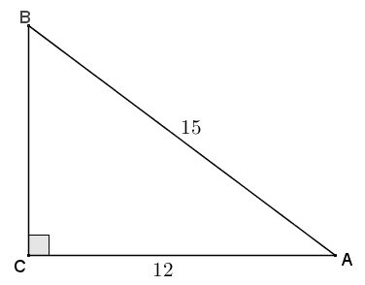
By the Pythagorean theorem, $BC=9$.
$$\sin{B}=\frac{12}{15}$$
$$arcsin\left(\frac{12}{15}\right)=m∠B$$
$$m∠B≈53°$$

$$\cos{A}=\frac{12}{15}$$
$$arccos\left(\frac{12}{15}\right)=m∠A$$
$$m∠A≈37°$$

Once you have found the measure of one of the acute angles in the right triangle, can you find the measure of the other acute angle using a different method than those used in this lesson? Explain.
Yes. We could use the angle sum of a triangle after finding the measure of one acute angle.

- A pendulum consists of a spherical weight suspended at the end of a string whose other end is anchored at a pivot point $P$. The distance from $P$ to the center of the pendulum’s sphere, $B$, is $6$ inches. The weight is held so that the string is taught and horizontal, as shown to the right, and then dropped.
  - What type of path does the pendulum’s weight take as it swings?
Since the string is a constant length, the path of the weight is circular.

  - Danni thinks that for every vertical drop of $1$ inch that the pendulum’s weight makes, the degree of rotation is $15°$. Do you agree or disagree with Danni? As part of your explanation, calculate the degree of rotation for every vertical drop of $1$ inch from $1$ to $6$ inches.
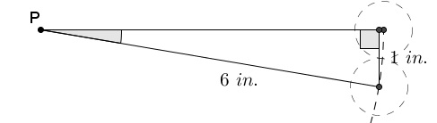
Disagree. A right triangle can model the pendulum and its vertical drops as shown in the diagrams.
The angle of rotation about $P$ for a vertical drop of $1$ inch is equal to the $arcsin\left(\frac{1}{6}\right)$, which is approximately $10°$.

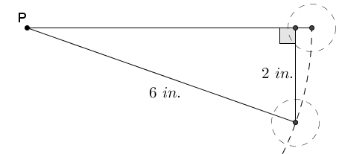
The angle of rotation about $P$, for a vertical drop of $2$ inches, is equal to the $arcsin\left(\frac{2}{6}\right)$, which is approximately $20°$.

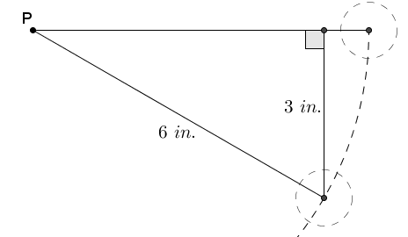
The angle of rotation about $P$, for a vertical drop of $3$ inches, is equal to the $arcsin\left(\frac{3}{6}\right)$, which is $30°$.

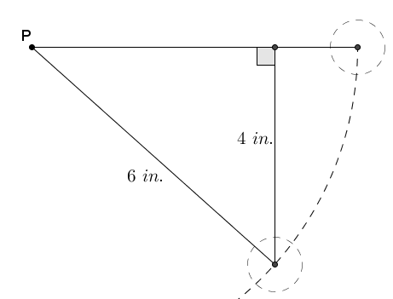
The angle of rotation about $P$, for a vertical drop of $4$ inches, is equal to the $arcsin\left(\frac{4}{6}\right)$, which is approximately $42°$.

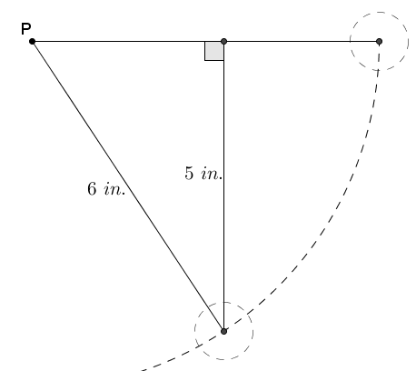
The angle of rotation about $P$, for a vertical drop of $5$ inches, is equal to the $arcsin\left(\frac{5}{6}\right)$, which is approximately $56°$.

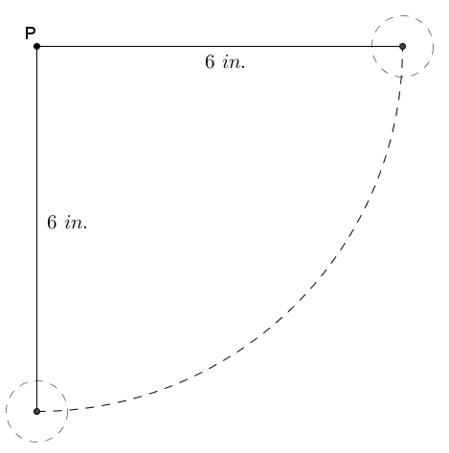
The pendulum’s weight will be at its maximum distance below the pivot point which means that the weight must be directly below the pivot point. This means that the string would be perpendicular to the horizontal starting position, therefore the degree of rotation would be $90°$.

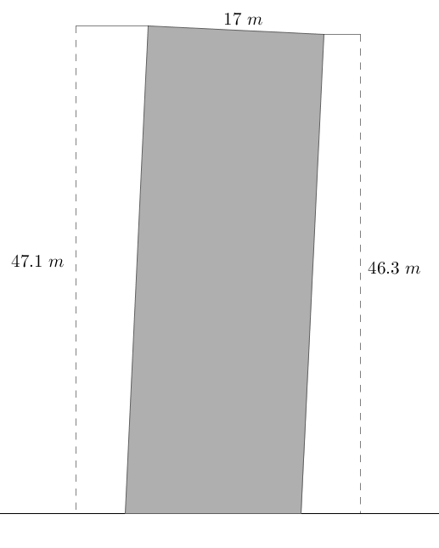
- A stone tower was built on unstable ground and the soil beneath it settled under its weight causing the tower to lean. The cylindrical tower has a diameter of $17$ meters. The height of the tower on the low side measured $46.3$ meters and on the high side measured $47.1$ meters. To the nearest tenth of a degree, find the angle that the tower has leaned from its original vertical position.
The difference in heights from one side of the tower to the other is $47.1 m-46.3 m=0.8 m$.
Model the difference in heights and the diameter of the tower using a right triangle. (The right triangle shown below is not drawn to scale).
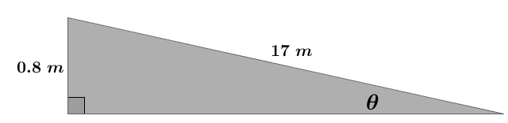

The unknown value $θ$ represents the degree measure that the tower has leaned.
$$\sin{θ}=\frac{0.8}{17}$$
$$θ=arcsin\left(\frac{0.8}{17}\right)$$
$$θ≈3$$
The tower has leaned approximately $3°$ from its vertical position.

- Doug is installing a surveillance camera inside a convenience store. He mounts the camera $8$ ft above the ground and $15$ ft horizontally from the store’s entrance. The camera is meant to monitor every customer that enters and exits the store. At what angle of depression should Doug set the camera to capture the faces of all customers?
Note: This is a modelling problem and therefore will have various reasonable answers.
The solution below represents only one of many possible reasonable solutions.
Most adults are between $4\frac{1}{2}$ and $6\frac{1}{2}$ ft. tall, so the camera should be aimed to capture images within the range of $1\frac{1}{2}$ to $3\frac{1}{2}$ ft. below its mounted height. Cameras capture a range of images, so Doug should mount the camera so that it points at a location in the doorway $2\frac{1}{2}$ ft. below its mounted height.
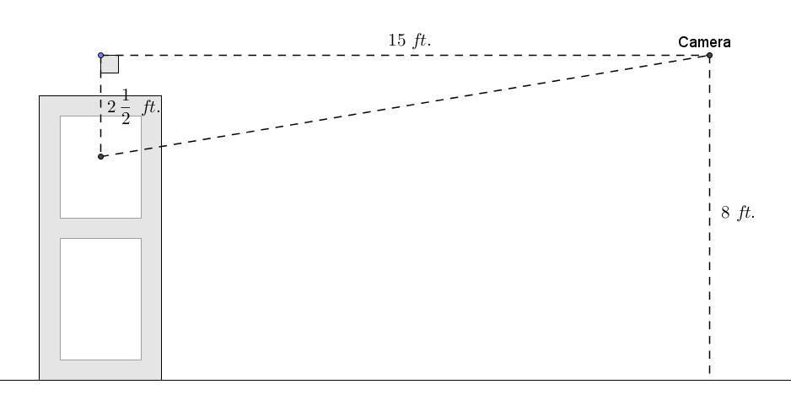
The angle of depression is equal to the $arctan\left(\frac{2\frac{1}{2}}{15}\right)≈10°$.

