Lesson 34: Unknown Angles

Classwork
Opening Exercise
  - Dan was walking through a forest when he came upon a sizable tree. Dan estimated he was about 40 meters away from a tree when he measured the angle of elevation between the horizontal and the top of the tree to be 35 degrees. If Dan is about 2 meters tall, about how tall is the tree?
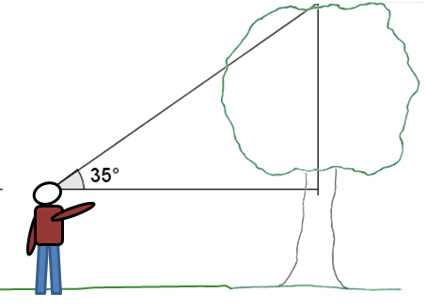

  - Dan was pretty impressed with this tree … until he turned around and saw a bigger one, also $40$ meters away but in the other direction. “Wow,” he said. “I bet that tree is at least $50$ meters tall!” Then he thought a moment. “Hmm … if it is $50$ meters tall, I wonder what angle of elevation I would measure from my eye level to the top of the tree?” What angle will Dan find if the tree is $50$ meters tall? Explain your reasoning.
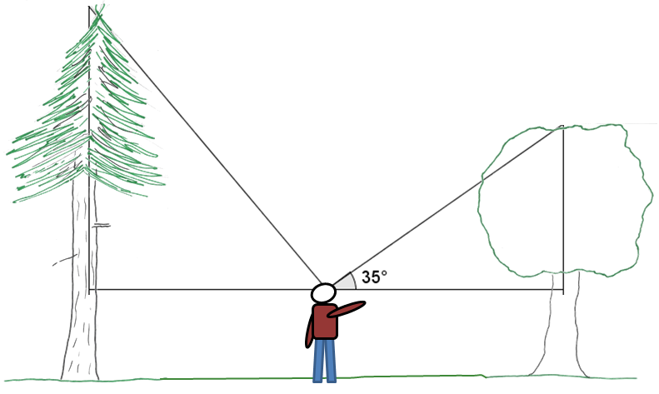

Exercises 1–5
- Find the measure of angles a–d to the nearest degree.
a.
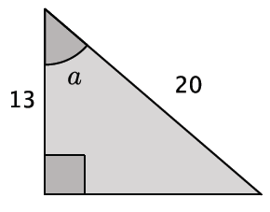

b.
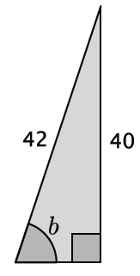

c.
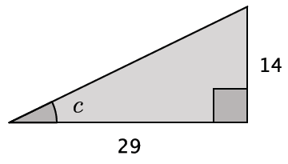

d.
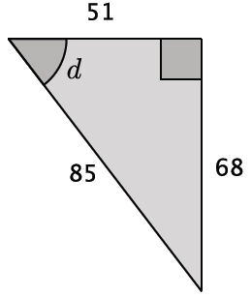

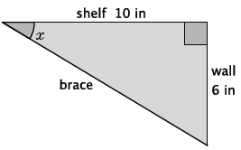
- Shelves are being built in a classroom to hold textbooks and other supplies. The shelves will extend $10$ in from the wall. Support braces will need to be installed to secure the shelves. The braces will be attached to the end of the shelf and secured $6$ in below the shelf on the wall. What angle measure will the brace and the shelf make?

- A $16$ ft ladder leans against a wall. The foot of the ladder is $7$ ft from the wall.
  - Find the vertical distance from the ground to the point where the top of the ladder touches the wall.

  - Determine the measure of the angle formed by the ladder and the ground.

- A group of friends have hiked to the top of the Mile High Mountain. When they look down, they can see their campsite, which they know is approximately $3$ miles from the base of the mountain.
  - Sketch a drawing of the situation.

  - What is the angle of depression?

- A roller coaster travels $80$ ft of track from the loading zone before reaching its peak. The horizontal distance between the loading zone and the base of the peak is $50$ ft.
  - Model the situation using a right triangle.

  - At what angle is the roller coaster rising according to the model?

Lesson Summary
In the same way that mathematicians have named certain ratios within right triangles, they have also developed terminology for identifying angles in a right triangle, given the ratio of the sides. Mathematicians will often use the prefix “arc” to define these because an angle is not just measured as an angle, but also as a length of an arc on the unit circle.

Given a right triangle $△ABC$, the measure of angle $C$ can be found in the following ways:
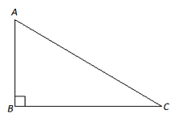
We can write similar statements to determine the measure of angle $A$.

We can use a calculator to help us determine the values of arcsin, arccos, and arctan. Most calculators show these buttons as “sin⁻¹,” “cos⁻¹,” and “tan⁻¹.” This subject will be addressed again in future courses.

- $\arcsin\left(\frac{AB}{AC}\right)=m∠C$
- $\arccos\left(\frac{BC}{AC}\right)=m∠C$
- $\arctan\left(\frac{AB}{BC}\right)=m∠C$

Problem Set

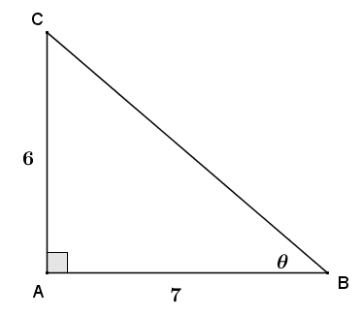
- For each triangle shown, use the given information to find the indicated angle to the nearest degree.

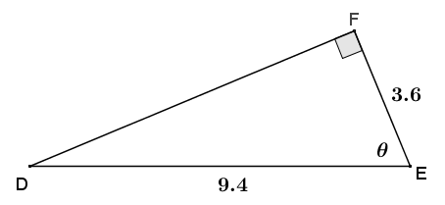

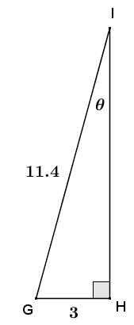

- Solving a right triangle means using given information to find all the angles and side lengths of the triangle. Use $arcsin$ and $arccos$, along with the given information, to solve right triangle $ABC$ if leg $AC=12$ and hypotenuse $AB=15$.
Once you have found the measure of one of the acute angles in the right triangle, can you find the measure of the other acute angle using a different method than those used in this lesson? Explain.

- A pendulum consists of a spherical weight suspended at the end of a string whose other end is anchored at a pivot point $P$. The distance from $P$ to the center of the pendulum’s sphere, $B$, is $6$ inches. The weight is held so that the string is taught and horizontal, as shown to the right, and then dropped.
  - What type of path does the pendulum’s weight take as it swings?
  - Danni thinks that for every vertical drop of $1$ inch that the pendulum’s weight makes, the degree of rotation is $15°$. Do you agree or disagree with Danni? As part of your explanation, calculate the degree of rotation for every vertical drop of 1 inch from 1 to 6 inches.

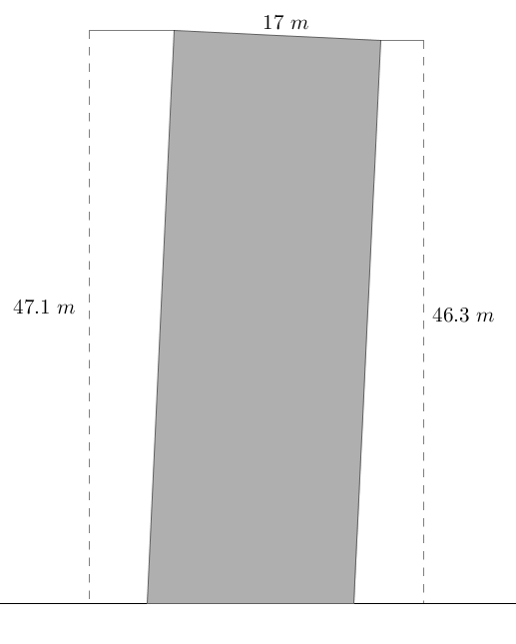
- A stone tower was built on unstable ground and the soil beneath it settled under its weight causing the tower to lean. The cylindrical tower has a diameter of $17$ meters. The height of the tower on the low side measured $46.3$ meters and on the high side measured $47.1$ meters. To the nearest tenth of a degree, find the angle that the tower has leaned from its original vertical position.

- Doug is installing a surveillance camera inside a convenience store. He mounts the camera $8$ ft above the ground and $15$ ft horizontally from the store’s entrance. The camera is being installed to monitor every customer that enters and exits the store. At what angle of depression should Doug set the camera to capture the faces of all customers?

